**Combining SQL (MySQL Workbench) with TABLEAU**

**Task 1 :**

Create a visualization that provides a breakdown between the male and female employees working in the company each year starting from 1990. Separate the data for year.

**SQL QUERY:**

SELECT

YEAR(d.from_date) as calender_year,

e.gender,

COUNT(e.emp_no) as num_of_employees

FROM

t_employees e

INNER JOIN

t_dept_emp d

on e.emp_no = d.emp_no

GROUP BY calender_year, e.gender

HAVING calender_year >= 1990;

**Bar chart:**

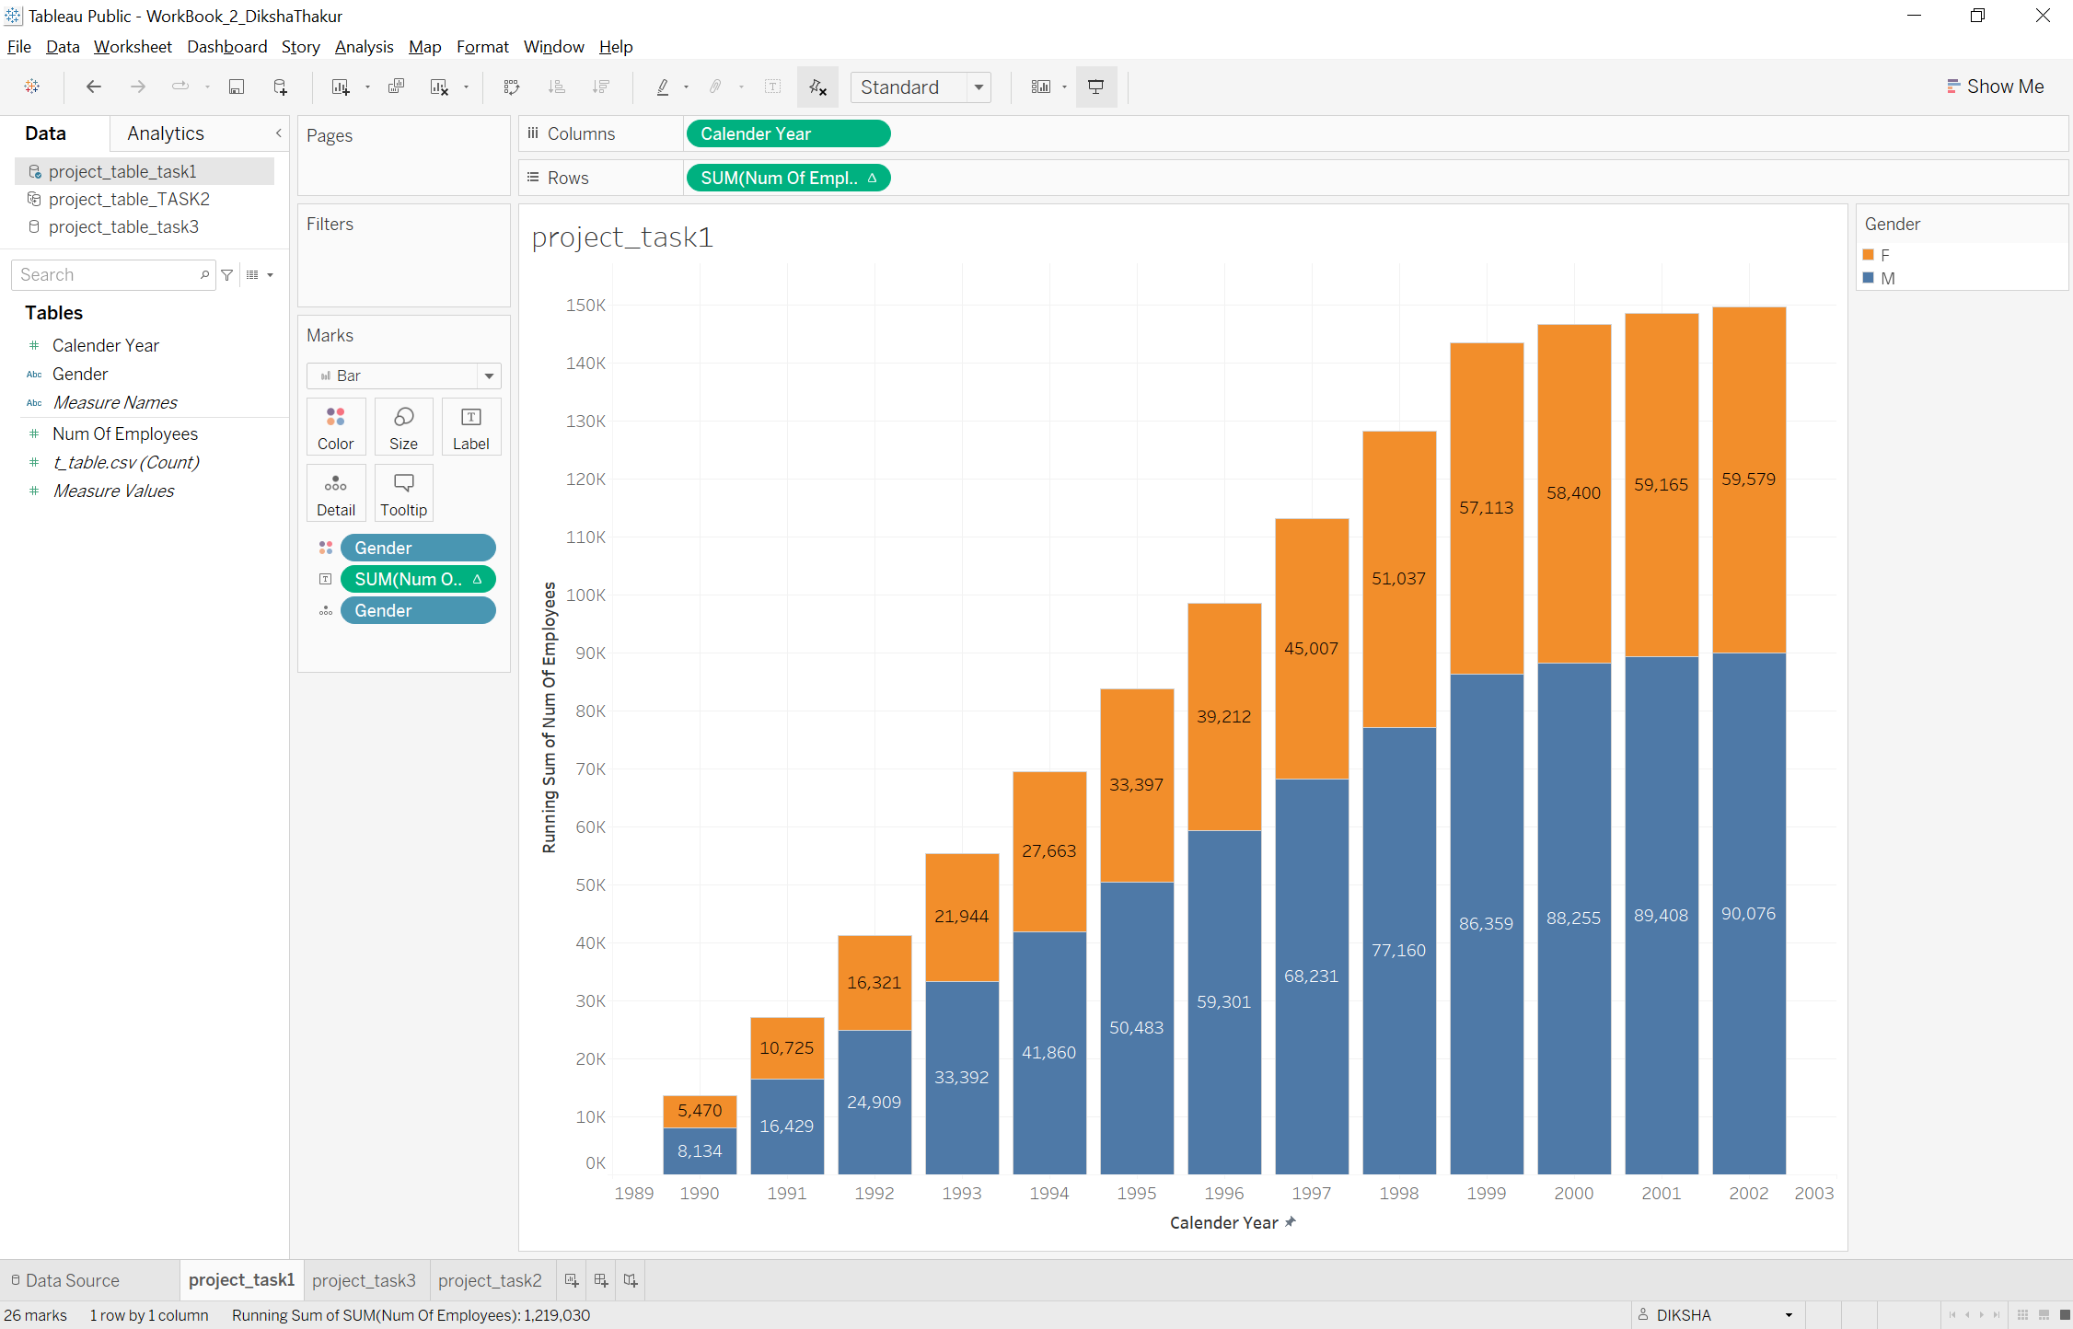

**Task 2:**

Compare the average salary of female versus male employees in the entire company until year 2002, and added filter to see that per each department.

**SQL Query:**

SELECT

e.gender, d.dept_name, ROUND(AVG(s.salary), 2) as Salary, YEAR(s.from_date) as calender_year

FROM

t_salaries s

JOIN

t_employees e ON s.emp_no = e.emp_no

JOIN

t_dept_emp de ON de.emp_no = e.emp_no

JOIN

t_departments d ON d.dept_no = de.dept_no

GROUP BY d.dept_no, e.gender, calender_year

HAVING calender_year <= 2002

ORDER BY d.dept_no;

**Line chart:**

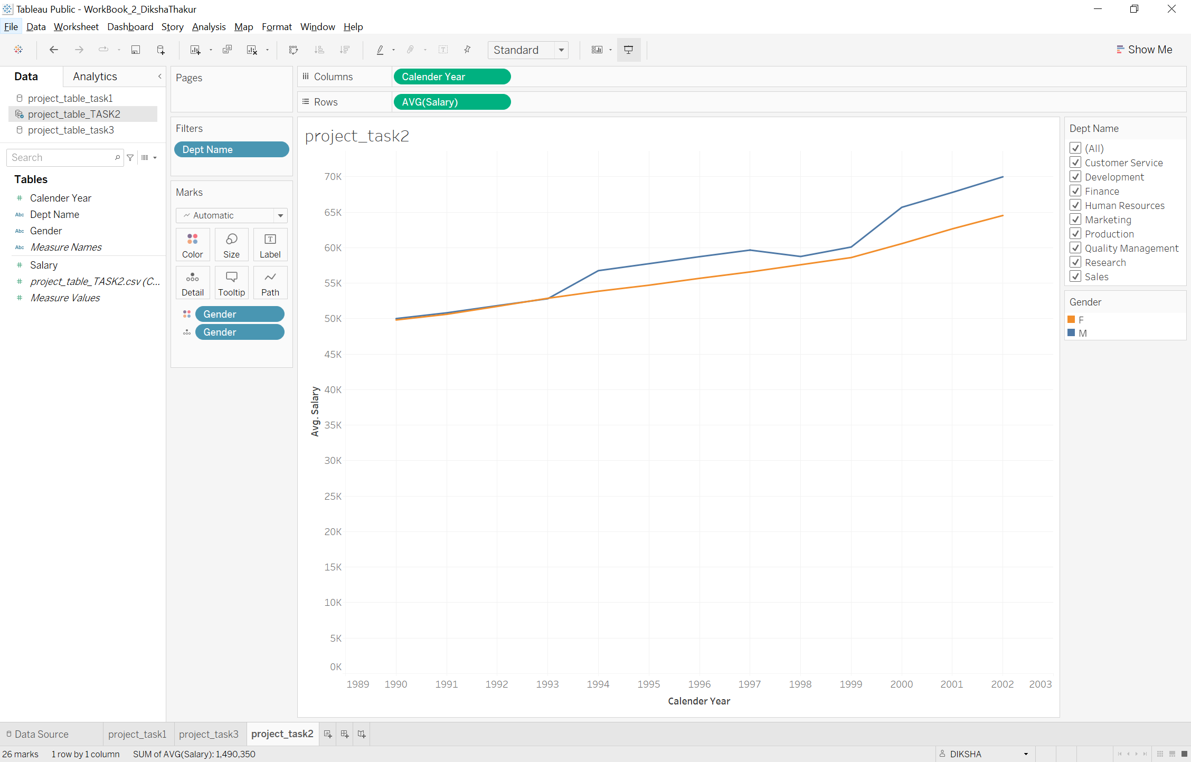

visualize average salary for specific department: lets say “marketing department”

**Task 3:**

**Compare the number of male managers to the number of female managers from departments different departments for each year, starting from 1990.**

**SQL QUERY:**

SELECT

d.dept_name,

ee.gender,

dm.from_date,

dm.to_date,

e.calender_year,

CASE

WHEN YEAR(dm.to_date) >= e.calender_year AND YEAR(dm.from_date) <=e.calender_year THEN 1

ELSE 0departments

END AS active

FROM

(SELECT YEAR(hire_date) AS calender_year

FROM

t_employees

GROUP BY calender_year) e

CROSS JOIN

t_dept_manager dm

JOIN

t_departments d ON dm.dept_no = d.dept_no

JOIN

t_employees ee ON dm.emp_no=ee.emp_no

ORDER BY dm.emp_no, calender_year;

**AREA CHART:**

