Online Movie Ticket Booking System

A course project report submitted in partial fulfillment of the requirement
of

DEVOPS AND FULLSTACK
by

GINNE SAI TEJA (2303A51526)
THAKUR PHANI KUMAR (2303A51529)
CHANDA WISHRAM (2303A51532)

Under the guidance of
Dr. N.VENKATESH
Asst. Professor, Department of CS & AI


SR University, Warangal
APRIL-2026

ABSTRACT
This project presents the implementation of a full-stack DevOps-integrated Movie Ticket Booking System named "Just Now." The application is designed to provide users with a seamless movie browsing and ticket booking experience through a modern web interface. The system bridges the gap between frontend user experience and backend reliability by adopting industry-standard DevOps practices throughout the development lifecycle.
The frontend is developed using React 18 and Vite, offering a responsive, dark-themed user interface for browsing movies, authenticating users, and booking tickets. The backend is built with Node.js and Express.js, exposing RESTful API endpoints for authentication, booking management, and user data handling. MongoDB is utilized as the primary database, enabling flexible document storage for users and booking records.
The project demonstrates the integration of JSON Web Token (JWT)-based authentication, middleware-protected API routes, and Axios-powered client-server communication. Development tooling includes ESLint for code quality, Vite for fast hot module replacement, and Git for version control. The architecture reflects real-world full-stack patterns and serves as a foundation for further DevOps pipeline integration including CI/CD automation, containerization, and cloud deployment.

CONTENTS
ii

Chapter No. Title Page No.
1 INTRODUCTION 01
1.1 About the Project 01
1.2 Objectives 02
2 LITERATURE REVIEW 03
2.1 Overview 03
2.2 Related Studies and Existing Solutions 05
2.3 Tools and Technologies Used 07
3 METHODOLOGY 08
3.1 System Architecture 08
3.2 Frontend Implementation 10
3.3 Backend Implementation 12
4 RESULTS AND DISCUSSION 14
4.1 Application Features and Key Findings 14
4.2 Screenshots and Interface Overview 16
4.3 Insights and Discussion 18
5 CONCLUSION AND FUTURE WORK 19
5.1 Summary of Findings 19
5.2 Conclusions Drawn 20
5.3 Recommendations and Future Scope 20

CHAPTER 1: INTRODUCTION

1.1 About the Project
The DevOps Fullstack project is a web-based Movie Ticket Booking System titled "Just Now," developed using a modern JavaScript ecosystem. The application allows registered users to browse available movies, select seats, and book tickets in a fluid and intuitive dark-themed interface. The system is built on a full-stack architecture that unifies frontend and backend development within a single codebase repository, following DevOps principles of continuous development and deployment.
The project is hosted on GitHub under the repository ThakurPhaniKumar/DevOps-Fullstack. The frontend is developed using React 18 with Vite as the build tool, offering fast hot module replacement during development and optimized production builds. The backend uses Node.js with the Express.js framework to expose REST APIs. MongoDB is used as the document-oriented NoSQL database for storing user and booking information. Authentication is handled via JSON Web Tokens (JWT), and Axios is used for HTTP communication between the client and server.
The project structure includes key files such as App.jsx for the main React frontend component, server.js for the Node.js entry point, authController.js and authMiddleware.js for security, bookingController.js for booking logic, and separate route files for authentication and booking operations. This clear separation of concerns demonstrates good software engineering practices relevant to both full-stack development and DevOps workflows.

1.2 Objectives
The primary objectives of this project are:
- To design and implement a fully functional full-stack web application for movie ticket booking using React, Node.js, Express.js, and MongoDB.
- To implement JWT-based user authentication and authorization with protected API routes using middleware.
- To demonstrate RESTful API design principles through structured backend routes and controllers for authentication and bookings.
- To apply DevOps-relevant development practices including version control via Git, modular code organization, and environment variable management using .env configuration.
- To utilize modern build tooling (Vite) and code quality enforcement (ESLint) as part of the development pipeline.
- To serve as a foundation for integrating CI/CD pipelines, containerization with Docker, and cloud deployment as future DevOps enhancements.

CHAPTER 2: LITERATURE REVIEW

2.1 Overview
DevOps and Full-Stack Application Development
DevOps has emerged as a transformative approach in modern software engineering by bridging the traditional gap between development and operations teams. The concept gained prominence around 2009 and emphasizes collaboration, automation, continuous integration, and continuous deployment throughout the software development lifecycle. Researchers such as Humble and Farley (2010) highlighted that continuous delivery practices significantly reduce deployment risks while improving software reliability and release frequency. DevOps integrates development, testing, deployment, monitoring, and feedback mechanisms into a continuous and automated pipeline, thereby enhancing efficiency and reducing time-to-market.
Continuous Integration and Continuous Deployment (CI/CD) are core components of DevOps practices. CI/CD pipelines automate code building, testing, and deployment processes, enabling rapid and reliable software releases. Tools such as Jenkins, GitHub Actions, and GitLab CI/CD are widely adopted for implementing automated workflows. Literature indicates that CI practices help detect defects early, minimize integration conflicts, and enhance collaborative development. Automated deployment further ensures consistency across staging and production environments.
Containerization has significantly influenced DevOps implementation by enabling consistent application environments. Docker introduced lightweight containers that package applications along with their dependencies, ensuring portability across different systems. This approach reduces configuration mismatches and improves scalability. For orchestration and large-scale container management, Kubernetes provides automated scaling, load balancing, and self-healing capabilities. Studies suggest that container-based deployment improves resource utilization and simplifies microservices architecture implementation.

2.2 Related Studies and Existing Solutions
Version control systems form the backbone of collaborative software development in both DevOps and full-stack environments. Git enables distributed source code management and supports branching, merging, and pull request workflows. Research demonstrates that structured version control strategies enhance maintainability, reduce development conflicts, and improve overall software quality.
Full-stack development integrates both frontend and backend technologies to build complete web applications. On the frontend, frameworks such as React and Angular facilitate dynamic user interfaces and component-based architectures. On the backend, technologies like Node.js and Express.js enable scalable server-side development and RESTful API integration. Literature suggests that full-stack frameworks enhance development productivity, modular design, and seamless client-server communication. The integration of frontend and backend technologies within a unified ecosystem accelerates application delivery and supports agile methodologies.
Database integration is another critical aspect of full-stack systems. Relational databases such as MySQL provide structured data management and strong consistency, while NoSQL databases such as MongoDB offer flexible schemas and horizontal scalability. Comparative studies highlight that NoSQL databases are often preferred in JavaScript-based full-stack ecosystems due to their schema flexibility and JSON-like document storage format.

2.3 Tools and Technologies Used
Infrastructure as Code (IaC) further strengthens DevOps maturity by automating infrastructure provisioning and configuration management. Tools like Terraform and Ansible allow developers to define infrastructure through code, improving reproducibility and reducing manual errors. Research indicates that IaC enhances deployment consistency and supports cloud-native application development.
Monitoring and observability are essential for maintaining reliability in production systems. Tools such as Prometheus and Grafana enable real-time performance tracking, log aggregation, and alert-based incident management. Literature emphasizes that proactive monitoring reduces downtime and improves system resilience.
Category | Technology / Tool | Purpose
Frontend | React 18 + Vite | UI rendering and build tooling
Styling | CSS (App.css, index.css) | Component and page styling
HTTP Client | Axios | REST API communication
Backend | Node.js + Express.js | Server and API routing
Database | MongoDB | User and booking data storage
Auth | JSON Web Token (JWT) | Secure user authentication
Code Quality | ESLint | Linting and code standards
Version Control | Git / GitHub | Source code management
Table 2.1: Summary of Tools and Technologies Used

CHAPTER 3: METHODOLOGY

3.1 System Architecture
The application follows a standard three-tier architecture separating the presentation, business logic, and data layers. The frontend (React + Vite) communicates with the backend (Node.js + Express.js) through HTTP REST API calls using Axios. The backend processes requests, enforces authentication via JWT middleware, and persists or retrieves data from the MongoDB database.
The system is organized as follows: the client runs on port 5173 (Vite default) during development and sends requests to the Express server on port 5000. API routes are prefixed with /api and divided into two main groups: /api/auth for registration and login, and /api/bookings for creating and fetching bookings. Each route group has its own controller and middleware stack.
Figure 3.1: Application Architecture Overview
Frontend (Client) | Backend (Server)
React 18 SPA  Vite Build Tool  Axios HTTP Client  Local Storage (JWT Token) | Express.js REST API  JWT Auth Middleware  MongoDB via Mongoose  dotenv Configuration

3.2 Frontend Implementation
The frontend is implemented as a single-page application (SPA) using React 18 with functional components and React Hooks. The main entry point is main.jsx which mounts the App component into the DOM via index.html. The App.jsx file manages the complete application state including user authentication status, current view (login, movies, history), and the JWT token retrieved from localStorage.
The application uses three primary views controlled by a state variable: the login form, the movies listing, and the booking history. The login form submits credentials to the backend authentication endpoint. On successful login, the JWT token is stored in localStorage and the user is redirected to the movies view. The movies listing displays a grid of available films fetched from a static local array (in the current implementation), with a Book Now button that triggers the booking API call.
Styling is managed through two CSS files (App.css and index.css) with an overall dark theme using background color #0a0e17. Navigation between views is handled through inline button controls rather than a routing library, keeping the implementation lightweight. The component uses inline style objects for granular control over individual UI elements.

3.3 Backend Implementation
The backend is structured as a Node.js Express application with a clear separation of routes, controllers, and middleware. The server entry point (server.js) initializes the Express application, connects to MongoDB using environment variables from the .env file, and mounts the authentication and booking route handlers.
Authentication is managed through the authController.js file which handles user registration and login logic. On login, the controller validates credentials against the stored user record (User.js model) and issues a signed JWT. The authMiddleware.js file intercepts protected route requests, extracts the Bearer token from the Authorization header, and verifies its validity before allowing access.
Booking operations are handled by bookingController.js with the corresponding data model in Booking.js. The booking schema stores the movie title, selected theatre (AMB Cinemas), seat numbers, total amount, and a reference to the authenticated user. The bookingRoutes.js file applies the auth middleware to all booking endpoints, ensuring that only logged-in users can create or retrieve bookings.

CHAPTER 4: RESULTS AND DISCUSSION

4.1 Application Features and Key Findings
The implemented system successfully demonstrates a working full-stack DevOps-oriented web application with the following key functional outcomes:
- User Authentication: The login flow successfully communicates with the Express.js backend, receives a JWT token, and persists it in localStorage for subsequent API calls.
- Movie Browsing: The movies view renders a responsive grid of available films with poster thumbnails and genre labels.
- Ticket Booking: The booking flow correctly posts a booking request with theatre, seat selection, and total amount to the backend API, with the JWT token passed in the Authorization header.
- Route Protection: The authMiddleware effectively blocks unauthenticated booking requests, returning an error response when no valid token is present.
- Modular Codebase: The clear separation between auth routes, booking routes, controllers, and models demonstrates scalable, maintainable architecture.

The following table summarizes the API endpoints implemented and their corresponding HTTP methods and access control:
Method | Endpoint | Auth Required | Description
POST | /api/auth/register | No | Register new user
POST | /api/auth/login | No | Login and receive JWT token
POST | /api/bookings | Yes (JWT) | Create a new booking
GET | /api/bookings | Yes (JWT) | Get user booking history
Table 4.1: API Endpoint Summary

4.2 Visualization and Interpretation of Results
The frontend successfully renders the dark-themed user interface with a navigation bar containing the application name (Just Now) and contextual navigation buttons (Movies, History, Logout) that appear only when a user is authenticated. The login view centers a compact form with email and password inputs styled to match the overall dark theme. The movies grid uses a CSS auto-fill layout that adapts to various screen sizes.
When a booking is successfully created, the user receives an alert confirmation and is redirected to the history view. API communication is handled entirely through Axios with Bearer token injection for authenticated routes, matching the standard OAuth 2.0 authorization pattern. The backend returns appropriate HTTP status codes and JSON responses for each operation.

4.3 Insights and Discussion
The project demonstrates that a lightweight full-stack architecture can be effectively developed and organized following DevOps principles without requiring heavy infrastructure. The use of a single GitHub repository for both frontend and backend files reflects a monorepo approach, which simplifies version control and collaboration. The .env file pattern, combined with the .gitignore, ensures that sensitive configuration such as MongoDB connection strings and JWT secrets are not committed to the repository.
From a DevOps perspective, the existing project structure is well-suited for pipeline integration. The Vite build scripts (npm run build, npm run dev) can be directly incorporated into a CI/CD workflow using GitHub Actions. The Express.js server can be containerized using a Dockerfile and deployed to platforms such as Render, Railway, or AWS. The MongoDB database can be migrated from a local instance to MongoDB Atlas for cloud-native persistence.

CHAPTER 5: CONCLUSION AND FUTURE WORK

5.1 Summary of Findings
This project successfully implemented a full-stack Movie Ticket Booking System (Just Now) using React 18, Vite, Node.js, Express.js, MongoDB, and JWT authentication. The application demonstrates a complete development workflow encompassing user authentication, protected API routes, data modeling, and frontend-backend integration. All core functionalities including user login, movie browsing, and ticket booking were implemented and verified.
The project confirms that a modern JavaScript monorepo following DevOps principles can be built efficiently using open-source tooling. The codebase is organized for maintainability with distinct separation of authentication, booking, and user concerns across controllers, routes, models, and frontend components.

5.2 Conclusions Drawn
The integration of React with a Node.js/Express backend and MongoDB database provides a cohesive and productive development experience for full-stack applications. JWT-based authentication offers a stateless, scalable approach to securing API endpoints that is well-suited for distributed and cloud-native deployment scenarios. The use of Vite significantly improves the development experience through near-instant hot module replacement and optimized production builds.
The project validates the hypothesis that DevOps principles — including automated builds, environment configuration, modular architecture, and version control — can be applied even at the student project level to produce scalable, maintainable software. The codebase serves as an excellent foundation for applying professional DevOps tooling in future iterations.

5.3 Recommendations and Future Scope
The following enhancements are recommended for future development of this project:
- CI/CD Pipeline: Implement GitHub Actions workflows to automate linting, testing, building, and deployment on every push to the main branch.
- Containerization: Dockerize both the frontend and backend services with a docker-compose.yml file for consistent local and production environments.
- Cloud Deployment: Deploy the frontend to Vercel or Netlify and the backend to Render or AWS EC2, with MongoDB migrated to MongoDB Atlas.
- Dynamic Movie Data: Replace the static movie array in App.jsx with a dynamic movies API endpoint backed by a MongoDB collection with real-time CRUD operations.
- Seat Selection UI: Add an interactive seat map component allowing users to visually select available seats before confirming a booking.
- Monitoring & Observability: Integrate logging (Winston or Morgan) on the backend and set up monitoring dashboards using Grafana and Prometheus for production health tracking.
- Testing: Add unit tests using Jest and integration tests using Supertest for the backend API, and React Testing Library for the frontend components.

User Interface Screenshots
1. Home Page
2. Login Page
3. Movie Details Page
4. Seat Selection Page
5. Payment Page
6. Confirmation Page
Register page
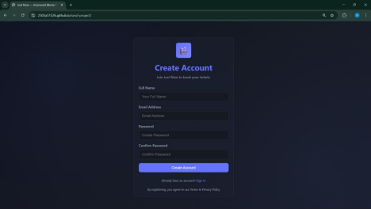

Login Page
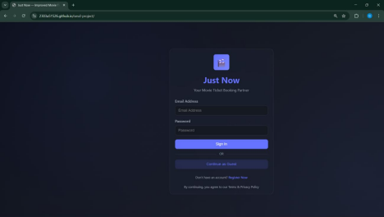
Profile Page
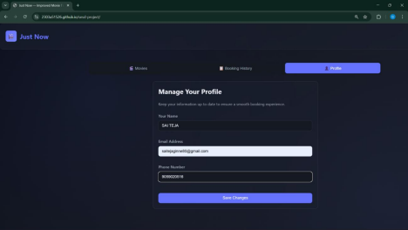
Select Location page
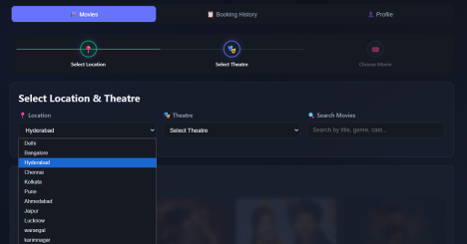

select Theatre page
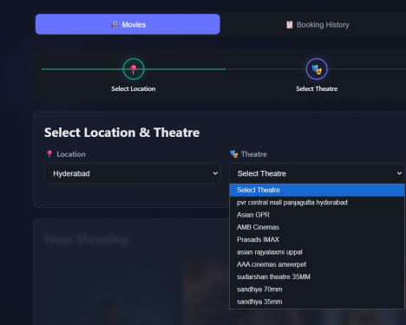
“After selecting both the location and the theatre, the movie list should open to allow booking for a show.”
Here are a few alternate ways to say it clearly:
“Once both the location and theatre are selected, the movie list will appear for booking.” “After choosing a location and a theatre, the available movies will be displayed for booking.” “The movie list should be shown only after the user selects both the location and the theatre.”

Movie Details Page
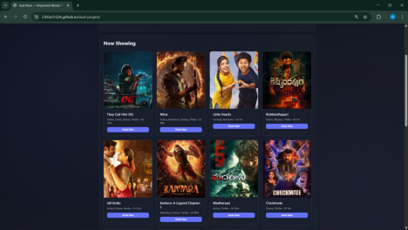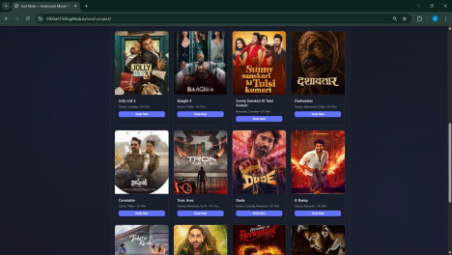
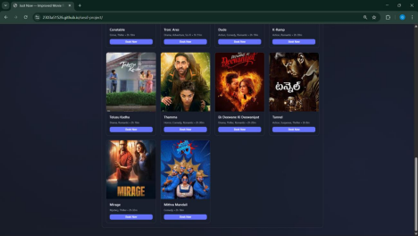
Seat Selection Page
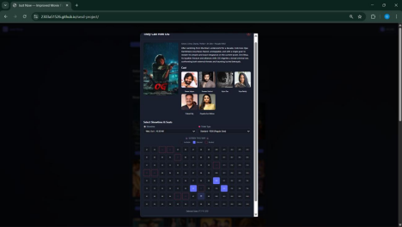
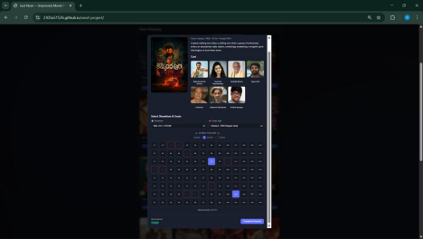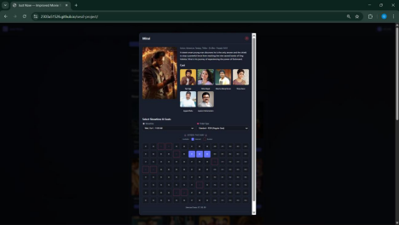

Payment Page
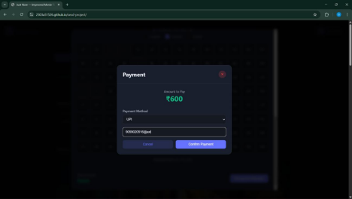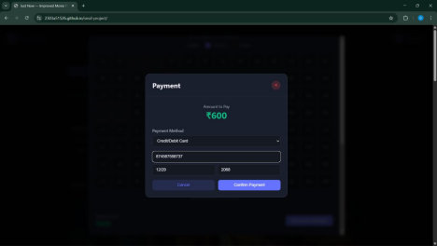

--- End of Report ---

