

SAM College of Engineering, Raisen

(Madhya Pradesh)

**Apartment Rent Predication Web App**

A Project Report *submitted to*

***SAM Global University***

*In partial fulfillment of the requirement for the*

*award of the degree of*

**BACHELOR OF TECHNOLOGY**

**Submitted by**

**Ma. Pradeep Rawat (22ENGG1AE03035)**

**Ma. Shashikant Sahu (22ENGG1AE03046)**

**Miss. Kunika Ahirwar (22ENGG1AE0326)**

**Miss. Durgeshwari Verma (22ENGG1AE03021)**

Under the guidance of

**Mr. Siddharth Jain**

**(Professor)**

**Faculty of Engineering, SAM Global University, Raisen**

SAM Global University

**Approved By : MPPURC, UGC, AICTE, NCTE, PCI, AIPC, CCIM, INC & M.P GOVT.**

**CERTIFICATE**

This is to certify that project report work entitled **“Apartment rent prediction web app**

**”** submitted to SAM Global University, was carried out by **Pradeep Rawat , Kunika Ahirwar , Shashikant Sahu , Durgeshwari Verma ,** in SAM College of Engineering , Raisen (MP), in partial fulfillment of the requirement for the degree of “**Bachelor of Technology ”** under supervision and guidance of **Mr. Siddharth Jain**  (Professor) Faculty of Engineering , SAM Global University, Raisen.

**Dr. Saurabh Mandloi**

**HOD OF CSE**

SAM Global University

**Approved By : MPPURC, UGC, AICTE, NCTE, PCI, AIPC, CCIM, INC & M.P GOVT.**

**CERTIFICATE**

This is to certify that the project report entitled **“Apartment rent prediction web app**

**”** submitted to SAM Global University was carried out by **Pradeep Rawat , Kunika Ahirwar , Shashikant Sahu , Durgeshwari Verma ,** in Faculty of Engineering , SAM Global University, Raisen (MP), in partial fulfillment of the requirement for the degree of “**Bachelor of Engineering”** under my supervision and guidance.

This work is original and has not been submitted in part or full for any other degree or diploma of any other university.

Place: Bhopal  **Guide Name**

**Mr. Siddharth Jain**

(Professor)

Date:

**Acknowledgement**

We express our profound gratitude to HOD **Dr. Saurabh Mandloi** , SAM Faculty of Engineering , Bhopal (M.P) Sir, We are highly obliged for your encouragement, foresightedness, valuable suggestions, ever willingness to discuss science, parental affection and the valuable time you have given me from your busy schedule, which provided me with the needed moral and confidence during the work.

We would like to express our sincere gratitude to my project guide **Mr . Siddharth Jain (**Professor) Faculty of Engineering , SAM Global University, Raisen enabling to complete my Project Work entitled **“Apartment rent prediction web app ”.** Your constant quest for knowledge, strive for excellence, dedication and discipline will always remain a source of inspiration to us for the rest of our life. Words will never be enough to express our indebtedness for your teachings and working under your guidance is lifetime achievement for us .

I thank our fellow lab mates in for the stimulating discussions, for the sleepless nights we were working together before deadlines, and for the all the fun we have had during project times. Also, we thanks to my friends

Last but not the least, we would like to thank our families , our Parents for supporting us spiritually and financially throughout our practice school work.

Place :- BHOPAL

Date:-

**Objective of the Project**

The goal of this project is to design and develop a **machine learning-powered web application** that can accurately **predict the monthly rent** of residential properties in major Indian cities. The system aims to assist users—**tenants, landlords, and agents**—in making informed rental decisions based on various property features.

**Why This is Important:**

* The rental housing market is vast and often lacks transparency.
* Tenants are unsure of fair pricing, and landlords may over/underestimate rent.
* An intelligent system can bring **speed, accuracy, and confidence** to the decision-making process.

**How It Works:**

* Users enter details like **number of bedrooms (BHK), city, floor level, size, furnishing status, tenant preference**, and more.
* These inputs are processed by a **trained Random Forest Regressor model**.
* The model outputs an **estimated rent** displayed instantly on a **Streamlit-based web interface**

**LITERATURE REVIEW**

**Understanding the Problem Space**

Several studies and machine learning models have been proposed in recent years for real estate price and rent prediction. The literature shows a shift from traditional statistical methods to more advanced machine learning techniques that offer better accuracy and flexibility.

**Key Findings from Existing Research:**

**1. Traditional Methods:**

* Earlier rent prediction systems relied on **linear regression**, which assumes a linear relationship between features and output.
* Limited in handling **non-linear patterns** and complex interactions among variables.

**2. Machine Learning Approaches:**

* **Decision Trees, Random Forest, and Gradient Boosting** have shown superior performance in rent prediction tasks.
* These models effectively capture **non-linear dependencies**, handle missing data, and perform better on heterogeneous datasets.

**3. Feature Importance in Rent Prediction:**

* **Location, number of rooms (BHK), area (sqft), floor level, furnishing status**, and **tenant preferences** are consistently found to be the most influential features.
* Studies show that city-level variation can significantly impact pricing models due to **urban economic differences**.

**4. Real-Time Web Applications:**

* Recent works integrate ML models into web frameworks using **Flask** or **Streamlit**, allowing users to interact with models via a user-friendly interface.
* **Model deployment** and **real-time predictions** are crucial components for making ML tools accessible to the public.

**Conclusion from Literature:**

The evolution from simple linear models to ensemble ML models like Random Forest has greatly improved the reliability of rent prediction systems. Additionally, integrating models into interactive apps is becoming standard practice for real-world usability.

**Problem Statement**

In metropolitan cities, rental prices fluctuate greatly based on a variety of factors like location, apartment size, amenities, and demand. However, there's no easy way for tenants or property owners to determine a fair and accurate rent estimate for a given property without manually comparing listings or relying on subjective judgments.

The Core Problem:

People lack a reliable, intelligent, and real-time system to **predict rental prices** based on a property's characteristics. This creates:

* Uncertainty for **tenants** about overpaying.
* Difficulty for **landlords** in setting competitive rent.
* Lack of **transparency** in the rental market.

**Challenges Identified:**

* Rental prices vary drastically even within the same city.
* Manual research is time-consuming and inaccurate.
* No standard method exists for rent calculation.
* Existing property websites only list prices; they don't help **predict** them.

**Proposed Solution**

Develop an intelligent, user-friendly web application that utilizes machine learning to accurately predict the monthly rent of residential properties based on user-input features.

**Key Components of the Proposed Solution:**

1. **Machine Learning Model**

* Use a Random Forest Regressor trained on historical rental data.
* Handles both numerical and categorical data effectively.
* Captures complex, non-linear relationships between features and rent.

2. **Interactive Web Interface (Streamlit)**

* Simple and intuitive GUI for users to input property details:
  + City, BHK, Bathroom, Area, Floor, Furnishing Status, Tenant Preference, etc.
* Instant prediction with a single click.

3. **Data Preprocessing Pipeline**

* Clean and encode the dataset (label encoding for categorical features).
* Normalize inputs for improved model accuracy.
* Handle missing or inconsistent entries during training.

**4. Deployment**

* Model saved using Pickle (.pkl) for efficient loading.
* Web app deployed using Streamlit, accessible via browser.

**Outcome:**

A real-time rent estimation system that empowers users with data-driven decisions, saving time and enhancing transparency in the rental mark

**Technology Stack**

**Frontend / User Interface**

* Streamlit
  + Python-based web app framework
  + Used to create the interactive UI for input and prediction
  + Real-time updates and user-friendly design

**Machine Learning / Backend**

* Python
  + Primary programming language for data handling and model development
* Pandas & NumPy
  + Data manipulation and numerical operations
* Scikit-learn
  + Model training and evaluation
  + Used to build and fine-tune the Random Forest Regressor
* Pickle
  + Model serialization for saving and loading the trained ML model

**Data Handling**

* CSV Dataset
  + Historical rental data including features like BHK, location, area, etc.
* Label Encoding
  + For converting categorical features (e.g., City, Furnishing Status) to numerical form

**Deployment Environment**

* Streamlit Cloud / Localhost
  + For hosting and running the app in real time
  + Easily shareable and browser-accessible interface

**Modules and Features**

**1. User Input Module**

* Collects property details from users through interactive widgets:
  + BHK (Bedrooms)
  + Bathrooms
  + City
  + Area (Sqft)
  + Floor and Total Floors
  + Furnishing Status
  + Tenant Preference
  + Contact Type
* Uses Streamlit sliders and select boxes for smooth input experience.

**2. Machine Learning Prediction Module**

* Loads pre-trained Random Forest Regressor model using Pickle.
* Handles both numerical and encoded categorical data.
* Generates real-time rent predictions based on input.

**3. UI/UX Styling Module**

* Built with custom HTML & CSS styling in Streamlit.
* Full-screen layout with improved readability.
* Uses color themes, black background for input sections, and modern component sizing.

**4. Output & Result Display**

* Displays predicted rent in real-time after button click.
* Shows result with styled formatting:  
   Estimated Monthly Rent: ₹ XXXXX.XX
* User-friendly feedback with success or error messages.

**Challenging Faced**

**1. Data Quality and Cleaning**

* Raw dataset contained missing values, inconsistent formats, and duplicate records.
* Required thorough preprocessing to ensure clean, structured data for model training.

**2. Categorical Data Handling**

* Features like City, Furnishing Status, and Tenant Preference were non-numeric.
* Had to implement label encoding carefully to maintain feature significance without introducing bias.

**3. Model Selection and Tuning**

* Initial models like Linear Regression underperformed due to data non-linearity.
* Required experimentation with Random Forest, Gradient Boosting, and hyperparameter tuning to get reliable accuracy.

**4. Streamlit UI Limitations**

* Streamlit offered limited built-in support for advanced CSS styling.
* Had to manually inject custom HTML and CSS to improve layout, responsiveness, and component sizing.

**5. Model Testing & Generalization**

* Ensuring the model didn’t overfit the training data was critical.
* Had to test on multiple subsets to check generalization across cities and property types.

**6. Model Deployment**

* Converting the trained model to a .pkl file and integrating it into the Streamlit app was non-trivial.
* Handling errors during prediction-time input mismatch was essential to avoid app crashes.

**FUTURE SCOPE**

**Integration with Real Estate Platforms**

* Embed the prediction system into websites like 99acres, MagicBricks, NoBroker, etc.
* Help users instantly estimate rent while browsing listings.

**Support for More Features**

* Include geolocation, proximity to amenities, property age, and local demand index for improved predictions.
* Use Google Maps API to fetch nearby landmarks and transport options.

**Advanced Machine Learning Models**

* Upgrade to models like:
  + XGBoost, LightGBM for better accuracy
  + Neural Networks for deep feature learning
* Implement AutoML pipelines for hyperparameter tuning.

**Deployment on Cloud Platforms**

* Host on AWS / Heroku / Azure / Streamlit Cloud for public access.
* Add user authentication and data logging for enterprise usage.

**Rent Trend Visualization**

* Show interactive charts for:
  + Rent trends across cities
  + Seasonal fluctuations
  + Area-wise comparisons

**Rental Recommendation System**

* Suggest ideal properties based on user preferences, income, and historical rent patterns.
* Combine rent prediction with property matching for complete rental assistance.

**Project Structure**

📦 Apartment -Rent-Predictor

├── app.py                       # Streamlit application

├── House_Rent.ipynb # Jupyter notebook used for training and EDA

├── House_Rent_Dataset.csv      # Source dataset

├── random_forest_regressor_model.pkl  # Trained machine learning model

├── requirement.txt             # Python dependencies

└── README.md                   # Project documentation

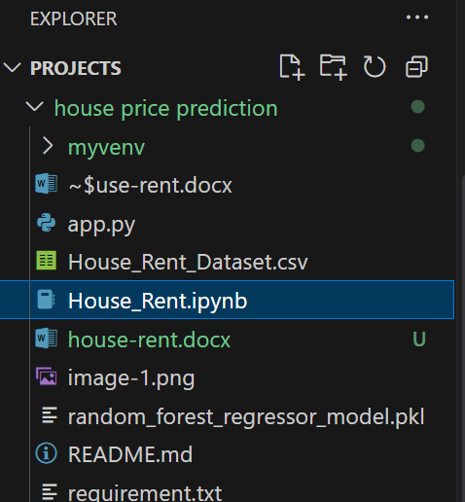

**APP.py DEMO CODE BLOCK**

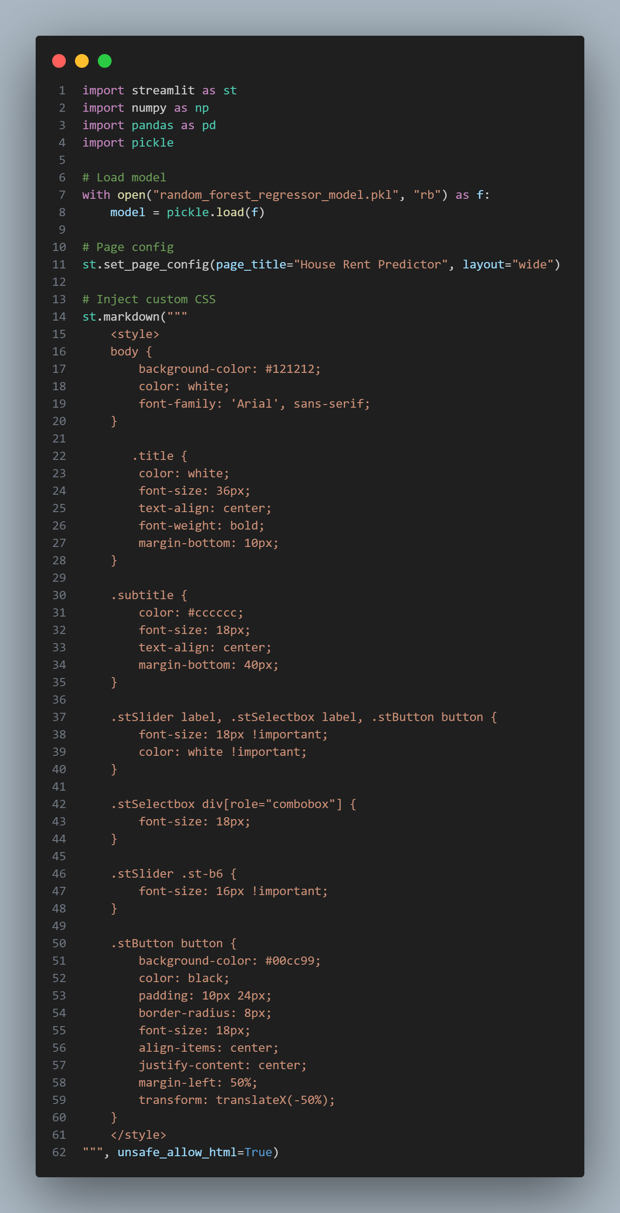

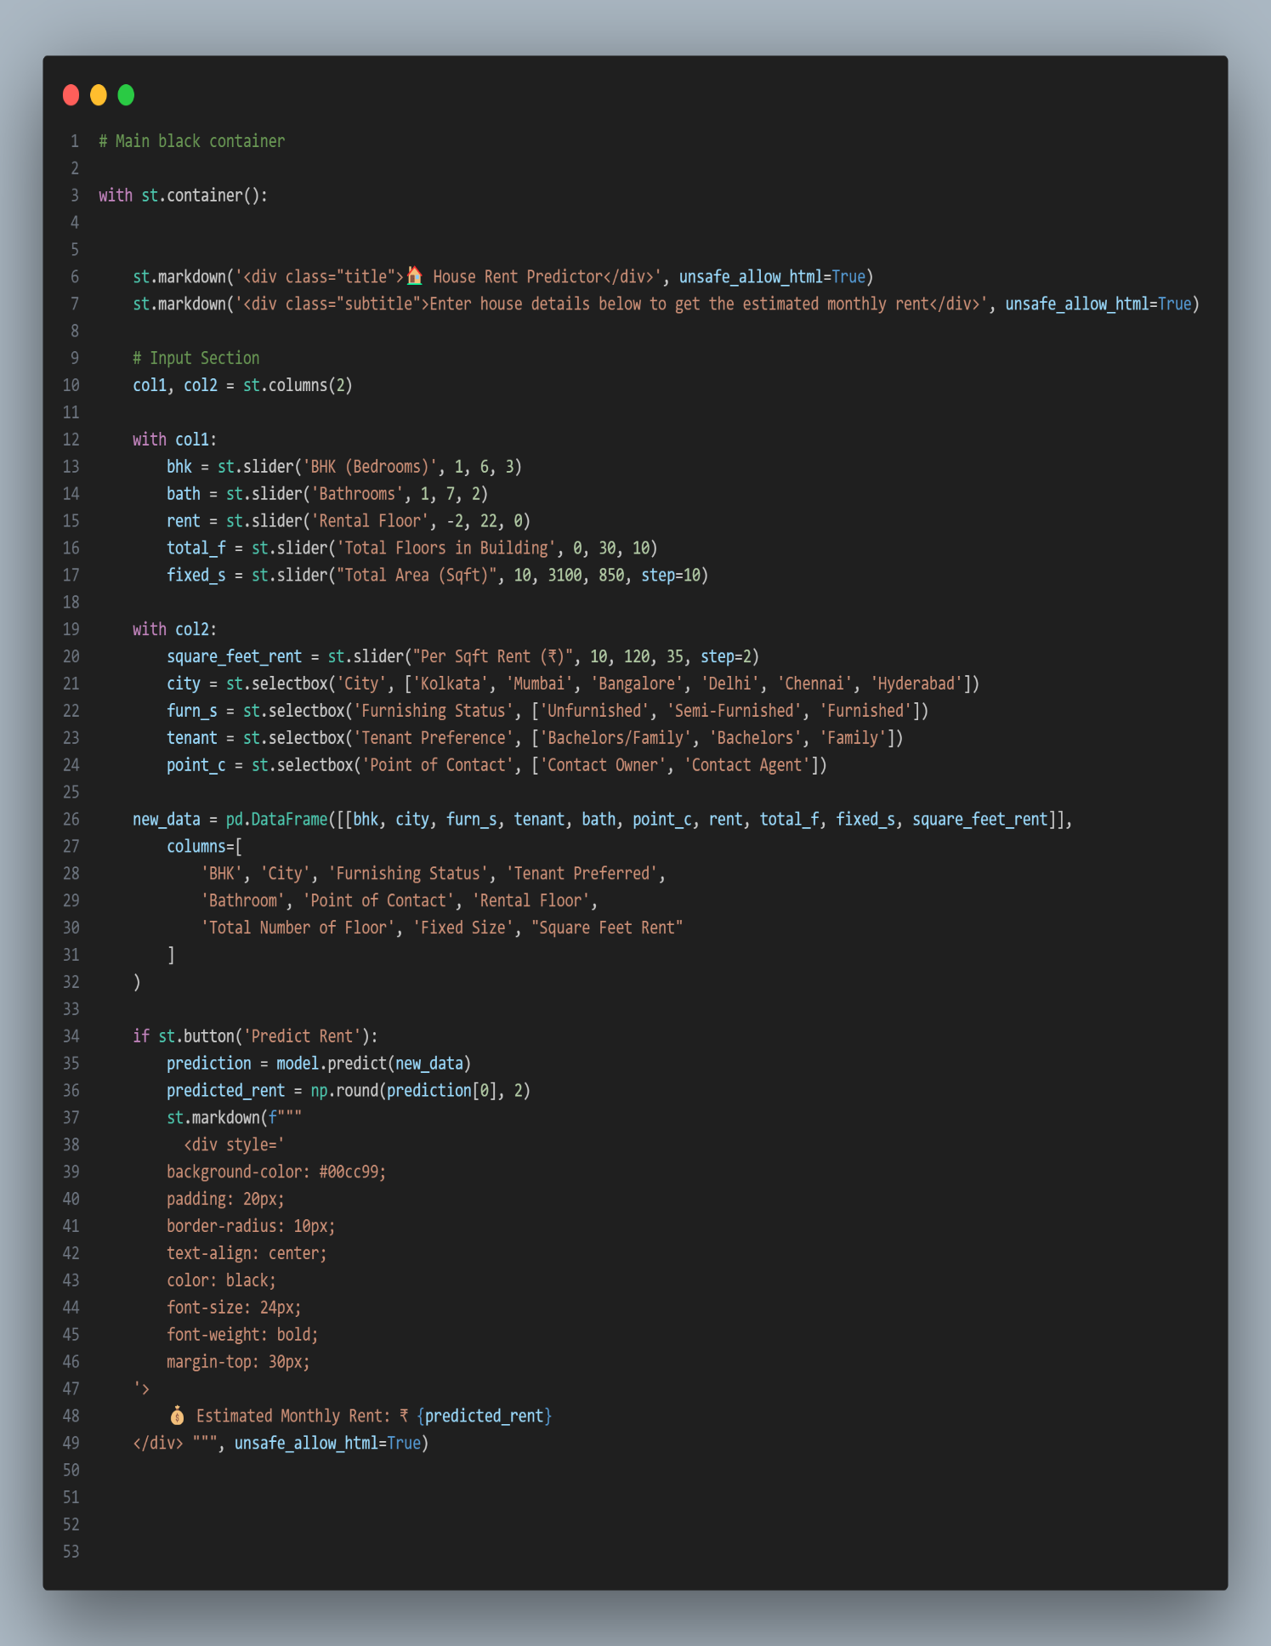

**HOUSE _rent.ipynb**

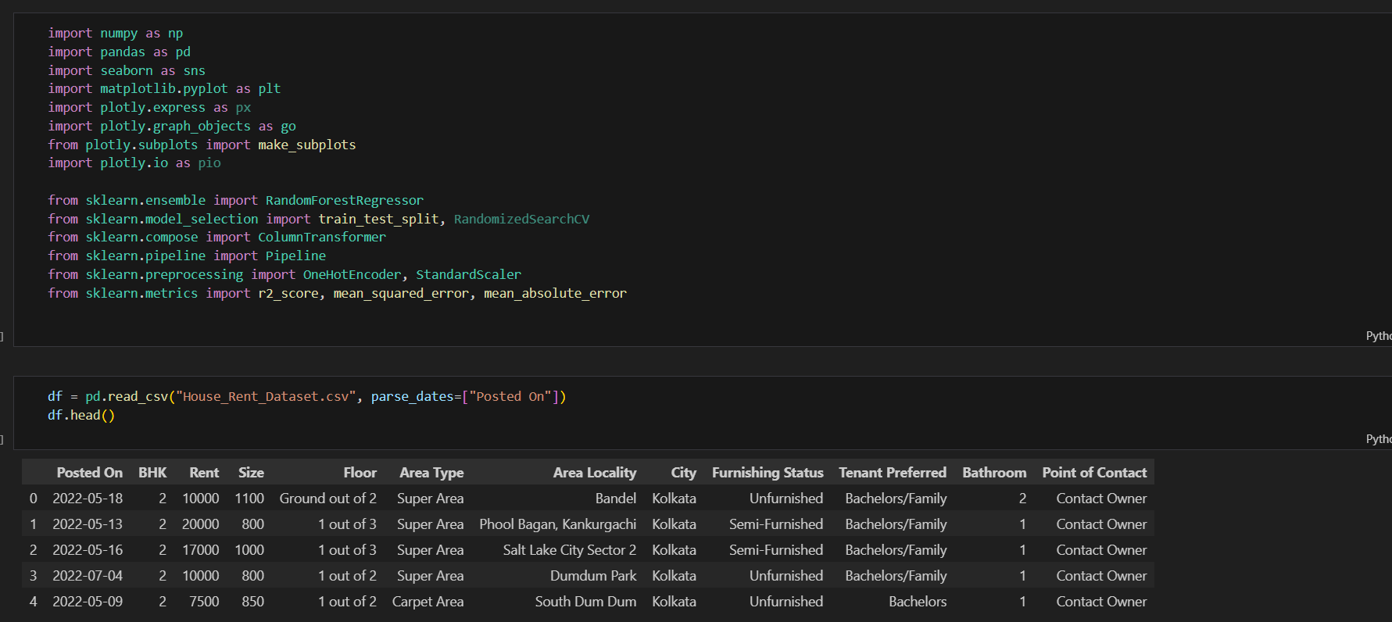

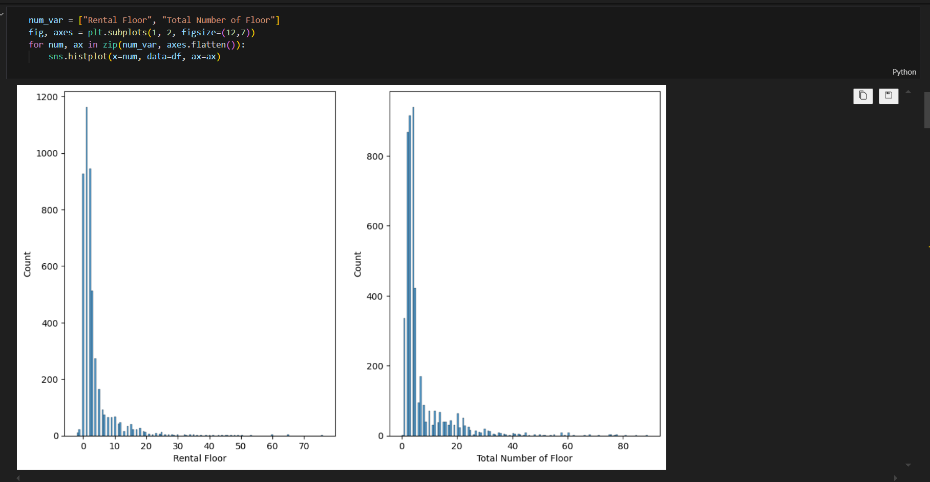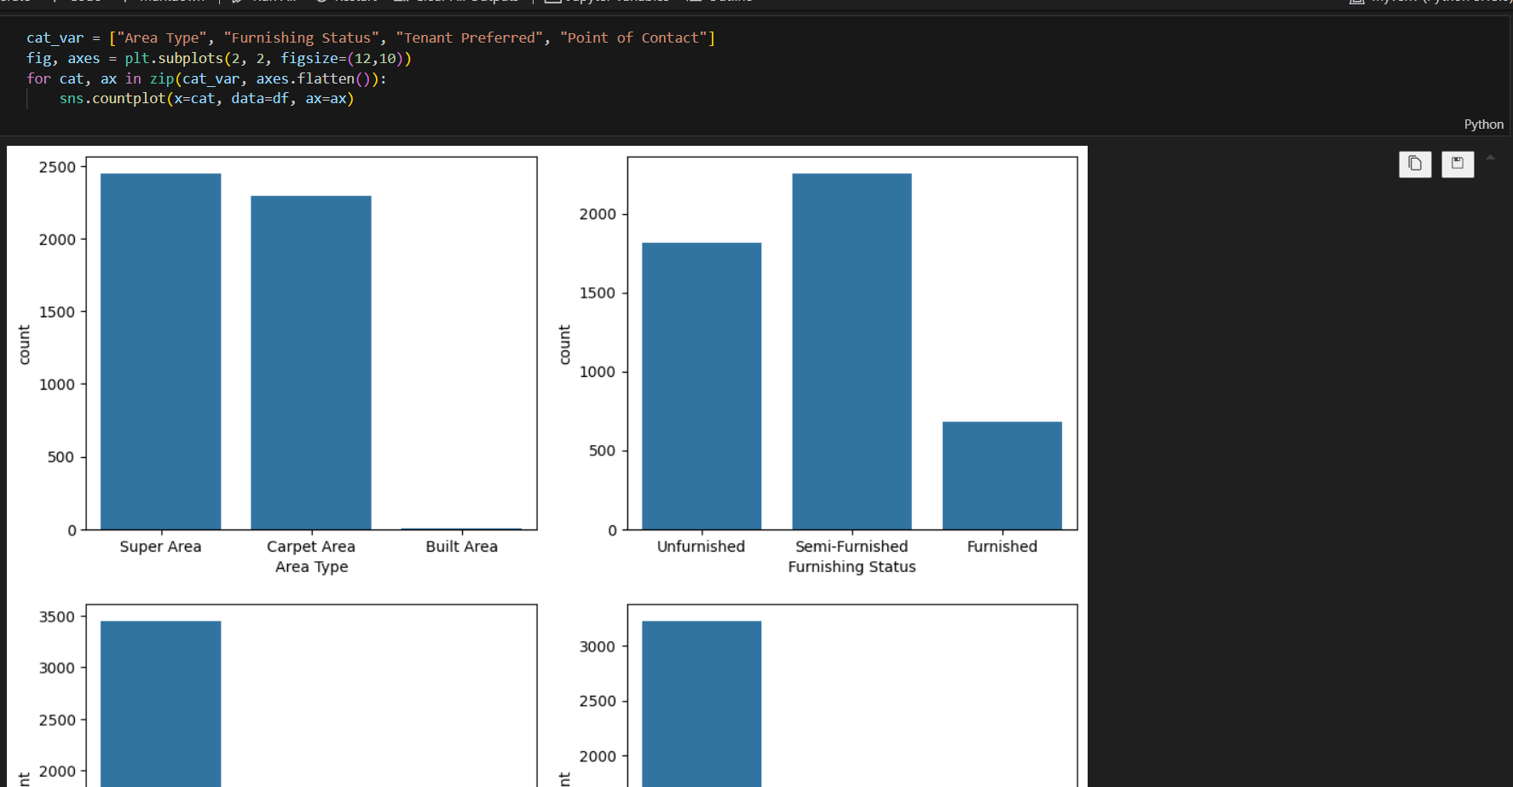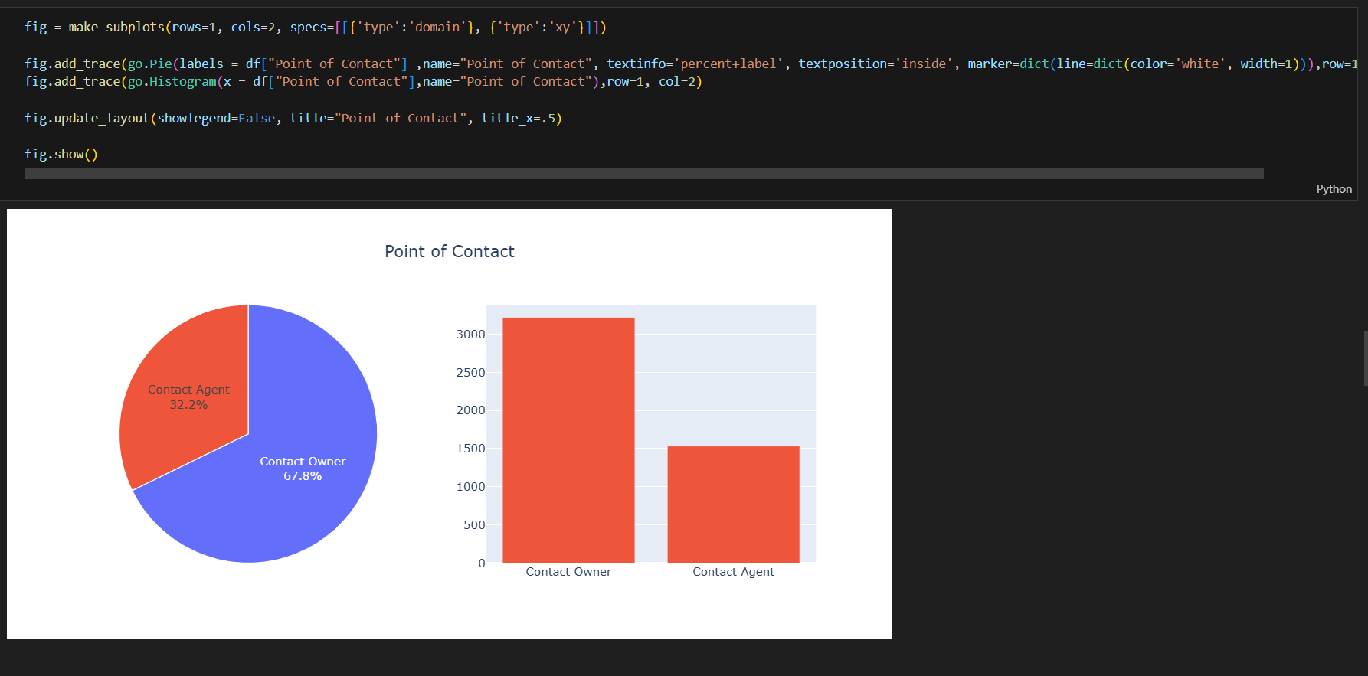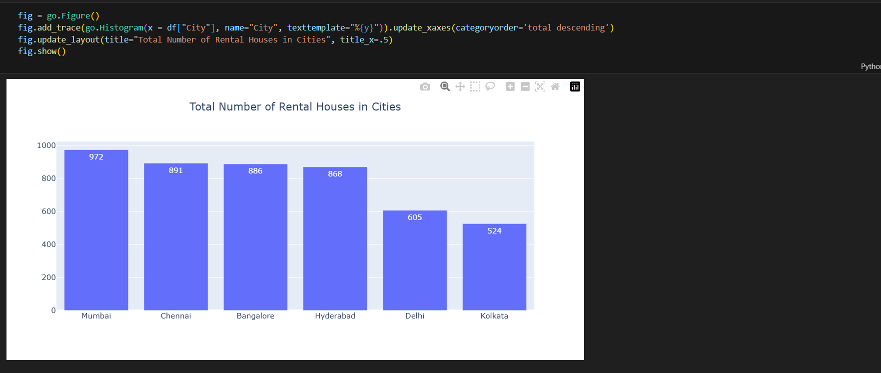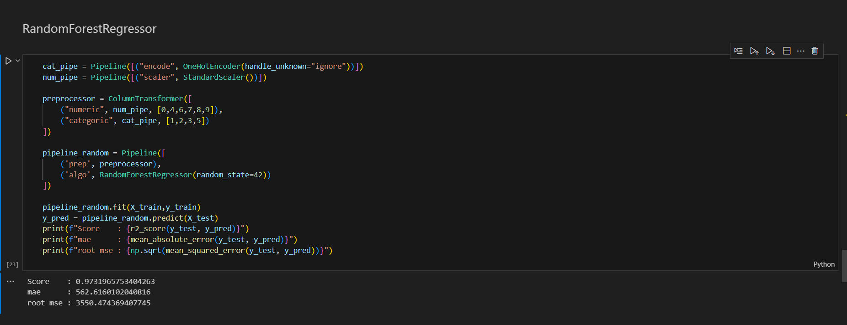

**Index.HTML**

<!DOCTYPE html>

<html lang="en">

<head>

  <meta charset="UTF-8">

  <meta name="viewport" content="width=device-width, initial-scale=1">

  <title>Rent Predictor</title>

  <link rel="stylesheet" href="style.css">

</head>

<body>

  <!-- Navbar -->

  <header>

    <div class="container">

      <h1 class="logo">Apartment Rent Predictor</h1>

      <nav>

        <ul>

          <li><a href="#">Home</a></li>

          <li><a href="#how-it-works">How It Works</a></li>

          <li><a href="#testimonials">Testimonials</a></li>

          <li><a href="#contact">Contact</a></li>

          <li><a href="http://localhost:8501" target="_blank" class="btn">Predict Rent</a></li>

        </ul>

      </nav>

    </div>

  </header>

  <!-- Hero Section -->

  <section class="hero">

    <div class="container">

      <h2>Know the Rent Before You Move In!</h2>

      <p>Use our AI-powered tool to predict rental prices instantly, accurately, and effortlessly.</p>

      <a href="http://localhost:8501" target="_blank" class="cta-btn">Try It Now</a>

    </div>

  </section>

  <!-- Features Section -->

  <section class="features">

    <div class="container">

      <h3>Why Use RentPredictor?</h3>

      <div class="feature-grid">

        <div class="feature">

          <h4>AI-Powered</h4>

          <p>Smart machine learning models trained on thousands of listings for reliable results.</p>

        </div>

        <div class="feature">

          <h4>Instant Results</h4>

          <p>No need to wait. Just input your details and get your rent estimate instantly.</p>

        </div>

        <div class="feature">

          <h4>Location-Based</h4>

          <p>Supports multiple cities and neighborhoods with region-specific accuracy.</p>

        </div>

        <div class="feature">

          <h4>Completely Free</h4>

          <p>No hidden charges. No login required. Just fast, free predictions.</p>

        </div>

      </div>

    </div>

  </section>

  <!-- How it Works Section -->

  <section id="how-it-works" class="how-it-works">

    <div class="container">

      <h3>How It Works</h3>

      <ol>

        <li>Enter your property location, area, and number of BHKs.</li>

        <li>Click “Predict Rent” and let our AI do the work.</li>

        <li>Get your rent estimate instantly on the screen.</li>

      </ol>

    </div>

  </section>

  <!-- Testimonials Section -->

  <section id="testimonials" class="testimonials">

    <div class="container">

      <h3>What Our Users Say</h3>

      <div class="testimonial-grid">

        <div class="testimonial">

          <p>“I used Rent Predictor before finalizing my flat. The estimate was spot on!”</p>

          <h5>– Riya Sharma, Mumbai</h5>

        </div>

        <div class="testimonial">

          <p>“Great tool for renters! Simple, fast, and no signup needed.”</p>

          <h5>– Akash Mehta, Bangalore</h5>

        </div>

        <div class="testimonial">

          <p>“Helped me negotiate better rent with the landlord. Highly recommended!”</p>

          <h5>– Sunita Verma, Pune</h5>

        </div>

      </div>

    </div>

  </section>

  <!-- Contact Section -->

  <section id="contact" class="contact">

    <div class="container">

      <h3>Contact Us</h3>

      <p>Email: <a href="mailto:support@rentpredictor.com">support@rentpredictor.com</a></p>

      <p>Follow us on:

        <a href="#">Twitter</a> |

        <a href="#">LinkedIn</a>

      </p>

    </div>

  </section>

  <!-- Footer -->

  <footer>

    <div class="container">

      <p>&copy; 2025 Rent Predictor. All rights reserved.</p>

      <p>Made with <span style="color: red;">&#10084;</span> by Pradeep Rawat</p>

    </div>

  </footer>

</body>

</html>

STYLE.CSS

/* ------------------------------

   Base Reset and Typography

------------------------------ */

* {

  margin: 0;

  padding: 0;

  box-sizing: border-box;

}

body {

  font-family: 'Segoe UI', Tahoma, Geneva, Verdana, sans-serif;

  background-color: #f9f9f9;

  color: #333;

  line-height: 1.6;

}

.container {

  width: 90%;

  max-width: 1100px;

  margin: auto;

  padding: 0 15px;

}

/* ------------------------------

   Navbar

------------------------------ */

header {

  background: #003366;

  color: white;

  padding: 20px 0;

}

.logo {

  float: left;

  font-size: 24px;

  font-weight: bold;

}

nav {

  float: right;

}

nav ul {

  list-style: none;

  display: flex;

  gap: 20px;

  align-items: center;

}

nav ul li a {

  color: white;

  text-decoration: none;

  font-weight: 500;

  transition: color 0.3s;

}

nav ul li a:hover {

  color: #ffcc00;

}

.btn {

  background-color: #ffcc00;

  color: #003366;

  padding: 8px 14px;

  border-radius: 5px;

  font-weight: bold;

}

header::after {

  content: "";

  display: table;

  clear: both;

}

/* ------------------------------

   Hero Section

------------------------------ */

.hero {

  background: linear-gradient(rgba(0,0,0,0.5), rgba(0,0,0,0.5)),

    url('https://images.unsplash.com/photo-1560184897-54f39aa0a6bd') center/cover no-repeat;

  color: white;

  padding: 120px 20px;

  text-align: center;

}

.hero h2 {

  font-size: 48px;

  margin-bottom: 20px;

}

.hero p {

  font-size: 20px;

  margin-bottom: 30px;

}

.cta-btn {

  background: #ffcc00;

  color: #003366;

  padding: 12px 28px;

  border: none;

  border-radius: 5px;

  text-decoration: none;

  font-size: 16px;

  font-weight: bold;

  transition: background 0.3s ease;

}

.cta-btn:hover {

  background: #e6b800;

}

/* ------------------------------

   Features Section

------------------------------ */

.features {

  padding: 60px 0;

  background-color: #fff;

  text-align: center;

}

.features h3 {

  font-size: 32px;

  margin-bottom: 40px;

}

.feature-grid {

  display: flex;

  flex-wrap: wrap;

  justify-content: center;

  gap: 30px;

}

.feature {

  background: #f1f1f1;

  padding: 20px;

  width: 250px;

  border-radius: 8px;

  box-shadow: 0 2px 4px rgba(0,0,0,0.1);

}

.feature h4 {

  font-size: 20px;

  margin-bottom: 10px;

}

/* ------------------------------

   How It Works Section

------------------------------ */

.how-it-works {

  background: #f4f4f4;

  padding: 60px 0;

  text-align: center;

}

.how-it-works h3 {

  font-size: 32px;

  margin-bottom: 20px;

}

.how-it-works ol {

  max-width: 600px;

  margin: 0 auto;

  text-align: left;

  font-size: 18px;

  padding-left: 20px;

  line-height: 1.8;

}

/* ------------------------------

   Testimonials Section

------------------------------ */

.testimonials {

  padding: 60px 0;

  background-color: #fff;

  text-align: center;

}

.testimonials h3 {

  font-size: 32px;

  margin-bottom: 40px;

}

.testimonial-grid {

  display: flex;

  flex-wrap: wrap;

  justify-content: center;

  gap: 30px;

}

.testimonial {

  background: #eaeaea;

  padding: 20px;

  border-radius: 10px;

  width: 280px;

  font-style: italic;

  box-shadow: 0 2px 5px rgba(0,0,0,0.1);

}

.testimonial h5 {

  margin-top: 15px;

  font-weight: bold;

  font-style: normal;

}

/* ------------------------------

   Contact Section

------------------------------ */

.contact {

  padding: 50px 0;

  background: #f9f9f9;

  text-align: center;

}

.contact h3 {

  font-size: 28px;

  margin-bottom: 20px;

}

.contact a {

  color: #003366;

  text-decoration: none;

  font-weight: 600;

}

/* ------------------------------

   Footer

------------------------------ */

footer {

  background-color: #003366;

  color: white;

  text-align: center;

  padding: 20px 0;

  font-size: 14px;

}

/* ------------------------------

   Responsive Design

------------------------------ */

@media (max-width: 768px) {

  nav {

    float: none;

    text-align: center;

    margin-top: 10px;

  }

  nav ul {

    flex-direction: column;

    gap: 10px;

  }

  .logo {

    float: none;

    text-align: center;

    margin-bottom: 10px;

  }

  .feature-grid, .testimonial-grid {

    flex-direction: column;

    align-items: center;

  }

  .hero h2 {

    font-size: 36px;

  }

  .cta-btn {

    font-size: 14px;

    padding: 10px 20px;

  }

}

**DEMO WEB APP**

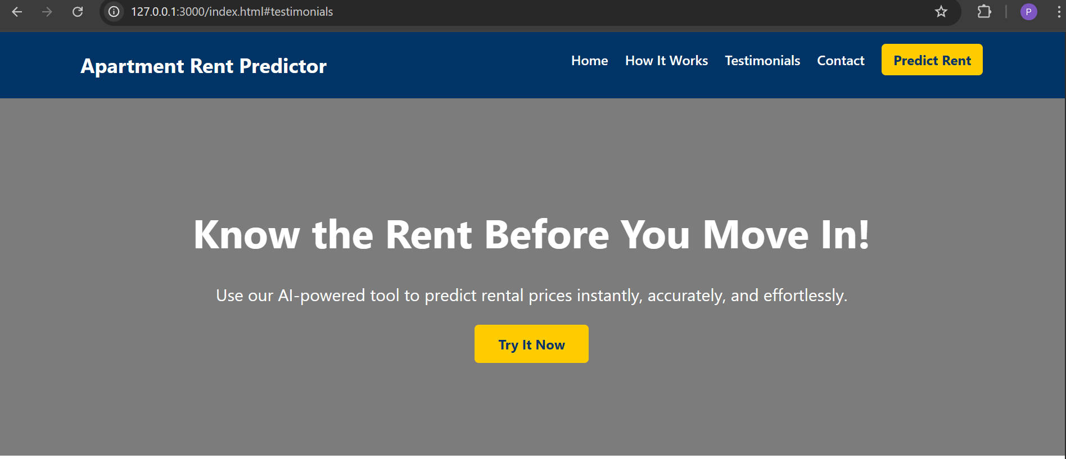

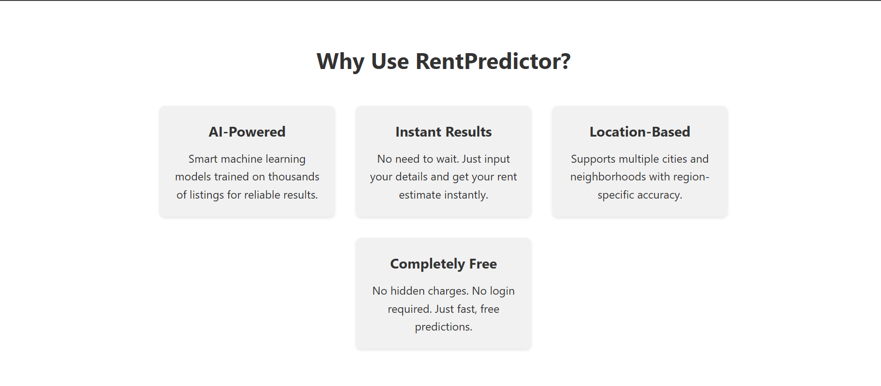

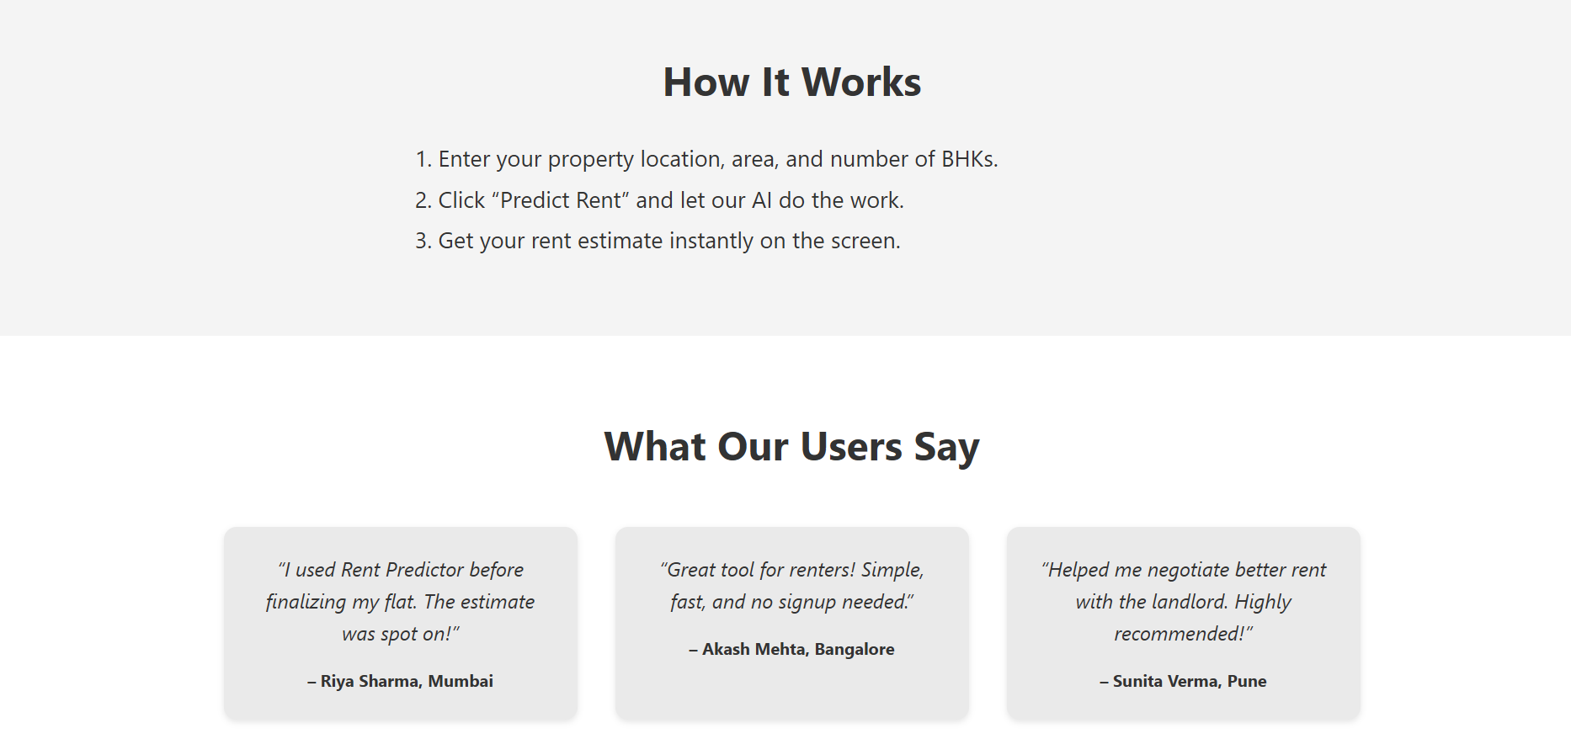

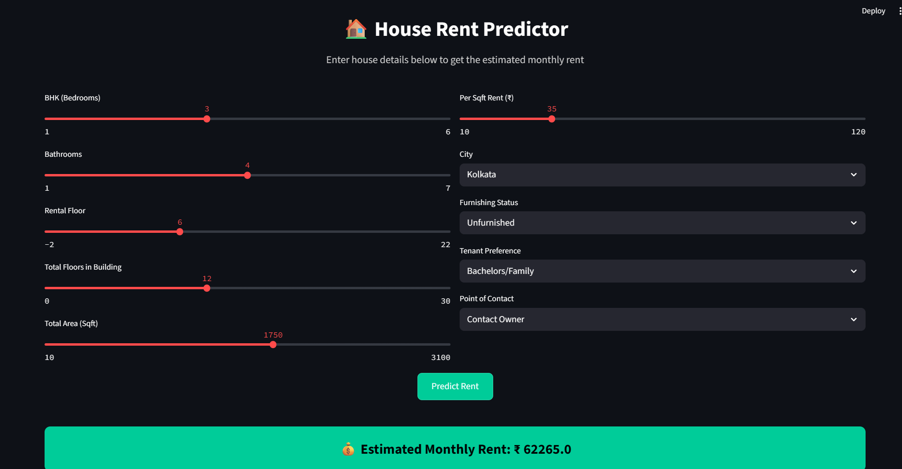

**CONCLUSION**

1. The **House Rent Prediction System** successfully leverages machine learning to estimate house rent prices based on multiple real-world features like BHK, city, furnishing status, tenant type, area, and more.

2. By integrating a user-friendly **Streamlit-based web interface**, the system ensures ease of access for both property owners and tenants.

3. The use of models like **Random Forest** or **LightGBM** ensures high prediction accuracy while managing non-linear relationships between variables.

4. This solution not only streamlines the rent estimation process but also aids decision-making by providing **transparent and data-driven insights**.

5. Overall, the project demonstrates the practical application of data science in solving urban real estate challenges and offers scope for **further scaling and integration** into commercial platforms.

