DEMONSTRATION

Minimum System Requirements
RAM – 512MB
ROM – 25MB
Software Requirements – PYTHON 3, OPERATING SYSTEM – Windows, Linux ,mac

Steps to run:

- In a system with python 3 move to the file location and then run command:
python 2020H1030121P_D3.py

- We would be asked to input 1 for replace and 2 for grep . Figure 1 shows it :
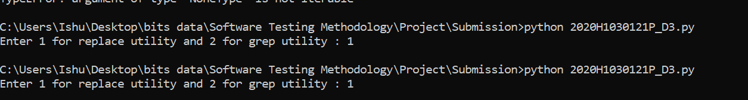

- Depending upon the utility we would be using the corresponding constraints and choices and the output test frames would be written in 2020H1030121P_grep_D3.txt and
2020H1030121P_replace_D3.txt for grep and replace respectively.These files are named 2020H1030121P_op1.txt and 2020H1030121P_op2.txt respectively
- Output test frames look like this

FOR GREP :

36:
{'TESTFRAME':
{'PATTERN SIZE': 'not_empty',
'Number of occurrences of pattern in the file': 'Many',
'Number of occurrences of pattern in one line': 'Many',
'Presence of enclosing quotes': 'Enclosed',
'Presence of blanks': 'Enclosed',
'Position of the pattern in the file': 'Last_line',
'file quality': 'more_than_one',
'presence of file': 'not_exist',
'filename': 'good_file'}
},

FOR REPLACE:

33:
{'TESTFRAME':
{
'PATTERN SIZE': 'not_empty',
'Number of occurrences of from string in the file': 'Many',
'Number of occurrences of from string in one line': 'Many',
'Position of the from string in the file': 'Last_line',
'file quantity': 'more_than_one',
'presence of file': 'not_exist',
'file name': 'good_file',
'length of first string': 'one',
'length of second string': 'one'
}
},

