Indian Institute Of Technology(ISM),Dhanbad
Bachelor Of Technology Electrical Engineering
DC Machine State Space Modelling
by Raunak Thakur(22JE0786)
Aditya Kumar(22JE055) Ayush Prasad(22JE0217) Vinay Kumar(22JE1074)
Kumar Pratik(22JE0505) Anshuman Tripathi(22JE0136)

Title-State Space Modelling Of DC Machine and Speed Control using PID
Objectives-
- To derive the mathematical model of a DC machine using fundamental electrical and mechanical equations in state-space form .
(i.e., $\dot{x}=Ax+Bu, y=Cx+Du$).
- To simulate the dynamic response for different input conditions (e.g., step voltage, load torque changes).

- To visualise the plot of speed ,current and torque responses using simulink tools.

Project Overview-
This project Consists of State Space model of DC machine . It demonstrates the DC Motor Speed Control Using PID Controller.It has been implemented using Simulink tools.It consists of following subsystem blocks-
- PID Control block-It consists of PID(s) controller, gain block to implement the control strategy.
- Datalogger Block-It contains the scope blocks and display blocks.It contains records of current torque and speed responses.
- DC motor plant Subsystem -It contains the state space model of DC machine.
- The Various Parameters of motor are modelled as Resistance(R),Inductance(L),Moment Of Inertia(J),Viscosity Constant(b),Motor Constant(K) variables.
- The PID block is connected in feedback loop connection and output speed is compared with reference speed and control signal generated is passed into supply input for variable supply generation.

Operating Principle-
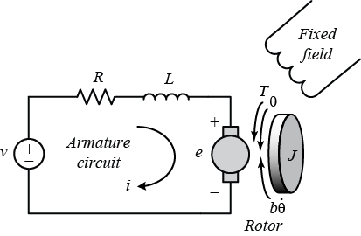

(J) moment of inertia of the rotor = 0.01 kg.m^2
(b) motor viscous friction constant = 0.1 N.m.s
(Ke) electromotive force constant = 0.01 V/rad/sec
(Kt) motor torque constant = 0.01 N.m/Amp
(R) electric resistance = 1 Ohm
(L) electric inductance = 0.5 H

Define the state variables:
$$x_{1}=i_{a},x_{2}=ω$$

Then, the state equations become:
$$[\begin{aligned}\dot{x_{1}} \\ \dot{x_{2}}\end{aligned}]=[\begin{matrix}-\frac{R_{a}}{L_{a}} & -\frac{K_{e}}{L_{a}} \\ \frac{K_{t}}{J} & -\frac{B}{J}\end{matrix}][\begin{aligned}x_{1} \\ x_{2}\end{aligned}]+[\begin{aligned}\frac{1}{L_{a}} \\ 0\end{aligned}]V_{a}+[\begin{aligned}0 \\ -\frac{1}{J}\end{aligned}]T_{L}$$

The output (e.g., speed) is given by:
$$y=[ 0 1 ][\begin{aligned}x_{1} \\ x_{2}\end{aligned}]$$

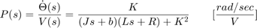

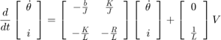

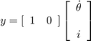

Block Diagram

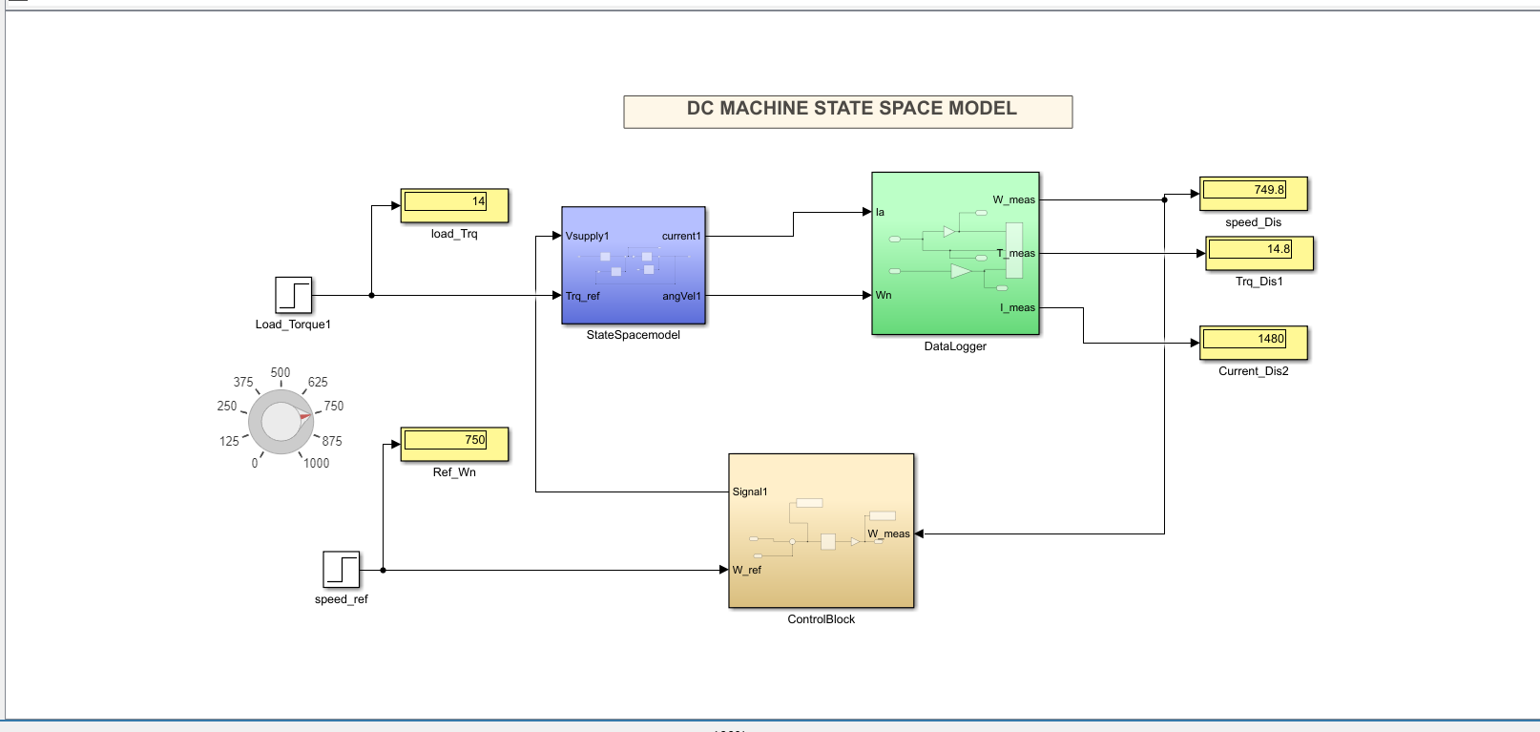

Key Outcomes-
- Accurate dynamic model of the DC machine.
- Understanding of state-space representation for electromechanical systems.

- Insight into system dynamics, control design, and simulation tools.

- For more reference visit Reference_Link

- Project Link -Github_Link

