# **Tasks**

**Learners have to develop a dashboard to support the answers to the following questions and suggestions for places for newer restaurants.**

**Objective Questions**:

1. What is the total no. of tables present in the data?

Total number of tables: There are 2 tables present in the data

1. What is the total no. of attributes present in the data?

Total number of attributes present in the data are 27

1. How many categorical columns are there in the data? [Search about categorical and continuous data, and try to answer this question]

There are 17 categorical columns in the DATA These include:

* RestaurantID
* RestaurantName
* CountryCode
* country
* City
* Address
* Locality
* LocalityVerbose
* Cuisines
* Currency
* Has_Table_booking
* Has_Online_delivery
* Is_delivering_now
* Switch_to_order_menu
* Price_range
* Datekey_Opening
* Openning_Year
* Average Cost With Currency
* Average cost for two in common currency
* average cost in usd
* average cost converted in rs

and two helper column for my reference

1. The data consists of some inconsistent and missing values so ensure that the data used for further analysis is cleaned

To identify missing values in the dataset, the COUNTBLANK() function was used in Excel to count the number of blank cells. This function helped in locating empty entries across important columns such as *Cuisine*, *Online Delivery*, and *Average Cost for Two*.

Based on the output, rows with blank values in critical fields were removed to maintain the quality and accuracy of the dataset used for further analysis.

1. Using the LookUp functions, fill up the countries in the original data using the country code.

We can use v lookup function to extract data from country description with the reference of country code (=VLOOKUP(@C:C,'country description'!$A$1:$B$16,2,0)) like these

1. Create a table to represent the number of restaurants opened in each country.

According to our analysis we find that India has highest number of restaurants **8651.**

And the Canada have least number of restaurants that is **4.**

And the total number of restaurants in the given data set that is **9550.**

Select all Raw data and create a pivot table, and in row we add the country column and in value we add the Restaurant Name column and summaries by count function.

| *country* | COUNTA of RestaurantName |
| --- | --- |
| Australia | 24 |
| Brazil | 60 |
| Canada | 4 |
| India | 8651 |
| Indonesia | 21 |
| New Zealand | 40 |
| Philippines | 22 |
| Qatar | 20 |
| Singapore | 20 |
| South Africa | 60 |
| Sri Lanka | 20 |
| Turkey | 34 |
| United Arab Emirates | 60 |
| United Kingdom | 80 |
| United States of America | 434 |

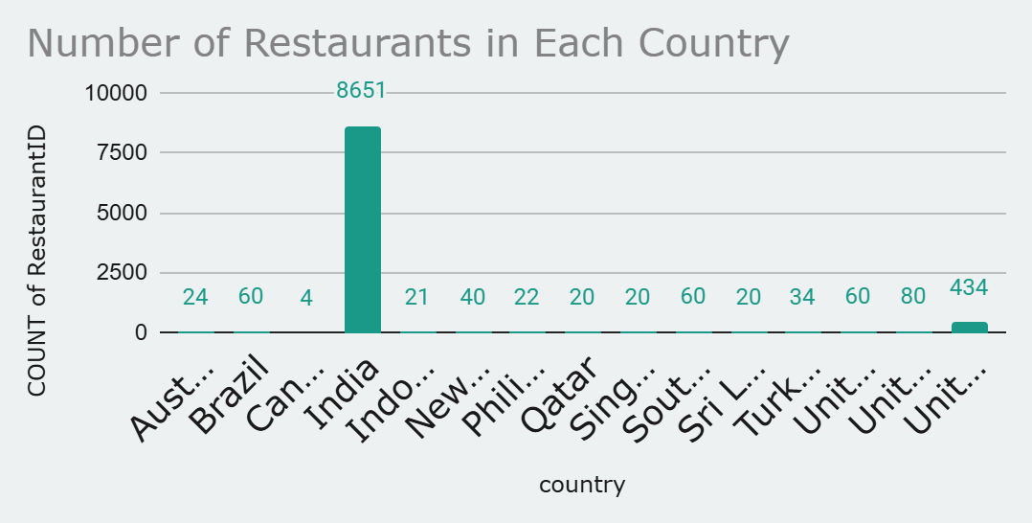

1. Also, the management wants to look at the number of restaurants opened each year, so provide them with something here.

According to our data, every year more than 1000 restaurants are open all over the country from 2010 to 2018.

As per our analysis the maximum number of restaurants open in 2018 and the minimum number of restaurants open in 2012.

Create the pivot table add Year column in row and Restaurant Name column in value and summaries by count function.

| *Openning_Year* | COUNT of RestaurantID |
| --- | --- |
| 2010 | 1080 |
| 2011 | 1098 |
| 2012 | 1022 |
| 2013 | 1061 |
| 2014 | 1051 |
| 2015 | 1024 |
| 2016 | 1027 |
| 2017 | 1086 |
| 2018 | 1101 |

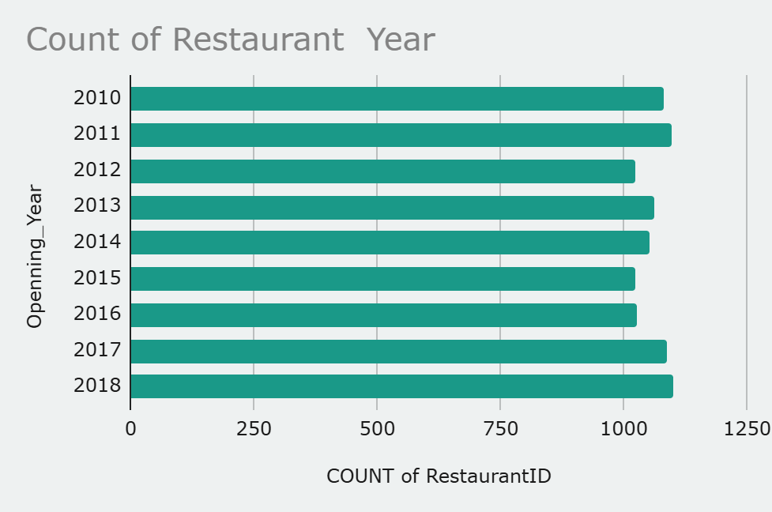

1. What is the total number of restaurants in India in the price range of 4?

=COUNTIFS ('Raw Data’! D2:D,"INDIA",'Raw Data’! Q2: Q,"4")

Using the COUNTIFS function on the Raw data, we get the number of restaurants in India which are in the (Price range of 4) 388.

1. What is the average number of voters for the restaurants in each country according to the data?

Create the pivot table and add country column in row and votes column in value and summaries by Average function.

With the help of pivot table, we can easily define the Average votes of country. According to our analysis Brazil got minimum average of votes and United Arab Emirates maximum average of votes

| *country* | AVERAGE of Votes |
| --- | --- |
| Australia | 111.4 |
| Brazil | 19.6 |
| Canada | 103.0 |
| India | 137.2 |
| Indonesia | 772.1 |
| New Zealand | 243.0 |
| Philippines | 407.4 |
| Qatar | 163.8 |
| Singapore | 31.9 |
| South Africa | 315.2 |
| Sri Lanka | 146.5 |
| Turkey | 431.5 |
| United Arab Emirates | 493.5 |
| United Kingdom | 205.5 |
| United States of America | 428.2 |

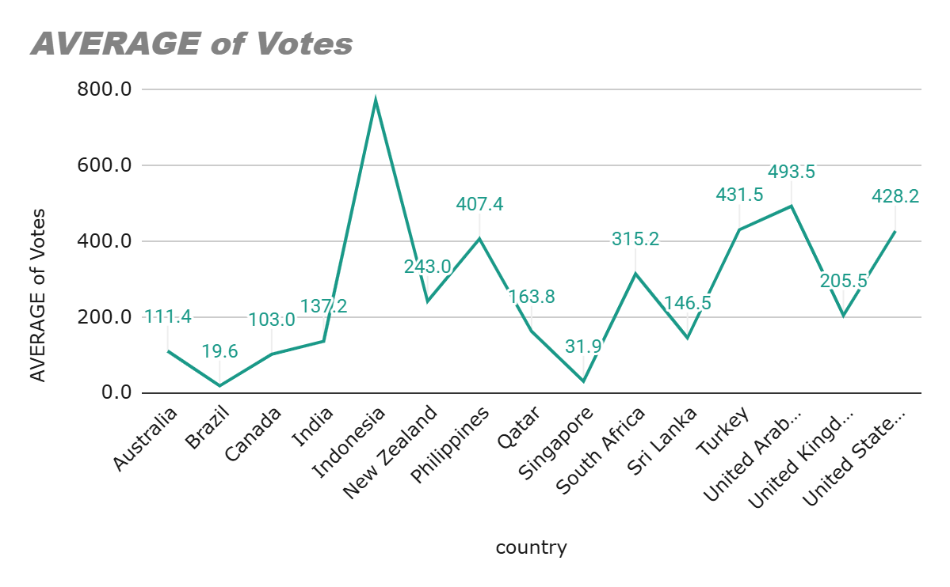.

1. Calculate the average rating for all the restaurants that have price_range < 4 and provide online delivery. Use only the “IF” function, Logical Operators, and Aggregation functions to solve this problem. **[Note: Don’t use Conditional aggregation in this question.]**

We can calculate the average rating of restaurant that have price range,<4 and provide online delivey by averageifs function

=AVERAGEIFS(T:T, Q:Q, "<4", N:N, "Yes") is 3.274760117

1. Using Conditional formatting highlights the rows of restaurants that are located in the countries or cities that you’ve suggested to the management for opening new restaurants.

The recommended country for opening a restaurant would be Canada, Qatar, Singapore, Sri Lanka, Indonesia, Philippines and Turkey as they have below average no. of restaurants and ratings are high

I Have have highlighted number of restaurant the basis of my suggested countries

1. Create a new customized price column that consists of the abbreviation/symbol of the currency along with the Average_cost_for_two value. [Use string operations to do this task]

I have created new column in thee aw data with these formula =MID(L7843, FIND("(", L7843) + 1, FIND(")", L7843) - FIND("(", L7843) - 1) & " " & S7843

1. How can you create an array formula in Excel or Google Sheets to count the number of restaurants listed that do not offer online delivery, are in the lowest price range, and have an average cost for two people less than or equal to 250 Indian Rupe

Number of restaurants listed that do not offer online delivery, are in the lowest price range, and have an average cost for two people less than or equal to 250 Indian Rupees is 1694

the formula we used to archive these is **=ARRAYFORMULA(COUNTIFS('Raw Data'!O:O,"No",'Raw Data'!R:R,"1",'Raw Data'!AA:AA,"<=250"))**

**Subjective Question:**

1 Suggest a few countries where the team can open newer restaurants with lesser competition. Which visualization/technique will you use here to justify the suggestions?

1. **Count of Restaurants (Competition Level)**
2. **Average Rating (Customer Satisfaction)**

We are suggesting few countries for opening new restaurants in Data Analysis sheet in excel project. That are **Canada, Indonesia, Qatar, Singapore, Sri Lanka, Turkey.** Number of restaurants in this country is very less and **rating is below than 4.5.**

On my visualization and technique create pivot table and add country column in row and restaurants name in value summaries by count function. We fetch the list of number of restaurants in each county after that we add filter on count of restaurants column and select only up to 40 restaurants and we get result of few countries where we open new restaurants in lesser competition.

## **Insights:**

1. **Canada** has the lowest competition but very poor customer ratings. This suggests a **quality gap**, presenting an opportunity for a high-standard brand to thrive.
2. **Indonesia** and **Turkey** both show good customer feedback and moderate competition — they are **ideal balanced markets** for new entries.
3. **Singapore** and **Sri Lanka** both have **average to low ratings**, suggesting **existing players may not be satisfying customers** — a well-targeted new brand could disrupt the market.
4. **Qatar** shows moderate competition and average ratings — this can be approached with a **focused mid-range or premium strategy**.

## **Recommendations:**

| **Country** | **Recommendation** |
| --- | --- |
| **Canada** | Target with a **premium quality restaurant** model to fill the satisfaction gap |
| **Indonesia** | Expand with a **modern or fusion concept**, as demand and satisfaction are high |
| **Turkey** | Use a **cost-effective strategy** in an active but positive market |
| **Sri Lanka** | Try **value-focused offerings** to improve customer satisfaction |
| **Singapore** | Launch **innovative or niche cuisine** to stand out in a moderately active market |
| **Qatar** | **Mid-sized entry** with emphasis on service and ambiance |

| ***country*** | **COUNT of RestaurantID** | **AVERAGE of Rating** |
| --- | --- | --- |
| Canada | 4 | 3.58 |
| Indonesia | 21 | 4.30 |
| Philippines | 22 | 4.47 |
| Qatar | 20 | 4.06 |
| Singapore | 20 | 3.58 |
| Sri Lanka | 20 | 3.87 |
| Turkey | 34 | 4.30 |

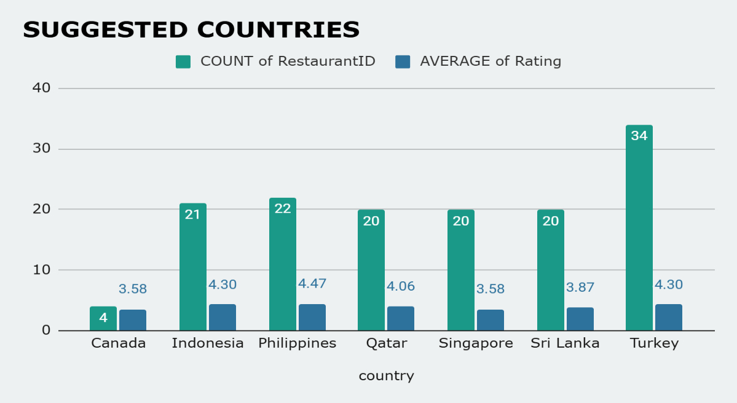

2 Come up with the names of States and cities in the suggested countries suitable for opening restaurants.

Based on our city-level analysis within the suggested countries, here are the cities with very low restaurant counts, which could be suitable for new openings, along with their average ratings as a quality indicator:

* **Canada:**
  + **Chatham-Kent:** 1 restaurant (Avg Rating: 3.70)
  + **Vineland Station:** 1 restaurant (Avg Rating: 4.30)
  + **Yorkton:** 1 restaurant (Avg Rating: 3.30)
  + **Indonesia:**
  + **Bogor:** 2 restaurants (Avg Rating: 3.85)
  + **Tangerang:** 2 restaurants (Avg Rating: 4.30)
  + **Bandung:** 1 restaurant (Avg Rating: 4.20)
  + Cities like Doha (Qatar), Singapore (Singapore), and Colombo (Sri Lanka) have 20 restaurants each. While higher than the above, they still represent the primary urban centers in their respective countries and might be suitable if the strategy is to compete in established but not extremely saturated markets.
  + By comparing these two factors, we can identify different types of market opportunities:
  + Cities with Moderate Competition & High Quality (Promising for Expansion):
  + Jakarta, Indonesia (16 restaurants, Avg Rating: 4.36): This city stands out. It has a decent number of restaurants (not as low as others, but significantly less than major global hubs like New Delhi) yet maintains a very high average rating. This indicates a robust market that values quality, and there's still room for new, high-quality entrants.
  + Doha, Qatar (20 restaurants, Avg Rating: 4.06): Similar to Jakarta, Doha has a moderate restaurant count but also a strong average rating, suggesting a mature market where quality is appreciated.
  + Cities with Very Low Competition & High Quality (Niche Opportunities):
  + Tangerang, Indonesia (2 restaurants, Avg Rating: 4.30) and Bandung, Indonesia (1 restaurant, Avg Rating: 4.20): These cities have very few existing restaurants in the dataset but boast extremely high average ratings. This suggests a potential for quality-focused restaurants to dominate an underserved market.
  + Vineland Station, Canada (1 restaurant, Avg Rating: 4.30): While only one data point, its very high rating hints at a local appreciation for quality. However, the extremely low count means extensive local research is crucial to validate market size and demand.
  + Cities with Moderate Competition & Moderate Quality (Competitive Entry):
  + Colombo, Sri Lanka (20 restaurants, Avg Rating: 3.87): With 20 restaurants and a decent average rating, Colombo presents a more balanced competitive landscape. New restaurants would need a clear differentiation strategy based on cuisine, concept, or value.
  + Singapore, Singapore (20 restaurants, Avg Rating: 3.575): Although Singapore has a moderate number of restaurants, its average rating is somewhat lower compared to cities like Jakarta or Doha. This could indicate a market where existing restaurants may not consistently meet higher customer expectations, creating an opening for genuinely high-quality new establishments.
  + Cities with Very Low Competition & Varying Quality (Requires Deep Research):
  + Bogor, Indonesia (2 restaurants, Avg Rating: 3.85): Low competition with a good average rating.
  + Chatham-Kent (1 restaurant, Avg Rating: 3.70), Yorkton (1 restaurant, Avg Rating: 3.30), Consort (1 restaurant, Avg Rating: 3.00) in Canada: These cities have minimal data, making broad conclusions difficult. While competition appears low, the ratings vary, and a single restaurant's rating might not reflect the entire city's potential. Detailed local market analysis is paramount here.

**Overall Recommendation:**

* + To maximize success, prioritize cities that combine a relatively low existing restaurant count (less competition) with a high average rating (indicating a market that values quality). Jakarta and Tangerang in Indonesia, and Doha in Qatar, appear to be the most promising cities for new restaurant openings based on this comparison.

## Justification

“Our selection of potential restaurant locations is backed by a data-driven approach using Pivot Table analysis to compare competition (restaurant count) and customer satisfaction (average rating). We shortlisted countries with less saturation and below-max ratings. Drilling further, we identified key cities and states that offer urban density, growth potential, or tourist footfall. This ensures that our recommendations are both strategic and practical for market entry.”

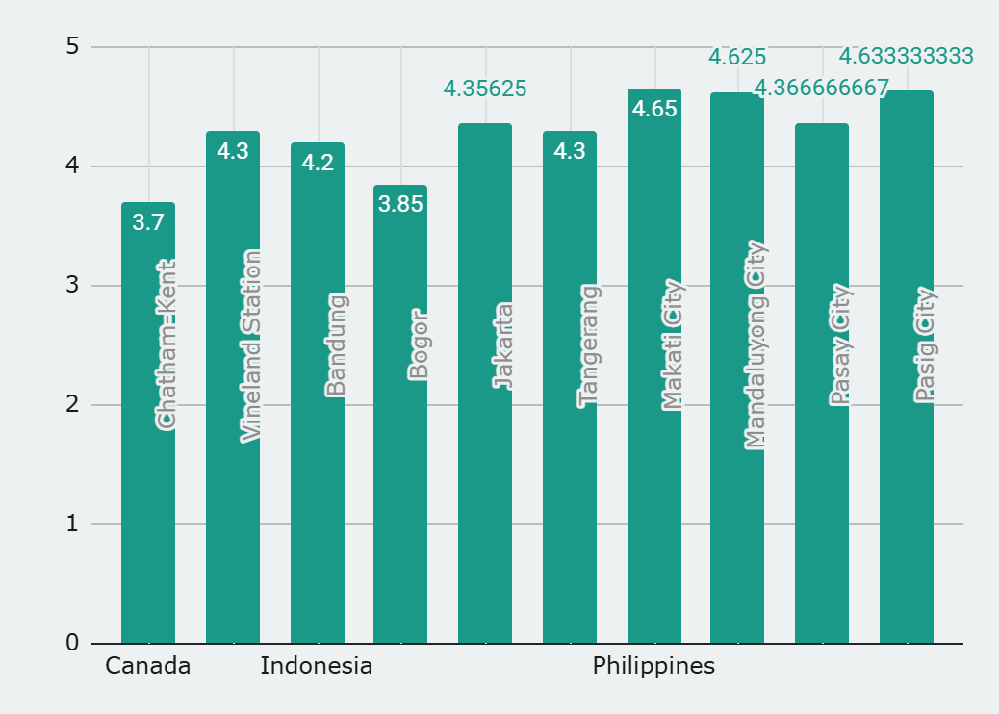

3 According to the countries you suggested, what is the current quality regarding ratings for restaurants that are open there?

### **Insights:**

1. **High-Performing Countries:**
   * **Philippines** (Avg. Rating: 4.47) and **Turkey** (4.30) have the **highest average ratings**, indicating **excellent restaurant quality and customer satisfaction**.
   * These countries also have **good sample sizes** (22 and 34 restaurants), making the ratings more reliable.
2. **Moderate Performers:**
   * **Canada** and **Singapore** have the **lowest average ratings** (3.58), indicating **room for improvement** in food quality, service, or customer experience.
   * The low number of restaurants in **Canada (only 4)** may also suggest limited data, which can skew the average.
3. **Balanced Performer:**
   * **Sri Lanka** shows a **decent average rating** of **3.87** across 20 restaurants, placing it in the **good but not excellent** category.

## Recommendations:

1. **Focus Investment and Marketing on High-Rating Countries:**
   * **Philippines and Turkey** should be considered **strategic markets** for expansion, promotion, or partnership, as high ratings indicate strong local food culture and customer satisfaction.
2. **Conduct Quality Audits in Moderate Countries:**
   * In **Canada and Singapore**, conduct **customer feedback surveys** or **quality audits** to identify issues (e.g., food taste, hygiene, service speed).
   * Use this data to **train staff**, **revise menus**, or **improve service protocols**.
3. **Encourage Reviews and Feedback:**
   * For countries with **low restaurant count**, like **Canada**, encourage more customers to **leave reviews** to get a **more accurate picture** of the restaurant quality.
4. **Deeper Analysis Opportunity:**
   * Break down the data further by **cuisine type, price range, or delivery availability** to understand **which factors** influence higher ratings.
5. **Monitor Trends Over Time:**
   * Set up a monthly or quarterly review to **track changes in average ratings** and **identify emerging trends**.

| *country* | AVERAGE of Rating | **COUNT of RestaurantID** |
| --- | --- | --- |
| Canada | 3.58 | 4.0 |
| Philippines | 4.47 | 22.0 |
| Singapore | 3.58 | 20.0 |
| Sri Lanka | 3.87 | 20.0 |
| Turkey | 4.30 | 34.0 |

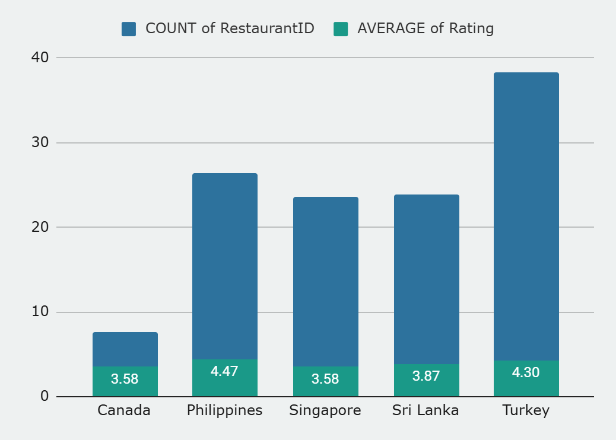

4 Also, what is the current expenditure on food in the suggested countries, so we can keep our financial expenditure in control?

A Pivot Table was created to calculate the average "Cost for Two" for restaurants in each country.

To make the values comparable, a currency conversion table with INR exchange rates was manually prepared. The average costs obtained from the Pivot Table (in local currencies) were then converted to INR using simple multiplication with the respective exchange rates.

For example:  
 If the average cost in Canada was 36.25 CAD and the exchange rate was ₹61.5, then the cost in INR was calculated as:  
 36.25 × 61.5 = ₹2,229This manual conversion approach ensured consistency and allowed for clear financial comparison of food expenditures across countries in Indian currency.

## **Insight**

## After converting the average restaurant cost in each country to Indian Rupees, it was observed that:

* Singapore shows the highest food cost (~₹9,625), indicating a premium dining market.
* Countries like Turkey (₹223) and Sri Lanka (₹665) are ideal for budget-conscious travelers or expansion.
* Indonesia appears to have a high average; this could be due to data inconsistency or extreme outliers.

#### **Recommendations:**

* Focus on countries like Turkey and Sri Lanka for cost-effective expansion.
* For high-end services or fine dining, Singapore and Qatar are more suitable.
* Clean and validate outlier-heavy data (like Indonesia) before making final decisions.

## 

5 Come up with the names of restaurants from the recommended states that are our biggest competitors and also those that are rated in the lower brackets, i.e. 1-2 or 2-3.

The condition for a restaurant to be a competitor will be to have rating more than 3 (Rating > 3).

| *City* | *RestaurantName* | AVERAGE of Rating |
| --- | --- | --- |
| Colombo | Elite Indian Restaurant | 2.4 |
|  | Queen's Cafe | 2.5 |
| Colombo Total |  | 2.45 |
| Consort | Consort Restaurant | 3 |
| Consort Total |  | 3 |
| Singapore | Makansutra Gluttons Bay | 3 |
| Singapore Total |  | 3 |

6 Which cuisines should we focus on in the newer restaurants to get better feedback? Does the choice of cuisines affect the restaurant ratings?

THESE ARE MY TOP RATED CUISINE AMONG THE SELECTED COUNTRY WITH RATING GREATER THAN 4

Ø According to the suggested countries, each country has its own favourite cuisine with the highest rating.

Ø Yes! The choice of cuisine affects the restaurant ratings because of the geographic location of the country and availability of food resources there.

It can be seen from the data that coastal countries like Sri Lanka and Indonesia are more focussed on Seafood and Non-vegetarian foods,

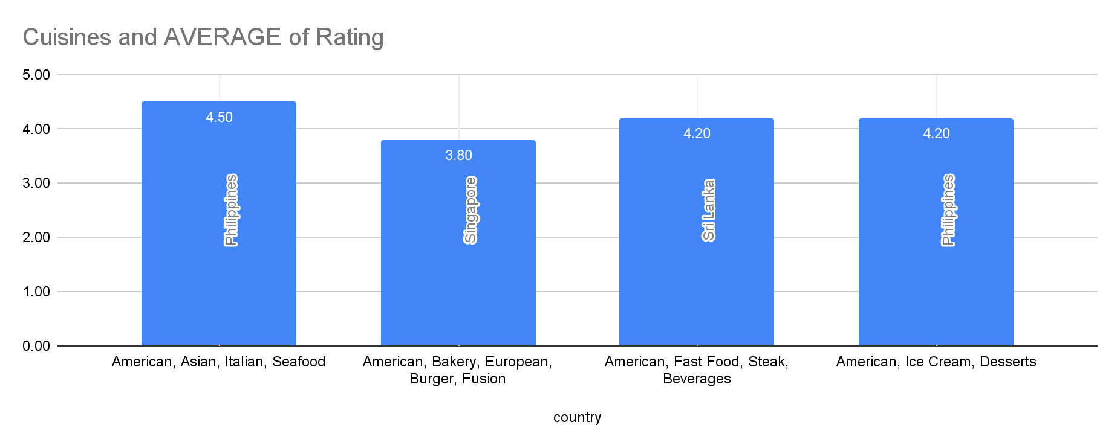

7 According to our current data, should we go for online delivery and table booking? Does that affect the customer’s ratings?

Yes, we can go for online delivery and table booking because the average of rating is higher in those restaurants having both online delivery and table booking. And it also affects the rating.

## **Insights**

### **1. Table Booking Increases Customer Satisfaction**

* Restaurants **with table booking** have a **much higher average rating (3.48)** than those without (2.81).
* This indicates that **customers value the ability to reserve tables**, which likely improves their overall dining experience (less waiting, better planning, etc.).

### **2. Online Delivery Also Improves Ratings**

* Restaurants offering **online delivery** receive **better average ratings (3.29)** than those that do not (2.75).
* While the difference is **not as large as with table booking**, it still suggests **customer preference for convenience**.

## **Recommendations**

| **Feature** | **Recommendation** |  |
| --- | --- | --- |
| **Table Booking** | Strongly Recommended |  |
| **Online Delivery** | Recommended |  |

* Formula for finding average rating have been table booking and online delivery.

**=AVERAGEIFS ('Raw Data’! T2: T, 'Raw Data’! M2:M,"Yes",'Raw**

**Data’! N2: N, "Yes")**

* Formula for finding average rating have not been table booking and online delivery.

**=AVERAGEIFS ('Raw Data’! T2: T, 'Raw Data'! M2:M,"No",'Raw**

**Data'!N2:N,"No")**

| *Table booking* | AVERAGE of Rating | *Online delivery* | AVERAGE of Rating |
| --- | --- | --- | --- |
| No | 2.809686644 | No | 2.754309859 |
| Yes | 3.482556131 | Yes | 3.288004896 |

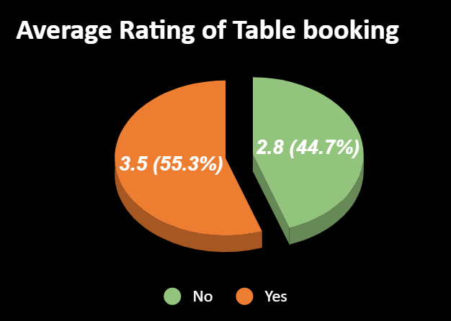

8 Should the team keep the rate of cuisines higher? Will that affect the feedback? According to our data are the rates of cuisines and ratings, correlated?

Correlation is calculated between Average cost for Two converted in Rs and Rating

=CORREL(A2:A,B2:B)

**Insight**  
The correlation coefficient of 0.0.34 suggests a weak positive relationship between the Cost and Rating This indicates that, in the selected countries, higher prices do not lead to significantly higher or lower customer satisfaction. Ratings appear to be influenced more by factors other than price, such as food quality, service, ambience, and value.

**Recommendation**

The team should not increase cuisine prices solely to improve customer ratings, as price and rating are not strongly correlated.

Focus should instead be placed on improving overall customer experience, including:

1. Food quality and taste
2. Cleanliness and hygiene
3. Staff behavior and service speed
4. Presentation and ambience

Pricing decisions should be made based on target audience affordability, competitor pricing, and value perception, not just feedback metrics.

9 What is the distribution of the number of restaurants of different price ranges in all the countries?

According to given data **9550** restaurants available in all country and with different price range like in Price Range 1 there are **4443**

restaurants, and Price Range 2 there are **3113** restaurants, Price Range 3 there are **1408** restaurants, and Price Range 4 there are **586** restaurants presents.

Once again, we create pivot table and add Prize range in row and Restaurants Name in value and summaries by Count function. So, we easily fetch the different prize range of restaurants of all the countries.

## **Insights**

1. **Almost half of all restaurants (46.5%) belong to the lowest price range (1).** This suggests that a significant portion of the market targets budget-conscious customers.
2. **Mid-range price restaurants (Price Range 2) also form a large segment (32.6%).** These are likely catering to middle-income customers looking for better quality but affordable pricing.
3. **Higher price range restaurants (Price Ranges 3 and 4) are comparatively fewer (about 20.8%).** This indicates limited availability of premium dining options.
4. The distribution indicates a **market heavily skewed toward budget and mid-range restaurants**, possibly due to broader affordability in the population or market demand.

## **Recommendations**

1. **Focus on mid-range (Price Range 2) expansion** Since a large customer base exists here, investing in mid-range restaurants could balance affordability and quality to attract more customers.
2. **Explore premium segment cautiously** Though premium restaurants are fewer, there is a niche for high-end dining (Price Range 3 and 4). Target premium locations or cities with higher purchasing power.
3. **Innovate in budget segment (Price Range 1)** Budget restaurants dominate, but competition is fierce. Focus on differentiation through unique cuisines, quality improvements, or better service to stand out.
4. **Balance portfolio across price ranges** For new restaurant openings, a balanced mix of budget, mid-range, and premium offerings can capture a wide market share and diversify risk.

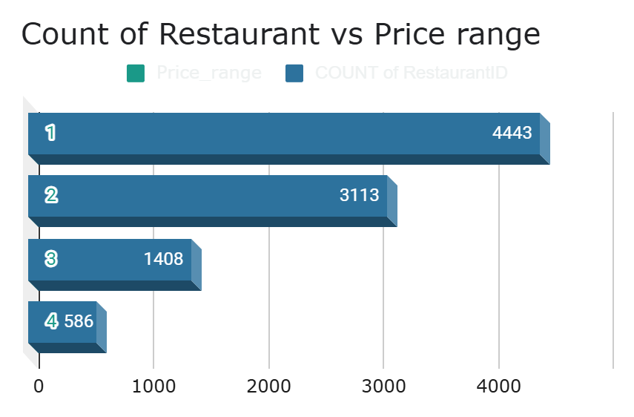

10 Explain your approach in brief for suggesting countries/cities in order to open new restaurants, if the objective and subjective questions would have not been given to assist you. **[you have to give bullet pointers in order to answer this question]**

If Objective/Subjective Questions Were Not Given…

🔹 Approach in Bullet Points:

* Explore Data: Clean and scan for missing values, nulls
* Identify Key Columns: Country, city, rating, cuisine, cost
* Check Competition: Count of restaurants per country/city
* Analyze Ratings: Average, distribution, high vs. low
* Cuisine Trends: Avg rating by cuisine
* Cost Analysis: Cost vs. rating correlation
* Feature Impact: Table booking, delivery vs. rating
* Visualizations: Pivot charts, histograms, bar charts for clarity
* Insights: Focus on areas with high rating potential & less competition

**The dashboard must consist of Year-wise and country slicers.**