**Student Name** — Mock Interview CV

Address Line 1 – City, State ZIP – Country

 +91 123 456 7890 •  [email@example.com](mailto:email@example.com) •  [linkedin-profile](https://www.linkedin.com/in/linkedin-profile)  [github-profile](https://github.com/github-profile)

# Objective

Clearly articulate your career objective, aligning it with your dream job profile:

*Example: ”To secure a challenging role as a [Job Title, e.g., Software Engineer] in a reputed organization where I can utilize my skills in [specific skills or domain, e.g., full-stack development, artificial intelligence, or cloud computing], contribute to impactful projects, and grow as a professional while achieving organizational goals.”* **Note:** Replace the placeholders with details specific to your aspirations and career goals.

# Education

## Lovely Professional University Jalandhar, Punjab

*Bachelor of Technology in Computer Science and Engineering, CGPA: X.XX Year of Graduation* Relevant Coursework: Data Structures and Algorithms, Operating Systems, Database Management Systems, Artificial Intelligence, Computer Networks, Software Engineering

## School Name City, State

*High School Degree (e.g., Higher Secondary Certificate), Percentage: XX.XX% Year of Completion*

Key Subjects: Physics, Chemistry, Mathematics, Computer Science

## School Name City, State

*Secondary School Certificate, Percentage: XX.XX% Year of Completion*

Achievements: Include significant academic awards or distinctions if applicable.

# Technical Skills

**Programming Languages**: Python, Java, C++ **Tools/Technologies**: Git, Docker, Kubernetes **Operating Systems**: Linux, Windows **Databases**: MySQL, MongoDB

**Frameworks**: React.js, TensorFlow

# Projects

**Project Title:** *First Project Name*

**Description:** Brief description of the project, highlighting its purpose and functionality.

**Technologies Used:** List tools and technologies, e.g., Python, React.js, Docker.

**Impact/Achievements:** Highlight the outcomes or benefits of the project, e.g., improved efficiency by 20%, automated tasks, or gained X users.

**Demo/Code Link:** [GitHub Repository](https://github.com/username/project) or [Live Demo](https://example.com/demo)

**Project Title:** *Second Project Name*

**Description:** Brief description of the project, emphasizing innovation or problem-solving aspects.

**Technologies Used:** List tools and technologies, e.g., Java, TensorFlow, Kubernetes. **Impact/Achievements:** Mention significant achievements, e.g., implemented a scalable solution, reduced processing time, or received positive feedback.

**Demo/Code Link:** [GitHub Repository](https://github.com/username/project) or [Live Demo](https://example.com/demo)

# Certifications (If Applicable)

**Certification Name**: Description of the certification, including the certifying body or organization. For example: ”AWS Certified Solutions Architect – Associate, awarded by Amazon Web Services.”

**Certification Name**: Brief details about the certification, such as its relevance, key skills acquired, or a noteworthy achievement. For example: ”Certified Kubernetes Administrator (CKA) by the Linux Foundation, demonstrating expertise in Kubernetes deployment and management.”

**Certification Name**: Mention the date of completion or validity period, if applicable, e.g., ”Completed in January 2023, valid until January 2026.”

# AI Recommendations for Improvement

**Recommendation 1**: Write the first recommendation here. **Recommendation 2**: Write the second recommendation here. **Recommendation 3**: Write the third recommendation here.

# Self-Assigned Tasks (Till 10*th* week of this semester)



**Task 1**: Write the first task here. **Task 2**: Write the second task here. **Task 3**: Write the third task here.

# Targets Allocated (Till 10*th* week of this semester)



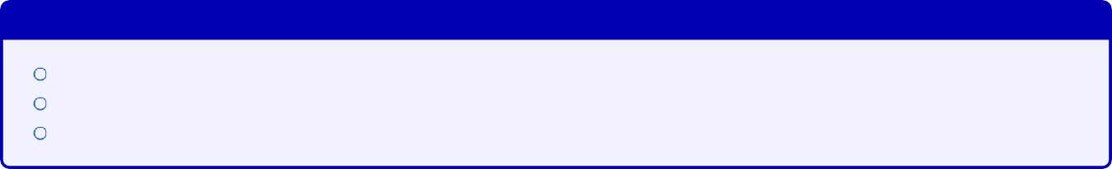

Targets Approved by Course Instructor

Complete certification in [Certification Name]. Enroll in and complete [Specific MOOC or course].

Finish the project titled ”[Project Name]” to strengthen your CV.

**Signatures**

**Bhogi Jyothir Raghavalu**

*Student’s Full Name Instructor’s Full Name*