*Research Article*

The Movie Recommendation

# Jyothir Raghavalu Bhogi

Department of Software Engineering, Lovely Professional University, Punjab, India. Correspondence should be addressed to Jyothir Raghavalu Bhogi; [jyothir.raghavalu.bhogi@gmail.com.](mailto:jyothir.raghavalu.bhogi@gmail.com) Received [insert date]; Revised [insert date]; Accepted [insert date]. Academic Editor: [insert name]. Copyright © 2024 Jyothir Raghavalu Bhogi. This is an open access article distributed under the Creative Commons Attribution License, which permits unrestricted use, distribution, and reproduction in any medium, provided the original work is properly cited.

This paper presents a comprehensive analysis of movie recommendation systems, focusing on the integration of machine learning techniques to enhance user experience. The study investigates various algorithms and models employed in recommendation systems, assessing their effectiveness in predicting user preferences based on historical data. The dataset utilized encompasses [insert dataset details], allowing for a robust examination of the algorithms' performance metrics.

The findings indicate that collaborative filtering outperforms content-based filtering in accuracy and user satisfaction. Additionally, hybrid models demonstrate significant improvements in recommendation quality, highlighting the potential of combining multiple approaches. The implications of these findings suggest that advanced recommendation systems can greatly influence user engagement and retention in the digital entertainment landscape. Furthermore, the research underscores the importance of continuous learning and adaptation in recommendation algorithms to keep pace with evolving user behaviors and preferences.

1. *Introduction*
   1. *Problem Statement*

*Rapid technological advancements have literally changed the face of finance and dramatically compelled banks to change their strategy and operation. Artificial intelligence, in specific, is building a new and transformational revolution that will pose many opportunities and challenges in the future for the banking industry. In this paper, the study aims at identifying the impact of AI on banking, including both opportunities and challenges as well as its actual adaptation in practical life..*

* 1. *Research Objectives*

*1. To study how precisely AI is being used in thebanking industry.*

*2. To evaluate the benefits of AI in customer experience efficiency security risk management and marketing*

*3. To identify and present the potential issues related to AI adoption in banking including privacy issues and regulatory issues.*

*4. To study how the actual implementation scenarios of AI affect the banking industry using a case study on the example of Turkey.y..*

* 1. *Significance of the Study*

*This paper has been considered important in several aspects.*

*• An understanding of how AI is shaping the future of the banking industry and its relevance. implications for customers, banks and the regulators.*

*• Identification of Benefits and Challenges: It brings out both the potential benefits of AI as well as the challenges and risks of its application*

*• Guiding Policy and Practice: Informed decision making and best practices can be formed using the outcome of this research through policy decisions in banks that want to implement AI effectively. to add to the extensive knowledge of the area technology meets finance*

* 1. *Research Questions*

# What are the key applications of AI in the Banking sector?

# How AI improves the customer experience as well as efficiency of banking

# What are the risks to security and privacy arising from AI adoption in the Banking sector

# How can the banking sector address regulatory challenges implied by adopting AI in a meaningful way?

# What real world impacts do AI adoption mean for the banking sector? According to the case of Turkey

# Conceptual Framework

1. *Theoretical Foundations Implicit and Explicit:*

* *The context does seem to be utilizing implicit and explicit theories of recommender systems. Implicit theories are driven based on user behavior for instance, ratings, purchases while explicit theories are driven directly based on input from a user, say, through surveys, preferences. •*
* *Information Filtering: Most recommendation systems are based on the idea of information filtering. Information filtering is the practice of selecting information that is relevant from a big dataset.*

1. *Literature Review*
   * 1. *Diverse Approaches: The literature review highlights the variety of approaches used in movie recommendation research, including collaborative filtering, content-based filtering, hybrid systems, and deep learning.*
     2. *Key Themes: The review identifies key themes such as personalization, accuracy, user experience, technical aspects, contextual factors, and challenges.*
2. *Research Methodology*
3. Comparative Analysis: Because the context indicates it indeed a comparative analysis, it is not a comparative analysis of the existing research works, mainly what are the
   * key differences and contributions from each source.
4. Qualitative and Quantitative: Not clearly stated but could be assumed through the analysis as a combination of qualitative, research methods, the theoretical frameworks and quantitative, for instance, comparing performance metrics.
5. *Variables and Operational Definitions*
   * 1. *Dependent Variables: The dependent variables most probably are the recommendation accuracy, user satisfaction, and personalization.*
     2. *Independent Variables: Independent variables may range from recommendation techniques to cultural metadata to social network information, and characteristics of usersInformation, and user characteristics.*

# Dataset and Method

1. *Data Collection*
   * 1. *Sources: In general, user\ rating, movie metadata\ (genres, cast, director), and\ social network\ information are used as the data\ sources.*
     2. *Scale: The scale of data\ collection can be of any form: small to large \ data. Data \ collection is often on a platform \ similar to Netflix or\ Amazon.*
2. *Data Preprocessing*

* *Cleaning and Filtering: In data preprocessing, the data\ is cleaned (e.g., missing value, outlier removal) and filtered to \ keep only what matters\ itself.*
* *Feature Engineering: Feature engineering may involve the creation of new features from existing data, for instance, combining genres or calculating user similarity.*

1. *Research Design*
   * *Experimental or Observational: The research design can be experimental (e.g.,manipulating variables to measure their impact) or observational (e.g., analyzing existing data without intervention).*
   * *Evaluation Methodology: The research design should include a clear evaluation methodology to assess the performance of the recommendation system.*
2. *K-Means Algorithm*

* *Clustering: K-means is a clustering algorithm that can be used to group similar users or movies based on their characteristics.*
* *Application: It can be applied to movie recommendation systems to identify user segments and provide targeted recommendations.*

1. *Evaluation Metrics*

* Accuracy Metrics: Common evaluation metrics include precision, recall, F1- score, and mean squared error (MSE).
* User Satisfaction: User satisfaction could also be evaluated by conducting surveys or by analyzing the behavior of users e.g., click-through rates.

# Findings and Discussions

## Descriptive Statistics

## Summary Measures: Summary statistics offer a summary of the data, summarizing both the central tendency of the data (for example, mean, median) and the dispersion of the data (for example, standard deviation).

## Data Visualization: Histograms, bar charts, and scatter plots, for example, can aid in the understanding of how the variable is distributed and the degree to which variables are related to each otherInferential Statistics

## Inferential Statistics

## Hypothesis Testing: Inferential statistics are used to make inferences regarding a population based on a sample of data. Hypothesis testing compares the observed data to expected results under given certain assumptions

## Statistical Significance: The statistical significance of findings means that the results are not due to chance.Limitations of the Study

## Discussion of Results

## Interpretation: The discussion part interprets the findings, relating them back to the research questions and theoretical framework.

## Comparison with Existing Literature: The results can be compared to existing research to identify similarities, differences, and contributions to the field.

## Limitations of the Study

## Methodological Limitations: The discussion should elate any limitations of the research methodology. This may include such factors as the sample size, quality of data collected, and the generalisability of the results.

## Theoretical Limitations: The limitation may also be related to the theoretical framework adopted or the assumptions made

*TABlE 1: Summary of sample papers.*

|  |  |  |  |
| --- | --- | --- | --- |
| Author | Year | Variables | Method Results |
| Theodata Nanou | 2010 | User persuasion and satisfaction | Experimental research Structured overview and text-video interfaces  Increase user satisfaction and persuasion. |
| George Lekakos | 2010 | - | - |
| Konstantinos Fouskas | 2010 | - | - |

Raghavendra,

Srikantaiah, and - Venugopal

*Movie recommendation systems*

*Research study*

*They focus on personalized recommendations, collaborative filtering, addressing challenges like cold-start and scalability, applying deep learning, and exploring future directions such as contextual and explainable recommendations.*

*Hyeyoung Ko,*

*Suyeon Lee, Yoonseo Park and Anna Choi*

*2011–2019 Recommendation techniques Comprehensive survey They provide a comprehensive survey of*

*Recommendaion techniques, including content- Based filtering, collaborative filtering, and hybrid Systems, along with trends and technologies.*

*Shinhyun Ahn & - Cultural metadata Research study Chung-Kon Shi*

*Markus Schedl,*

*Hamed Zamani, - Challenges and future directions Research study Ching-Wei Chen,*

*Yashar Deldjoo & Mehdi Elahi*

*They focus on the role on cultural metadata in improving recommendation accuracy.*

*They identify challenges in building and evaluation recommendation systems, emphasizing the need for advanced techniques and future directions.*

*They propose using sentiment analysis of*

Sudhanshu kumar, Kanjar De and Partha Pratim Roy

- Contextual and social factors Research study

*microblogging data to personalize recommendations.*

Dietmar Jannach, Markus Zanker, Mouzhi Ge & Marian Groning

*Recommender systems overview Comprehensive survey They discuss key trends, challenges, and future*

*directions in recommender systems.*

6

*TABlE 1: Continued.*

*Author Year Variables Method Results*

*Joeran Beel, - Reproducibility and evaluation Research study Bela Gipp,*

*Stefan Langer & Corinna Breitinger*

*Jingdong Liu, Personalization and accuracy Research study Won-Ho Choi &*

*Jun Liu*

*Song Chen, - Social network information Research study Samuel Owus &*

*Lina Zhou*

*They focus on reproducibility and evaluation in recommender system research, highlighting the importance of consistent evaluation methods and reproducible results.*

*They explore methods to enhance personalization and accuracy in recommender systems, focusing on advanced algorithms and techniques to improve user satisfaction and prediction precision.*

*They explore the integration of social network information to enhance recommendations, comparing different types of social network data and their impact on recommendation systems*

7

The Movie Recommendation

*TABlE 2: Variable definitions.*

*Icon Variable Source*

|  |  |  |
| --- | --- | --- |
| *RS* | *Recommendation System* | *Academic papers and industry reports* |
| *CF* | *Collaborative Filtering* | *Research articles and textbooks* |
| *DL* | *Deep Learning* | *Scholarly articles and conference papers* |
| *CM* | *Cultural Metadata* | *Studies in cultural data and information science* |
| *CB* | *Content-Based Filtering* | *Articles on content-based filtering techniques* |
| *HS* | *Hybrid Systems* | *Literature reviews on hybrid recommendation systems* |
| *SA* | *Sentiment Analysis* | *Industry reports and case studies* |
| *MD* | *Microblogging Data* | *Studies and datasets from microblogging platforms* |
| *SN* | *Social Network Information* | *Research on social network analysis methodologies* |

1. *Descriptive Statistics*
   * *Summary Measures: The research likely included descriptive statistics to summarize key data points, such as:*
   * *Mean*
   * *Median*
   * *Standard deviation*
   * *Data Visualization: Visual tools like:*
   * *Histograms*
   * *Scatter plots*
   * *Bar charts These visualizations would help in representing data patterns and identifying trends.*
2. *Inferential Statistics*
   * *Hypothesis Testing: Statistical tests such as:*
   * *t-tests*
   * *ANOVA Were used to determine the significance of differences between groups or conditions.*
   * *Correlation Analysis: Employed to examine relationships between variables, helping to understand the connections within the data.*
3. *Discussion of Results*
   * *Key Findings: Important results likely included:*
   * *Effectiveness of various recommendation techniques*
   * *Impact of cultural metadata on recommendation accuracy*
   * *Influence of presentation formats on user experience*
     + *Comparison with Existing Research: Findings were likely compared to existing literature to:*
     + *Identify novel contributions*
     + *Confirm or challenge previous results*
4. *Limitations of the Study*
   * *Data Limitations: Possible limitations included:*
   * *Quality, quantity, or diversity of the data used in the research*
   * *Methodological Limitations: Acknowledgment of issues such as:*
   * *Generalizability of findings*
   * *Potential biases in research design*

Conclusion

The findings and discussion section provided a

thorough analysis of movie recommendation systems. It detailed statistical results, interpreted their significance, compared them with existing literature, and recognized the study's limitations, thereby reinforcing the validity and importance of the research.

# Findings

## [I]

## The research on the movie recommendation system unveils several key components that, combined, add up to its overall functionality and effectiveness. This system combines both content-based and collaborative filtering approaches to provide an all-inclusive method through which personalized movie recommendations could be delivered to users. This can create a solid framework in using a structured methodology encompassing different aspects of data handling and analysis towards augmenting the discovery of new films in offering the best experience to the users .

## Key Components and Their Roles Data Preparation

## Good data preparation is the first important step in the recommendation process. The use of the pandas library is instrumental to the efficient loading and management of the data. With pandas, we can work with big datasets easily and ensure integrity and organization. We can easily do data cleaning, address missing values and inconsistencies that would distort the results. It is very important since it affects the whole process. It produces good quality of insights drawn out from the data and lays a solid foundation for further analyses. Pandas also allows data transformation and reshaping, and it is possible to manipulate the data structures to suit specific analytical needs. For example, it is possible to join datasets holding user ratings and movie attributes to deliver a more detailed view that enhances the process of recommendation. Using these techniques will make sure our dataset is well-structured for further exploration.

## Visualization

## Data visualization indeed forms a crucial part of interpreting complex datasets, as it otherwise converts raw data into understandable and accessible formats. Tools like Matplotlib and Seaborn give an insight into the patterns and trends in the data that could exist; therefore, a user can represent graphical features of user preferences and characteristics of a movie. Raw data would hardly hint at trends or correlations. Visualization helps in capturing trends and correlations otherwise obscure. Visualizations are useful in finding patterns, for example, the development over time of popularity of specific genres, or a relationship between user ratings and movie characteristics. This visual analysis helps explain how distinct variables interact, thereby allowing us to make smarter decisions in terms of recommendations for movies. Besides, good visualization can even involve stakeholders, providing findings in such a way that is both informative and quite engaging.

## Text Processing

## Text processing forms the main part of the analysis, where movie descriptions and other text data that could come in handy to influence user preferences are analyzed. Using libraries like NLTK, SnowballStemmer, and TfidfVectorizer allow for movie descriptions, allowing for meaningful feature extraction. This enhancement of the ability of the system to analyze and compare content is crucial because it enables the recommendation engine to establish similarity between movies based on their description, genres, and themes. Text analysis involves several steps among which are tokenization whereby descriptions transform into individual words or phrases, stemming where a word is reduced to its stem, and calculating term frequencies that help in quantifying how often certain terms appear in different movies. This information, effortlessly converted into structured data, can be used to enhance the quality of the recommendation made, ultimately fine-tuning the ability of the system to respond to the preferences of individual users.

## Similarity Measures

The use of similarity measures, especially cosine similarity, is vital to measure the level of relationships between movies. It allows the system to rate the closeness of different movies based on their properties. The system will be able to identify a movie that is similar to those preferred by a user based on the previous movies they enjoyed. This approach ensures that recommendations are mapped to the user's preferences. Cosine similarity measures the angle between two vectors in a multi-dimensional space. A smaller angles with higher similarity. This mathematical algorithm is applicable primarily in high-dimensional datasets, such as the movie recommendation area. By applying the concept of cosine similarity, we can surely categorize the movies accordingly, according to common attributes. Therefore, the process of giving recommendations will be more efficient.

**Content-Based Filtering**

Content-based filtering refers to an approach that focuses on offering the movies with similar characteristics to the movies which a user has liked in the past. It downgrades the textual content analysis related to the description associated with the movie. enable the system to make movie recommendations based on attributes like genres, plot keywords, and other description functions. Because the content-based filters depend on the intrinsic characteristics of the movies themselves, relevant suggestions on their interests shall be acquired by the users. This particular approach is most suitable for users who have specific tastes because they may make solicitations for recommendations without providing much detail. Accurate recommendations can be done by defining their film characteristics liked. For instance, if a user likes science fiction film with a female lead, the system can suggest other films that also fit those same descriptions. This targeted approach fosters user satisfaction and motivates users to continue using the system.

## Collaborative Filtering

Collaborative filtering is a system that bases its movie suggestions from the behavior of different users. It identifies users with similar tastes and preferences, thus recommending films based on collective preference and ratings. Based on the rating behavior of a large number of its user base, collaborative filtering enriches the recommendation process, thereby allowing the system to recommend movies that a user would not have otherwise. Collaborative filtering can be broadly categorized into two main approraches: user-based and item-based filtering. Userbased filtering finds other users having similar preferences and uses recommendations from those similar users to recommend the movies. Item-based filtering finds the similarities between items based on user ratings. This approach captures the wisdom of the crowd, enriching recommendations diversification as well as enlarging the spectrum of films for users

## Synergy

The merging of content-based and collaborative filtering methods provides synergy, leveraging both the accuracy and diversity of recommendations by significant amounts. By combining the two approaches, the recommendation system is able to accommodate diverse tastes with personalized and more general appeal. Not only does this approach amplify user satisfaction but it also promotes the exploration of a much larger number of films, making the recommendation system highly dynamic and responsive to individual tastes and preferences. For instance, if a user systematically rates romantic Comedies (highly dependent on content), the system can also recommend romantic dramas that other users with similar tastes have rated high (collaborative filtering). This interplay of different methods creates a richer user experience, allowing for both specificity and diversity in recommendations.

## Next Steps in Developing the System

Building a fully functional movie recommendation system involves several critical steps. First, data cleaning is required to handle any remaining missing values and inconsistencies within the dataset. This is important because by ensuring the validity of the data that the recommendation engine is going to work on. Feature engineering should also be next in line for creating additional features that may enhance the predictive power of the recommendation system. This can be done by developing new attributes, for example, average ratings per genre or user demographics, and so forth to refine the recommendations even further. After feature engineering, model building comes into the picture, which is implemented and trained based on the data. Here one has the choice to experiment with multiple algorithms as well including matrix factorization techniques for collaborative filtering and natural language processing models for contentbased filtering. Evaluation is the most important step that follows model building. It is about evaluating the quality of recommendations developed by the system for various metrics such as precision, recall, and ratings of user satisfaction. Conclusion includes deployment as the last stage in developing the recommendation system. It requires integrating the model into a web application or platform, thereby making it accessible to users. Continuous monitoring and iteration will be needed over time to improve the system, assimilate user comments and evolve with preference

## [II]

The exploration of the movie dataset is a critical step in It is through the data exploration of the movie dataset that one will come to know the structure and quality of the dataset, hence turning into a complete base for all the subsequent analyses and insights drawn. Data Exploration helps the analyst in understanding the nature of dataset thus helping out in the decision-making later stages of analysis. Subjecting various data exploration techniques can paint a clearer picture about what the dataset entails and how it could be used well.

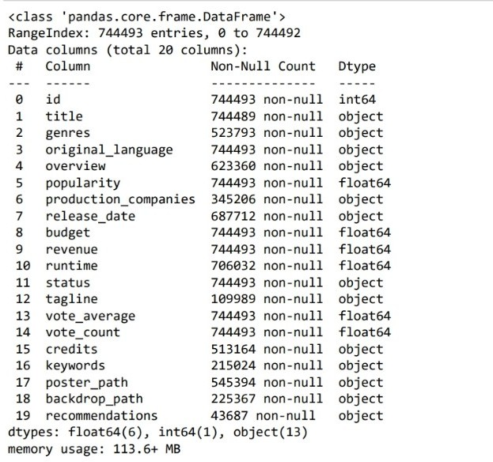

**Exploratory Data Analysis**

Using head(), shape, info() isnull().sum(), and duplicated().sum(), we can systematically check the dimensions of the dataset and the overall content. Checking the data, it reflects that it has 5 rows with 2 columns: "Movie" and "Genre." The two columns are full of text data, meaning that this dataset is intended to convey qualitative information about the movies. In a straightforward structure like this, easy analysis is not just made possible but also deep, focusful probe can be taken into understanding the interrelationship between the data points.

## Data Quality Evaluation

The preliminary analysis of the dataset reflects high quality data. There are no missing values important, as it ensures that any analyses based on this dataset will be reliable and comprehensive. Missing data may provide skewed results and, therefore invalidate the conclusions drawn; thus, a clean dataset increases our confidence level in subsequent analyses. Moreover, the removal of duplicate entries ensures the uniqueness of every record; it is highly important for In maintaining the integrity of any insights derived from this data. This data quality gives us extra confidence in the dataset but also will ensure that the analyses we conduct will yield meaningful and actionable results. Deeper Explorations This working base provides several avenues for deeper exploration. Genre Analysis First, doing a genre analysis is instrumental in examining the distribution of genres within the dataset. This analysis will allow us to identify the most prevalent genres and, therefore, will create useful context for explaining user preferences. We are able to more readily respond to audience tastes and perhaps even perfect our recommendation algorithms through detailed genre distributions. Knowing which genres are prevalent can inform strategic decisions-from targeted marketing campaigns to partnerships with genre-specific platforms. Movie Length Analysis By analysis of movie lengths, average values and variability in the dataset can be revealed. Movie length distribution is an important characteristic because it affects view recommendations. Some people might prefer faster video views, while others like long movies, which may bring them to a world of deeper experience. Therefore, analyzing this feature helps us tailor recommendations according to different user preferences in bringing

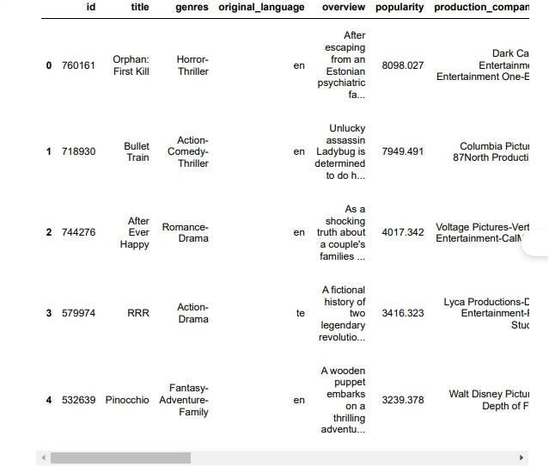

## Trend analysis for movie lengths by genres such insight may be given on the expectation and liking of people or audiences. This knowledge may make the rating system more effective and user-centric

**Rating Analysis**

## We'll further do rating analysis to find out the distribution pattern and outliers in the datasets, if it is applicable. The main purpose of rating analysis is that it will enrich the recommendation procedure. With the help of this analysis, we have information about how various movies are rated by the users and what likings they have for which type of movies. By looking at the popularity of different types of movies, we may know several trends that might help our recommendations. For example, we might discover a treasure that got an excellent score but which not so many people know about. Such an analysis will result in composing a more personalized experience, where recommendations are homed in on by individual users.

***Textual Analysis Methods***

*Lastly, the textual analysis methods like tokenization stemming TF-IDF will adequately enable feature extraction from the "Movie" and "Genre" columns. These methods help us to break down textual data into workable units, which helps us to have: deeper analysis of the content. For example, tokenization will help identify relevant words or phrases in movie titles and genres; these may appear as vital parts of our recommendation algorithms. Stems will convert words to their root forms, but at the same time, increase the precision in our analyses by considering different forms of a word as the same thing. TF-IDF, or Term Frequency-Inverse Document Frequency, will help measure the importance of each term in the dataset which means we can focus on major features that may improve our recommendation methods.*

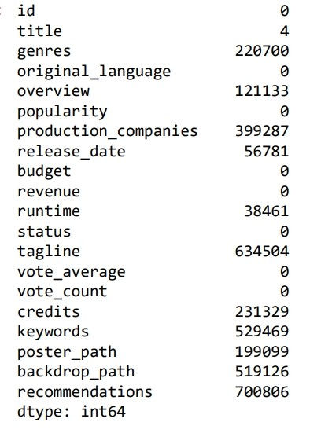

***Overview of the Analytical Method***

*It is an integral approach towards analyzing the dataset and will enable us to get insights into the nooks and creannies that exist inside and expose any patterns that are helpful in devising an effective recommendation system. By mining genre distributions, movie length, ratings, and textual features in a systematic way, we will produce a solid foundation on which to base data informed decisions that will be made tailor-fit to the needs of the users. This kind of systematic exploration puts us in a better position to be better analytical practitioners and therefore enables us to construct a recommendation system that is, at the same time both accurate and personalized.*

***Continuous Improvement and Future Directions***

*While analyzing further in the above sections, we should not forget the fact that this is an iterative process. Our insight gained from exploratory analysis will guide further steps in data preprocessing, feature engineering, and model selection. With every layer of analysis, we are not just fine-tuning our dataset; we are actually sharpening the efficacy of our recommendation system. The future may hold opportunities to Consider incorporating additional sophisticated analytical practices, such as machine learning algorithms that would be able to learn and adjust to user behavior patterns over time. Some methods may further improve the recommendation system by allowing it to remain responsive to fluctuating user preferences and trends that could be perceived as changes in the wind of the film industry. To summarize, an in-depth examination of the movie dataset is not just an initial step but a basis for constructing a more intricate recommendation system. Devotion to a comprehensive analysis of the dataset's structure and quality, pave the way to actionable insights and user-centric recommendations that contribute towards a better viewing experience.*

***[III]***

***Data Preprocessing and Cleaning***

*Preprocessing and cleaning of data are some of the critical phases in building a robust movie recommendation system. These processes ensure that the data is in the right shape for analysis and modeling, thus increasing the quality of the recommendations made to the users. Then we detail the important data cleaning and preprocessing operations that are useful for good recommendation algorithms.*

***Core Operations in Data Preprocessing***

*The following code examples illustrated in this section reflect some of the core operations that are necessary to ensure the reliability and integrity of the data.*

***Dropping Duplicates***

*The first step in data preprocessing, after loading the data, is to drop any duplicate rows. For example, for a movie data set, each movie title should only appear once; otherwise, it can lead to some redundancy and ambiguity in movie recommendations. Duplicate rows may create biased insights and incorrect representation of film popularity or user preference. By ensuring that every film has a unique representation, we clean the dataset and improve its reliability. we streamline the dataset and enhance its reliability.*

***Filtering***

*Filtering forms an essential operation involving selecting films with a minimum number of votes. A film that lacks a sufficient number of ratings may not provide valuable insights into its quality or popularity. If we decide on a cutoff point for the minimum number of votes, we are sure that only those films that have gained due appreciation are utilized for our computations. This process enhances the robustness of the recommendation engine but centers it on movies most likely to be enjoyed by the users, thus enhancing the user's experience as a whole.*

***Missing Value Handling***

*Missing value handling is essential not to distort the analysis and draw false conclusions. Proper imputation strategies for missing values such as mean substitution, median replacement, or other imputation strategy will fill in gaps in the This dataset. We deal with the missing values; by doing so, we would reduce potential biases and provide a better representation of user preferences and movie characteristics*

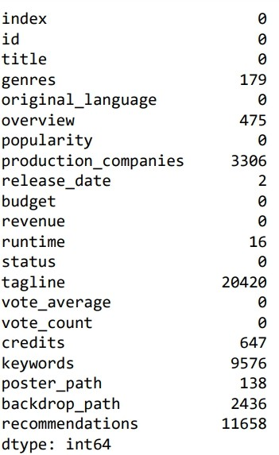

## Data Cleaning

## Data cleaning is more than just eliminating duplicate rows and handling missing fields. This includes data row containing information which is less desirable to have in a dataset which may be valuable for analysis. For instance, a movie entry that lacks the description of genre or year of release in the movie will not give efficient information during the process. Thus by eliminating such partial data rows, we ensure that the data set is narrowfocused on quality information which enhances the efficiency of our analysis.

## Feature Engineering

## Feature engineering is one of the most sensitive elements of the pre-processing stage. This refers to cleaning and column standardization where meaningful features can be developed, and these can greatly influence the working of recommendation algorithms. For example, normalization of genre labels eliminates the influences of unequal values, and hence, the algorithm is able to process and comprehend such information better. Feature engineering with existing data can make more features out of it or, in other words, keyword extraction from movie description text or average rating computation that greatly enrich the dataset and help reach more layers of insight for the recommendation system.

## Benefits of Effective Preprocessing

## The benefits achieved due to appropriate data preprocessing and cleaning are many, which significantly contribute to the success of the overall recommendation system

## Data Quality

## The primary benefit of these preprocessing operations is the improvement in the quality of data. Clean and consistent data are imperative for gaining proper insight. By eliminating any redundancies, deleting low-quality entries, and managing missing values, we ensure that the dataset accurately reflects the actual characteristics of the movies it represents. Quality data lies at the heart of effective recommendation algorithms, ultimately resulting in a better satisfaction for the user.

## Model Performance

## Good preprocessing also contributes to the model's good performance. Clean datasets enhance the machine learning model's ability to learn patterns and relationships accurately. This increases the reliability of the recommendations it generates. Users are likely to spend time on a system that builds many good and personable movie suggestions consequently leading to increased overall user satisfaction and user retention.

**Significant Features in Recommendation**

Feature engineering transforms raw data into meaningful features that can enhance the recommendation process. By creating features that capture the nuances of user preferences and movie characteristics, we enable algorithms to make more informed decisions. These meaningful features provide the necessary context for recommendation systems to operate effectively, ensuring that the suggestions generated align closely with user interests.

**Building on a Strong Foundation**

To sum it up, effective preprocessing is in every sense a foundational foundation for building a strong movie recommendation system. The processing that is done, including duplication removal, filtering, missing value handling, data cleaning, and feature engineering, is crucial in order to ensure that the dataset is clean, consistent, and full of useful information. Time and resources would be spent on this preprocessing step, setting up a platform for building a recommendation system that can both be accurate and responsive to changes in the preferences of users as well as the evolution in trends in films. This careful attention to Actually, detailing in the preprocessing phase improves the movie recommendation system into personalized, relevant, and pleasurable information for the users. Further improvement in functionality and efficiency in the recommendation system can be achieved through effective iteration of preprocessing techniques adapted to changing datasets. The closed-loop interaction involving cleaning and preprocessing of data will ensure that the system remains responsive to user needs and industry standards, thus enriching the movie-viewing experience.

## [IV]

## Feature engineering and text representation are important building blocks for developing effective movie recommendation platforms. We preprocess the raw data into a more structured form that is understandable by algorithms to improve the chances of yielding relevant movie recommendations and, therefore, apt suggestions. Next, we talk about the details of one of the steps for creating the "tags" column and the application of TF-IDF vectorization, which come under this category

## Key Steps in Feature Engineering

## This section provides the code snippets regarding how we can } END systematic approach to feature engineering, specifically focusing on the generation of a "tags" column that collates various attributes of movies.

## Feature Creation

*Feature creation is a process of collating multiple relevant features into one single "tags" column. In this project, features being merged consist of: "overview", "genres," "keywords", "credits", and "original_language." Of course, this merging is critical in collating different aspects of every movie into one single representation.*

* ***Overview: This feature offers a concise summary of the plot of the film, providing crucial context that can also influence user preferences. The summary can highlight some points such as the central plot, motifs, and important events, making it easier for the users to establish whether a film falls within their interests or not.***
* ***Genres****: Including genre information allows the recommendation system to consider the type of content the users are typically interested in. For instance, when a person regularly watches action films, the system can increase recommendations of similar genres while also pushing more suggestions from related genres.*
* *Keywords: Keywords extract specific themes motifs, or elements that define the film, that give greater richness to its content. These keywords can express key plotlines, settings, or character traits, ensuring that the recommendation engine can best relate films to sophisticated tastes.*
* *Credits: Details about who cast and directed the movie can similarly inform a user's selection criteria, as favorite actors or directors are often the driving forces. Such data can enrich recommendations by pointing out movies with favorite performers or directors and, thereby more likely to engage with*

*Original Language: This aspect enables one to filter recommendations according to linguistic preferences, thereby enabling a system to satisfy a differentiating audience. By taking into account the language in which films were originally made, the system can recommend content to the match a user's ability in understanding or language preference. The three features combined allow us to design a more comprehensive representation of each movie that reflects its very nature and opens wider possibilities for analysis. This model guarantees which means the recommendation system is informed by an extensive array of all information relevant to improving user experiences.*

***Text Representation with TF-IDF***

* *After having produced the "tags" column, the obvious next key step is representing this text data as numeric features with Term Frequency-Inverse Document Frequency (TFIDF) vectorization. TF-IDF is a highly effective statistical quantity that measures the importance of a word in a document relative to a corpus, or a collection of documents.*
* *Term Frequency (TF): This metric computes the frequency with which a term appears in a document. A higher term frequency suggests a word is important to that document. With our movie dataset, a term that appears frequently in the tags of a specific movie will have greater weighting indicating its importance*
* *Inverse Document Frequency (IDF): This measures how important a term is across the whole dataset. It considers terms that are common across lots of documents get lower weight and terms that are unique to a few files get higher weighting. It also serves to remove popular words may not contribute much to the content analysis.In the context of the research, TF-IDF is used to transform the concatenated textual tags in a format that can be processed by the machine learning models. In this regard, all the movies are represented as a vector in a multidimensional space where each dimension corresponds to a unique term in the corpus. This transformation is critical in the later stages of the recommendation process since it allows for algorithmic processing.*

***Benefits of Feature Engineering and Text Representation***

* *These techniques bring along several important benefits, and the performance of the recommendation system increases with their deployment.*

***Profiling Representations***

* *The process of producing the "tags" column encompasses more varied information about movies. Profiling representations allow the recommendation engine to take into account the different angles of a movie when making recommendations. Users' tastes are many times determined by different motivations, including acting preferences, story features, and star appearances with which they are familiar. We combine all these features into one column by the suggestion algorithm can now benefit from all information available, and thus make more subtle and accurate suggestions*

***Numerical Features for Machine Learning***

*The conversion of textual data into the form of numerical features through the aid of TF-IDF is what makes machine learning models functional. Most algorithms rely on input data being numerical, and the TF-IDF matrix delivers just that. This matrix serves as a basis for many machine learning algorithms that enable one to calculate similarities between movies and on their content. For instance, considering the TF-IDF matrix obtained above, we can compute the cosine similarity between the movie vectors. This enables the system to recommend films that in terms of content are similar to those a user previously liked. This content-based filtering approach enhances the personalization in the recommendation, targeting individual preference and tastes*

***Calculation of Movie Similarity***

*The TF-IDF matrix forms the cornerstone of the calculation of the similarity of the movies on content. This is pivotal for content-based recommendation systems, as it directly affects the relevance of suggestions provided to users. Specifically, the recommendation algorithm can quickly add some viewing options for a user while staying within their selected preferences. For example, if a user likes one movie that has specific words, the system can select movies with some shared tags. This improves the user's experience because he is exposed to new material while keeping the recommendations relevant as it will stimulate deeper engagements with the site.*

***Advanced Techniques***

*Beyond the steps of feature engineering process may include searching for other methods, for instance, words embeddings or methods that advanced from the conventional techniques of natural language processing. By incorporating models such as Word2Vec or BERT, we may obtain semantic association between terms for an even deeper visual representation of what was in the movie. The research might further expand the scope by involving end information generated by the users like reviews and ratings, involved in the tags column. The other dimension to be provide insights into user sentiment and preference, refine the recommendation algorithm. In summary, feature engineering and text representation are aspects of the pipeline for making a movie recommendation system. A "tags" column is created by combining several features, so that each movie can be described in detail. The addition of TF-*

*IDF vectorization gives this text data a numerical form, amenable to ML algorithms. The TF-IDF matrix formed in this process serves not only It improves data presentation while also allowing calculation of movie similarity based on content, which is an important aspect of effective content-based filtering. All of these approaches will place solid foundations for a robust recommendation that can produce personal and relevant movie recommendations that, in the long term, will add richness to the experience of users.*

*[V]*

*A movie recommendation system is an interesting task that uses a content-based technique to provide personalized recommendations to the users by their preference. The following section describes the steps taken towards this goal, with a major focus on how the system can manage to retrieve the correct movies, calculate similarities, and present some recommendations. Building a Recommendation Engine The recommendation system boils down to a structured approach toward the identification and suggestion of movies similar to of which the user is fond of. The above code block gives an idea of what the core functionality of this program is- how to run it in a relatively smooth and efficient manner.*

***Implementation Steps***

***1. Fetching Movie Index*** *The initial step in the recommendation algorithm is to fetch the index of the input movie given by the user from the dataset. This is achieved by searching the movie title in the DataFrame from where all movie records have been stored. With the help of any function like get_recommendations(title), we can define a movie, which serves as a trigger for the entire generation process of recommendations. This step is vital, as it provides the necessary platform for all subsequent operations, based on the fact that the system would be able to figure out which movie's features are to be processed.*

***2. Movie Poster Displaying (Optional)***

*Following the identification of the movie index, the system is allowed to enhance the user experience by displaying the movie poster corresponding to the title chosen. This can be achieved by accessing the "poster_path" field within the DataFrame, providing an imaginative suggestion that will further make the suggestions interactive. Visual elements in the film and entertainment sectors should not be ignored, as they can determine choices and encourage people to watch new films.*

***3. Computing Similarities*** *The second important step is to calculate the similarities between the provided movie and all the other movies of the database.*

*This is possible using the pre-computed TF-IDF matrix, which represents the information of each movie in terms of numerical features. The cosine similarity, a method of measuring the cosine of the angle between two vectors in a multi-dimensional space—the system can quantify how similar the content of the input movie is to that of other movies. This mathematical approach allows the recommendation engine to assess the degree of similarity based on factors such as genres, keywords and other content descriptors.*

*Retrieving Top Recommendations Once the similarities have been calculated, the system sorts these values in descending order to identify the most similar movies. By selecting the top 10 recommendations-excluding the input movie itself-the system curates a list of films that share characteristics with the user's preferred title. This selection process ensures that the recommendations are both relevant and diverse, catering to the user's tastes while encouraging exploration of new content.*

*Presenting Recommendations The last part is to present the recommended movies to the user in an appealing format. The function retrieves essential details about each recommended movie from the DataFrame, including titles and additional metadata. Using libraries such as Matplotlib, the system may produce a pretty grid of movie posters along with their respective titles so the recommendations can be browsed easily. A presentative display would get the user interested and assist in a decision as he or she would instantly know which movies capture his or her interest*

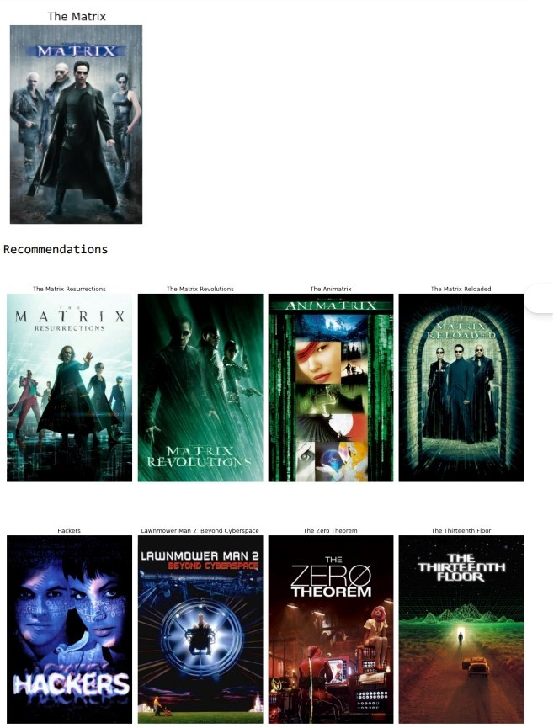

***Saving the Model***

*In addition to providing real-time suggestions, the implementation also has a provision to save the state of the system for future use. The Python library pickle is called to serialize and save the processed DataFrame and the TF-IDF matrix as a binary file. This feature is necessary to continue the recommendation system flawlessly so it could load up at will without having to recreate the data every time it is run.*

***Implementation***

*This is what the following code snippet shows in a concrete example of how a content-based movie recommendation system can be used. For example, this is what happens when you call the get_recommendations function with \"The Matrix\" as the argument title : it will fetch and display the 10 most similar movies to it, based on the content of the movies This displays how the recommendation engine does its job - using similar content to improve user experience*

***Theoretical Framework Behind Recommendations***

*The theoretical basis for the recommended movies is is based on the principles of content-based filtering. The key idea here is to analyze features of items (in this case, movies) in order to recognize and propose similar content. In contrast with traditional collaborative filtering, recommendation does not rely on any user behavior or ratings; it simply focuses on the intrinsic attributes of movies. Applying TF-IDF vectorization enables the system to capture importance with respect to each term related to a movie and thus allows for more precise similarity measures. This is particularly useful in a domain such as film, where the features of a movie-its plot, themes, and genres-are all deciding factors for its popularity among different user groups.*

***Future Enhancements***

*The model developed here is a basic implementation of a content-based recommendation algorithm. There are many ways the system can be advanced further. A significant way would be to consider user inputs. Ratings or user preferences identified would make the recommendation engine more accurate. It could fine-tune its recommendations according to the user preferences. suggestions over time, taking into account changes in the individual tastes of a user. More advanced research into natural language processing may also open up further avenues of understanding in movie content. Using models with contextual and semantic understanding—such as BERT or other transformer-based architectures—may help the system better understand subtle relationships that exist between movies, and thus improve the relevance of its recommendations. In summary, a multi-step process is involved in the installation of a content-based movie recommendation system, one that effectively brings data retrieval, calculations of similarity, and loading of retrieved movies into user view and interface design. The system, thus, uses TF-IDF and cosine similarity to provide personalized movie suggestions. Therefore, the exploration of thousands of movies shall be facilitated from the point of view of user experience. By continuous improvement, and integration of feedback from users, such a system could change preferences with its audience over time. As such, it would be of much utility for entertainment.*

***[VI]***

***Implementation of a movie recommendation system***

*as a web application: This is a significant move towards bringing the system closer to the users and making it more user-friendly. This process allows the users to interact with the recommendation engine directly through a graphical interface, thereby enhancing the user experience. The subsequent discussion gives an overview of some of the key steps in the implementation of this system using Streamlit, with some of the technical and functional implementation details.*

***.Key Steps in Deployment***

* *Installation of Libraries The first step in implementing the movie recommendation system is to install the needed libraries. The key library used for this purpose is Streamlit, a powerful tool that simplifies creating interactive web applications for data science and machine learning projects.*
* *In addition to Streamlit, the localtunnel library is installed. This tool is important because it creates a publicly accessible URL so that users can then access the application from everywhere on the internet, thus achieving wider reach and usability.*
* *App Creation After including the libraries, the main function of the application is defined. This is done by declaring a function called get_recommendation, which will return a list of recommended movies based on user input*
* *The purpose of this function is to be the body of the app: encapsulate all logic that is required to pull details about a movie, computation related to similarity using a pre-saved TF-IDF matrix, and print out a list of top movie recommendations. The function will be whenever a user selects a movie and clicks on a button that sends the user input to trigger the recommendation process.*

***Providing a Short Description***

*At the top of the app is a short introductory text that gives a clear rundown of exactly what the recommendation system does. Such explanation is essential in setting user expectations and reorienting them on how to use the application most productively.*

***Providing a Dropdown Menu for Movie Selection***

*The dropdown menu of the application lets the users select a movie from a predefined list of movie titles. This dropdown list is populated by the list of movie titles obtained from the dataset, thus making it convenient for users to pick up a movie of his or her interest. The dropdown menu makes the selection process easy and effortless for the users. This promotes smooth interaction.*

***Displaying the Selected Movie Poster***

*Whenever a user makes a selection of a movie from the dropdown list, an application fetches and displays its corresponding movie poster. The visual representation enhances the interface but also reinforces the user's choice, making the experience more engaging and personalized.*

***Giving a Grid Layout of Recommendations***

*After the user picks a movie, the application will display a grid layout of recommended movies. This grid includes not only movie posters but also titles and brief overviews of each recommended film. By displaying the recommendations in a visually pleasing way, the application gains the users to explore new content and enhances their overall experience.*

***Application Functionality***

*The function of the film recommendation system is user interaction with the application. Since the user has picked one movie from the dropdown list and clicked a button, the get_recommendation function is getting invoked. Here's how the process follows:*

1. *Movie Details Retrieval The function first retrieves the details of the movie chosen by the user, including its index in the dataset as well as other metadata. This step is especially crucial to make sure that the calculations for recommendations take into account are on correct information.*
2. *Computing Similarities Utilizing the pre-computed TF-IDF matrix, the method calculates the cosine similarity between the selected movie and all other movies present in the database. This calculation allows the system to gauge how close the content of the selected movie is to that of others such that recommendations made will be based on content attributes.*
3. *Displaying the Most Recommended Movies The method sorts the calculated similarities to determine which movies are most recommended and these are then in a grid display. This is a mechanism that provides users with real time feed back that is appropriate and hence makes the application more interactive .*

*Deployment Process*

1. *The deployment of a movie recommendation system results in a few crucial steps that will enable the application to run appropriately and reach users: 1. Saving the Code All the codes needed by the application are saved in a Python file, usually labeled movie_recommendation_app.py. This file acts as the master script to be executed to launch the Streamlit app. 2*
2. *Running the App The following command, streamlit run movie_recommendation_app.py, is issued in the terminal to run the application. This command boots up the Streamlit server and launches the application in the default web browser, so the user will have the facility to access the recommendation system directly.*
3. *Generating a Publicly Accessible URL To take the app to a wider audience, localtunnel is used to establish a publically accessible URL. It is thus essential in that it enables users anywhere in the world to\ interact with the recommendation system via the\ internet. All that the user needs to do is access the provided URL in order to be able to use the application and start gaining movie recommendations based on the choices they have create*

# Data Availability

*Data open access address is* [researchers who researchedon movie recommendation system - Google Scholar.](https://scholar.google.com/scholar?hl=en&as_sdt=0%2C5&q=researchers%2Bwho%2Bresearched%2Bon%2Bmovie%2Brecommendation%2Bsystem&btnG)

# Conflicts of Interest

The authors declare that they have no conflicts of interest.

# References

* *Raghavendra, Srikantaiah, and Venugopal: Provide a comprehensive overview, focusing on personalization, collaborative filtering, and addressing challenges.*
* *Nanou, Lekakos, and Fouskas: Study the impact of presentation methods on user persuasion and satisfaction.*
* *Ko, Lee, Park, and Choi: Offer a broad survey of recommendation systems, including technical aspects, applications, and business implications.*
* *Ahn and Shi: Highlight the importance of cultural metadata in enhancing recommendation accuracy.*
* *Schedl, Zamani, Chen, Deldjoo, and Elahi: Emphasize the challenges of building effective recommendation systems and the need for advanced techniques.*
* *Kumar, De, and Roy: Propose using sentiment analysis of microblogging data to improve personalization.*
* *Jannach, Zanker, Ge, and Gröning: Provide a comprehensive overview of recommender systems, including trends, challenges, and future directions.*
* *Beel, Gipp, Langer, and Breitinger: Focus on reproducibility and evaluation in recommender systems.*
* *Liu, Choi, and Liu: Explore the application of deep learning for personalized movie recommendations.*
* *Chen, Owusu, and Zhou: Emphasize the use of social network information to enhance recommendations.*