Data Science for Public Health - Exercise 01d - Word output

Ifakara Health Institute

2022-08-17

Table of Contents

# 1 Use R code blocks

You can create an **R code block** (or **chunk**) by using 3 backticks followed by the programming language to be used inside braces ({r}) to open the code chunk and 3 backticks to close the code chunk.

summary(iris)

## Sepal.Length Sepal.Width Petal.Length Petal.Width   
## Min. :4.300 Min. :2.000 Min. :1.000 Min. :0.100   
## 1st Qu.:5.100 1st Qu.:2.800 1st Qu.:1.600 1st Qu.:0.300   
## Median :5.800 Median :3.000 Median :4.350 Median :1.300   
## Mean :5.843 Mean :3.057 Mean :3.758 Mean :1.199   
## 3rd Qu.:6.400 3rd Qu.:3.300 3rd Qu.:5.100 3rd Qu.:1.800   
## Max. :7.900 Max. :4.400 Max. :6.900 Max. :2.500   
## Species   
## setosa :50   
## versicolor:50   
## virginica :50   
##   
##   
##

plot(iris)

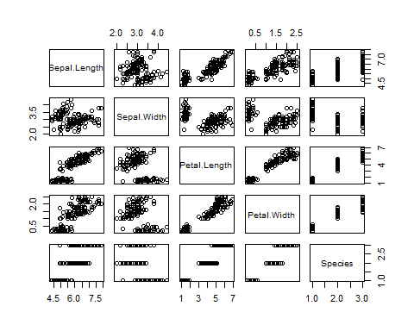

The code and its output will both be displayed in the resulting report.

# 2 Display or hide code chunks

You can hide the R code chunk and only display its output by setting the echo chunk parameter to FALSE ({r, echo=FALSE} instead of {r}):

## Sepal.Length Sepal.Width Petal.Length Petal.Width   
## Min. :4.300 Min. :2.000 Min. :1.000 Min. :0.100   
## 1st Qu.:5.100 1st Qu.:2.800 1st Qu.:1.600 1st Qu.:0.300   
## Median :5.800 Median :3.000 Median :4.350 Median :1.300   
## Mean :5.843 Mean :3.057 Mean :3.758 Mean :1.199   
## 3rd Qu.:6.400 3rd Qu.:3.300 3rd Qu.:5.100 3rd Qu.:1.800   
## Max. :7.900 Max. :4.400 Max. :6.900 Max. :2.500   
## Species   
## setosa :50   
## versicolor:50   
## virginica :50   
##   
##   
##

# 3 Simple table format

By default, R Markdown displays data frames and matrices as they would be in the R terminal. If you prefer that data be displayed with additional formatting you can use the simple table generator provided by the kable() function in the knitr package. You need to set the results chunk parameter to 'asis' to ensure that the raw table output is not processed further by knitr ({r, results='asis'}).

df <- summary(iris)  
knitr::kable(df)

|  | Sepal.Length | Sepal.Width | Petal.Length | Petal.Width | Species |
| --- | --- | --- | --- | --- | --- |
|  | Min. :4.300 | Min. :2.000 | Min. :1.000 | Min. :0.100 | setosa :50 |
|  | 1st Qu.:5.100 | 1st Qu.:2.800 | 1st Qu.:1.600 | 1st Qu.:0.300 | versicolor:50 |
|  | Median :5.800 | Median :3.000 | Median :4.350 | Median :1.300 | virginica :50 |
|  | Mean :5.843 | Mean :3.057 | Mean :3.758 | Mean :1.199 | NA |
|  | 3rd Qu.:6.400 | 3rd Qu.:3.300 | 3rd Qu.:5.100 | 3rd Qu.:1.800 | NA |
|  | Max. :7.900 | Max. :4.400 | Max. :6.900 | Max. :2.500 | NA |

# 4 Use R variables in Markdown text

n <- nrow(iris)  
idx <- sample(1:n, 1)  
var <- iris[idx, 1]

You can display the content of a variable in text by using backticks followed by r and the formula you want to use. Can you add **10** to the value of var, then take the square value of your result and multiply by **3.1**?

This should be done directly in the Markdown text as displayed hereafter.

$3.1*{\left(10+6.8\right)}^{2}=874.944$.