Statistics

dir(path = paste0(getwd(),"/hmm/", pattern=".docx"))

## character(0)

##character(0)  
library(WordR)

## Warning: package 'WordR' was built under R version 3.5.2

library(officer)

## Warning: package 'officer' was built under R version 3.5.2

library(ggplot2)  
plotti <- plot(1:10, 1:10)

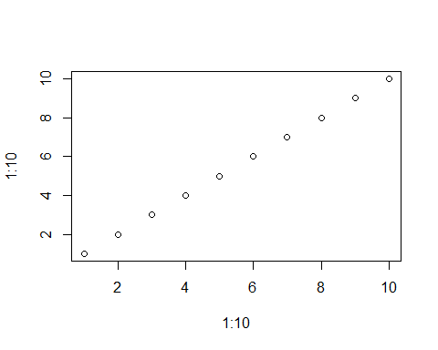

addPlots("hmm/thesis.docx", "hmm/thesis2.docx", plotti, height = 4)

## [1] "hmm/thesis2.docx"

xtable is for making latex tables from r objects

This is an [R Markdown](http://rmarkdown.rstudio.com) Notebook.

Add a new chunk by clicking the *Insert Chunk* button on the toolbar or by pressing *Ctrl+Alt+I*.

When you save the notebook, an HTML file containing the code and output will be saved alongside it (click the *Preview* button or press *Ctrl+Shift+K* to preview the HTML file).

The preview shows you a rendered HTML copy of the contents of the editor. Consequently, unlike *Knit*, *Preview* does not run any R code chunks. Instead, the output of the chunk when it was last run in the editor is displayed.