Software Requirements Specification

for

OrgHub
Version 1.0 approved
Prepared by Kelompok 16
BINUS University
25th February 2026
Table of Contents
Table of Contents ii
Revision History ii
1. Introduction 1
1.1 Purpose 1
1.2 Document Conventions 1
1.3 Intended Audience and Reading Suggestions 1
1.4 Product Scope 1
1.5 References 1
2. Overall Description 2
2.1 Product Perspective 2
2.2 Product Functions 2
2.3 User Classes and Characteristics 2
2.4 Operating Environment 2
2.5 Design and Implementation Constraints 2
2.6 User Documentation 2
2.7 Assumptions and Dependencies 3
3. External Interface Requirements 3
3.1 User Interfaces 3
3.2 Hardware Interfaces 3
3.3 Software Interfaces 3
3.4 Communications Interfaces 3
4. System Features 4
4.1 System Feature 1 4
4.2 System Feature 2 (and so on) 4
5. Other Nonfunctional Requirements 4
5.1 Performance Requirements 4
5.2 Safety Requirements 5
5.3 Security Requirements 5
5.4 Software Quality Attributes 5
5.5 Business Rules 5
6. Other Requirements 5
Appendix A: Glossary 5
Appendix B: Analysis Models 5
Appendix C: To Be Determined List 6

Revision History
Name | Date | Reason For Changes | Version
Group 15 | 25/02/”26 | Introduction | 1.0
Group 16 | 20/04/”26 | Overall Description | 1.0
Group 16 | 22/04/”26 | External Interface Requirements | 1.0

Introduction

Purpose
This Software Requirements Specification (SRS) document provides a comprehensive description of OrgHub, a centralized management platform designed for university student organizations. The document details the functional and non-functional requirements for the platform, which aims to streamline organizational operations, centralize resource management, and improve project deadline tracking.This SRS will serve as the foundation for the system design and development phases, ensuring all stakeholders have a clear understanding of the system's operation and goals.
The purpose of OrgHub is to provide an exclusive, centralized platform for university student organizations to replace fragmented tools like scattered group chats and shared drives. It aims to streamline operations, manage division-specific resources, and effectively track project deadlines.
The target audience consists of members within university student organizations. The specific users include the Core Board (e.g., CEO, Secretary), Division Heads or Managers (e.g., R&D, Public Relations), Mentors or Project Leads, and General Members or Mentees.

Intended Audience and Reading Suggestions
This document is intended for the following stakeholders:
- The Product Owners: President, VP, and Secretary roles who require a bird’s eye view of activities and document approval power
- The Development Team: Technical staff responsible for designing and implementing the system
- Technical Evaluators: Personnel who will assess the software against these defined specifications
- University Administration: Officials responsible for approving the platform's deployment and ensuring university email domain compliance
- Users, such as:
  - Core Board: Reviewers for high-level organizational activities and tracking needs
  - Division Heads: Reviewers for task assignment and division-specific resource tools
  - Mentors / Project Leads: Reviewers for sub-group coordination and material distribution tools
It is suggested that readers begin with the overview sections and proceed through the sections that are most pertinent to each reader type:
- Project Managers and Users: Should focus primarily on the Introduction and Overall Description sections to understand the product's capabilities and user classes
- Developers and Testers: Must review the document in its entirety, paying critical attention to the System Features and Other Nonfunctional Requirements to guide system architecture and testing protocols
The remainder of this Software Requirements Specification (SRS) is organized to detail the product's full functional and non-functional scope. It includes structured sections covering the Overall Description of the product, External Interface Requirements, detailed System Features, and Other Nonfunctional Requirements (which encompasses performance, safety, and security).

Product Scope
The OrgHub platform is designed to replace fragmented tools like scattered group chats and shared drives with a single, exclusive workspace.
In Scope
The platform will include the following key components:
- Authentication System: Restricted login via university email domains (e.g., @org.net) and role-based profile setup
- Workspace Management: Support for nested organizational hierarchies (Organization > Division > Project > Team)
- Communication Channels: Private workspaces for divisions and "General" channels for broad updates
- Task & Event Management: Centralized calendars, task assignment tracking (To Do, In Progress, Done), and automated reminders
- Resource Repository: Role-based file management system for uploading and retrieving division-specific materials
- Security Framework: Token-based authentication and data encryption for sensitive information

Out of Scope
The following items are explicitly excluded from this initial project phase:

Hardware procurement for hosting the solution

Integration with university systems beyond email domain verification

Development of native mobile applications

References
Reference for writing the SRS: https://www.enabel.be/app/uploads/2025/06/Annex-A-Detailed-Software-Requirements-Specification-SRS.pdf

Overall Description

Product Perspective
OrgHub is a new, self-contained, centralized management platform designed specifically for the university student organization ecosystem. It is intended to replace the currently fragmented landscape of scattered group chats (e.g., WhatsApp, Telegram) and disorganized shared drives (e.g., Google Drive) with a single, unified workspace. While the platform operates independently, it requires integration with university email domains (e.g., @org.net) to verify users and ensure only authorized students can access internal data. Hardware procurement for hosting and native mobile application development are out of scope for this initial phase.

Product Functions (Use Case)
The major functions that OrgHub must perform includes:
- Authentication & Onboarding: Secure, restricted login via university email domains and role-based user profile setup.
- Workspace Management: Support for nested organizational hierarchies (Organization > Division > Project > Team) with private division channels and "General" channels for broad updates.
- Task & Event Management: Centralized calendars for events/meetings, task assignment tracking (To Do, In Progress, Done), and automated email or push notifications for impending deadlines.
- Resource Repository: A role-based file management system allowing users to upload, categorize, and retrieve division-specific materials (e.g., workshop slides, meeting minutes).

The full scope of planned functions as of this initial phase is as follows:
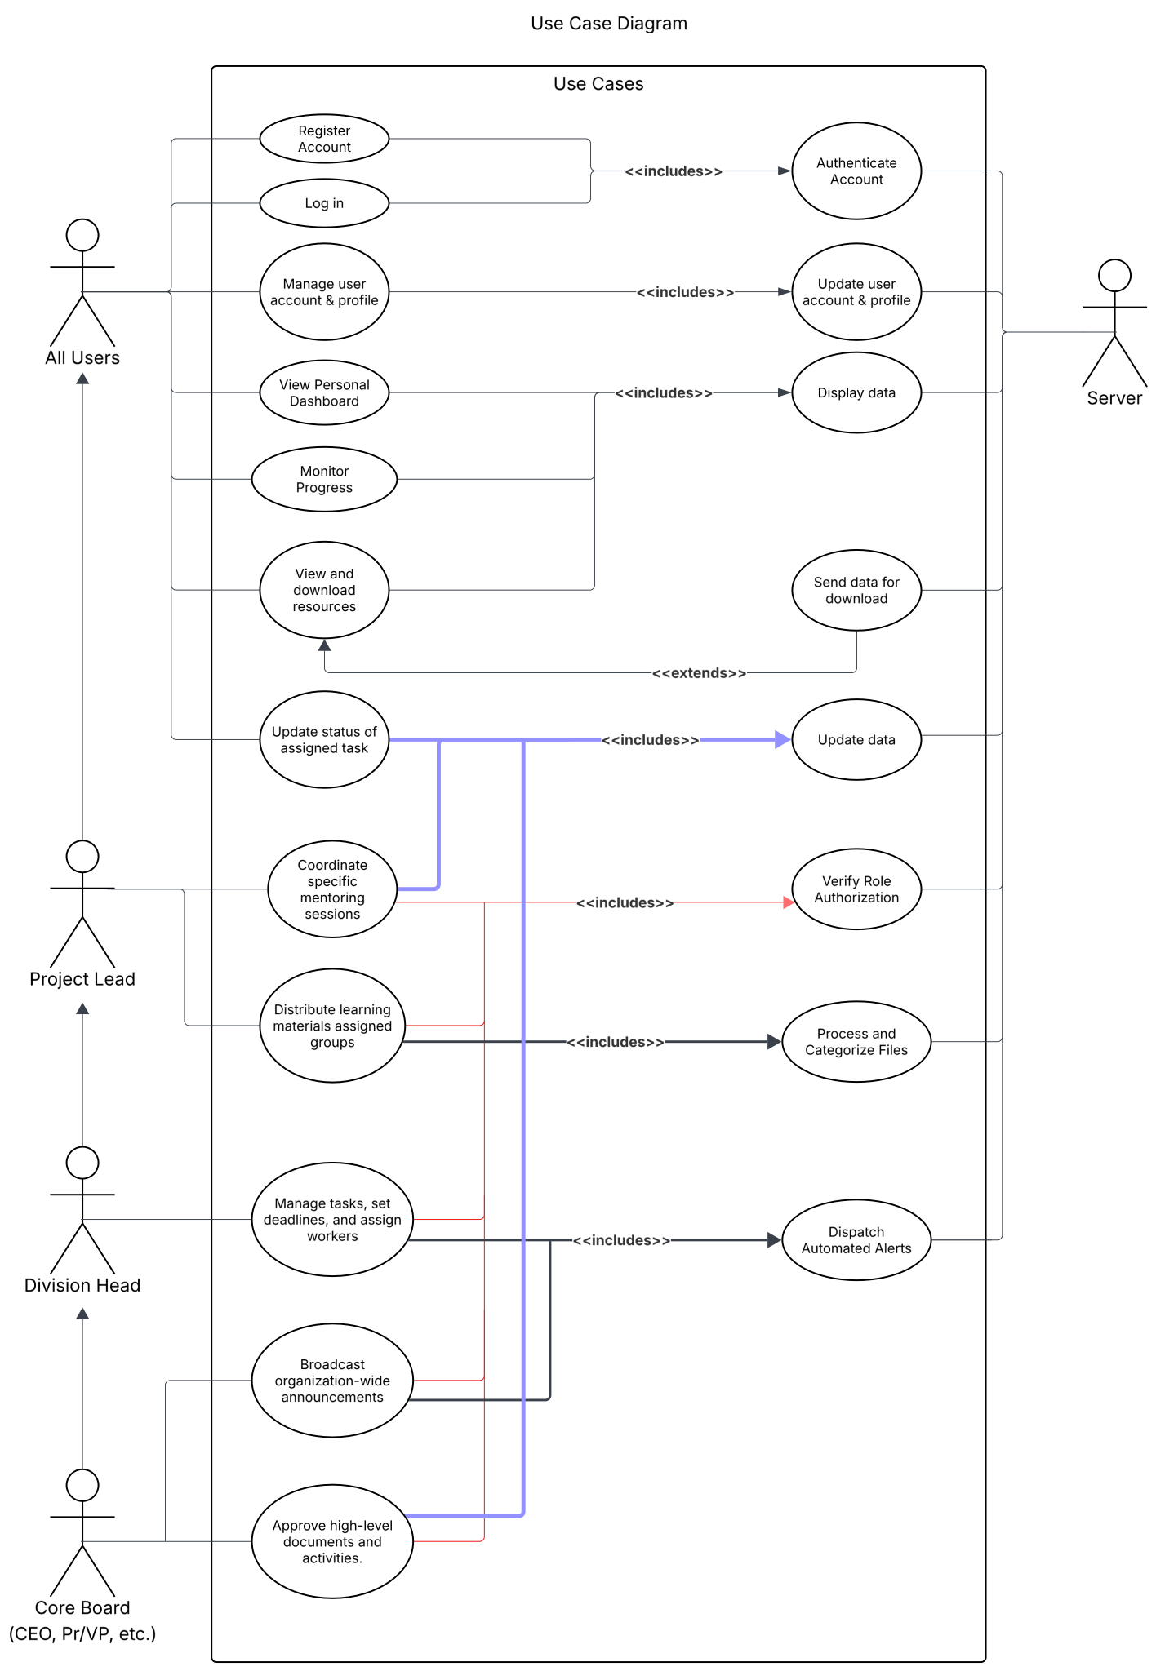

User Classes and Characteristics (Class diagram)
OrgHub utilizes Role-Based Access Control (RBAC) to differentiate user classes based on privilege levels and operational needs. The prominent user classes are:
- Core Board (e.g., President, VP, Secretary): High-level reviewers who require a bird’s-eye view of all organizational activities, cross-division tracking, document approval power, and the ability to broadcast announcements.
- Division Heads / Managers (e.g., R&D, Public Relations): Users who need tools to assign tasks, monitor their specific division's progress, organize materials, and manage file deletion permissions.
- Mentors / Project Leads: Users responsible for coordinating specific sub-groups, tracking mentee progress, and distributing learning materials.
- General Members / Mentees: Users who require a clear dashboard displaying personal deadlines and meeting schedules, with read/download access to division-specific resources.

The full scope of planned classes as of this initial phase is as follows:
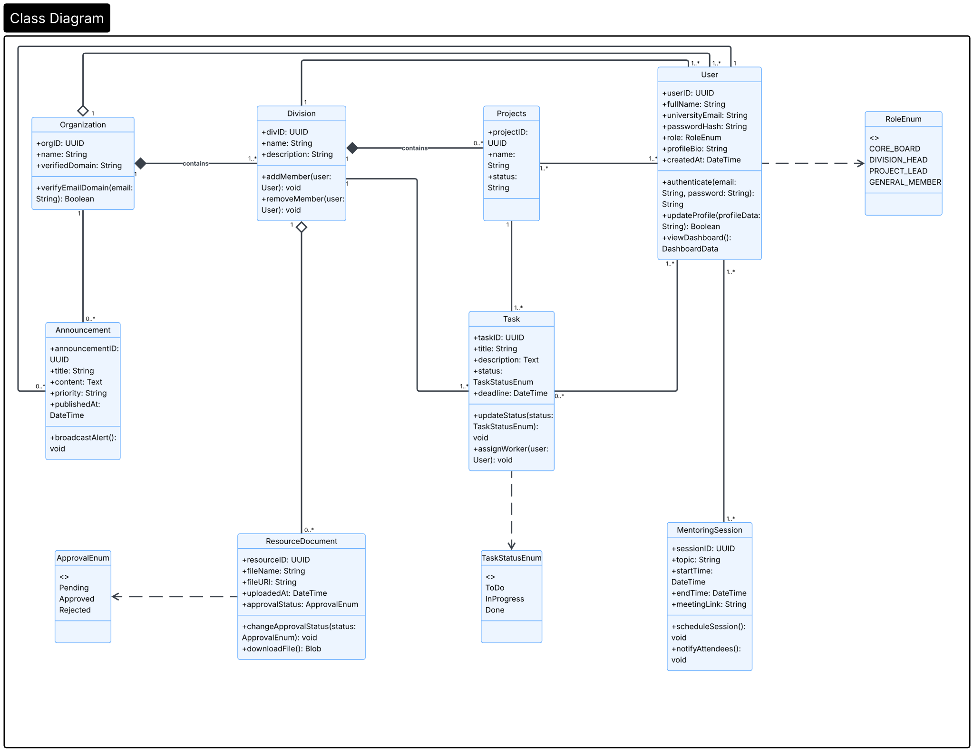

Operating Environment
The platform will operate purely in a web-based environment, as the development of native mobile applications is explicitly excluded from the initial project scope. The solution will require third-party hardware hosting, as internal hardware procurement for hosting is out of scope.

Design and Implementation Constraints
The development of OrgHub is constrained by the following requirements:
- Security Restrictions: The system must implement token-based authentication (e.g., JWT) and utilize data encryption to protect sensitive user information.
- Authentication Limits: Login access must be strictly limited to verified university email domains; integration with other university systems beyond this email domain verification is out of scope.
- Data Permissions: The file management system is constrained by strict role-based read/write access (e.g., only Division Heads can delete files, while Members can only view and download).

User Documentation
The following documentation components will be delivered along with the OrgHub platform to ensure smooth onboarding and operation:
- General Member Onboarding Guide: Delivered in two distinct phases to ensure accessibility:
  - Pre-Login Guide (External PDF): A brief instructional document distributed externally (e.g., via the university's standard email communications) detailing the prerequisites for access, specifically how to securely authenticate using the required university email domain.
  - Post-Login Guide (In-App Walkthrough): An interactive, first-time-login tutorial that guides the user through setting up their role-based profile, navigating their personal dashboard, and accessing their upcoming deadlines and division-specific resources.
- Administrator & Management Manual: A comprehensive guide tailored for the Core Board, Division Heads, and Mentors. This will detail how to manage nested organizational hierarchies (Organization > Division > Project > Team), utilize the task assignment tools, broadcast announcements, and manage read/write permissions for the division-specific file repository.
- Online Help and FAQs: An easily accessible in-app help section covering everyday functions, such as updating task statuses (To Do, In Progress, Done), utilizing the centralized calendar, and configuring automated push notification or email reminders.
- Internal Developer Documentation: Technical API documentation detailing the backend structure, payload formatting, and JWT token-based authentication implementation to guide the frontend development team.

Assumptions and Dependencies
The development of OrgHub is subject to these assumptions:
- Device Availability: Because the development of native mobile applications is explicitly out of scope, it is assumed that all users will have access to standard internet-connected devices (e.g., laptops, desktop PCs) with modern web browsers to access the platform.
- Consistent Email Infrastructure: It is assumed that the university will maintain a standardized and consistent email domain structure (e.g., @org.net) for all active students. If the university changes its email formatting or issues alternative domains, the system's authentication process will be impacted.
- Administrative Approval: It is assumed that the university administration will approve the platform's deployment and cooperate with ensuring email domain compliance.
- Hosting Procurement: Since internal hardware procurement is out of scope, it is assumed that the organization has the budget and means to procure appropriate third-party cloud hosting services (e.g., AWS, Google Cloud) prior to deployment.

The development of OrgHub follows these dependencies:
- Dependency on External Systems: The platform is entirely dependent on the university's email infrastructure for domain verification to ensure platform exclusivity.
- Hosting Dependency: Because hardware procurement is out of scope, the system depends on the procurement of external or third-party hosting services.

External Interface Requirements

User Interfaces
The OrgHub platform will operate exclusively in a web-based environment. The user interface must be accessible via modern web browsers and intuitively designed to accommodate the distinct needs of all role-based user classes (Core Board, Division Heads, Project Leads, and General Members).

Key interface components and characteristics include:
- Authentication & Profile Screens: Forms for user registration and login, including error message displays for invalid credentials or unregistered domains (e.g., "View Credential Error", "View Error Message"). Upon successful login, users will also have access to an "Account Settings" page to edit profile details (major, campus location, division, role).
- Role-Based Dashboards: A dynamic "Personal Dashboard" that renders formatted data specific to the user's role, identifying their ID and context to display upcoming personal deadlines, meeting schedules, and general progress.
- Task & Progress Boards: Interactive task boards allowing authorized users (Division Heads and above) to open task boards, create/edit task forms, and assign workers. It must also allow assigned users to select tasks and update statuses (ToDo, InProgress, Done).
- Resource Repository UI: A file management interface that renders a list of division-specific resources, supports file previews, and triggers download requests. For authorized users, this includes an "Upload Form" to select target groups and save files.
- Management & Broadcast Forms: Specific form screens for coordinating mentoring sessions (requiring Project Lead authorization or higher) and filling out announcement details (Title, Content, Priority) strictly accessible to the Core Board.
- Standardized Notifications: The UI must consistently display standard error dialogs (e.g., "View Permission Error" for unauthorized access attempts) and confirmation dialogs (e.g., "View Success Message", "Confirm Update") across all modules.
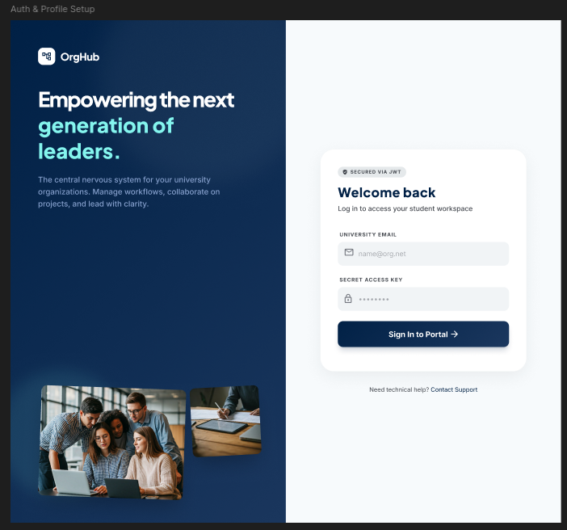

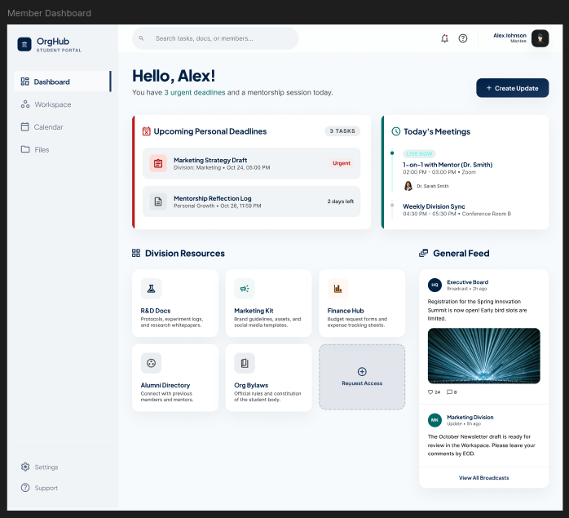

Hardware Interfaces
Because the development of native mobile applications is explicitly excluded from the initial scope, the system is designed to interface with standard internet-connected devices, such as laptops and desktop PCs.
- User Devices: The logical hardware interface requires the user's device to support standard network communication and possess sufficient memory/processing capabilities to run modern web browsers smoothly.
- Hosting Servers: As internal hardware procurement is out of scope, the software will be hosted on third-party cloud server architecture (e.g., AWS, Google Cloud). The system will interface logically with these remote servers to handle database requests, process backend logic, and store repository files.

Software Interfaces
OrgHub relies on several software interfaces to maintain its exclusivity, manage data, and authenticate users:
- University Email Infrastructure: The system must interface with the university's standardized email domains (e.g., @org.net). The software will send queries to verify that registered emails match the approved domain and send outbound messages containing verification links.
- Database Management System: OrgHub will require a database interface to permanently store and retrieve data models including User, Projects, Task, MentoringSession, ResourceDocument, and Announcement. The server will frequently send SQL/NoSQL queries to fetch progress data, save files to the repository, and update task statuses.
- Authentication System (JWT): The product will utilize secure token-based authentication (e.g., JSON Web Tokens) to verify user roles and sessions. The system will securely send credentials to generate tokens, which will be utilized by the backend to fetch role-based data and grant or restrict form access (e.g., validating a user's role before granting access to High-Level Document approval).

Communications Interfaces
The application requires reliable and secure communication protocols to facilitate web operations and automated alerts:
- Web Protocols: Standard HTTP/HTTPS protocols will be used to facilitate all communication between the web browser clients and the cloud-hosted servers.
- Email / Push Notification Protocols: The system will utilize electronic communication protocols (like SMTP or external notification APIs) to dispatch automated alerts. This includes sending email alerts for impending deadlines, upcoming mentoring sessions, broad organization-wide announcements, and initial account verification links.
- Data Formatting: API communications will handle user and system data payloads (such as fetching formatted dashboard data and sending form data). Downloading files from the resource repository requires transmitting data packaged as a Blob.
- Security & Encryption: All communication interfaces handling sensitive user information must be secured with data encryption. Token-based authentication payloads must be securely transmitted with every request requiring role authorization (such as uploading files or broadcasting announcements).

System Features
<This template illustrates organizing the functional requirements for the product by system features, the major services provided by the product. You may prefer to organize this section by use case, mode of operation, user class, object class, functional hierarchy, or combinations of these, whatever makes the most logical sense for your product.>

System Feature 1
<Don’t really say “System Feature 1.” State the feature name in just a few words.>
4.1.1 Description and Priority
<Provide a short description of the feature and indicate whether it is of High, Medium, or Low priority. You could also include specific priority component ratings, such as benefit, penalty, cost, and risk (each rated on a relative scale from a low of 1 to a high of 9).>
4.1.2 Stimulus/Response Sequences
<List the sequences of user actions and system responses that stimulate the behavior defined for this feature. These will correspond to the dialog elements associated with use cases.>
4.1.3 Functional Requirements
<Itemize the detailed functional requirements associated with this feature. These are the software capabilities that must be present in order for the user to carry out the services provided by the feature, or to execute the use case. Include how the product should respond to anticipated error conditions or invalid inputs. Requirements should be concise, complete, unambiguous, verifiable, and necessary. Use “TBD” as a placeholder to indicate when necessary information is not yet available.>

<Each requirement should be uniquely identified with a sequence number or a meaningful tag of some kind.>

REQ-1:
REQ-2:

System Feature 2 (and so on)

Other Nonfunctional Requirements

Performance Requirements
<If there are performance requirements for the product under various circumstances, state them here and explain their rationale, to help the developers understand the intent and make suitable design choices. Specify the timing relationships for real time systems. Make such requirements as specific as possible. You may need to state performance requirements for individual functional requirements or features.>

Safety Requirements
<Specify those requirements that are concerned with possible loss, damage, or harm that could result from the use of the product. Define any safeguards or actions that must be taken, as well as actions that must be prevented. Refer to any external policies or regulations that state safety issues that affect the product’s design or use. Define any safety certifications that must be satisfied.>

Security Requirements
<Specify any requirements regarding security or privacy issues surrounding use of the product or protection of the data used or created by the product. Define any user identity authentication requirements. Refer to any external policies or regulations containing security issues that affect the product. Define any security or privacy certifications that must be satisfied.>

Software Quality Attributes
<Specify any additional quality characteristics for the product that will be important to either the customers or the developers. Some to consider are: adaptability, availability, correctness, flexibility, interoperability, maintainability, portability, reliability, reusability, robustness, testability, and usability. Write these to be specific, quantitative, and verifiable when possible. At the least, clarify the relative preferences for various attributes, such as ease of use over ease of learning.>

Business Rules
<List any operating principles about the product, such as which individuals or roles can perform which functions under specific circumstances. These are not functional requirements in themselves, but they may imply certain functional requirements to enforce the rules.>

Other Requirements
<Define any other requirements not covered elsewhere in the SRS. This might include database requirements, internationalization requirements, legal requirements, reuse objectives for the project, and so on. Add any new sections that are pertinent to the project.>
Appendix A: Glossary
<Define all the terms necessary to properly interpret the SRS, including acronyms and abbreviations. You may wish to build a separate glossary that spans multiple projects or the entire organization, and just include terms specific to a single project in each SRS.>
Appendix B: Analysis Models
<Optionally, include any pertinent analysis models, such as data flow diagrams, class diagrams, state-transition diagrams, or entity-relationship diagrams.>
Appendix C: To Be Determined List
<Collect a numbered list of the TBD (to be determined) references that remain in the SRS so they can be tracked to closure.>

