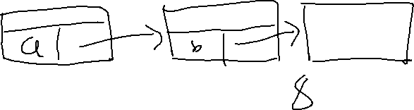

User class

* Add user and etc ( function same)
* remain same



Save linked list to file

Pet class



* Add pet and etc (function same)
* remain same

Service class

1. Staycation (function)
2. Grooming (function)
3. Training (function)

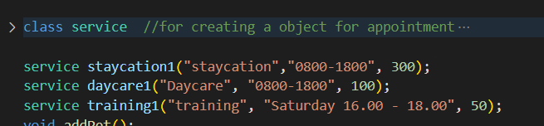

**Figure out how to create service first (e.g: grooming 3 session perday, one week 5 days, then only can book for that month)

* staycation date use binary tree
* grooming use binary tree
* training use binary tree

Appointment

* staycation date use binary tree to check/book appointment *max 5 pet one day
* training set saturday max 6pet per session ** one month 4 training session //next month
* daycare change to grooming ** 3 session per day. customer can only book for that particular month.
  + let user search for particular day to check whether available for booking
  + if available ask user want to book or not

Admin

* show the list of pet and owner name for every day section
* add / delete user ** delete user's file
* search for owner
* search for pet name
* sort by name (both)
* Create a linked list, store the user’s object into linked list and point to next
  + Object include all of the attributes of user
* Same for pet

Others almost same

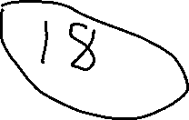

**Service**

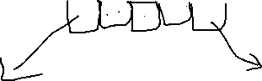

Sort using date (Binary Seach Tree)



**Admin :user**

