WSO2 Machine Learner REST API Implementation
Generating REST API Code using Swagger Definition

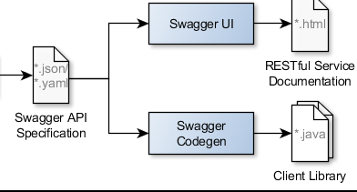

Following document discusses implementation details for generating client library using swagger API definition.

Tools:
Swagger Codegen
Swagger Editor
Maven mojo plugins
Apache CXF

Procedure:
First step is to generate swagger API specification using swagger editor.
Next step is to create a maven project and add the created swagger specification yaml file to the resources folder.
There are certain dependencies to be added to the POM file.
To generate a war with tomac naming convention use maven-war-plugin with the following.

<plugin>
<artifactId>maven-war-plugin</artifactId>
<version>2.2</version>
<configuration>
<webResources>
<resource>
<!-- this is relative to the pom.xml directory -->
<directory>src/main/webapp</directory>
</resource>
</webResources>
<warName>api</warName>
</configuration>
</plugin>

Add the following plugin to generate server stub for CXF.

<plugin>
<groupId>org.wso2.maven.plugins</groupId>
<artifactId>swagger2cxf-maven-plugin</artifactId>
<version>1.0-SNAPSHOT</version>
<configuration>
<inputSpec>${project.basedir}/src/main/resources/s.yml</inputSpec>
</configuration>
</plugin>

Also add the following maven build helper plugin

<plugin>
<groupId>org.codehaus.mojo</groupId>
<artifactId>build-helper-maven-plugin</artifactId>
<version>1.9.1</version>
<executions>
<execution>
<id>add-source</id>
<phase>generate-sources</phase>
<goals>
<goal>add-source</goal>
</goals>
<configuration>
<sources>
<source>src/gen/java</source>
</sources>
</configuration>
</execution>
</executions>
</plugin>

mvn swagger2cxf:generate command is used to generate the server stub

In src/gen/java folder, set of factories are generated and in main/Java folder, a set of impl files are generated.

The remaining logic should be added to the impl to complete the REST API code

