# Purpose

The purpose of this newsletter is to promote IMDG, by developing a Work Experience newsletter for young adults that would have an interest in technology, by offering them work experience placements through this, as well as other content, such as; an introduction into tech, internships and skills, help with interviews and applications and the different sectors of working within tech. The client has stated that the newsletter should be created from scratch, using HTML and CSS, as well as using a bit of JavaScript if need be. As the newsletter will be created from scratch, this will make it easier to design the layout and test out the colour scheme of the layout.

Since it is easy to ignore online newsletters, money being invested into print newsletters would stand out as more successful of the two, in terms of response rate. This is because printed newsletters have more influence, as well as being more portable, meaning that they can be read at a later date. However, as the client had wanted the product to be created for their online presence, the newsletter will still be created as an e-newsletter.

Newsletters are one way that the brand IMDG can build last longing relationships with their consumers/readers. While creating the newsletter, we would have to take in the consideration of what the young adults would like, in terms of layout, as young adults are much more sceptical of the information that is presented to them, therefore, they would usually demand more evidence to support claims than teenagers do.

It would be important to apply proper writing and formatting techniques when creating the newsletter as this is crucial in communicating with the young adults. The newsletter would display content in small, meaningful blocks with plenty of white space. This would help the young adults to retain information and pick up where they had left off after inevitable interruptions in their life, such as text messages and/or phone calls.

It is important to help the young adults to learn and stay focused on the content that they are reading on the newsletter, by choosing words to put onto the newsletter wisely. It would be good to use words that would make them understand, as many young adults’ word banks aren’t very large, as many individuals have different literacy skills to others.

# Target Audience

This work experience newsletter is targeted at young adults aged 16 to 18, who are either in full time or part time education. This newsletter is not gender specific, as both genders, male and female, can read this newsletter. The newsletter will be distributed to young adults that have an interest in tech as well as how to get into the tech industry for their future careers.

Through the development of the newsletter, we would have to take into consideration that for more young adults to read the newsletter, we have to think how the audience differs to teenagers, which can be thought as, teenagers tend to be poor readers, as they prefer non-text alternatives, like multimedia content. However, most young adults, particularly college students, are strong readers, but they don’t enjoy reading large amounts of text online.

# Resources and Personnel

The newsletter will be developed through a template that was bought and provided by the company, the software that will be used in the development of this media product, the work experience newsletter, will be both Adobe Photoshop and Visual Studio Code.

Adobe Photoshop would be used for the logo of IMDG, as well as any other designs that would go onto the newsletter.

Visual Studio Code would be used for the layout of the information and images, as to the location of where each block of text would be placed, and where the images would be placed, so that the newsletter wouldn’t look unappealing. Another way that Visual Studio Code would be used is that there would be white spacing involved in the newsletter, from the first to the last pages of the newsletter, so that the copy and the images do not look “squashed”.

Microsoft Office Publisher may be used for the front cover of the newsletter, as this would allow the creation of good quality newsletters. Microsoft Office Publisher is a good software to use for multi page projects, like newsletters, as having templates that are already created means that we will be able to just drop in text, add images and make changes. However, this may also be a disadvantage as most templates may reduce creativity, making users go with what is already designed, therefore we may use Visual Studio Code for the layout instead.

In terms of assets, the main assets will come from the company itself, IMDG, as they will provide the main template, in which I must use to put information, as well as images into it. The newly-built website has been created and put online, so information about the brand, as well as information about it who produced it would come from the main site.

For the programming, this would be including online websites such as; “W3Schools” and “Code Academy” to help with the additional coding of the newsletter.

Stock images may also be used in the newsletter as content, which will be from sites, such as [Pexels.com](https://www.pexels.com/), [Unsplash.com](https://unsplash.com/) and [Shutterstock.com](https://www.shutterstock.com/photos).

These two images have been given from the company as assets that would be included in the final production of the media product, the newsletter. This is because these assets represent the company as it is part of their logo.

These are the potential colours that would be used in the production of the newsletter. The colours that are shown in the image above are:

* #EA0000
* #191614
* #FFFFFF
* #B2CFF5
* #8CCB94

The first three colours have been chosen by representing the logo, whereas the next two colours have been chosen by looking random, but also by choosing what looks good with this.

Font Moodboard

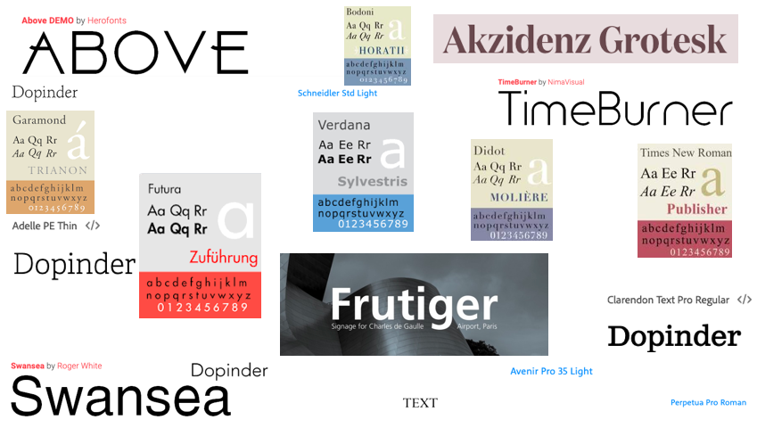

Heading Font

Copy Font

Gantt Chart

The following Gantt Chart shows the breakdown of the creation for the newsletter, from preparing the pre-production materials, all the way to the final design of the newsletter.

After the meeting with the client, ideas were discussed about the main picture of the newsletter, and through planning, the client had suggested that the five images should relate to one another. The image below shows what the client and I had discussed.

As seen above, the next four images, relate to the original template, which had the four sections of the IMDG logo. With this idea, images of; inspiration, motivation, direction and guidance were found and used, including a small caption about each and CTA’s to each article, video or website.

Desktop Version (Before 🡪 After)

Light Mode in Gmail

Dark Mode in Outlook

Mobile View

(Gmail)

(Outlook)

