**Test Scenario 1:**

API Endpoint “/viewcustomer” which will take in “customername” as input and display customer details like,

1. PAN
2. Account Type
3. Username
4. Address

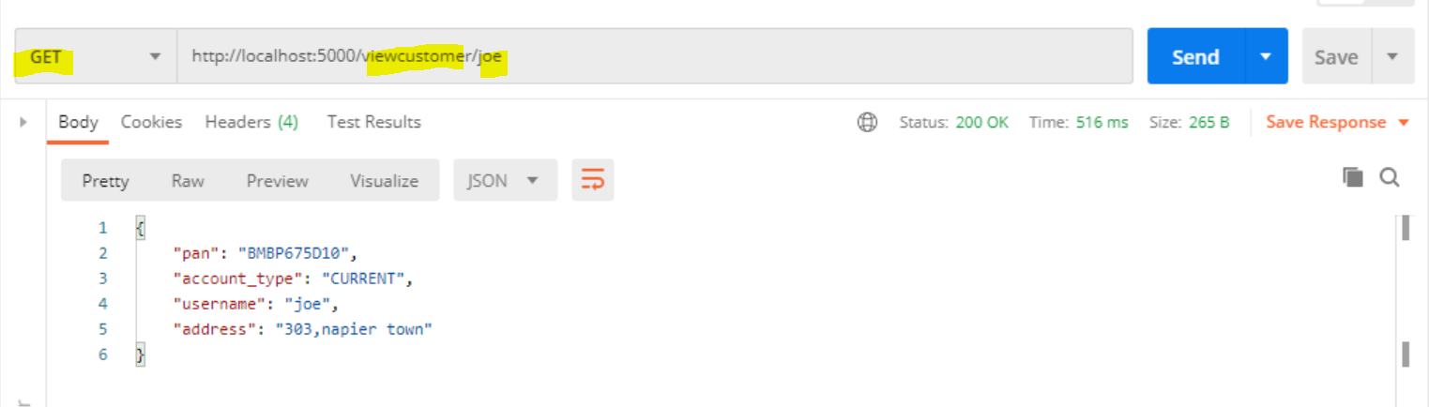

**Test Scenario 2:**

API Endpoint “/addcustomer” will add the customer to table “Customers”

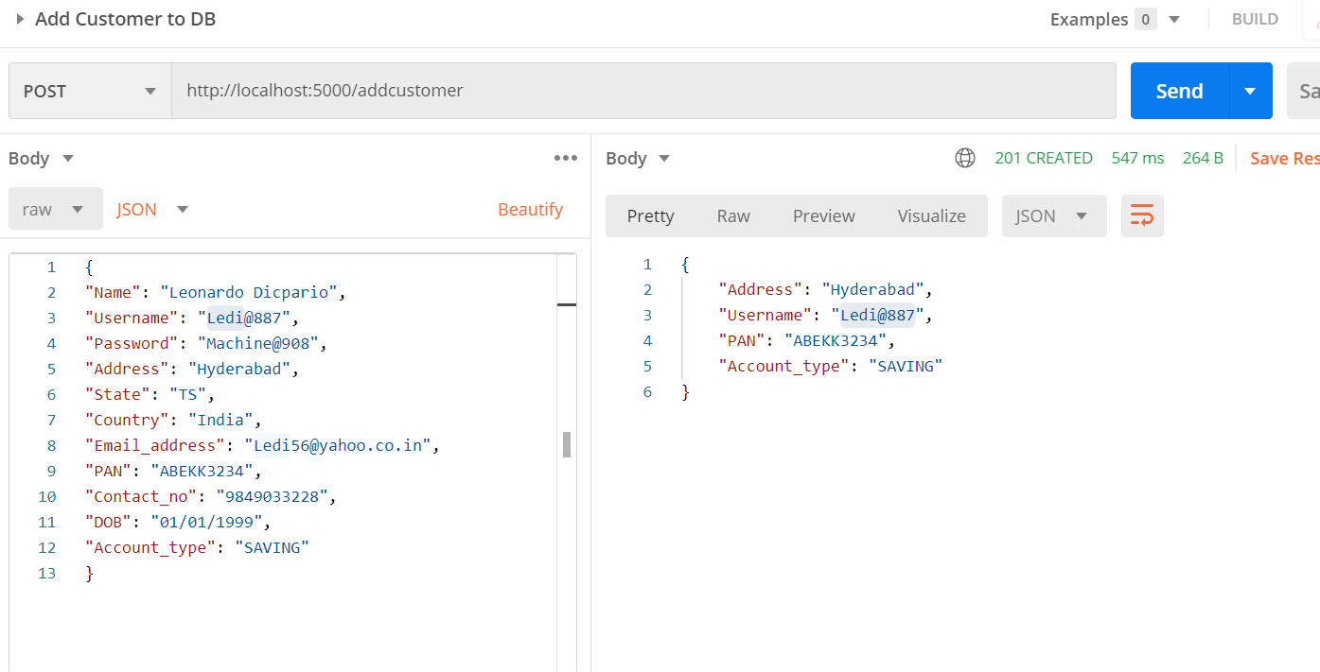

**Test scenario 3:**

API Endpoint “/login” will login the customer by validating the data from table “Customers”

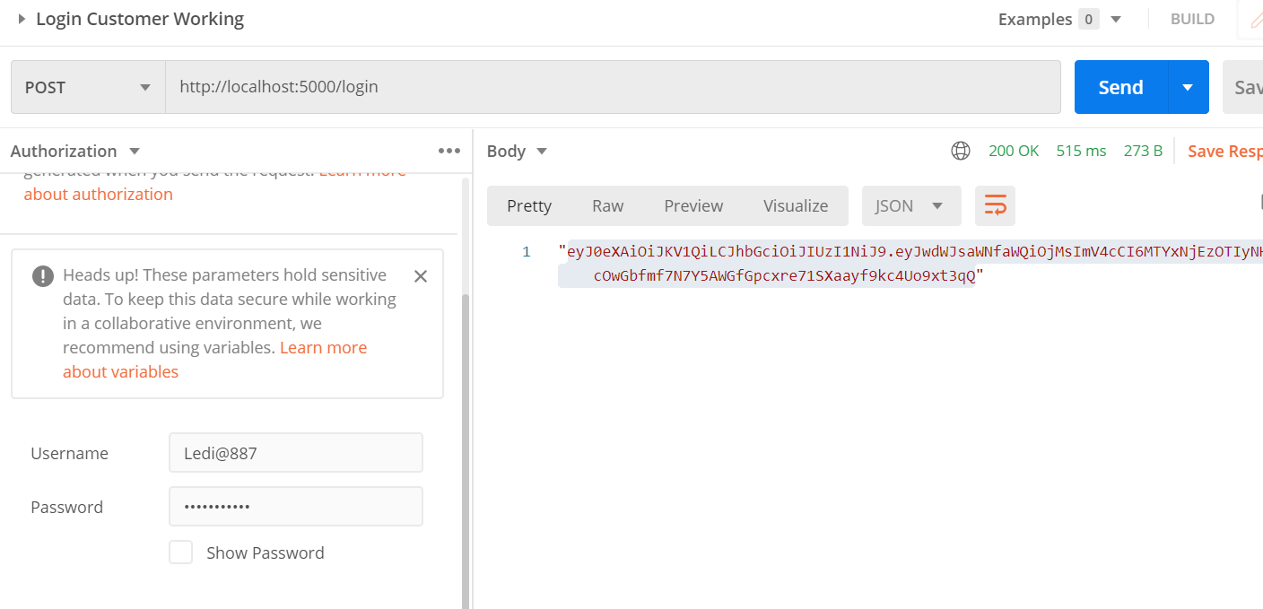

**Test scenario 4:**

API Endpoint “/ApplyLoan” will Apply Loan for the customer by validating the data from table “Customers” and “Loan”

**Positive Test ->**

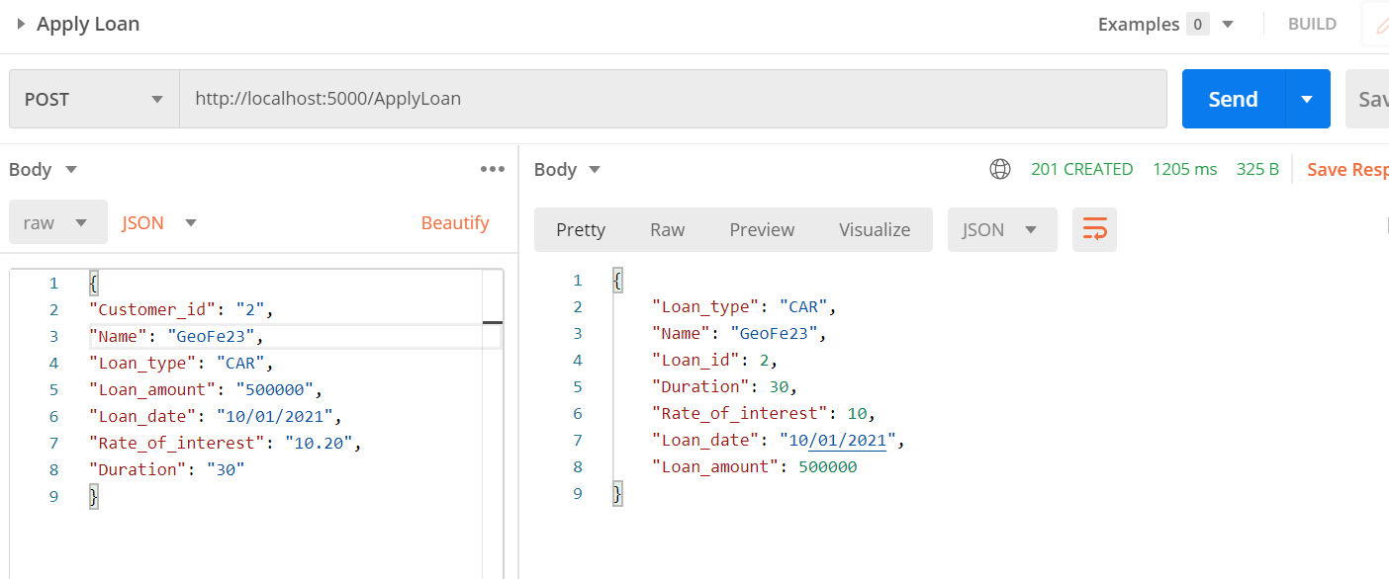

**Negative Test ->**

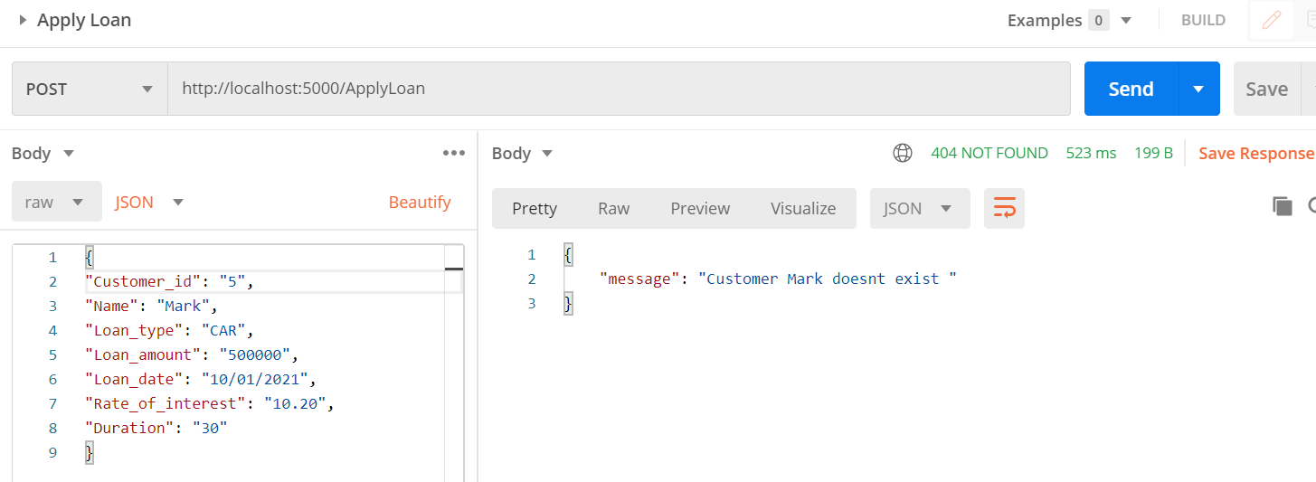

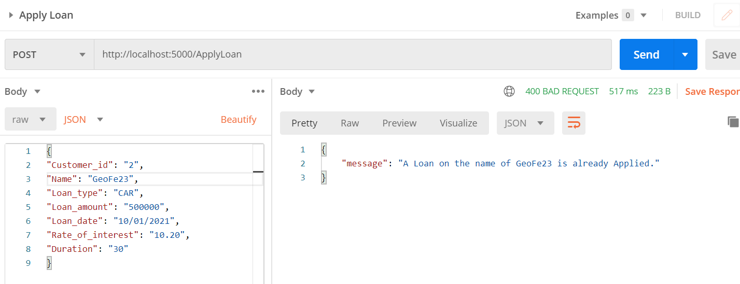

**Test Scenario 5:**

API Endpoint “/GetLoanDetail/<loan_id>” will Get Loan Details based on Loan ID.

**Positive Test ->**

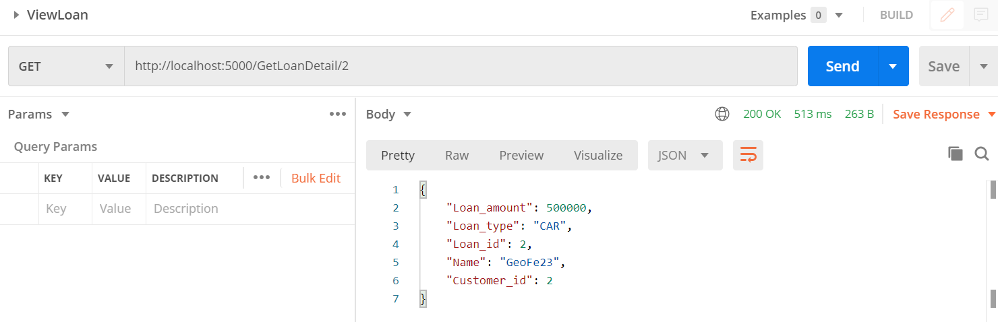

**Negative Test ->**

