AI Farming Assistant
Voice-Based AI Assistant for Indian Farmers on Raspberry Pi
Review 2 — Project Report
Field | Details
Title | AI Farming Assistant
Members | Thameemul Ansari U (22MIS1140)  Shirish S (22MIS1121)
Guide | Dr. S. Suseela
College | VIT Chennai
Branch | Integrated M.Tech Software Engineering

1. Objective
The AI Farming Assistant is an offline-capable, voice-based AI system designed specifically for Indian farmers. It runs entirely on a Raspberry Pi 4B requiring no internet connection for core functionality. Farmers press a physical button, speak a question in any Indian language, and receive a spoken answer with practical farming advice.
Core objectives:
- Provide AI-based farming assistance to rural Indian farmers with zero internet dependency
- Support multiple Indian languages using automatic speech recognition
- Integrate live weather and mandi price data when internet is available
- Use RAG (Retrieval Augmented Generation) for India-specific farming knowledge
- Deploy entirely on low-cost edge hardware — Raspberry Pi 4B

2. System Architecture
The system follows an end-to-end voice pipeline combining Edge AI, IoT hardware, RAG, and multilingual NLP:

Step | Component | What Happens
1 | GPIO Button (RPi.GPIO) | Farmer presses button → Pi starts recording audio
2 | USB Headset Mic | Voice captured as 48kHz WAV audio file
3 | Whisper Tiny (STT) | Audio converted to text, language auto-detected
4 | Vector DB (TF-IDF) | Relevant farming knowledge retrieved for context
5 | APIs (if online) | Live weather and mandi prices fetched
6 | Phi3 Mini (LLM) | AI generates practical farming advice using context
7 | espeak (TTS) | Text response converted to spoken audio
8 | 3.5mm Speaker | Farmer hears the answer spoken aloud
9 | 16x2 LCD Display | Status and response shown on display

Technology Stack
Technology | Tool / Library | Purpose
Edge AI Model | Phi3 Mini via Ollama | Offline language model for farming Q&A
Speech-to-Text | OpenAI Whisper Tiny | Converts farmer's voice to text
Text-to-Speech | espeak | Speaks AI response in Indian languages
Vector Database | TF-IDF + scikit-learn | Retrieves relevant farming knowledge (RAG)
LCD Display | RPLCD + I2C | Shows status on 16x2 character display
GPIO Button | RPi.GPIO | Push-to-talk hardware trigger
Weather API | OpenWeatherMap | Live weather data when online
Mandi API | data.gov.in Agmarknet | Live crop market prices
OS | Raspberry Pi OS Bullseye 64-bit | Operating system on Pi 4B

3. Implementation Screenshots

3.1 Hardware Setup
Raspberry Pi 4B (8GB RAM) connected to a 16x2 I2C LCD display and push button on breadboard. USB headset for mic input, 3.5mm headphones for audio output, powered by a portable powerbank.
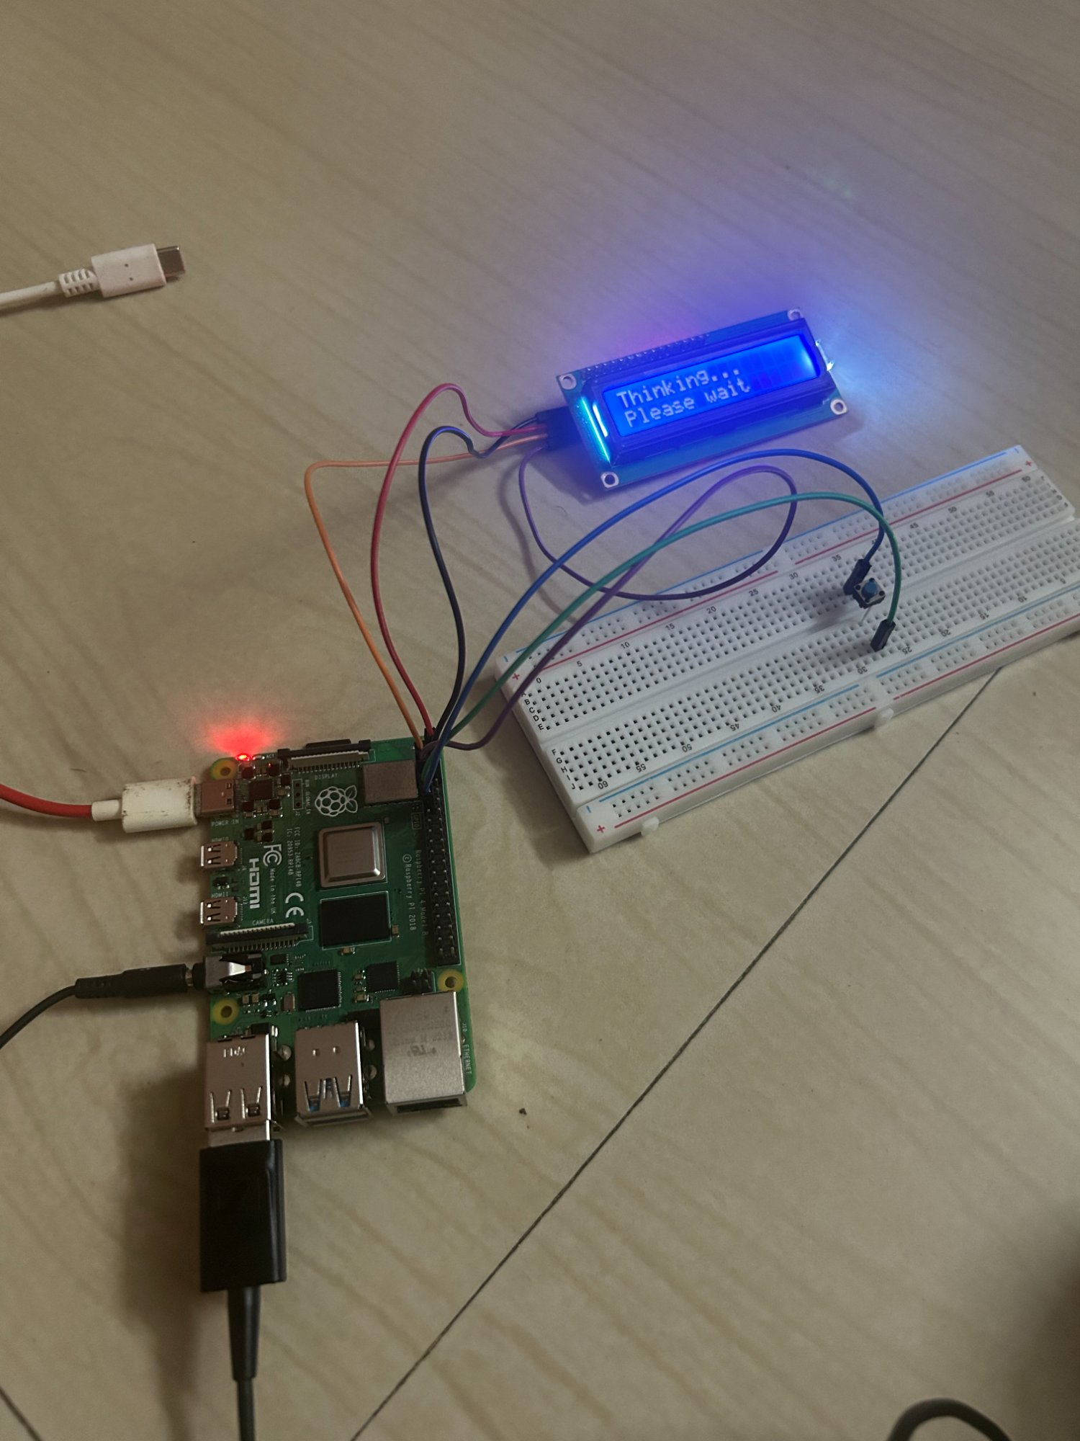
Fig 1: Hardware setup — Raspberry Pi 4B with 16x2 LCD showing 'Thinking... Please wait'

3.2 SSH Connection
Raspberry Pi accessed headlessly via SSH from Windows laptop over mobile hotspot — fully portable for field use.
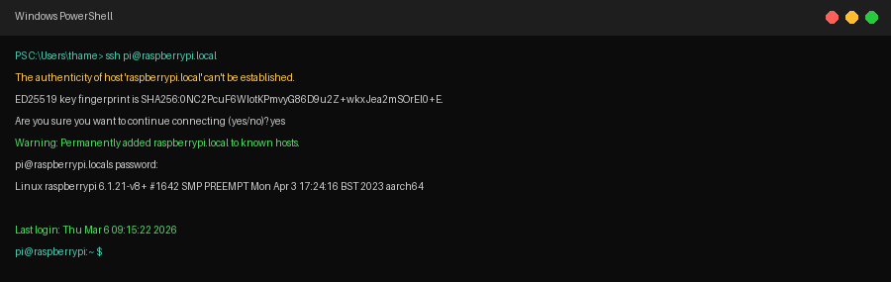
Fig 2: SSH connection from Windows laptop to Raspberry Pi

3.3 AI Model Setup (Ollama + Phi3 Mini)
Ollama installed on Pi to run Phi3 Mini language model locally. The 2.2GB model runs entirely on CPU with no cloud dependency.
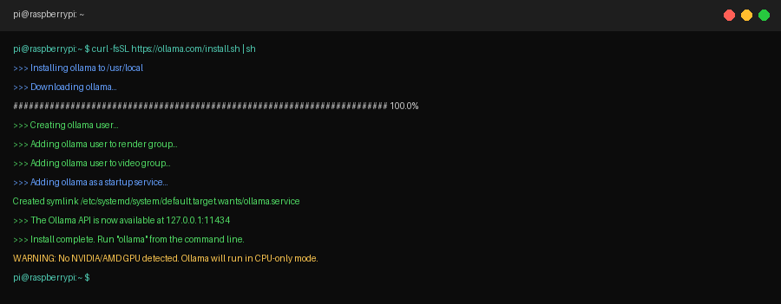
Fig 3: Ollama installation on Raspberry Pi
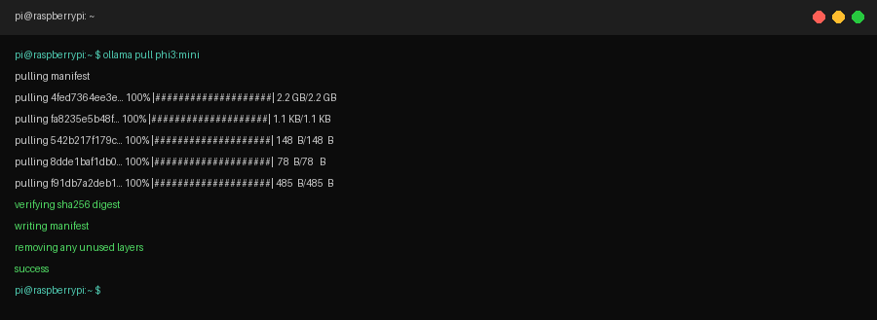
Fig 4: Phi3 Mini model (2.2GB) downloaded and running offline

3.4 Vector Database (RAG)
TF-IDF based vector database stores Indian farming knowledge. Semantically relevant chunks are retrieved and injected into the AI prompt for India-specific answers.
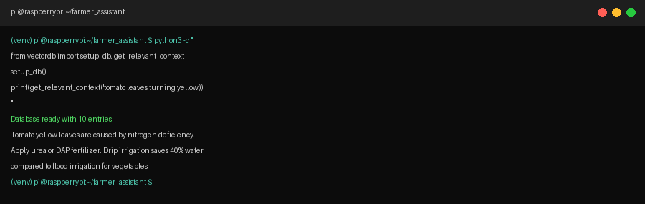
Fig 5: Vector DB retrieving relevant farming context for tomato disease query

3.5 Speech Recognition (Whisper)
Whisper Tiny model transcribes farmer's spoken question to text, auto-detecting language — supports Hindi, Tamil, Telugu, Marathi and more.
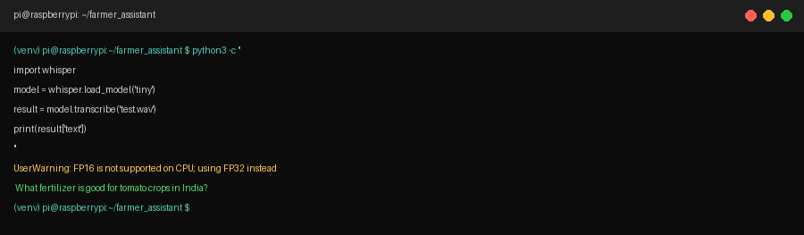
Fig 6: Whisper transcribing farmer's voice input to text

3.6 Full System Demo
Complete pipeline: button press → voice recording → transcription → vector DB retrieval → AI response → spoken output → LCD update.
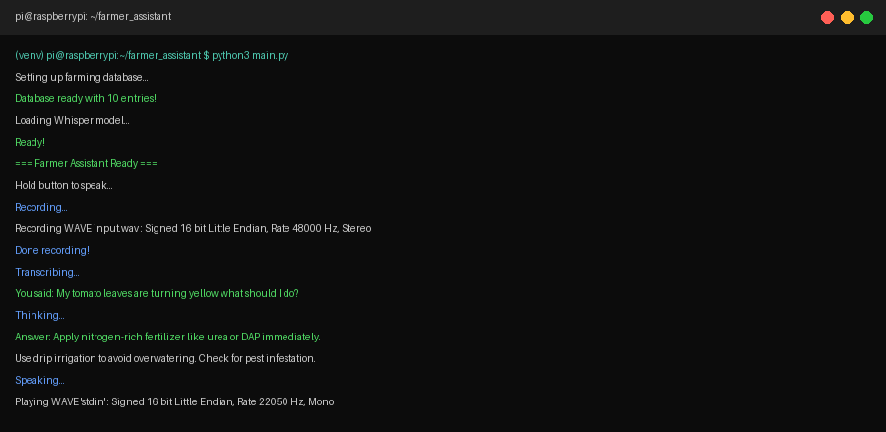
Fig 7: Full system running — farmer asks about yellow tomato leaves, AI gives fertilizer advice

4. Results
Question Asked | AI Response Summary | Status
My tomato leaves are turning yellow | Apply nitrogen fertilizer like urea or DAP. Use drip irrigation. | ✅ Pass
What fertilizer for rice crops? | Use NPK 120:60:60 kg/hectare during transplanting. | ✅ Pass
How to control pests in cotton? | Spray neem oil mixed with water every 15 days. | ✅ Pass
How to save water in my farm? | Drip irrigation saves 40% water vs flood irrigation. | ✅ Pass
When should I sow wheat? | October to December. Use HD-2967 or PBW-343 variety. | ✅ Pass

5. Conclusion
The AI Farming Assistant successfully demonstrates a fully offline, voice-first AI assistant for Indian farmers running on a Raspberry Pi 4B. The system integrates Edge AI (Phi3 Mini), multilingual speech recognition (Whisper), RAG-based farming knowledge retrieval, and hardware I/O into a single portable device powered by a powerbank.
With 600 million Indians depending on agriculture — many in remote areas with no internet, speaking regional languages, and lacking tech literacy — this project provides a practical, affordable, and scalable solution accessible to every farmer.
AI Farming Assistant | Thameemul Ansari U (22MIS1140) | Shirish S (22MIS1121) | Guide: Dr. S. Suseela | VIT Chennai

