 Al-Yamamah University

College of Engineering and Architecture

Department of Software Engineering

**CarShowRoom**

Fundamental of web design (CIS 201)

Students involved:

**Louaai Zailaei – 202311058**

**Thamer Almadi – 202311136**

**Amro Elian – 202311430**

Supervised by:

**Ms. Sara Alsabeg**

Contents

Introduction 3

Color scheme 3

Pages layout 4

Page Hierarchy 4

Pages 5

Home page: 5

Contacts Us: 6

About Us: 6

Registration: 7

External Links 7

# Introduction

Our website is a showroom for different kinds of cars that range in price and luxury. The website consists of a home page, about us, contact us, and a registration form. We target car enthusiasts seeking detailed information about new models, potential buyers looking for a new vehicle, and individuals interested in financing and leasing options.

# Color scheme

|  |  |  |
| --- | --- | --- |
| Hexadecimal | Color | Used for |
| #5d7c7e |  | General Background |
| #333333 |  | Header, Footer, and Containers |
| #ffffff |  | Texts and car’s containers |
| #0096bf |  | Buttons |

# Pages layout

## Page Hierarchy

## Pages

### Home page:

The Home Page displays the products we are offering with their prices. We used containers to separate the cars, and their prices form each other. We also added a navigation bar so the user can easily access all the pages, as well as a footer with the GitHub page of the website.

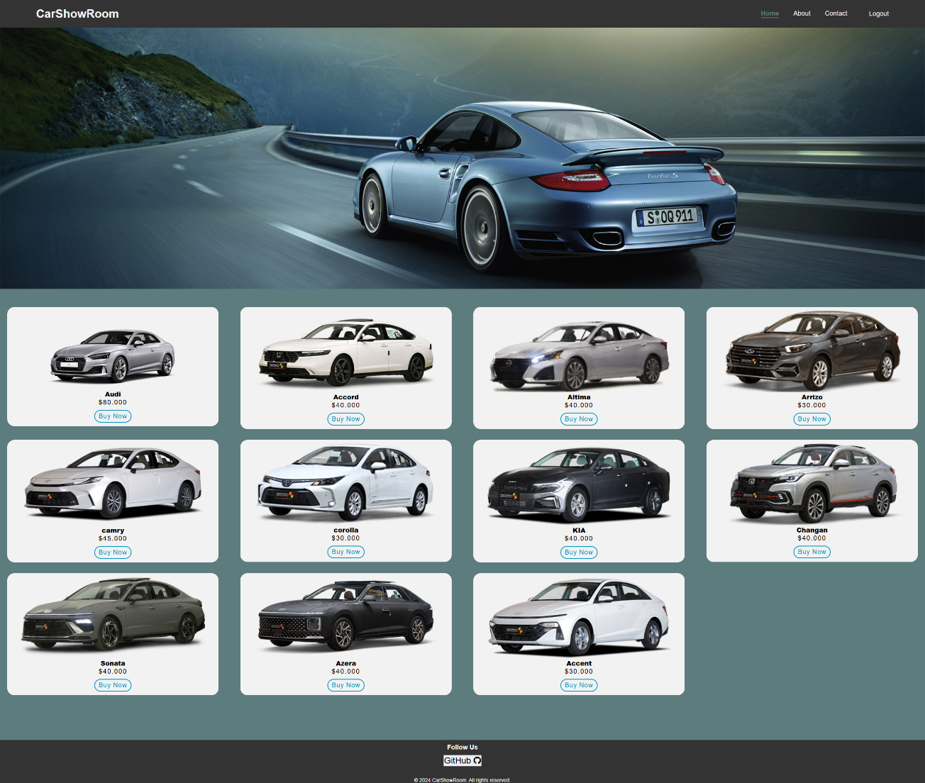

### Contacts Us:

We added a Contact us page as a way of connecting the user with our team by asking, giving comments, or reporting bugs. We used a container to coordinated the form. We also added a navigation bar so the user can easily access all the pages, as well as a footer with the GitHub page of the website.

### About Us:

We made an About us page to help the user know our team and the skills we have. We connected the header and footer as for the pages before.

### Registration:

registration is the signing in page for the website. The user will have access to the home page after completing the sigh in process. We used a container to coordinate the form.

## External Links

For Bootstrap:

For CSS:

For JavaScript:

