

Network Programming (IE2102)
2nd Year, 2nd Semester

Assignment
Design and Implementation of a Secure Multiprocessor TCP Application
Server with Custom Protocol and Session Management

Submitted to
Sri Lanka Institute of Information Technology

IT24104294
Sumanawardane. W.D.T.N

In partial fulfillment of the requirements for the
Bachelor of Science Special Honors Degree in Information Technology

10/04/2026

Declaration
I certify that this report does not incorporate, without acknowledgement, any material previously submitted for a degree or diploma in any university, and to the best of my knowledge and belief, it does not contain any material previously published or written by another person, except where due reference is made in text.

Contents
Hostname Configuration 3
Network Configuration 3
Server running proof 4
User Registration 4
User Authentication 5
Authorized Commands 6
User log-out 8
User data storage 9
Handling Multiple Clients. 10
Build server 11
Figure Table 12

Hostname Configuration
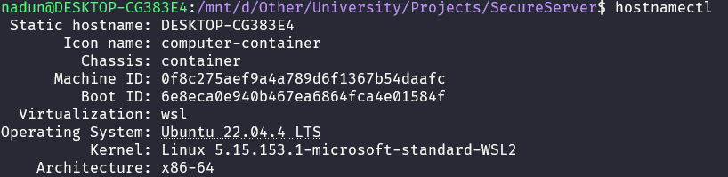
Host name of the machine. hostnamectl returns the host name, ID, and architecture of the machine.
Figure 1.1: Hostname

Network Configuration
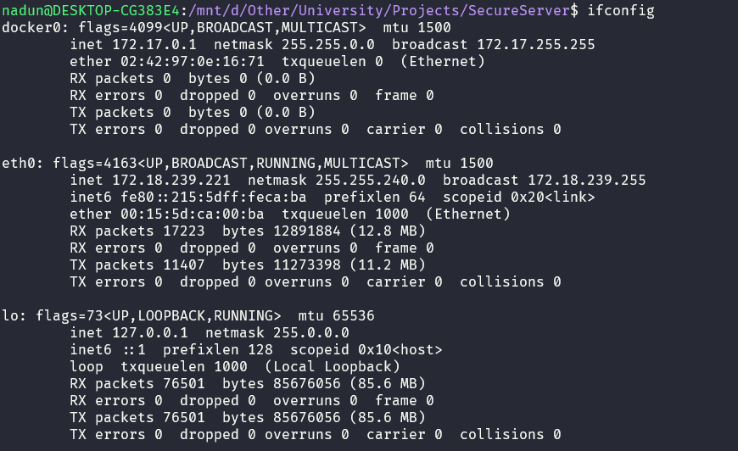
Here is the network interface that this machine has, and we utilize the loopback address to communicate with the server and the client.
Figure 2.1: Network Configuration

Server running proof
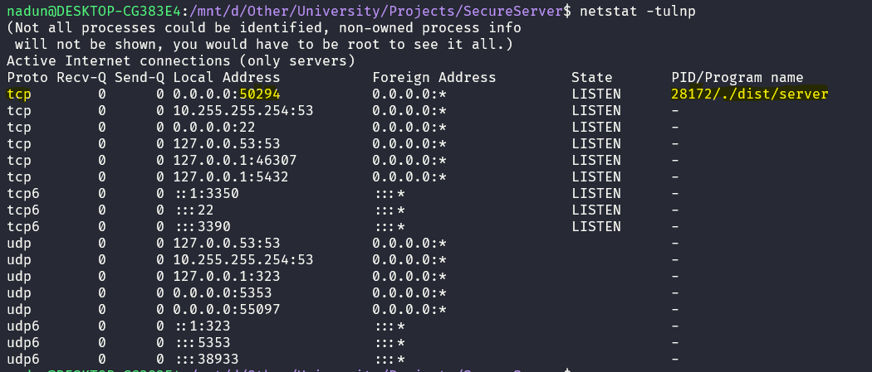
We can utilize the netstat command to see running connection details such as protocol, address + port, and process ID.
Figure 3.1: Network Information

User Registration
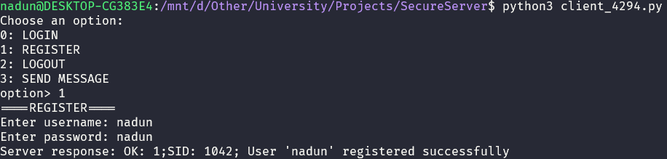
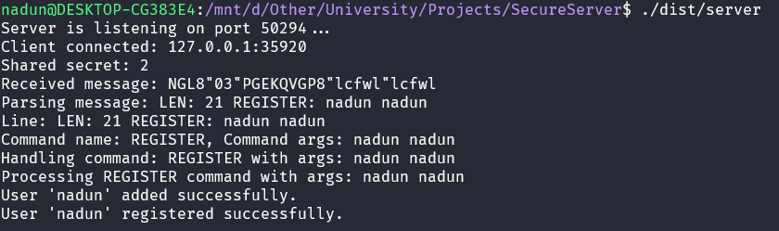
When a client sends a registration command, the server parses it and saves the user securely.
Figure 4.2: user registration (client)
Figure 4.1: user registration (server)

When a user is successfully saved, it will be logged in to the server log file; therefore, it provides auditability.
Figure 4.3: user registration (log)
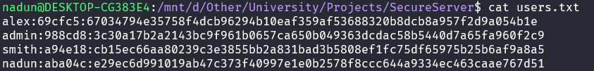
All passwords are saved using the SHA256 hashing algorithm with random salt.
Figure 4.4: user database

User Authentication
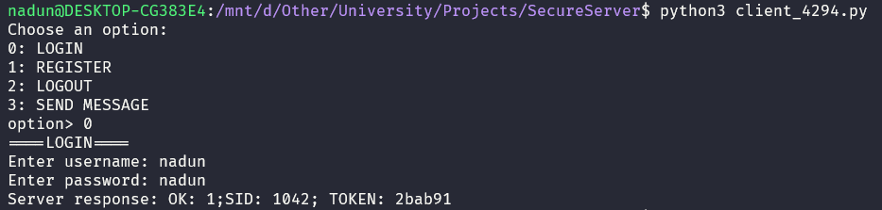
Users can log in to the server with a username and password; if the password is correct, the server sends a valid token for 5 minutes.
Figure 5.1: user authentication (client)

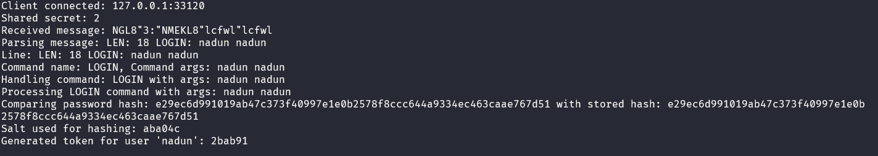
When a password is received, it will be hashed with salt, and then we compare it with the original hash. If it’s valid, we send a token.
Figure 5.2: user authentication (server)
This process is also logged in to the server log file.
Figure 5.3: user authentication (log)

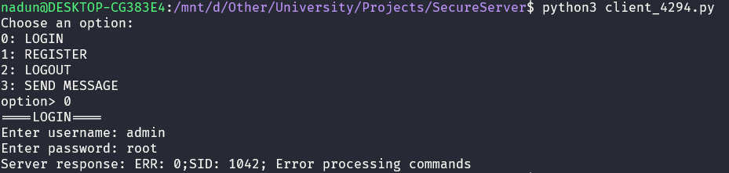
When a user sends an incorrect password, it will log and reject the authentication.
Figure 5.4: user authentication failure (client)
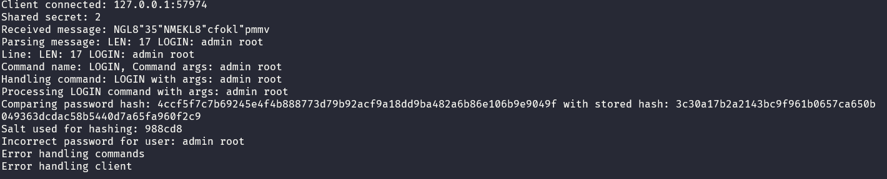
Figure 5.6: user authentication failure (log)
Figure 5.5: user authentication failure (server)

Authorized Commands
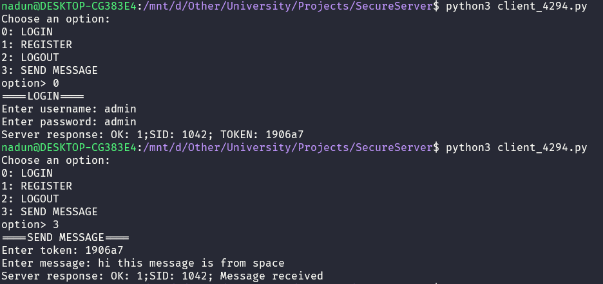
Users can send messages with their token.
Figure 6.1: message command (client)

It will be displayed on the server console. And it will be directly logged into separate log files of the user.
Figure 6.2: message command (log)

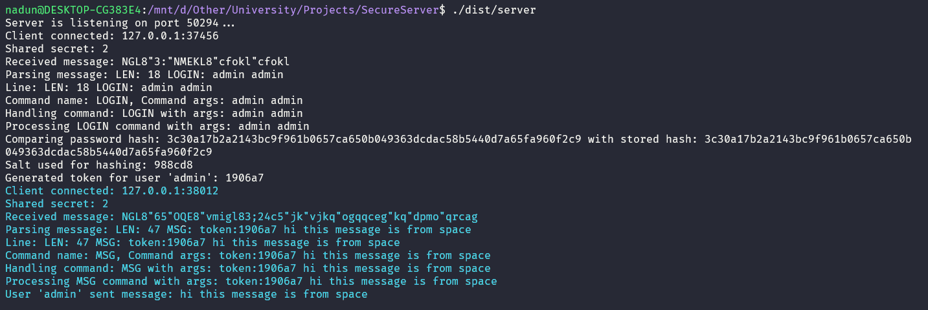
Figure 6.3: message command (server)

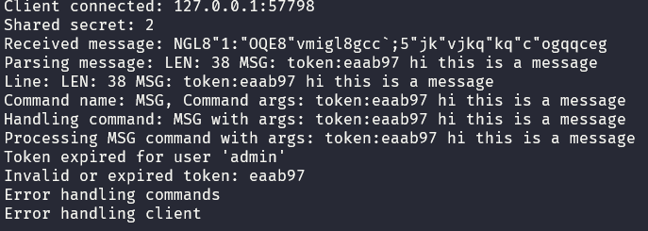
If the token is invalid, in other words, if the token is expired, the authorized commands will be rejected, and the attempt will be logged.
Figure 6.4: message command failure (server
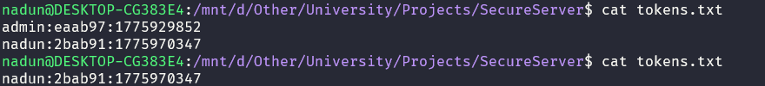
An expired token will be removed.
Figure 6.5: Expired token removal

User log-out
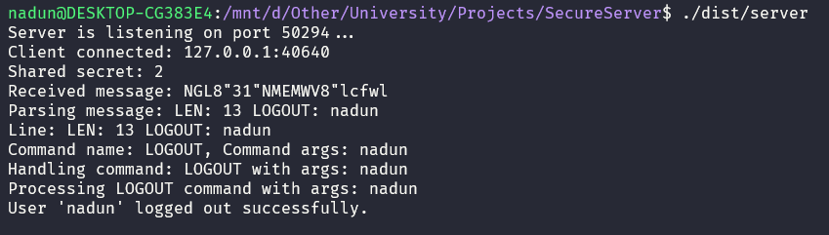
Users can log out from the server. Once they do that, if there is a valid token, it will be removed; therefore, bad actors cannot utilize that token if it was compromised.
Figure 7.2: user log out (server)
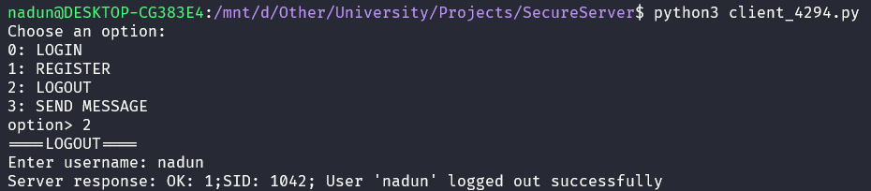
Figure 7.3: user log out (log)
Figure 7,1: user log out (client)

User data storage

All users' data will be stored securely. Passwords are stored using the SHA256 hashing algorithm with a salt value.
Figure 8.1: user database

Handling Multiple Clients.
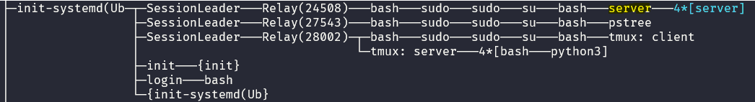
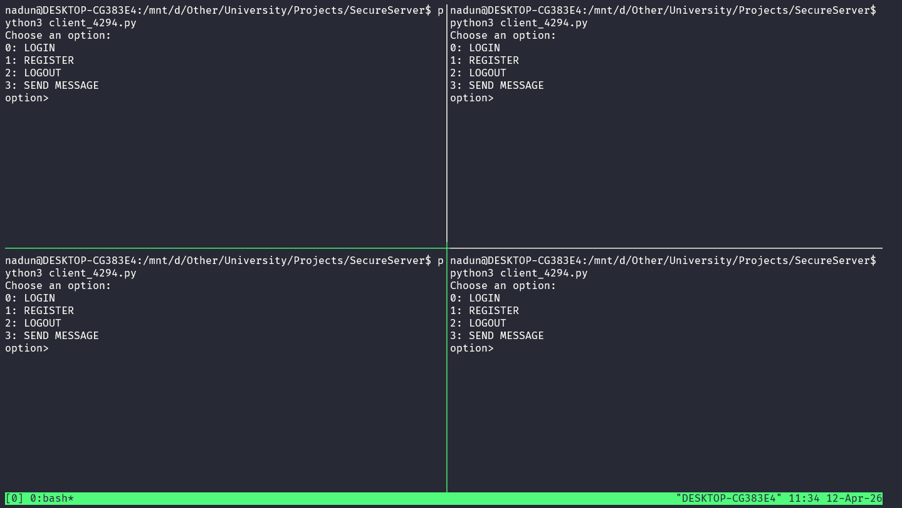

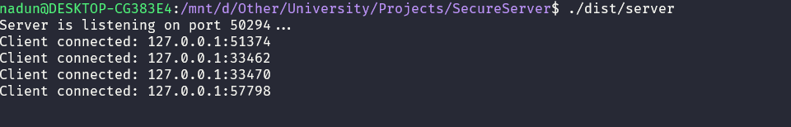
This server is able to handle multiple clients at the same time.
Figure 9.3: pstree
Figure 9.2: creating multiple clients using tmux
Figure 9.1: handling multiple clients (server)

Build server
We can use Makefile to build the server executable with ease.
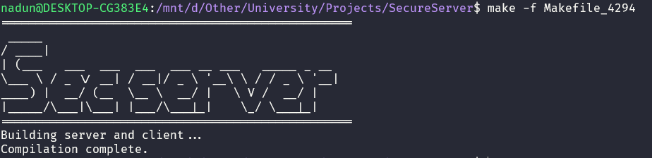
Figure 10.1: Build server

Figure Table
Figure 1.1: Hostname 3
Figure 2.1: Network Configuration 3
Figure 3.1: Network Information 4
Figure 4.2: user registration (client) 4
Figure 5.1: user authentication (client) 5
Figure 6.1: message command (client) 6
Figure 7.2: user log out (server) 8
Figure 8.1: user database 9
Figure 9.2: creating multiple clients using tmux 10
Figure 10.1: Build server 11

