 

BOOK STORE APPLICATION USING MERN STACK

**NAAN MUDHALVAN PROJECT REPORT**

***Submitted by***

# ANNE JOAN BENITA V 311521205008

# MATHUMITHA M311521205030

# SHAWN GODFREY T 311521205050

**THAMIZHINI S 311521205055**

*submitted to the Faculty of*

## INFORMATION TECHNOLOGY

*in partial fulfillment for the award of the degree*

***of***

**BACHELOR OF TECHNOLOGY**

***in***

**INFORMATION TECHNOLOGY**

## MEENAKSHI SUNDARARAJAN ENGINEERING COLLEGE KODAMBAKKAM

*(An Autonomous Institution)*

**ANNA UNIVERSITY::CHENNAI 600 024**

**NOVEMBER 2024**

# ANNA UNIVERSITY:CHENNAI 600025 BONAFIDE CERTIFICATE

Certified that this project report titled **BOOK STORE SPLLICATION USING MERN STCAK** is the bonafide work of **ANNE JOAN BENITA V 311521205008 MATHUMITHA M 311521205030 SHAWN GODFREY T 311521205050 THAMIZHINI S 311521205055** who carried out project work under my supervision. Certified further that to the best of my knowledge and belief, the work reported herein does not form part of any other thesis or dissertation on the basis of which a degree or an award was conferred on an earlier occasion on this or any other candidate.

**SIGNATURE**

**MRS. G.ASWINI M.TECH(IT)**

**NAAN MUDHALVAN**

**CO-ORDINATOR**

**ASSISTANT PROFESSOR DEPARTMENT OF IT, MSEC**

**(An Autonomous Institution) KODAMBAKKAM CHENNAI 600024**

**SIGNATURE**

**DR. A. KANIMOZHI M.E., Ph.D. HEAD OF THE DEPARTMENT DEPARTMENT OF IT, MSEC**

**(An Autonomous Institution) KODAMBAKKAM CHENNAI 600024**

Submitted for the project viva voce held at Meenakshi Sundararajan Engineering College on

**INTERNAL EXAMINER EXTERNAL EXAMINER**

# TABLE OF CONTENTS

|  |  |  |
| --- | --- | --- |
| **S NO** | **CONTENTS** | **PAGE NO** |
| **1** | **INTRODUCTION** | **4** |
| **2** | **PROJECT OVERVIEW** | **5** |
| **3** | **ARCHITECTURE** | **8** |
| **4** | **SETUP INSTRUCTIONS** | **12** |
| **5** | **FOLDER STRUCTURE** | **18** |
| **6** | **RUNNING THE APPLICATION** | **22** |
| **7** | **API DOCUMENTATION** | **25** |
| **8** | **AUTHENTICATION** | **30** |
| **9** | **USER INTERFACE** | **31** |
| **10** | **TESTING** | **33** |
| **11** | **SCREENSHOTS** | **35** |
| **12** | **RESULT** | **41** |

## INTRODUCTION

Project Title: Book Store Application with MERN Stack

### Welcome to the ultimate digital haven for book lovers—our cutting-edge Book-Store Application, built with the powerful MERN (MongoDB, Express.js, React, Node.js) stack. Seamlessly blending technology and literature, our platform redefines how bibliophiles explore and indulge in their passion for reading.

### Backed by MongoDB’s scalable database, Express.js ensures efficient server operations, and Node.js delivers high-performance functionality. At its core, React powers a dynamic and interactive interface, offering a visually engaging experience across all devices. Discover new releases, revisit classics, and personalize your journey—our Book-Store Application makes every interaction a literary adventure.

### Team Members:

* **SHAWN GODFREY T** (Frontend Developer): Responsible for building the user interface using React and ensuring the frontend’s responsiveness and user experience.
* **ANNE JOAN BENITA V**(Full Stack Developer): Works on both the frontend and backend to ensure seamless integration and overall functionality of the application.
* **MATHUMITHA M** (Backend Developer): Handles the backend API development with Node.js, Express.js, and MongoDB.
* **THAMIZHINI S**(UI & UX Design) : Focused on designing the platform’s interface and creating intuitive and user-friendly experiences.

The project is developed with the **MERN** (MongoDB, Express.js, React, Node.js) stack, utilizing Socket.io for real-time communication and React’s contex for state management on the frontend.

## PROJECT OVERVIEW

### **Purpose**

The **BookEase: Online Bookstore Application with MERN Stack** is designed to revolutionize the book-shopping experience by bridging the gap between readers and booksellers. It offers a seamless and secure platform to browse, purchase, and manage books. Readers often face challenges in discovering diverse collections and receiving reliable reviews, while booksellers struggle with reaching their audience and managing stock efficiently. BookEase addresses these pain points with comprehensive solutions such as advanced book management, real-time updates, and secure payment processing.

The platform emphasizes simplicity and efficiency, integrating features that elevate the experience of buying and selling books online. BookEase focuses on intuitive navigation, secure transactions, and interactive functionalities to foster a vibrant marketplace for book enthusiasts.

The core goals of the platform include:

**1**. Expanding Market Accessibility

* BookEase connects readers to a broad network of booksellers offering a vast range of books across genres and categories.
* Sellers can easily display their collections, attract potential buyers, and showcase their inventory, creating a thriving ecosystem for book lovers.

2. Real-Time Updates

* Leveraging real-time technologies like Socket.io, BookEase provides instant notifications about order statuses, book availability, and offers.
* This feature ensures timely communication and enhances interaction between buyers and sellers.

3. Secure Payment Gateway

* A primary focus of BookEase is the integration of trusted payment gateways, ensuring that transactions are safe and efficient.
* This feature builds trust and confidence among users for hassle-free purchases.

4. Efficient Book Management

* Sellers can effortlessly manage book inventory, update book details, monitor sales, and analyze performance.
* Readers benefit from easy browsing, filtering options by genres/authors/prices, and seamless purchasing workflows.
* The centralized system simplifies operations for both parties, ensuring smooth transactions and operations.

5. User-Friendly Design

* BookEase emphasizes intuitive navigation, responsive design, and accessibility for users of all technical levels.
* Optimized for a seamless experience across devices, the platform ensures users can browse and shop effortlessly whether on a mobile device or desktop.

### **Features**

* **User Registration and Authentication:** Allow users to register accounts securely, log in, and authenticate their identity to access the book store platform.
* **Book Listings:** Display a comprehensive list of available books with details such as title, author, genre, description, price, and availability status.
* **Book Selection:** Provide users with options to select their preferred books based on factors like genre, author, ratings, and popularity.
* **Purchase Process:** Allow users to add books to their cart, specify quantities, and complete purchases securely. Upon successful completion, an order is generated, and the inventory is updated accordingly.
* **Order Confirmation:** Provide users with a confirmation page or notification containing details of their order, including book information, total price, and order ID.
* **Order History**: Allow users to view their past and current orders, providing options to track shipments, review purchased books, and rate their shopping experience.
* **Organizer Dashboard:** Offer administrators an interface to manage book listings, inventory levels, user accounts, orders, and other platform-related activities.
* **Create Item:** Organizer can create items and add new items and he can get the items and he can update items.
* **Admin Dashboard:** Offer administrators an interface to manage book listings, inventory levels, user accounts, orders, and other platform-related activities. Manage the users and organizers.
* **Reporting and Analytics:** Generate reports and analytics on book sales, popular genres, user demographics, and other relevant metrics to gain insights into platform usage and performance.
* **Integration with External APIs:** Integrate with third-party APIs for services like payment processing, shipping logistics, and book recommendations to enhance the functionality and user experience of the book store platform.

## ARCHITECTURE

Frontend Architecture

The frontend of BookEase is developed using React.js, leveraging a component-based architecture for modularity, scalability, and maintainability. This approach ensures optimal performance and a seamless user experience.

Key Features:

1. Component-Based Design:
   * Major features such as book listings, shopping cart, checkout process, and user profiles are designed as independent React components.
   * Reusable components like buttons, modals, form inputs, and book cards ensure consistency and reduce redundancy across the application.
2. State Management:
   * Context API is utilized to manage global states like user authentication, cart items, and book filters.
   * The combination of Context API and useReducer ensures efficient management of complex state updates, avoiding unnecessary re-renders and maintaining application performance.
3. Routing:
   * React Router is employed to create dynamic and nested routes for seamless navigation across pages like Home, Book Details, Categories, Order History, and Wishlist.
   * Lazy loading with route-based code splitting enhances performance by loading components on demand.
   * React Router Hash Link enables smooth scrolling for in-page navigation, improving user experience in sections like FAQs and book reviews.
4. UI/UX Design:
   * CSS/SCSS is used to implement a clean and responsive layout, following a mobile-first approach for an optimized experience across devices.
   * The interface features user-friendly navigation, intuitive design elements, and visually appealing book displays.

### **Backend Architecture :**

The backend of BookEase is built using Node.js and Express.js, creating a RESTful API that manages the core functionalities of the bookstore. These include user authentication, book management, cart operations, order tracking, and review systems.

Key Features:

1. API Routes:
   * User Management: Handles routes for user registration, login, and profile management.
   * Book Management: Provides CRUD operations for books, including adding, updating, deleting, and fetching book details.
   * Cart Operations: Manages adding/removing books from the cart, updating quantities, and calculating subtotals.
   * Order Processing: Handles placing orders, tracking order statuses, and fetching order history.
   * Reviews and Ratings: Allows users to leave reviews and rate books, enhancing the shopping experience and providing feedback for sellers.
2. Security:
   * Bcrypt is used to securely hash passwords before storing them in the database.
   * JWT (JSON Web Tokens) is implemented for authentication, ensuring secure access to sensitive routes, such as managing user profiles, order history, and book listings.
3. Error Handling:
   * Centralized error handling middleware ensures all API endpoints return consistent and meaningful error messages for better debugging and user experience.
4. Performance Optimization:
   * Backend services are optimized with caching mechanisms (e.g., Redis) for frequently accessed data like book listings and categories, improving response times.
5. Scalability:
   * The backend is designed to handle high user traffic and concurrent operations by leveraging the asynchronous nature of Node.js and horizontal scaling options.

**Database Architecture**

The platform uses MongoDB, a NoSQL database, to manage and store data. Its flexibility and scalability make it an ideal choice for the dynamic requirements of BookEase.

Key Collections:

1. Users Collection:
   * Stores details about buyers and sellers, including authentication data, contact information, and profiles.
   * Buyers have access to features like order history, saved addresses, and wishlist.
   * Sellers manage their book listings and track sales directly.
2. Books Collection:
   * Contains details about books such as title, author, genre, price, description, ratings, availability, and images.
   * Sellers can update book details and manage inventory, while buyers can browse and review books.
3. Cart Collection:
   * Manages items added to user carts, linking them to respective users and books.
   * Stores information like quantity, subtotal, and timestamps.
   * Persistent cart functionality ensures buyers can continue shopping seamlessly after logging out.
4. Orders Collection:
   * Tracks completed orders, including user ID, book IDs, quantities, subtotal, and timestamps.
   * Enables sellers to track order statuses and provides buyers with detailed order history.
5. Payments Collection:
   * Stores details of transactions, including payment IDs, status, and timestamps.
   * Ensures transparency and reconciliation while maintaining security.

## SETUP INSTRUCTIONS

### Prerequisites:

Before setting up the **BookEase: Book Store** **with MERN Stack** locally, ensure you have the following software installed on your machine:

### Node.js:

* + Node.js is a JavaScript runtime environment required to run both the frontend and backend.
  + You can download and install Node.js from [here](https://nodejs.org/).

### MongoDB:

* + MongoDB is a NoSQL database used to store application data such as user profiles, products, orders, and messages.
  + You can install MongoDB locally or use MongoDB Atlas for a cloud-based solution.

### npm (Node Package Manager):

* + npm is bundled with Node.js and is used to install the project dependencies for both the frontend and backend.

### Installation

Follow these steps to set up the project locally:

### Clone the Repository:

Start by cloning the project repository to your local machine using the following command:

bash

Copy code

git clone <repository-url>

Replace <repository-url> with the actual URL of the project repository.

### Install Dependencies:

Navigate to each project directory and install the required dependencies.

### Frontend (Client):

The frontend, built with React, is located in the frontend directory. Run the following commands:

bash

Copy code cd frontend/ npm install

This will install all dependencies specified in package.json, such as react, react-router-dom, and bootstrap.

### Backend (API):

The backend, developed with Node.js and Express, is located in the backend directory. Run the following commands:

bash

Copy code cd backend/ npm install

This will install required packages like express, mongoose, and multer.

### Setup Environment Variables:

Create .env files in both the frontend and backend directories to configure environment-specific variables.

### Frontend (frontend/.env):

Add the following variables:

env

Copy code REACT_APP_API_URL=http://localhost:4000

This URL points to the backend server.

### Backend (backend/.env):

Add the following variables:

env

Copy code

MONGODB_URI=<your-mongodb-uri>

* + - MONGODB_URI: MongoDB connection string. Use your local database URI or the one from MongoDB Atlas.

### Run the Application:

Use separate terminals to start the frontend and backend servers:

### Start the Backend Server:

Navigate to the backend directory and run:

bash

Copy code cd backend/ npm start

The backend will run on http://localhost:4000 by default.

### Start the Frontend Server:

Navigate to the frontend directory and run:

bash

Copy code cd frontend/ npm start

The frontend will run on http://localhost:4000 by default.

## FOLDER STRUCTURE

Backend Structure:

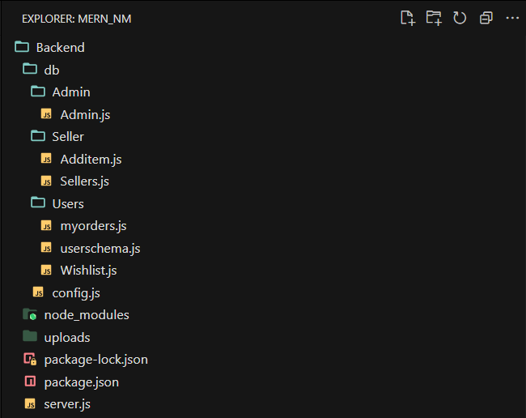

Frontend Strucutre

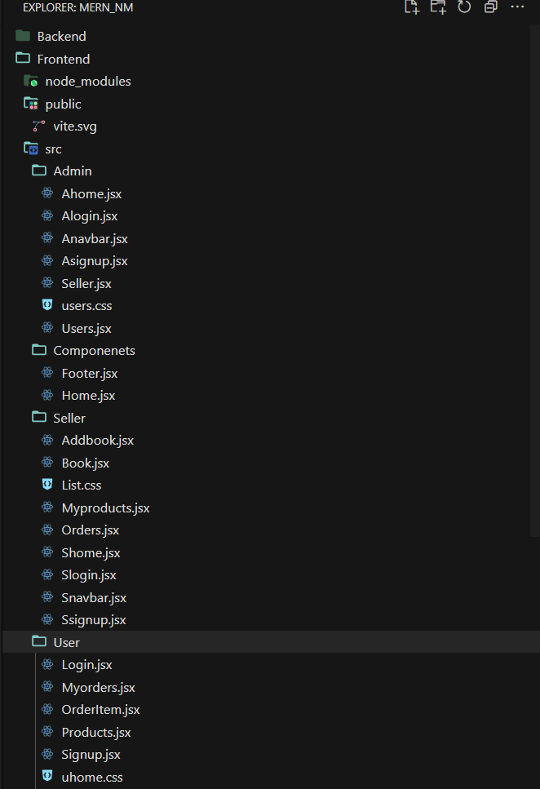

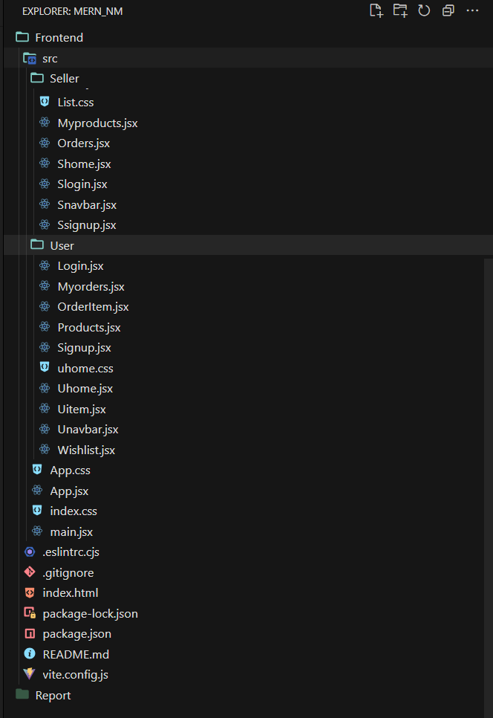

## Running the Application

To run the Freelancing Application locally, follow the steps below: # Frontend:

1. Navigate to the client directory:

```bash cd client/

```

1. Install the required dependencies:

```bash npm install

```

1. Start the frontend server:

```bash npm start

```

1. The frontend will be available at [http://localhost:3000](http://localhost:3000).

# Backend:

1. Navigate to the server directory:

```bash

cd server/

```

1. Install the required dependencies:

```bash npm install

```

1. Start the backend server:

```bash npm start

```

1. The backend will be available at [http://localhost:3000](http://localhost:3001).

By following these steps, you'll have the application running locally, with the frontend accessible on port `3000`, the backend on port `3001` server enabling real-time communication.

# API DOCUMENTATION

## Base URL

[**http://localhost:4000**](http://localhost:4000)

**Middleware and Utilities**

1. **CORS:**  
   Allows requests from http://localhost:5173 with POST, GET, DELETE, and PUT methods.
2. **Multer:**  
   Configured for file uploads. Uploaded files are stored in the uploads directory and served at /uploads.

**Admin Routes**

1. Admin Login

* Endpoint: /alogin
* Method: POST
* Request Body:

json

Copy code

{

"email": "string",

"password": "string"

}

* Response:
  + On success:

json

Copy code

{

"Status": "Success",

"user": {

"id": "string",

"name": "string",

"email": "string"

}

}

* + On failure: "login fail", "no user"

**Admin Signup**

* Endpoint: /asignup
* Method: POST
* Request Body:

json

Copy code

{

"name": "string",

"email": "string",

"password": "string"

}

* Response:
  + On success: "Account Created"
  + On failure: "Already have an account"

**Get All Users**

* **Endpoint:** /users
* **Method:** GET
* **Response:**

json

Copy code

[

{

"_id": "string",

"name": "string",

"email": "string"

}

]

**Delete User**

* **Endpoint:** /userdelete/:id
* **Method:** DELETE
* **Response:** 200 OK or 500 Internal Server Error

**Delete User Order**

* **Endpoint:** /userorderdelete/:id
* **Method:** DELETE
* **Response:** 200 OK or 500 Internal Server Error

**Seller Routes**

1. Seller Login

* Endpoint: /slogin
* Method: POST
* Request Body:

json

Copy code

{

"email": "string",

"password": "string"

}

* Response:
  + On success:

json

Copy code

{

"Status": "Success",

"user": {

"id": "string",

"name": "string",

"email": "string"

}

}

* + On failure: "login fail", "no user"

**Seller Signup**

* **Endpoint:** /ssignup
* **Method:** POST
* **Request Body:**

json

Copy code

{

"name": "string",

"email": "string",

"password": "string"

}

* **Response:**
  + On success: "Account Created"
  + On failure: "Already have an account"

**Add Item**

* **Endpoint:** /items
* **Method:** POST
* **Request Body:**

json

Copy code

{

"title": "string",

"author": "string",

"genre": "string",

"description": "string",

"price": "number",

"userId": "string",

"userName": "string"

}

Also requires an uploaded file (image).

* **Response:**  
  On success:

json

Copy code

{

"itemImage": "string",

"title": "string",

...

}

**Get Items for a Seller**

* **Endpoint:** /getitem/:userId
* **Method:** GET
* **Response:**

json

Copy code

[

{

"title": "string",

...

}

]

**. Delete Item**

* **Endpoint:** /itemdelete/:id
* **Method:** DELETE
* **Response:** 200 OK

**User Routes**

**1.** User Login

* Endpoint: /login
* Method: POST
* Request Body:

json

Copy code

{

"email": "string",

"password": "string"

}

* Response:
  + On success:

json

Copy code

{

"Status": "Success",

"user": {

"id": "string",

"name": "string",

"email": "string"

}

}

* + On failure: "Invalid Password", "User not found"

**User Signup**

* Endpoint: /signup
* Method: POST
* Request Body:

json

Copy code

{

"name": "string",

"email": "string",

"password": "string"

}

* Response:
  + On success: "Account Created"
  + On failure: "Already have an account"

**Place Order**

* Endpoint: /userorder
* Method: POST
* Request Body:

json

Copy code

{

"flatno": "string",

"city": "string",

"state": "string",

"pincode": "string",

...

}

* Response:  
  On success:

json

Copy code

{

"_id": "string",

...

}

**Wishlist Routes**

1. Add to Wishlist

* Endpoint: /wishlist/add
* Method: POST
* Request Body:

json

Copy code

{

"itemId": "string",

"title": "string",

...

}

* Response:  
  On success:

json

Copy code

{

"itemId": "string",

...

}

2. Remove from Wishlist

* Endpoint: /wishlist/remove
* Method: POST
* Request Body:

json

Copy code

{

"itemId": "string"

}

* Response:

json

Copy code

{

"msg": "Item removed from wishlist"

}

## AUTHENICATION

**User Registration**

* When a user registers (e.g., as a customer or admin):
  + User details (e.g., name, email, and password) are securely stored in the **database**.
  + Passwords are stored in plain text or a hashed format if hashing is enabled, using a hashing algorithm other than Bcrypt.
  + After successful registration, the system creates a **user session** and stores it in the **backend session store**.

**Login**

* During login:
  + The system validates the user’s credentials (email and password) against the database.
  + If the credentials are correct:
    - A **session** is created for the user and stored in the server-side session storage.
    - A unique **session ID** is sent to the client and stored in a **cookie**.

**Authorization**

* **Session-based authorization** ensures that users access only permitted areas:
  + On every request to protected routes, the server verifies the session ID stored in the user’s cookie.
  + If the session is valid, the user is granted access to perform actions like:
    - Adding or removing books (admin access).
    - Viewing order history or making purchases (customer access).

**Session Management**

* **Frontend:**
  + The session ID is stored in the client’s browser as a **secure HTTP-only cookie**, preventing JavaScript access and mitigating XSS risks.
* **Backend:**
  + User sessions are maintained on the server side in a **session store** (e.g., in-memory or database-backed storage).
  + Sessions have a predefined timeout period, and users are logged out after inactivity.

## User Interface

**Homepage**

**Features:**

* **Banner Section:** Displays featured books, promotions, or seasonal discounts.
* **Categories Section:** Helps users browse books by genres, authors, or publishers.
* **Highlights:** Displays bestsellers, newly added books, and editor’s picks.

**Book Listings Page**

**Features:**

* **Display:** A grid or list layout showing book covers, titles, authors, prices, and short descriptions.
* **Filters:** Options to filter books by genre, author, price range, and publication date.
* **Search Functionality:** Allows users to search for books by title, author, or ISBN.

**Book Details Page**

**Features:**

* **Book Information:** Detailed description, including title, author, genre, price, publisher, and ISBN.
* **High-Quality Images:** Displays book covers with zoom functionality.
* **Actions:**
  + "Add to Cart" and "Buy Now" buttons for quick purchases.
  + Recommendations for similar or related books.
* **User Reviews Section:** Displays ratings and reviews left by other customers.

**Shopping Cart**

**Features:**

* **Cart Overview:** Displays books added by the user, including title, quantity, price, and total cost.
* **Editing Options:**
  + Update quantities or remove books from the cart.
* **CTA Buttons:** Clear buttons to continue shopping or proceed to checkout.

**Checkout Page**

**Features:**

* **User Information:** Form for users to enter shipping and billing details.
* **Order Summary:** A list of books in the cart with total cost, including taxes and shipping charges.
* **Payment Gateway Integration:** For secure and seamless order completion.

**User Dashboard**

**Features:**

* **For Customers:**
  + View past orders with details like purchase date, book titles, and total cost.
  + Manage saved addresses and payment methods.
  + Update account details, such as name, email, and password.
* **For Admins:**
  + Manage books (add, update, delete) and stock levels.
  + View and process customer orders, including order statuses.

**Profile Management**

**Features:**

* **Customer Profile:**
  + Update personal details, including name, email, phone number, and saved addresses.
* **Admin Profile:**
  + Access admin tools and update account credentials.

**ROLES AND RESPONSIBILITY**

**User:**

• Registration: Users are responsible for registering an account on the BookEase book store app by providing essential details such as name, email, and password.

• Profile Management: Users have the capability to manage their profiles, allowing them to update information like email, name, and password.

• Book Browsing: Users can browse through the available books, explore different genres, and search for specific titles or authors.

• Purchase: Users can add books to their cart, specify quantities, and complete purchases securely.

• Feedback: Provide feedback and ratings for purchased books and sellers on the BookEase platform.

• Logout: Lastly, they can logout from the BookEase book store app.

**Seller:**

• Registration: Sellers register an account on the BookEase book store app by providing necessary details such as business name, email, and password.

• Profile Management: Sellers have the capability to manage their profiles, allowing them to update information like email, business name, and password.

• Book Listing: Sellers can add new books to the platform, including details such as title, author, genre, description, price, and quantity available.

• Inventory Management: Sellers can manage their book inventory, updating stock levels, removing inactive listings, and handling book ratings.

• Order Fulfillment: Sellers are responsible for fulfilling orders placed by users, including packaging and shipping books in a timely manner.

• Logout: Finally, they can logout from the BookEase book store app.

**Admin:**

• System Management: Admins have full control over all aspects of the book store system, overseeing functionalities, configurations, and security.

• User Management: Admins can manage user information, including creating, updating, and deleting accounts. They also have authority over user ratings.

• Book Management: Admins can manage book listings, including adding new books, updating details, and removing inactive listings from the platform.

• Seller Management: Admins have the authority to manage seller information, including approving new seller accounts, updating profiles, and handling seller ratings.

• Logout: Finally, they can logout from the BookEase book store app.

This adaptation aligns user, seller, and admin functionalities with those of a book store app, emphasizing actions and terminology relevant to book browsing, purchasing, and selling.

## TESTING

To ensure a high-quality, secure, and smooth shopping experience, a comprehensive testing strategy was implemented for the E-Commerce MERN stack website. Below are the key testing approaches used:

### Unit Testing Frontend (React)

* + **Tools Used:** Jest, React Testing Library

### Focus Areas:

* + - Components such as ProductDisplay, CartItems, and CheckoutForm were tested to ensure they render correctly and handle user interactions as expected.
    - Tests covered:
      * Button clicks (e.g., "Add to Cart").
      * Proper rendering of product information (title, price, ratings).
      * Input validation for checkout forms.
    - Example Test Case:
      * Verify that adding a product to the cart updates the cart count.

### Backend (Node.js/Express)

* + **Tools Used:** Mocha, Chai

### Focus Areas:

* + - Tested individual API endpoints to ensure they handle requests and responses correctly.
    - Key API tests:
      * **Product Retrieval:** Ensures products are fetched correctly from the database.
      * **User Authentication:** Validates token generation and user session handling.
      * **Order Placement:** Tests that orders are stored properly in the database and trigger the appropriate success messages.

### API Testing

* + **Tools Used:** Postman, Newman

### Focus Areas:

* + - Tested all key REST API endpoints for functionality, including:
      * **GET /api/products:** Ensures all products are retrieved with correct details.
      * **POST /api/cart:** Verifies products can be added to the cart.
      * **POST /api/orders:** Confirms successful order placement.
      * **POST /api/users/register and /login:** Ensures valid registration and login functionality.
    - Checked response codes, data validation, and error handling for invalid requests.

### Example Scenarios:

* + - Placing an order without authentication should return a 401 error.
    - Adding out-of-stock items to the cart should return an appropriate error.

### Integration Testing

* + **Focus Areas:**
    - Tested the integration of the frontend with backend APIs to ensure seamless data flow.
    - Mock Data Testing:
      * Simulated various scenarios, such as:
        + Users browsing products, adding items to the cart, and placing orders.
        + Admins adding or updating products.
    - Tested end-to-end processes like:
      * A customer searching for a product, adding it to the cart, and successfully completing a purchase.
      * Admins uploading new products and viewing them on the frontend.

### Performance Testing

* + **Tools Used:** Lighthouse, JMeter

### Focus Areas:

* + - **Page Load Speed:** Ensured that the homepage, product listing, and checkout pages load within optimal timeframes.

### API Performance:

* + - * Measured response times for key API endpoints under different loads.
      * Simulated multiple users browsing products and placing orders simultaneously to check server scalability.
    - **Stress Testing:** Tested the website’s behavior under high traffic, including scenarios like flash sales or heavy seasonal traffic.

### User Acceptance Testing (UAT)

* + Conducted manual testing with real users to simulate real-world scenarios.
  + Gathered feedback from testers for improvements in:
    - Navigability of the UI.
    - Simplicity of checkout and payment processes.
    - Responsiveness across devices (mobile, tablet, desktop).

### Security Testing

* + **Focus Areas:**
    - Validated secure handling of sensitive user data (e.g., passwords, payment details).
    - Tested for common vulnerabilities such as:
      * SQL injection (database security).
      * XSS (cross-site scripting) attacks.
      * CSRF (cross-site request forgery).
    - Ensured HTTPS and encryption of sensitive API endpoints.

### Regression Testing

* + **Tools Used:** Selenium (for frontend automation)
  + Performed automated regression tests to ensure that new updates do not break existing functionality.
  + Automated workflows for:
    - Login and registration.
    - Adding items to the cart and completing checkout.

**SCREENSHOTS**

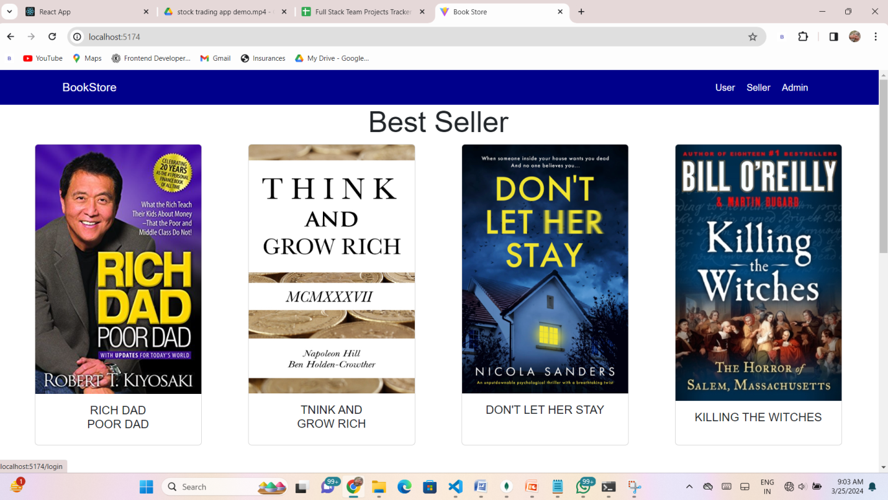

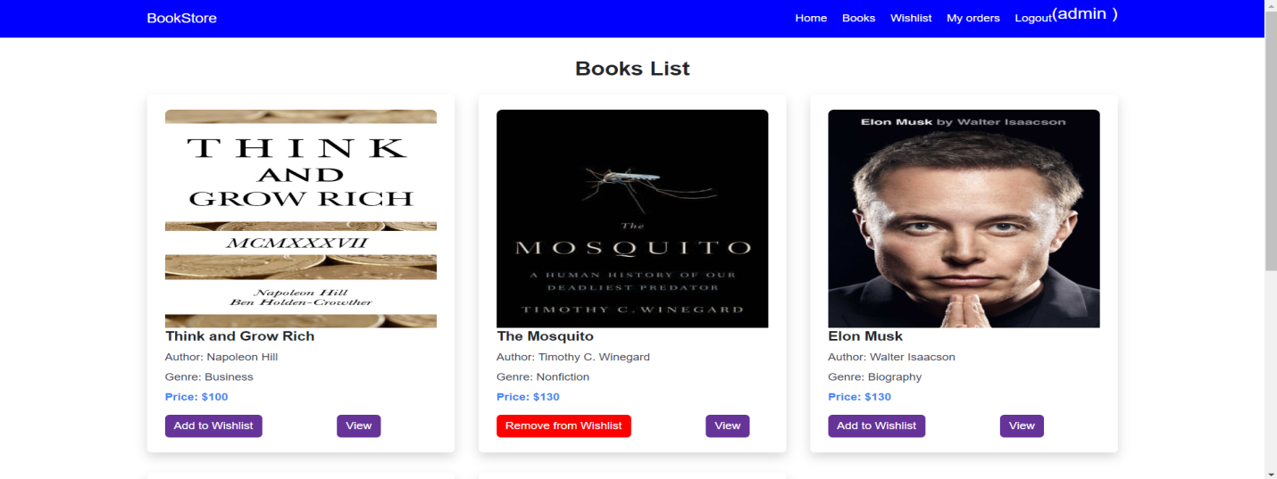

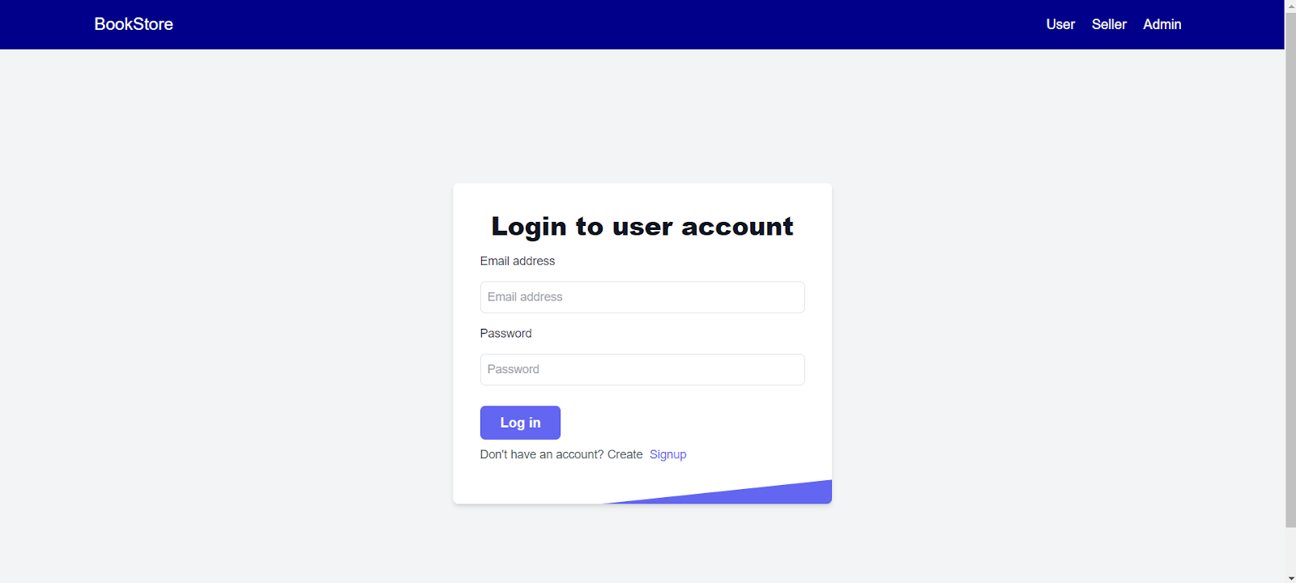

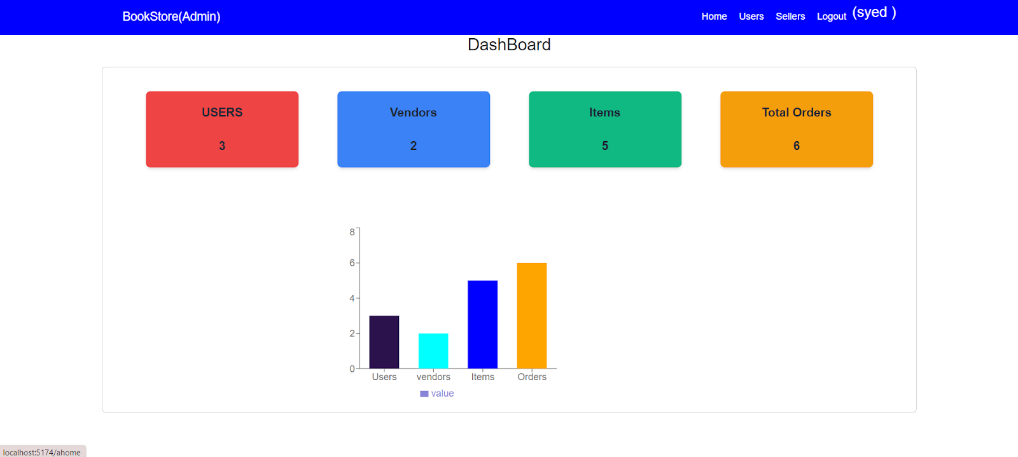

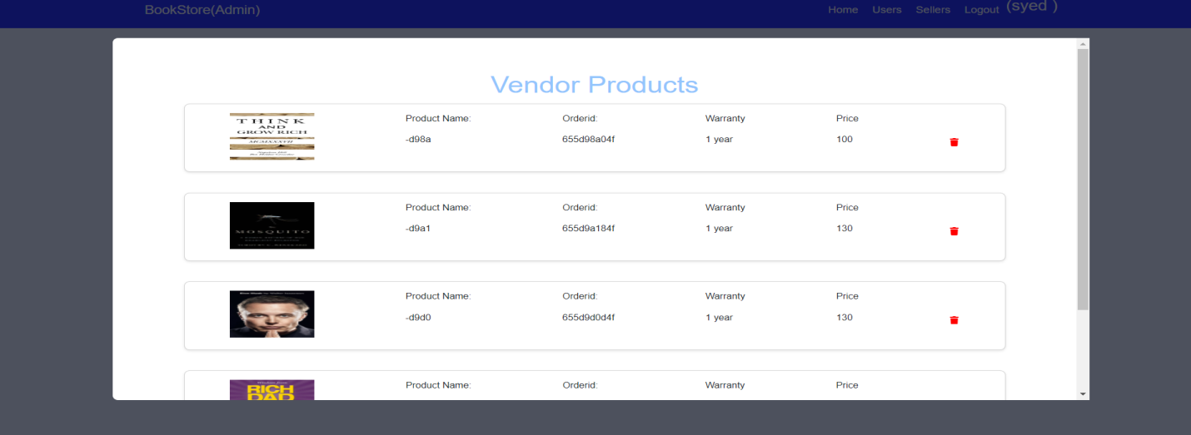

## CONCLUSION :

In conclusion, the development of this **Bookstore Platform** using the MERN stack demonstrates the power and flexibility of modern web technologies. By utilizing React for the frontend, Node.js and Express.js for the backend, and MongoDB for the database, the platform ensures a responsive, dynamic, and scalable user experience.

Key features such as book browsing, secure user authentication, seamless cart management, order processing, and an efficient admin dashboard make the platform both user-friendly and functional for customers and administrators alike. Readers can explore a wide range of books, view detailed descriptions, and place orders conveniently, while administrators can manage inventory, orders, and announcements with ease.

The architecture of the MERN stack provides the scalability required to handle increasing traffic and an expanding catalogue of books, ensuring consistent performance and reliability. This project serves as an example of how the MERN stack can be harnessed to build robust, feature-rich solutions tailored to specific domains like online bookstores, meeting the diverse needs of users effectively.

### **RESULT:**

The app has been successfully developed using the required software and technologies.