How do you get the number of containers running, paused and stopped?

Docker Basic Questions
This category of Docker Interview Questions consists of questions that you’re expected to know. These are the most basic questions. An interviewer will start with these and eventually increase the difficulty level. Let’s have a look at them.
1. What is Hypervisor?
A hypervisor is a software that makes virtualization possible. It is also called Virtual Machine Monitor. It divides the host system and allocates the resources to each divided virtual environment. You can basically have multiple OS on a single host system. There are two types of Hypervisors:
Type 1: It’s also called Native Hypervisor or Bare metal Hypervisor. It runs directly on the underlying host system. It has direct access to your host’s system hardware and hence does not require a base server operating system.
Type 2: This kind of hypervisor makes use of the underlying host operating system. It’s also called Hosted Hypervisor.
2. What is virtualization?
Virtualization is the process of creating a software-based, virtual version of something(compute storage, servers, application, etc.). These virtual versions or environments are created from a single physical hardware system. Virtualization lets you split one system into many different sections which act like separate, distinct individual systems. A software called Hypervisor makes this kind of splitting possible. The virtual environment created by the hypervisor is called Virtual Machine.
3. What is containerization?
Let me explain this is with an example. Usually, in the software development process, code developed on one machine might not work perfectly fine on any other machine because of the dependencies. This problem was solved by the containerization concept. So basically, an application that is being developed and deployed is bundled and wrapped together with all its configuration files and dependencies. This bundle is called a container. Now when you wish to run the application on another system, the container is deployed which will give a bug-free environment as all the dependencies and libraries are wrapped together. Most famous containerization environments are Docker and Kubernetes.
4. Difference between virtualization and containerization
Once you’ve explained containerization and virtualization, the next expected question would be differences. The question could either be differences between virtualization and containerization or differences between virtual machines and containers. Either way, this is how you respond.
Containers provide an isolated environment for running the application. The entire user space is explicitly dedicated to the application. Any changes made inside the container is never reflected on the host or even other containers running on the same host. Containers are an abstraction of the application layer. Each container is a different application.
Whereas in Virtualization, hypervisors provide an entire virtual machine to the guest(including Kernal). Virtual machines are an abstraction of the hardware layer. Each VM is a physical machine.
5. What is Docker?
Since its a Docker interview, there will be an obvious question about what is Docker. Start with a small definition.
Docker is a containerization platform which packages your application and all its dependencies together in the form of containers so as to ensure that your application works seamlessly in any environment, be it development, test or production. Docker containers, wrap a piece of software in a complete filesystem that contains everything needed to run: code, runtime, system tools, system libraries, etc. It wraps basically anything that can be installed on a server. This guarantees that the software will always run the same, regardless of its environment.
6. What is a Docker Container?
Docker containers include the application and all of its dependencies. It shares the kernel with other containers, running as isolated processes in user space on the host operating system. Docker containers are not tied to any specific infrastructure: they run on any computer, on any infrastructure, and in any cloud. Docker containers are basically runtime instances of Docker images.
7. What are Docker Images?
When you mention Docker images, your very next question will be “what are Docker images”.
Docker image is the source of Docker container. In other words, Docker images are used to create containers. When a user runs a Docker image, an instance of a container is created. These docker images can be deployed to any Docker environment.
8. What is Docker Hub?
Docker images create docker containers. There has to be a registry where these docker images live. This registry is Docker Hub. Users can pick up images from Docker Hub and use them to create customized images and containers. Currently, the Docker Hub is the world’s largest public repository of image containers.
9. Explain Docker Architecture?
Docker Architecture consists of a Docker Engine which is a client-server application with three major components:
A server which is a type of long-running program called a daemon process (the docker command).
A REST API which specifies interfaces that programs can use to talk to the daemon and instruct it what to do.
A command line interface (CLI) client (the docker command).
The CLI uses the Docker REST API to control or interact with the Docker daemon through scripting or direct CLI commands. Many other Docker applications use the underlying API and CLI.
Refer to this blog, to read more about Docker Architecture.
10. What is a Dockerfile?
Let’s start by giving a small explanation of Dockerfile and proceed by giving examples and commands to support your arguments.
Docker can build images automatically by reading the instructions from a file called Dockerfile. A Dockerfile is a text document that contains all the commands a user could call on the command line to assemble an image. Using docker build, users can create an automated build that executes several command-line instructions in succession.
The interviewer does not just expect definitions, hence explain how to use a Dockerfile which comes with experience. Have a look at this tutorial to understand how Dockerfile works.

FROM python:3.8-slim-buster

WORKDIR /python-docker

COPY requirements.txt requirements.txt
RUN pip3 install -r requirements.txt

COPY . .

CMD [ "python3", "-m" , "flask", "run", "--host=0.0.0.0"]

11. Tell us something about Docker Compose.
Docker Compose is a YAML file which contains details about the services, networks, and volumes for setting up the Docker application. So, you can use Docker Compose to create separate containers, host them and get them to communicate with each other. Each container will expose a port for communicating with other containers.
12. What is Docker Swarm?
You are expected to have worked with Docker Swarm as it’s an important concept of Docker.
Docker Swarm is native clustering for Docker. It turns a pool of Docker hosts into a single, virtual Docker host. Docker Swarm serves the standard Docker API, any tool that already communicates with a Docker daemon can use Swarm to transparently scale to multiple hosts.
13. What is a Docker Namespace?
A namespace is one of the Linux features and an important concept of containers. Namespace adds a layer of isolation in containers. Docker provides various namespaces in order to stay portable and not affect the underlying host system. Few namespace types supported by Docker – PID, Mount, IPC, User, Network
14. What is the lifecycle of a Docker Container?
This is one of the most popular questions asked in Docker interviews. Docker containers have the following lifecycle:
Create a container
Run the container
Pause the container(optional)
Un-pause the container(optional)
Start the container
Stop the container
Restart the container
Kill the container
Destroy the container
15. What is Docker Machine?
Docker machine is a tool that lets you install Docker Engine on virtual hosts. These hosts can now be managed using the docker-machine commands. Docker machine also lets you provision Docker Swarm Clusters.
Docker Basic Commands
Once you’ve aced the basic conceptual questions, the interviewer will increase the difficulty level. So let’s move on to the next section of this Docker Interview Questions article. This section talks about the commands that are very common amongst docker users.
16. How to check for Docker Client and Docker Server version?
The following command gives you information about Docker Client and Server versions:
$ docker version
17. How do you get the number of containers running, paused and stopped?
You can use the following command to get detailed information about the docker installed on your system.
$ docker info


You can get the number of containers running, paused, stopped, the number of images and a lot more.
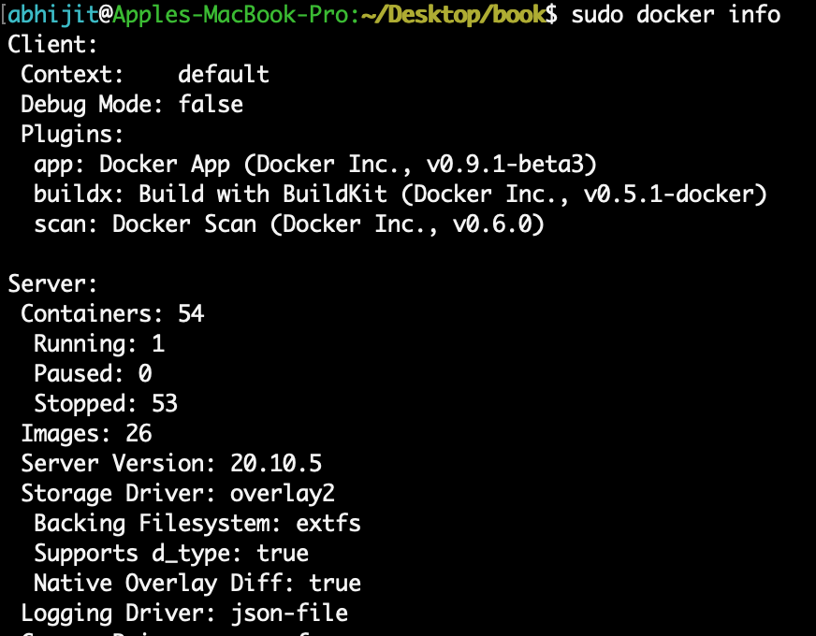

18. If you vaguely remember the command and you’d like to confirm it, how will you get help on that particular command?
The following command is very useful as it gives you help on how to use a command, the syntax, etc.
$ docker --help
The above command lists all Docker commands. If you need help with one specific command, you can use the following syntax:
$ docker <command> --help
19. How to login into docker repository?
You can use the following command to login into hub.docker.com:
$ docker login
You’ll be prompted for your username and password, insert those and congratulations, you’re logged in.
20. If you wish to use a base image and make modifications or personalize it, how do you do that?
You pull an image from docker hub onto your local system
It’s one simple command to pull an image from docker hub:
$ docker pull <image_name>
21. How do you create a docker container from an image?
Pull an image from docker repository with the above command and run it to create a container. Use the following command:
$ docker run -it -d <image_name>
Most probably the next question would be, what does the ‘-d’ flag mean in the command?
-d means the container needs to start in the detached mode. Explain a little about the detach mode. Have a look at this blog to get a better understanding of different docker commands.
22. How do you list all the running containers?
The following command lists down all the running containers:
$ docker ps
23. Suppose you have 3 containers running and out of these, you wish to access one of them. How do you access a running container?
The following command lets us access a running container:
$ docker exec -it <container id> bash
The exec command lets you get inside a container and work with it.
24. How to start, stop and kill a container?
The following command is used to start a docker container:
$ docker start <container_id>
and the following for stopping a running container:
$ docker stop <container_id>
kill a container with the following command:
$ docker kill <container_id>
25. Can you use a container, edit it, and update it? Also, how do you make it a new and store it on the local system?
Of course, you can use a container, edit it and update it. This sounds complicated but its actually just one command.
$ docker commit <conatainer id> <username/imagename>
26. Once you’ve worked with an image, how do you push it to docker hub?
$ docker push <username/image name>
27. How to delete a stopped container?
Use the following command to delete a stopped container:
$ docker rm <container id>
28. How to delete an image from the local storage system?
The following command lets you delete an image from the local system:
$ docker rmi <image-id>
29. How to build a Dockerfile?
Once you’ve written a Dockerfile, you need to build it to create an image with those specifications. Use the following command to build a Dockerfile:
$ docker build <path to docker file>
Usage

$ docker build [OPTIONS] PATH | URL | -

The docker build command builds Docker images from a Dockerfile and a “context”. A build’s context is the set of files located in the specified PATH or URL. The build process can refer to any of the files in the context. For example, your build can use a COPY instruction to reference a file in the context.
The URL parameter can refer to three kinds of resources: Git repositories, pre-packaged tarball contexts and plain text files.

Build with a PATH
$docker build .
This example specifies that the PATH is ., and so all the files in the local directory get tard and sent to the Docker daemon.

Tag an image (-t, --tag)
$docker build -t vieux/apache:2.0 .

This will build like the previous example, but it will then tag the resulting image. The repository name will be vieux/apache and the tag will be 2.0

Specify a Dockerfile (-f, --file)
$docker build -f dockerfiles/Dockerfile.debug -t myapp_debug .
docker build -f dockerfiles/Dockerfile.prod -t myapp_prod .
The next question would be when do you use “.dockerfile_name” and when to use the entire path?
Use “.dockerfile_name” when the dockerfile exits in the same file directory and you use the entire path if it lives somewhere else.

30. Do you know why docker system prune is used? What does it do?
$ docker system prune
The above command is used to remove all the stopped containers, all the networks that are not used, all dangling images and all build caches. It’s one of the most useful docker commands.
Docker Advanced Questions
Once the interviewer knows that you’re familiar with the Docker commands, he/she will start asking about practical applications This section of Docker Interview Questions consists of questions that you’ll only be able to answer when you’ve gained some experience working with Docker.
31. Will you lose your data, when a docker container exists?
No, you won’t lose any data when Docker container exits. Any data that your application writes to the container gets preserved on the disk until you explicitly delete the container. The file system for the container persists even after the container halts.
32. Where all do you think Docker is being used?
When asked such a question, respond by talking about applications of Docker. Docker is being used in the following areas:
Simplifying configuration: Docker lets you put your environment and configuration into code and deploy it.
Code Pipeline Management: There are different systems used for development and production. As the code travels from development to testing to production, it goes through a difference in the environment. Docker helps in maintaining the code pipeline consistency.
Developer Productivity: Using Docker for development gives us two things – We’re closer to production and development environment is built faster.
Application Isolation: As containers are applications wrapped together with all dependencies, your apps are isolated. They can work by themselves on any hardware that supports Docker.
Debugging Capabilities: Docker supports various debugging tools that are not specific to containers but work well with containers.
Multi-tenancy: Docker lets you have multi-tenant applications avoiding redundancy in your codes and deployments.
Rapid Deployment: Docker eliminates the need to boost an entire OS from scratch, reducing the deployment time.
33. How is Docker different from other containerization methods?
Docker containers are very easy to deploy in any cloud platform. It can get more applications running on the same hardware when compared to other technologies, it makes it easy for developers to quickly create, ready-to-run containerized applications and it makes managing and deploying applications much easier. You can even share containers with your applications.
If you have some more points to add you can do that but make sure the above explanation is there in your answer.
34. Can I use JSON instead of YAML for my compose file in Docker?
You can use JSON instead of YAML for your compose file, to use JSON file with compose, specify the JSON filename to use, for eg:
$ docker-compose -f docker-compose.json up
35. How have you used Docker in your previous position?
Explain how you have used Docker to help rapid deployment. Explain how you have scripted Docker and used it with other tools like Puppet, Chef or Jenkins. If you have no past practical experience in Docker and instead have experience with other tools in a similar space, be honest and explain the same. In this case, it makes sense if you can compare other tools to Docker in terms of functionality.
36. How far do Docker containers scale? Are there any requirements for the same?
Large web deployments like Google and Twitter and platform providers such as Heroku and dotCloud, all run on container technology. Containers can be scaled to hundreds of thousands or even millions of them running in parallel. Talking about requirements, containers require the memory and the OS at all the times and a way to use this memory efficiently when scaled.
37. What platforms does docker run on?
This is a very straightforward question but can get tricky. Do some company research before going for the interview and find out how the company is using Docker. Make sure you mention the platform company is using in this answer.
Docker runs on various Linux administration:
Ubuntu 12.04, 13.04 et al
Fedora 19/20+
RHEL 6.5+
CentOS 6+
Gentoo
ArchLinux
openSUSE 12.3+
CRUX 3.0+
It can also be used in production with Cloud platforms with the following services:
Amazon EC2
Amazon ECS
Google Compute Engine
Microsoft Azure
Rackspace
38. Is there a way to identify the status of a Docker container?
There are six possible states a container can be at any given point – Created, Running, Paused, Restarting, Exited, Dead.
Use the following command to check for docker state at any given point:
$ docker ps
The above command lists down only running containers by default. To look for all containers, use the following command:
$ docker ps -a
The Docker Remote API defines the following states:
created A container that has been created (e.g. with docker create) but not started
restarting A container that is in the process of being restarted
running A currently running container
paused A container whose processes have been paused
exited A container that ran and completed ("stopped" in other contexts, although a created container is technically also "stopped")
dead A container that the daemon tried and failed to stop (usually due to a busy device or resource used by the container)

39. Can you remove a paused container from Docker?
The answer is no. You cannot remove a paused container. The container has to be in the stopped state before it can be removed.
40. Can a container restart by itself?
No, it’s not possible for a container to restart by itself. By default the flag -restart is set to false.
41. Is it better to directly remove the container using the rm command or stop the container followed by remove container?
Its always better to stop the container and then remove it using the remove command.
$ docker stop <coontainer_id>
$ docker rm -f <container_id>
Stopping the container and then removing it will allow sending SIG_HUP signal to recipients. This will ensure that all the containers have enough time to clean up their tasks. This method is considered a good practice, avoiding unwanted errors.
42. Will cloud overtake the use of Containerization?
Docker containers are gaining popularity but at the same time, Cloud services are giving a good fight. In my personal opinion, Docker will never be replaced by Cloud. Using cloud services with containerization will definitely hype the game. Organizations need to take their requirements and dependencies into consideration into the picture and decide what’s best for them. Most of the companies have integrated Docker with the cloud. This way they can make the best out of both the technologies.
43. How many containers can run per host?
There can be as many containers as you wish per host. Docker does not put any restrictions on it. But you need to consider every container needs storage space, CPU and memory which the hardware needs to support. You also need to consider the application size. Containers are considered to be lightweight but very dependant on the host OS.
44. Is it a good practice to run stateful applications on Docker?
The concept behind stateful applications is that they store their data onto the local file system. You need to decide to move the application to another machine, retrieving data becomes painful. I honestly would not prefer running stateful applications on Docker.

45. Suppose you have an application that has many dependant services. Will docker compose wait for the current container to be ready to move to the running of the next service?
The answer is yes. Docker compose always runs in the dependency order. These dependencies are specifications like depends_on, links, volumes_from, etc.
Docker-compose.yaml
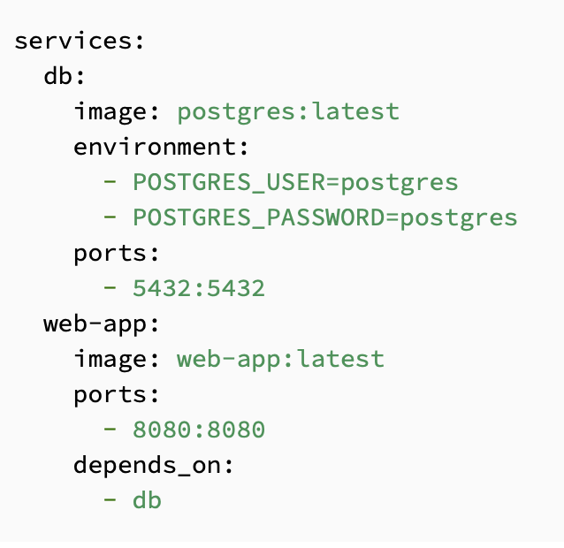

46. How will you monitor Docker in production?
Docker provides functionalities like docker stats and docker events to monitor docker in production. Docker stats provides CPU and memory usage of the container. Docker events provide information about the activities taking place in the docker daemon.
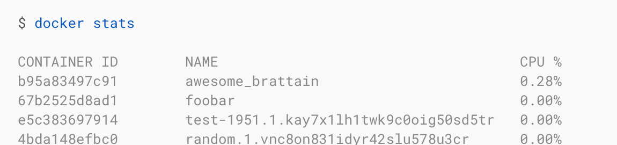

47. Is it a good practice to run Docker compose in production?
Yes, using docker compose in production is the best practical application of docker compose. When you define applications with compose, you can use this compose definition in various production stages like CI, staging, testing, etc.
48. What changes are expected in your docker compose file while moving it to production?
These are the following changes you need make to your compose file before migrating your application to the production environment:
Remove volume bindings, so the code stays inside the container and cannot be changed from outside the container.
Binding to different ports on the host.
Specify a restart policy
Add extra services like log aggregator
49. Have you used Kubernetes? If you have, which one would you prefer amongst Docker and Kubernetes?
Be very honest in such questions. If you have used Kubernetes, talk about your experience with Kubernetes and Docker Swarm. Point out the key areas where you thought docker swarm was more efficient and vice versa. Have a look at this blog for understanding differences between Docker and Kubernetes.
You Docker interview questions are not just limited to the workarounds of docker but also other similar tools. Hence be prepared with tools/technologies that give Docker competition. One such example is Kubernetes.
50. Are you aware of load balancing across containers and hosts? How does it work?
While using docker service with multiple containers across different hosts, you come across the need to load balance the incoming traffic. Load balancing and HAProxy is basically used to balance the incoming traffic across different available(healthy) containers. If one container crashes, another container should automatically start running and the traffic should be re-routed to this new running container. Load balancing and HAProxy works around this concept.
This brings us to the end of the Docker Interview Questions article. With increasing business competition, companies have realized the importance of adapting and taking advantage of the changing market. Few things that kept them in the game were faster scaling of systems, better software delivery, adapting to new technologies, etc. That’s when docker swung into the picture and gave these companies boosting support to continue the race.

Can Windows containers run on Linux?
A: No. They cannot. But you can run Linux on Windows.
But - you can do it by using VM - as it works on Windows. You can install a Windows VM on your Linux host, which will allow to run Windows containers.

Docker for Windows can run a Linux VM freely, Docker for Linux would require a Windows license in order to run it inside a VM.

Docker for Windows allows you to simulate running Linux containers on Windows, but under the hood a Linux VM is created, so still Linux containers are running on Linux, and Windows containers are running on Windows.

3. What is the benefit of using a Docker over a Hypervisor?

Though Docker and Hypervisor might do the same job overall, there are many differences between them in terms of how they work. Docker can be thought of as lightweight since it uses very few resources and also the host kernel rather than creating it like a Hypervisor.

4. What are the unique features of Docker over other containerization technologies?

Some of the most important and unique features of Docker are as follows:
We can run our Docker container either on our PC or on our enterprise IT system.
Along with the Docker Hub, which is a repository of all containers, we can deploy and download all our applications from a central location.
We can even share our applications with the containers that we create.

10. What is Docker Compose?

Docker Compose defines and runs multi-container Docker applications. With Compose, a YAML file is used to configure an application’s services. All the services from the configuration can be created and started with a single command.

11. Why use Docker?

Following are the reasons why one should use Docker:
It allows the use of system resources more efficiently
Software delivery cycles are faster with it
Application portability is possible and easy
It is great for the microservices architecture

12. What are the drawbacks of Docker?

Docker has a few drawbacks as listed below:
No storage option
Poor monitoring
Unable to automatically reschedule inactive nodes
Has a complicated automatic horizontal scaling setup

13. What is Docker Engine?

Docker Engine is an open-source containerization technology that facilitates the development, assembling, shipping, and running of applications with the help of the following components:
Docker Daemon
Docker Engine REST API
Docker CLI

14. What are registries?

Docker registries provide locations for storing and downloading images. There are two types of registries
Public registry
Private registry
Public registries include Docker Hub and Docker Cloud.

15. What are Docker namespaces?

When a container is run, Docker creates a set of isolated workspaces for the container called namespaces.

16. How to use Docker?

The Docker command syntax looks like this:
docker run [OPTIONS] IMAGE [COMMAND] [ARG...]
To run a container, we must incorporate the image on which it is based:
docker run [docker_image]
We can run containers if the Docker images are locally stored. If they are not, the software will take it from the online registry.
Docker can be used to run a container:
Under a specific name
Interactively
And publish container ports
In the background in the detached mode
And mount host volumes
And remove it once the process is complete

18. What is the process for creating a Docker container?

We can use any specific Docker image for creating a Docker container using the below command:
docker run -t -i command name
This command not only creates the container but also starts it for us. If we want to check whether the Docker container has been created or not, then we need to have the following command that will list all the Docker containers, along with the host on which the Docker containers run:
docker ps -a

19. What is the process for stopping and restarting a Docker container?

To stop a Docker container, we need to use the following command:
docker stop CONTAINER_ID
To restart a Docker container, we need to use the following command:
docker restart CONTAINER_ID

22. How to remove Docker images?

Use docker images with the -a flag to get the image IDs for removal. Then, pass their IDs or tags to
docker rmi:
List:
docker images -a
Remove:
docker rmi Image Image

23. Where are Docker images stored?

It depends on which system the Docker is running and the Docker storage driver is being used.
For example, on Windows, Docker images are stored by default in:
C:\ProgramData\DockerDesktop
On a Mac, Docker images are stored by default in:
~/Library/Containers/com.docker.docker/Data/vms/0/

26. How to use Docker Compose?

Docker Compose typically includes a three-step process:
Using a dockerfile to define the app’s environment to facilitate reproduction anywhere
Defining the app services in docker-compose.yml so that they can run in an isolated environment together
Running docker-compose up

28. What is Docker daemon?

Docker daemon is a service that manages Docker containers, images, storage volumes, and the network. It constantly listens to Docker API requests and processes them. A daemon can communicate with other daemons as well for the management of Docker services.

30. What is Docker Hub?

Docker Hub helps with linking to code repositories. This cloud-based registry enables the building, testing, and storing of images in Docker Cloud. Images can also be deployed to the host with it.

33. What are Docker object labels?

Docker object labels help us add metadata to Docker objects, including containers, images, Swarm nodes, network, volumes, and services.

34. What are the steps in a Docker container life cycle?

Build
Pull
Run

35. Name the three components of the Docker architecture.

Client
Docker host
Registry

37. How does communication happen between Docker client and Docker daemon?

The communication between Docker client and Docker daemon happens with the help of the combination of TCP, Rest API, and Socket.IO.

38. Explain the implementation method of continuous integration (CI) and continuous deployment (CD) in Docker.

Run Jenkins on Docker
Using docker-compose, run integration tests in Jenkins

39. How to run a Docker container?

The Docker run command manages the running of containers in Docker.
Running a container under a specific name:
The command for running a container under a specific name is:
docker container run --name [container_name] [docker_image]
Running a container in the background in the detached mode:
The command for running a container in the background is:
docker container run -d [docker_image]
Running a container interactively:
The following command is run for running a container interactively:
docker container run -it [docker_image] /bin/bash
Running a container and publishing container ports:
We have to include -p to the docker run command, along with the following:
-p [host_ip]:[host_port]:[container_port]
Here, host_ip is optional. It is not mandatory to specify this while we run the command.
Running a container and mounting host volumes:
The docker container run command looks like this:
docker container run -v [/host/volume/location]:[/container/storage] [docker_image]

40. Tell us how you have used Docker in your past position.

This is a question wherein we could bring upon our whole experience with Docker and any other Container technologies we have used prior to Docker. We could also explain the ease that this technology has brought in the automation of the development-to-production life cycle management. We can also discuss any other integrations that we might have worked, along with Docker, such as Puppet, Chef, or even the most popular of all technologies—Jenkins. If we do not have any experience with Docker but we have it with similar tools from this space, we could convey the same and also show our interest in learning this leading containerization technology.

1. Docker Vs VM (Virtual Machine)
Virtual Machines | Docker Containers
Need more resources | Less resources are used
Process isolation is done at the hardware level | Process Isolation is done at Operating System-level
Separate Operating System for each VM | Operating System resources can be shared within Docker
VMs can be customized | Custom container setup is easy
Takes time to create a Virtual Machine | The creation of docker is very quick
Booting takes minutes | Booting is done within seconds.

19. Why do my services take 10 seconds to recreate or stop?
A docker-compose stop will attempt to stop a specific Docker container by sending a SIGTERM message. Once this message is delivered, it waits for the default timeout period of 10 seconds and once the timeout period is crossed, it then sends out a SIGKILL message to the container – in order to kill it forcefully. If you are actually waiting for the timeout period, then it means that the containers are not shutting down on receiving SIGTERM signals/messages.
In an attempt to solve this issue, the following is what you can do:
You can ensure that you are using the JSON form of the CMD and also the ENTRYPOINT in your docker file.
Use [“program”, “argument1”, “argument2”] instead of sending it as a plain string as like this – “program argument1 argument2”.
Using the string form, makes Docker run the process using a bash that can’t handle signals properly. Compose always uses the JSON form.
If it is possible then modify the application which you intend to run by adding an explicit signal handler for the SIGTERM signal
Also, set the stop_signal to a proper signal that the application can understand and also know how to handle it.
20. How do I run multiple copies of a Compose file on the same host?
Docker’s compose makes use of the Project name to create unique identifiers for all of the project’s containers and resources. In order to run multiple copies of the same project, you will need to set a custom project name using the –p command-line option or you could use the COMPOSE_PROJECT_NAME environment variable for this purpose.
21. What’s the difference between up, run, and start?
In any given scenario, you would always want your docker-compose up. Using the command UP, you can start or restart all the services that are defined in a docker-compose.yml file. In the “attached” mode, which is also the default mode – we will be able to see all the log files from all the containers. In the “detached” mode, it exits after starting all the containers, which continue to run in the background showing nothing over in the foreground.
Using the docker-compose run command, we will be able to run the one-off or the ad-hoc tasks that are required to be run as per the Business needs and requirements. This requires the service name to be provided which you would want to run and based on that, it will only start those containers for the services that the running service depends on. Using the run command, you can run your tests or perform any of the administrative tasks like removing/adding data to the data volume container. It is also very similar to the docker run –ti command, which opens up an interactive terminal to the containers an exit status that matches with the exit status of the process in the container.
Using the docker-compose start command, you can only restart the containers that were previously created and were stopped. This command never creates any new Docker containers on its own.

22. What’s the benefit of “Dockerizing?”
Dockerizing enterprise environments helps teams to leverage the Docker containers to form a service platform like CaaS (Container as a Service). It gives teams the necessary agility, and portability and also lets them control staying within their own network/environment.
Most of the developers opt to use Docker and Docker alone because of the flexibility and also the ability that it provides to quickly build and ship applications to the rest of the world. Docker containers are portable and these can run in any environment without making any additional changes when the application developers have to move between Developer, Staging, and Production environments. This whole process is seamlessly implemented without the need of performing any recoding activities for any of the environments. These not only help reduce the time between these lifecycle states but also ensures that the whole process is performed with utmost efficiency. There is every possibility for the Developers to debug any certain issue, fix it and also update the application with it and propagate this fix to the higher environments with the utmost ease.
The operations teams can handle the security of the environments while also allowing the developers to build and ship the applications in an independent manner. The CaaS platform that is provided by the Docker framework can deploy on-premise and is also loaded with full of enterprise-level security features such as role-based access control, integration with LDAP or any Active Directory, image signing and etc. Operations teams have heavily relied on the scalability provided by Docker and can also leverage the Dockerized applications across any environment.
Docker containers are so portable that it allows teams to migrate workloads that run on an Amazon’s AWS environment to Microsoft Azure without even having to change its code and also with no downtime at all. Docker allows teams to migrate these workloads from their cloud environments to their physical datacenters and vice versa. This also enables the Organizations to focus on the infrastructure from the gained advantages both monetarily and also the self-reliability over Docker. The lightweight nature of Docker containers compared to traditional tools like virtualization, combined with the ability for Docker containers to run within VMs, allows teams to optimize their infrastructure by 20X, and save money in the process.

23. How many containers can run per host?
Depending on the environment where Docker is going to host the containers, there can be as many containers as the environment supports. The application size, and available resources (like CPU, and memory) will decide on the number of containers that can run on an environment. Though containers create newer CPUs on their own they can definitely provide efficient ways of utilizing the resources. The containers themselves are super lightweight and only last as long as the process they are running.
24. Is there a possibility to include a specific code with COPY/ADD or a volume?
This can be easily achieved by adding either the COPY or the ADD directives in your docker file. This will count to be useful if you want to move your code along with any of your Docker images, for example, sending your code an environment up the ladder – The development environment to the Staging environment or from the Staging environment to the Production environment.
Having said that, you might come across situations where you’ll need to use both approaches. You can have the image include the code using a COPY, and use a volume in your Compose file to include the code from the host during development. The volume overrides the directory contents of the image.

27. What are the differences between the ‘docker run’ and the ‘docker create’?
The most important difference that can be noted is that, by using the ‘docker create’ command we can create a Docker container in the Stopped state. We can also provide it with an ID that can be stored for later usages as well.
This can be achieved by using the command ‘docker run’ with the option –cidfile FILE_NAME as like this:
‘docker run –cidfile FILE_NAME’
28. What are the various states that a Docker container can be in at any given point in time?
There are four states that a Docker container can be in, at any given point in time. Those states are as given as follows:
• Running
• Paused
• Restarting
• Exited
29. Can you remove a paused container from Docker?
To answer this question blatantly, No, it is not possible to remove a container from Docker that is just paused. It is a must that a container should be in the stopped state before it can be removed from the Docker container.
30. Is there a possibility that a container can restart all by itself in Docker?
To answer this question blatantly, No, it is not possible. The default –restart flag is set to never restart on its own. If you want to tweak this, then you may give it a try.
31. What is the preferred way of removing containers - ‘docker rm -f’ or ‘docker stop’ then followed by a ‘docker rm’?
The best and the preferred way of removing containers from Docker is to use the ‘docker stop’, as it will allow sending a SIG_HUP signal to its recipients giving them the time that is required to perform all the finalization and cleanup tasks. Once this activity is completed, we can then comfortably remove the container using the ‘docker rm’ command from Docker and thereby update the docker registry as well.
32. Difference between Docker Image and container?
Docker container is the runtime instance of the docker image.
Docker Image doesn't have a state and its state never changes as it is just a set of files whereas the docker container has its execution state.

What are image layers ?

https://jessicagreben.medium.com/digging-into-docker-layers-c22f948ed612

Docker images are mainly responsible for shipping, storing, and delivering containerized applications. Docker images are your starting point if you are a first-time Docker user. However, these images are a composition of different Docker image layers.

Docker images consist of many layers. Each layer is built on top of another layer to form a series of intermediate images. This arrangement ensures that each layer depends on the layer immediately below it. The way layers are placed in a hierarchy is very significant. It allows you to place the layers that frequently change high up the hierarchy so that you manage the Docker image’s lifecycle efficiently.

Each Docker image layer represents an instruction in the Dockerfile. A Dockerfile refers to a text document consisting of all the commands required to assemble an image. Only the top layer of Docker images has read-write permissions; the rest have read-only permissions. Like the copy-on-write concept, this technology ensures that the changes you make when running a container from the image are made to the top writable layer.

Why Docker Image Layers Are Important
Docker image layers are beneficial in many ways.
Layers allow you to work with Docker images faster. This is because the builds avoid unnecessary steps, and the pulling and pushing of images skips the transfer of a large unchanged amount of data already available in the intended destination.
The use of the copy-on-write file system saves disk space for future containers and images.
Layers allow you to apply less computational effort (in image building) and save on bandwidth (in image distribution).

Each time a command is executed from the Dockerfile, a new image layer is created on top of the existing image. This process is iterated until Docker reads the last command of the Dockerfile. Each instruction created a new image.

What is overlayfs ?

When docker image deployed on multiple machines.
When docker host initiates a swarm or joins a swarm cluster, 2 new networks are created

A default overlay network: ingress
A virtual bridge network: dockcer_gwbridge

Where the image layers can be found in which directory ?

In the command line interface (CLI), each layer of a Docker image is viewable under /var/lib/docker/aufs/diff, or via the Docker history command). Docker shows all top-layer images, Like the repository, tags and file sizes, by default.
$docker history --no-trunc <Image ID>

How can we check the content of each layer ?

You can view the contents of each layer on the Docker host at /var/lib/docker/aufs/diff . Layers are neat because they can be re-used by multiple images saving disk space and reducing time to build images while maintaining their integrity.

What is Union Mount & AUFS ?

AUFS is a union filesystem, which means that it layers multiple directories on a single Linux host and presents them as a single directory. These directories are called branches in AUFS terminology, and layers in Docker terminology. The unification process is referred to as a union mount.

In computer operating systems, union mounting is a way of combining multiple directories into one that appears to contain their combined contents.

How to create a volume in docker container to store data ?

docker volume create: Creates a new volume that containers can consume and store data in.
Creates a new volume that containers can consume and store data in. If a name is not specified, Docker generates a random name.

Create a volume and then configure the container to use it:

$ docker volume create hello

hello

$ docker run -d -v hello:/world busybox ls /world

3 types:
Mount host doler/directory to container internal path

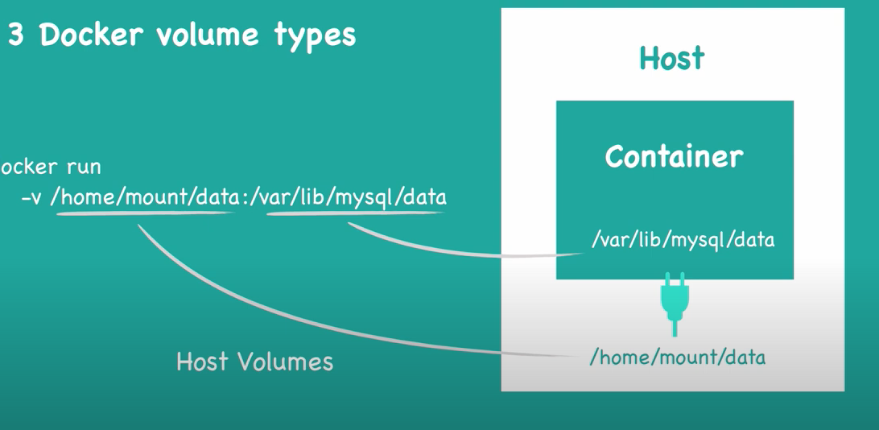

Anonymous volume

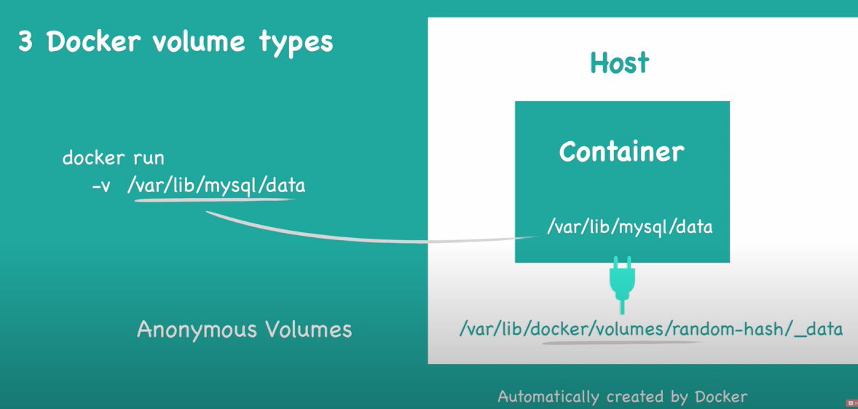

Named Volume

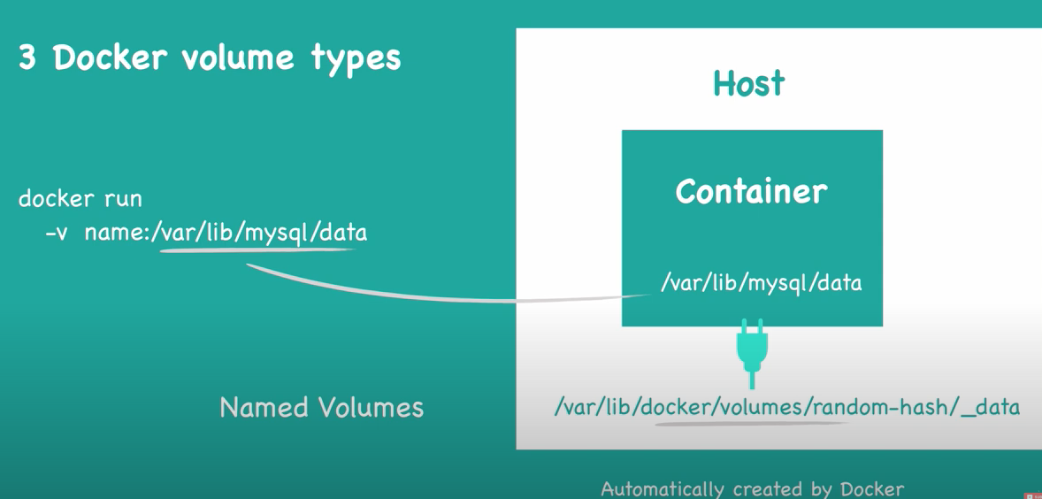
Docker compose:

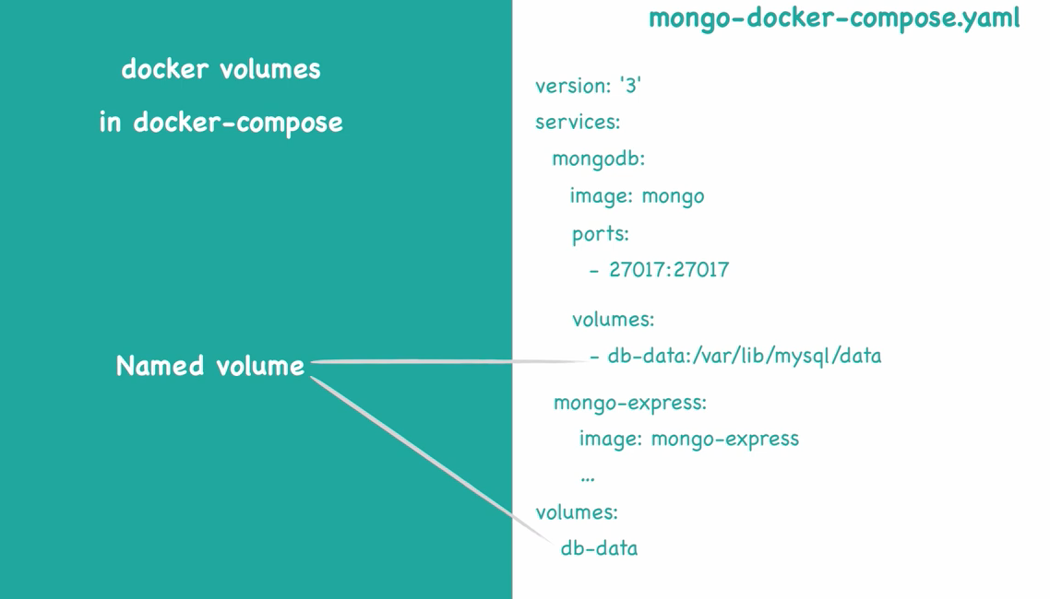

How docker container communicate with each other ?

Two containers can talk to each other in one of two ways, usually:
Communicating through networking: Containers are designed to be isolated. But they can send and receive requests to other applications, using networking. For example: a web server container might expose a port, so that it can receive requests on port 80. Or an application container might make a connection to a database container.
Sharing files on disk: Some applications communicate by reading and writing files. These kinds of applications can communicate by writing their files into a volume, which can also be shared with other containers. For example: a data processing application might write a file to a shared volume which contains customer data, which is then read by another application. Or, two identical containers might even share the same files.

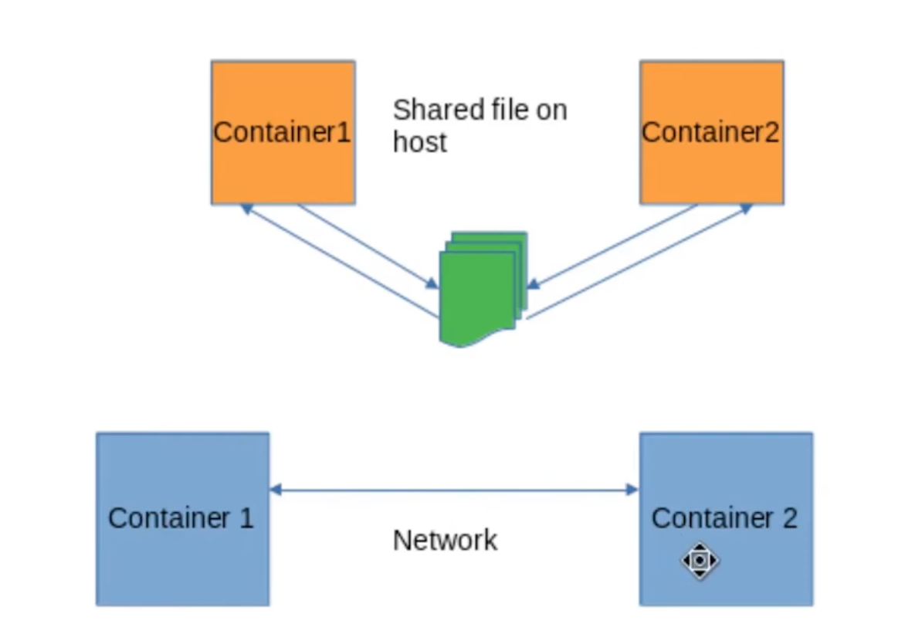

By default container join bridge network. We can inspect docker container , get IP address and use that IP to communicate.

Docker creates virtual networks which let your containers talk to each other. In a network, a container has an IP address, and optionally a hostname.
You can create different types of networks depending on what you would like to do. We’ll cover the easiest options:
The default bridge network, which allows simple container-to-container communication by IP address, and is created by default.
A user-defined bridge network, which you create yourself, and allows your containers to communicate with each other, by using their container name as a hostname.

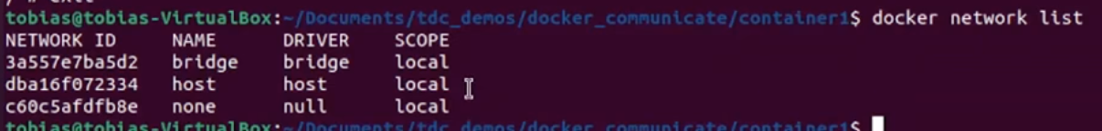

Create a user-defined bridge network:
docker network create tulip-net

Start a container and connect it to the bridge
docker run --rm --net tulip-net --name tulipnginx -d nginx

Address another container, using its name as the hostname:

# Start a busybox container so that we can test out the network
$ docker run --net tulip-net -it busybox sh

# Use 'wget' inside busybox, using the container name as the hostname!
busybox$ wget -q -O - tulipnginx:80

How do you sequence the containers? A first then B should execute after that ?

services:
web:
build: .
depends_on:
- db
- redis
redis:
image: redis
db:
image: postgres

User depends_on in Docker-compose file.

How to mount a local directory into a container ?

Using the parameter -v allows you to bind a local directory. -v or --volume allows you to mount local directories and files to your

$ docker run --name mysql-db -v $(pwd)/datadir:/var/lib/mysql -e MYSQL_ROOT_PASSWORD=my-secret-pw -d mysql:8.0.28-debian

How to expose a port number to access container ?

Including an EXPOSE instruction in the Dockerfile
EXPOSE 8081/tcp
EXPOSE 8080/tcp

Using –expose
On the other hand, –expose is a runtime flag that lets you expose a specific port or a range of ports inside the container.
docker run –expose=8080 test

Publishing Docker ports via -P or -p
There are two ways of publishing ports in Docker:
Using the -P flag
Using the -p flag

Using the -P (upper case) flag at runtime lets you publish all exposed ports to random ports on the host interfaces. It’s short for –publish-all.
Docker allows you to add -P at runtime and convert the EXPOSE instructions in the Dockerfile to specific port mapping rules.

-p 8080:80. Binds container TCP port 80 to host’s port 8080

How to see the port number ? Inspect ? $docker ps -a --no-trunc

What is entrypoint in docker ?

ENTRYPOINT is one of the many instructions you can write in a dockerfile. The ENTRYPOINT instruction is used to configure the executables that will always run after the

What is the difference between CMD and ENTRYPOINT ?

The ENTRYPOINT instruction looks almost similar to the CMD instruction.
CMD: Sets default parameters that can be overridden from the Docker command line interface (CLI) while running a docker container.
ENTRYPOINT: Sets default parameters that cannot be overridden while executing Docker containers with CLI parameters.

Can I use both ENTRYPOINT and CMD?

If both ENTRYPOINT and CMD are present, what is written in CMD is executed as an option of the command written in ENTRYPOINT. If an argument is added at the time of docker run , the contents of CMD will be overwritten and the ENTRYPOINT command will be executed.

Difference between ADD & COPY parameters in dockerfile ?

COPY takes in a source and destination. It only lets you copy in a local or directory from your host (the machine-building the Docker image) into the Docker image itself. ADD does that same but in addition, it also supports 2 other sources. A URL instead of a local file/directory.

While functionality is similar, the ADD directive is more powerful in two ways as follows:
It can handle remote URLs
It can also auto-extract tar files.

How to create a bridge in container ?

Use the docker network create command to create a user-defined bridge network.

$ docker network create my-net

How a container gets an internal IP ?

A container receives an IP address out of the IP pool of the network it attaches to. The Docker daemon effectively acts as a DHCP server for each container. Each network also has a default subnet mask and gateway.

Can we check the process of a container inside as well as outside the container ?

Yes, you can run ps -aux or -eaf outside and inside the container.

$ps -aux (On host machine)
$docker exec -it 3256d81c7c4c sh (attach to running docker and get shell prompt)
#ps -ef

If you have ubuntu and running docker on that, both use same kernel so you will be able to see process from the outside, if you run Mac, and docker, on Mac, Linux VM will be running and docker will be running on it. So process of Linux VM cannot be seen from Mac.

https://forums.docker.com/t/processes-running-inside-the-container-are-visible-outside-the-container-on-host-machine/107777

I have my docker container running on ubuntu-20.04 machine. Many processed are running inside the container. On running “top” and “ps” command inside the container I can see the processes running inside the container with specific PID.
If I use the “ps” commands (for any process running inside the container) on host i.e outside the container I could see the processes running inside the container but with different PIDs. It looks something like those processes are running on my host machine. And, If I stop my container and check with the “ps” command then the process will also disappear on host machine.

Inside Ubuntu

Inside docker
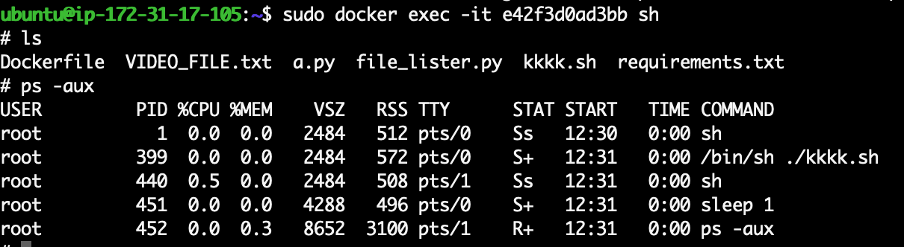

How kernel isolates to run the container and how resources managed by the kernel ?

Namespaces. Docker makes use of kernel namespaces to provide the isolated workspace called the container . When you run a container, Docker creates a set of namespaces for that container. These namespaces provide a layer of isolation.

What is namespace and cgroups ?

Namespaces provide isolation of system resources,

and cgroups allow for fine-grained control and enforcement of limits for those resources.

How you can give different network IP to the container ?

When you connect an existing container to a different network using docker network connect , you can use the --ip or --ip6 flags on that command to specify the container's IP address on the additional network. In the same way, a container's hostname defaults to be the container's ID in Docker.

How to pass parameters in Dockerfile?

You can use the ARG command inside a Dockerfile to define the name of a parameter and its default value. This default value can also be overridden using a simple option with the Docker build command.

How to check resource utilisation of a container ?

The docker stats command returns a live data stream for running containers. To limit data to one or more specific containers, specify a list of container names or ids separated by a space. You can specify a stopped container but stopped containers do not return any data.

How to save changes of a container ?

To save the container, use the docker commit command. The docker commit command locally saves a new container image based on the specified container ID; in this case, based on the currently running container. You can view the images available locally using the docker images command.

What are docker registries ?

A Docker registry is a storage and distribution system for named Docker images. The same image might have multiple different versions, identified by their tags. A Docker registry is organized into Docker repositories , where a repository holds all the versions of a specific image.

Difference between docker commands: up, run &start ?

The run command acts like docker run -ti in that it opens an interactive terminal to the container and returns an exit status matching the exit status of the process in the container. The docker compose start command is useful only to restart containers that were previously created, but were stopped.

Can we run more than one process in a container ?

It's ok to have multiple processes, but to get the most benefit out of Docker, avoid one container being responsible for multiple aspects of your overall application. You can connect multiple containers using user-defined networks and shared volumes.

Imagine a scenario where you have built Docker images and containers that you would be interested to keep and share it with your other collaborators or colleagues.
How will you do that ?

Four basic Docker CLI comes into action:
The docker export - Export a container’s filesystem as a tar archive
The docker import - Import the contents from a tarball to create a filesystem image
The docker save - Save one or more images to a tar archive (streamed to STDOUT by default)
The docker load - Load an image from a tar archive or STDIN

What is the difference between docker load and docker import ?

How to run an image which is in tar format ?

Write a Docker file to create a Docker image which should have Wordpress installed

Dockerfile for Wordpress Image:

FROM php:7.4-apache

RUN apt-get update && apt-get install -y \
libpng-dev \
mariadb-client \
wget \
unzip

RUN docker-php-ext-install pdo pdo_mysql mysqli gd

RUN a2enmod rewrite

WORKDIR /var/www/html

RUN wget https://wordpress.org/latest.zip && \
unzip latest.zip && \
rm latest.zip && \
mv wordpress/* . && \
chown -R www-data:www-data .

Dockerfile for Database Image:

FROM mariadb:10.5

COPY my.cnf /etc/mysql/conf.d/

VOLUME /etc/mysql

Docker Compose:
version: '3'
services:
db:
build:
context: .
dockerfile: Dockerfile-db
ports:
- "3306:3306"
environment:
MYSQL_ROOT_PASSWORD: password
volumes:
- /etc/mysql:/etc/mysql

wordpress:
build:
context: .
dockerfile: Dockerfile-wordpress
ports:
- "80:80"
environment:
WORDPRESS_DB_HOST: db:3306
WORDPRESS_DB_NAME: wordpress
WORDPRESS_DB_USER: root
WORDPRESS_DB_PASSWORD: password
depends_on:
db

Scenario based question

After running $dokcer run ubuntu , container is automatically getting killed. Why ?

That is the default behaviour of a container. When a process running inside a container exist the container gets killed.
If you want your container to run then make ENTRYPOINT/CMD script run in the foreground without exiting.

$docker run -d ubuntu sleep 120
as soon as the process gets terminated, container will also get terminated.

How do we run an NGINX web server on localhost:8088 using a Bridge Network ?

Execute command below
$docker run -it -d -p 8080:80 —name web-server nginx

(Bridge Network is the default network , it is added to confuse you)

What is the difference between Bind Mounts & Volumes ?

Though both methods are similar, there is a slight difference. Docker manages Volumes and is usually not affected by other processes running on the same host. In contrast, Bind Mounts are just a directory on the host file system and may be modified by other processes other than docker.

A "bind mount" is when you let your container see and use a normal directory in a normal filesystem on your host. Changes made by programs running in the container will be visible in your host's filesystem.
A "volume" is a single file on your host that acts like a whole filesystem visible to the container. You can't normally see what's inside it from the host.

What
The most notable difference between the two options is that --mount is more verbose and explicit, whereas -v is more of a shorthand for --mount . It combines all the options you pass to --mount into one field.

There are 3 types of storage in Docker.

1. Bind mounts-also known as host volumes.
2. Anonymous volumes.
Named volumes.

Volumes have several advantages over bind mounts:
Volumes are easier to back up or migrate than bind mounts.
You can manage volumes using Docker CLI commands or the Docker API.
Volumes work on both Linux and Windows containers.
Volumes can be more safely shared among multiple containers.
Volume drivers let you store volumes on remote hosts or cloud providers, to encrypt the contents of volumes, or to add other functionality.
New volumes can have their content pre-populated by a container.
Volumes on Docker Desktop have much higher performance than bind mounts from Mac and Windows hosts.

Our company has restrictions on pulling/pushing from Docker or any cloud provider private/public registry, so how do I setup my own local Docker registry. If possible ? Then how ?

The above scenario can be achieved by running our own Registry container.

Run a local registry
docker run -d -p 5000:5000 --restart=always --name registry registry:2

Copy an image from Docker Hub to your registry🔗
docker pull ubuntu:16.04
docker tag ubuntu:16.04 localhost:5000/my-ubuntu
docker push localhost:5000/my-ubuntu

What is the difference of docker run and docker create?

Docker run command is a combination of create and start as it creates a new container and starts it immediately.

The docker container create (or shorthand: docker create ) command creates a new container from the specified image, without starting it.

What is the difference of docker run and docker create?

Docker run command is a combination of create and start as it creates a new container and starts it immediately.

The docker container create (or shorthand: docker create ) command creates a new container from the specified image, without starting it.

Can docker container pack up complete OS ?

Inside a container are all the necessary executables, binary code, libraries, and configuration files. Compared to server or machine virtualization approaches, however, containers do not contain operating system images. This makes them more lightweight and portable, with significantly less overhead.

What is Docker’s privileged mode ?

Docker privileged mode grants a Docker container root capabilities to all devices on the host system. Running a container in privileged mode gives it the capabilities of its host machine.
The --privileged flag gives all capabilities to the container, and it also lifts all the limitations enforced by the device cgroup controller. In other words, the container can then do almost everything that the host can do. This flag exists to allow special use-cases, like running Docker within Docker.

What is Docker machine ?
Docker Machine is a tool that lets you install Docker Engine on virtual hosts, and manage the hosts with docker-machine commands. You can use Machine to create Docker hosts on your local Mac or Windows box, on your company network, in your data center, or on cloud providers like Azure, AWS, or DigitalOcean.

