Please explain CI-CD process of your organisations ?

CI/CI is a continuous integration and continuous delivery.
In current organisation, we use GitHub as a source code repository.
We have configured a GitHub webhook that triggers a Jenkins Pipeline on every commit. The Jenkins pipeline is setup with multiple stages.
We also have several Jenkins slaves to build android application, iOS application.
iOS application is built on Mac Jenkin node. Android app is built on Windows.

Build Stage: Takes care of static code analysis. Build and Unit testing
Test stage: Run smoke testing
Deploy stage: Push artifacts to registry, deploys on cluster. App is deployed on phone and tested using Appium.

1. What is Jenkins?
Jenkins is a self-contained, open-source automation server that can be used to automate all sorts of tasks related to building, testing, and delivering or deploying software. Jenkins can be installed through native system packages, Docker, or even run standalone by any machine with a Java Runtime Environment (JRE) installed.
2. Tell me something about Continuous Integration, Continuous Delivery, and Continuous Deployment?
Continuous integration
Developers practicing continuous integration merge their changes back to the main branch as often as possible. The developer's changes are validated by creating a build and running automated tests against the build. By doing so, you avoid integration challenges that can happen when waiting for release day to merge changes into the release branch.
Continuous integration puts a great emphasis on testing automation to check that the application is not broken whenever new commits are integrated into the main branch.
Continuous delivery
Continuous delivery is an extension of continuous integration since it automatically deploys all code changes to a testing and/or production environment after the build stage.
This means that on top of automated testing, you have an automated release process and you can deploy your application any time by clicking a button.
In theory, with continuous delivery, you can decide to release daily, weekly, fortnightly, or whatever suits your business requirements. However, if you truly want to get the benefits of continuous delivery, you should deploy to production as early as possible to make sure that you release small batches that are easy to troubleshoot in case of a problem.
Continuous deployment
Continuous deployment goes one step further than continuous delivery. With this practice, every change that passes all stages of your production pipeline is released to your customers. There's no human intervention, and only a failed test will prevent a new change to be deployed to production.
Continuous deployment is an excellent way to accelerate the feedback loop with your customers and take pressure off the team as there isn't a "release day" anymore. Developers can focus on building software, and they see their work go live minutes after they've finished working on it.

Based on the level of automation, the above three paradigms can be better represented as below -

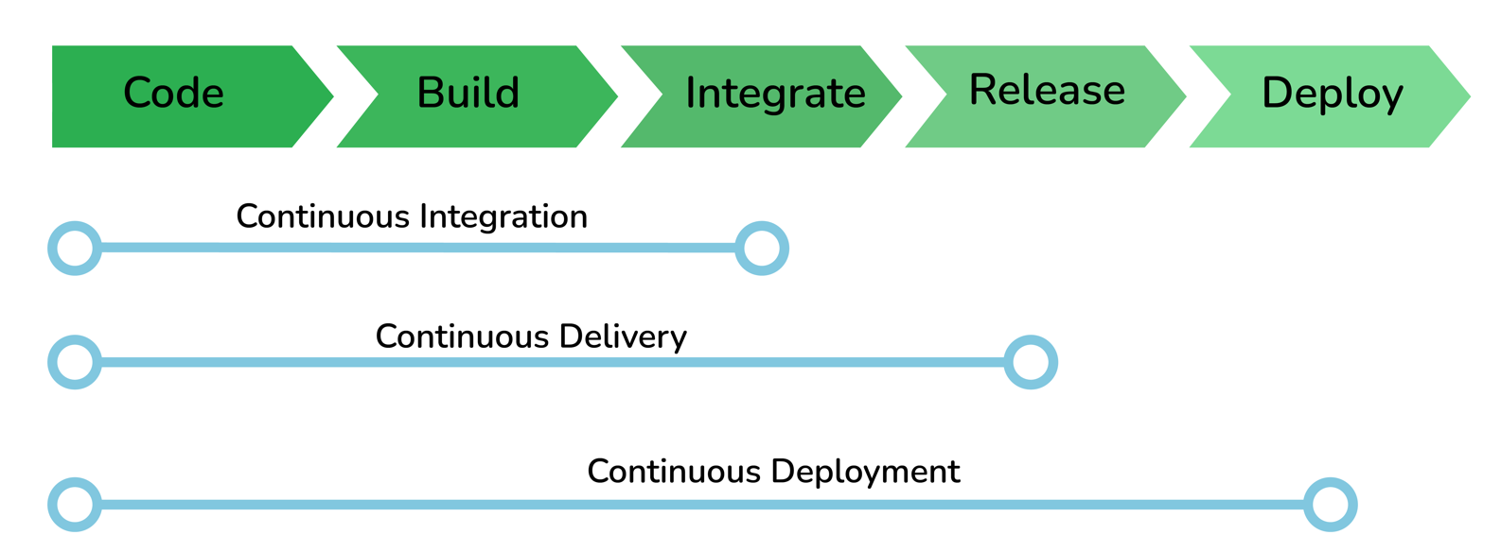

CI/CD and Continuous Deployment
3. What are the common use cases Jenkins is used for?
Jenkins being open-source automation can be used for any kind of software-based automation. Some of the common use-cases include but not limited to -
Software build jobs
Sanity/Smoke/CI/Regression test jobs
Code coverage measurement jobs
General-purpose automation

Some of the possible steps that can be performed using Jenkins are:
- Software build using build systems such as Gradle, Maven, and more.
- Automation testing using test frameworks such as Nose2, PyTest, Robot, Selenium, and more.
- Execute test scripts (using Windows terminal, Linux shell, etc.
- Achieve test results and perform post actions such as printing test reports, and more.
- Execute test scenarios against different input combinations for obtaining improved test coverage.
- Continuous Integration (CI) where the artifacts are automatically created and tested. This aids in identification of issues in the product at an early stage of development.

4. What are the ways to install Jenkins?
Jenkins can be installed using -
Native System Package Manager like - apt (Linux), brew (Mac), etc.
Docker (popular docker images for Jenkins is available for different platforms like Unix/Mac/Windows in the docker registry)
Kubernetes (available as a helm chart and can be installed on our Kubernetes clusters)
Standalone (on any machine with a Java Runtime Environment installed)
For more detailed installation instructions refer official documentation
5. What is a Jenkins job?
A Job/Project is the fundamental unit of a logical work (like a software build, an automation task, test execution, etc) using the Jenkins automation server and other required plugins, configurations & infrastructures.
Jobs can be of different types like - a freestyle project, a multi-configuration project, a pipeline project, a multi-branch project, etc.
- What is a Jenkins Pipeline?
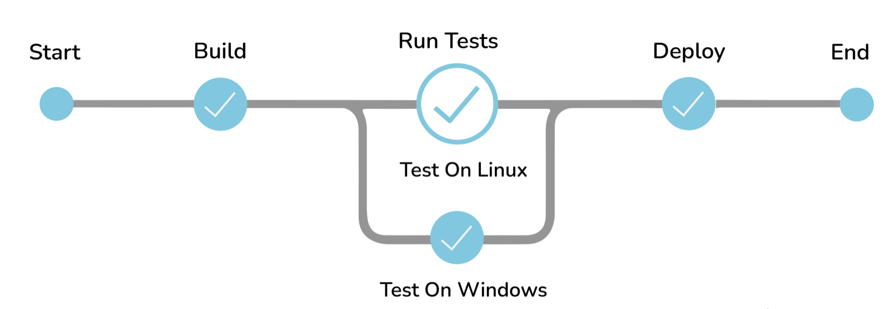

Jenkins Pipeline
The pipeline is a special type of Jenkins job - simply a sequence of steps controlled by a defined logic - which Orchestrates long-running activities that can span across multiple build agents. It is suitable for building pipelines (formerly known as workflows) and/or organizing complex activities that cannot be easily achieved using a freestyle job.
Understand how to create your first pipeline here
7. What are the types of Jenkins pipelines?
Jenkins Pipelines can be either - a Declarative pipeline or a Scripted Pipeline. Declarative pipeline makes use of numerous, generic, predefined build steps/stages (i.e. code snippets) to build our job according to our build/automation needs whereas, with Scripted pipelines, the steps/stages can be custom-defined & used using a groovy syntax which provides better control & fine-tuned execution levels.
- Explain Jenkins Multibranch Pipeline?

Create multi branch pipeline
Mention project repository.
Jenkins will scan how many branches are there containing Jenkinsfile in it.
It will create build for it.

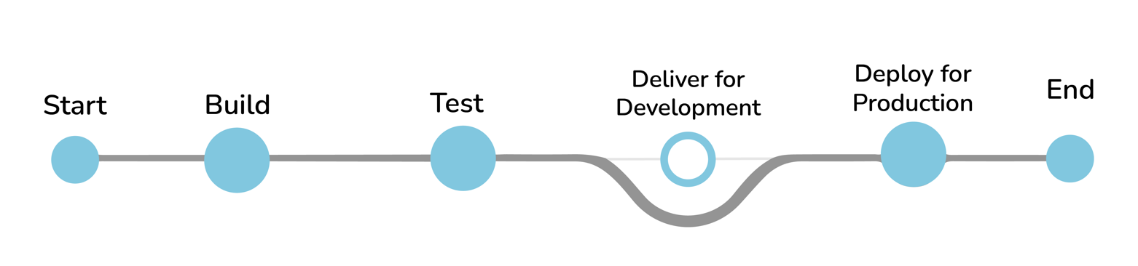

Jenkins Multibranch Pipeline
It is a pipeline job that can be configured to Create a set of Pipeline projects according to the detected branches in one SCM repository. This can be used to configure pipelines for all branches of a single repository e.g. if we maintain different branches (i.e. production code branches) for different configurations like locales, currencies, countries, etc.

If there are two branches, you will see two build srunning.
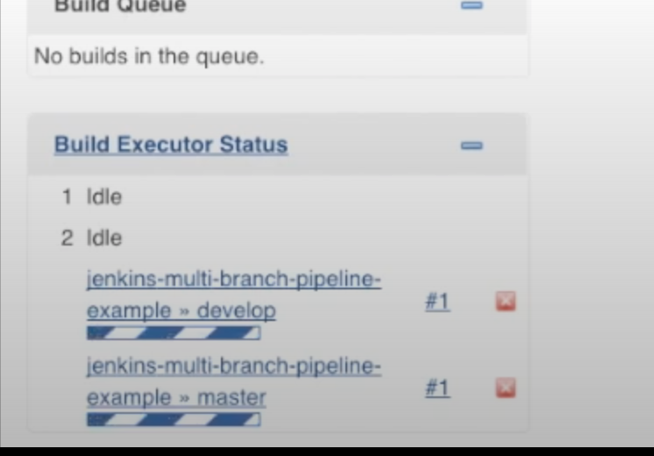

9. How do you store credentials in Jenkins securely?
Credentials can be stored securely in Jenkins using the Credentials plugin, which stores different types of credentials like - Username with a password, SSH username with the private key, AWS Credentials, Jenkins Build Token, Secret File/Text, X509 & other certificates, Vault related credentials securely with proper encryption & decryption as and when required.
10. How can we stop a scheduled job from being executed temporarily?
Disable the job from the job details page to temporarily stop all scheduled executions & other factors/events from triggering the job and enable it back to resume the job schedules/triggers. If a job is not required permanently, we can delete the job from the jobs list view page.
Intermediate Questions
11. What are the ways to trigger a Jenkins Job/Pipeline?
There are many ways we can trigger a job in Jenkins. Some of the common ways are as below -
Trigger an API (POST) request to the target job URL with the required data.
Trigger it manually from the Jenkins web application.
Trigger it using Jenkins CLI from the master/slave nodes.
Time-based Scheduled Triggers like a cron job.
Event-based Triggers like SCM Actions (Git Commit, Pull Requests), WebHooks, etc.
Upstream/Downstream triggers by other Jenkins jobs.
12. What is Jenkins Build Cause?
Build Cause is a text attribute that represents what made a job's build to be triggered, say it could be a Jenkins User (from UI), Timer for Scheduled jobs, Upstream jobs for a job which was triggered by upstream job, etc. This is mainly used to identify the nature of the builds - be it nightly, manual, automated, etc.
13. How Jenkins knows when to execute a Scheduled job/pipeline and how it is triggered?
Jenkins master will have the cron entries set up for the jobs as per the scheduled Job's configurations. As and when the time for a particular job comes, it commands agents (based on the configuration of the job) to execute the job with required configurations.
14. What are the credential types supported by Jenkins?
There are numerous 3rd-party sites and applications that can interact with Jenkins, for example, artifact repositories, cloud-based storage systems and services, and so on.
A systems administrator of such an application can configure credentials in the application for dedicated use by Jenkins. This would typically be done to "lock down" areas of the application’s functionality available to Jenkins, usually by applying access controls to these credentials. Once a Jenkins manager (i.e. a Jenkins user who administers a Jenkins site) adds/configures these credentials in Jenkins, the credentials can be used by Pipeline projects to interact with these 3rd party applications.

Jenkins can store the following types of credentials:

- Secret text - a token such as an API token (e.g. a GitHub personal access token),
- Username and password - which could be handled as separate components or as a colon separated string in the format username:password (read more about this in Handling credentials),
- Secret file - which is essentially secret content in a file,
- SSH Username with private key - an SSH public/private key pair,
- Certificate - a PKCS#12 certificate file and optional password, or
- Docker Host Certificate Authentication credentials.

15. What are the Scopes of Jenkins Credentials?
Jenkins credentials can be of one of the two scopes - Global & System
Global - the credential will be usable across all the jobs configured in the Jenkins instance (i.e. for all jobs). This is more suited for user Jobs (i.e. for the freestyle, pipeline, or other jobs) to authenticate itself with target services/infrastructures to accomplish the purpose of the job)
System - This is a special scope that will allow the Jenkins itself (i.e. the core Jenkins functionalities & some installed plugins) to authenticate itself to external services/infrastructures to perform some defined tasks. E.g. sending emails, etc.
16. What is a Jenkins Shared Library and how it is useful?
As an organization starts using more and more pipeline jobs, there is a chance for more and more code being duplicated in every pipeline job, since a part of the build/automation processes will be the same for most of the jobs. In such a situation, every other new upcoming job should also duplicate the same piece of code. To avoid duplications, the Jenkins project brought in the concept of Shared Libraries, to code - DRY - Don't Repeat Yourself.
Shared libraries are a set of code that can be common for more than one pipeline job and can be maintained separately. Such libraries improve the maintenance, modularity & readability of the pipeline code. And it also speeds up the automation for new jobs.
17. How Jenkins jobs can be Triggered/Stopped/Controlled programmatically?
Jenkins Remote Access API can be used to do things like -
Retrieving information about jobs, views, nodes, builds, etc. from Jenkins for programmatic consumption.
Trigger a build (both parameterized & non-parameterized), stop/abort a build, enable/disable a Job, group/remove jobs into/from views, etc.
Create/copy/modify/delete jobs.
and many other programming language-specific functionalities. It has wrappers for main programming languages like - Python, Ruby & Java. It can be triggered via CURL as below -
Jobs without parameters
Simply an HTTP POST on JENKINS_URL/job/JOBNAME/build.
Jobs with parameters
Simple example - sending "String Parameters":
curl JENKINS_URL/job/JOB_NAME/buildWithParameters --user USER:TOKEN --data id=123 --data verbosity=high
18. How to get the Jenkins version programmatically in Jobs/Pipelines or nodes other than master?
To check the version of Jenkins, load the top-level page or any top-level Remote Access API path like the '.../api/*' page and then check for the 'X-Jenkins' response header.
This contains the version number of Jenkins, like "1.404". This is also a good way to check if an URL is a Jenkins URL.
19. What happens when a Jenkins agent is offline and what is the best practice in that situation?
When a job is tied to a specific agent on a specific node, the job can only be run on that agent and no other agents can fulfill the job request. If the target node is offline or all the agents on that particular node are busy building other jobs, then the triggered job has to wait until the node comes online or an agent from that node becomes available to execute the triggered build request.
As a result, a triggered job may sometimes wait indefinitely without knowing that the target node is offline. So, it is always the best practice to tie the jobs to a group of nodes & agents, referred to with a 'Label'. Once a job is tied to a Label, instead of a specific node/agent, any of the nodes/agents falling under the label can fulfill a build request, when a job is triggered. This way we can reduce the overall turn-around time of the builds.
Even then if a job is waiting for more time for the nodes/agents, then it is time to consider adding more nodes/agents.
20. What is the Blue Ocean?
Blue Ocean is the redefined user experience for Jenkins. Designed from the ground up for Jenkins Pipeline, it is still compatible with freestyle jobs, Blue Ocean reduces clutter and increases clarity. Blue Ocean’s main features include -
Sophisticated visualizations of continuous delivery (CD) Pipelines, allowing for fast and intuitive comprehension of your Pipeline’s status.
Pipeline editor - makes the creation of Pipelines approachable by guiding the user through an intuitive and visual process to create a Pipeline.
Personalization to suit the role-based needs of each member of the team.
Pinpoint precision when intervention is needed and/or issues arise. Blue Ocean shows where in the pipeline attention is needed, facilitating exception handling and increasing productivity.
Native integration for branch and pull requests, enables maximum developer productivity when collaborating on code with others in GitHub, Bitbucket, etc.
Conventional UI - Job Details Page
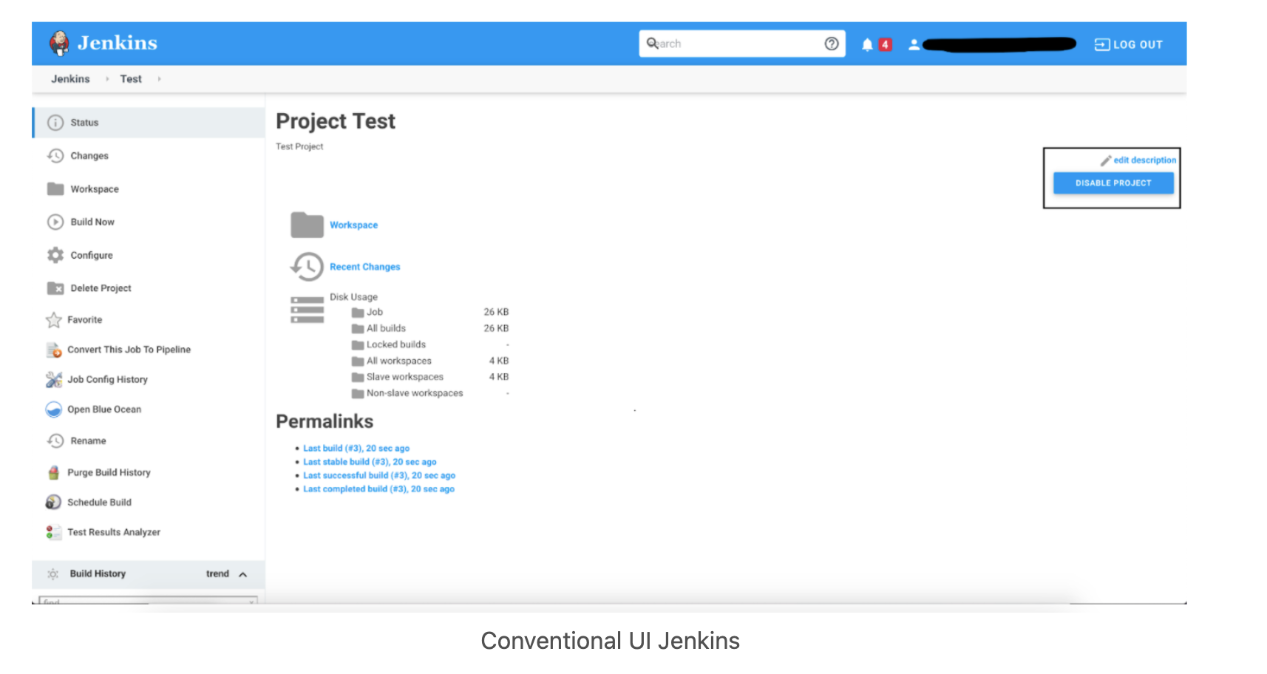

Conventional UI Jenkins
21. What is the Jenkins User Content service?
Jenkins has a mechanism known as "User Content", where administrators can place files inside the $JENKINS_HOME/userContent folder and these files are served from yourhost/jenkins/userContent.
This can be thought of as a mini HTTP server to serve images, stylesheets, and other static resources that you can use from various description fields inside Jenkins.
Advanced Interview Questions
22. How is continuous integration achieved using Jenkins?
Continuous integration is a process where a developer’s code changes are constantly integrated into the main code and the same will be tested automatically and the results of the tests will decide whether the change is ready for deployment. In this process -
Developer Makes a change - commit/pull_request - in feature/dev branch
Source Control Management system generates appropriate events
SCM Specific Jenkins Plugins like Git/SVN will detect those events from the configured repositories and these events will be used to Trigger - build/dependent/test - jobs on Jenkins
After the Test/Dependent jobs are completed, the change/patch will be labeled according to the status of the test job
Based on the Status (i.e. readiness of a change to be merged with the main branch), the Continuous Delivery or Continuous Deployment strategy/tool will take it forward.
23. What is Artifact Archival & how to do it in Pipelines?
Artifacts are the exportable/storable/archivable results of a specific job build. This can be configured using a plugin called - Copy artifact Plugin. Based on the configured pattern, the files/directories matching the configured patterns will be archived for a Jenkins build, which can be used for future references. In the pipeline, it can be configured as follows -
archiveArtifacts artifacts: 'output/**/*'
24. How to configure inclusions & exclusions in Artifacts Archival?
Artifact archival takes in a pattern for matching target files. Similarly, it also takes in a pattern (ANT build system pattern for matching files) for exclusion as well which will be ignored while selecting the files for archival.
For e.g.
archiveArtifacts artifacts: 'output/*.txt', excludes: 'output/specific_file.txt'
The above command will archive all the text files from the output folder except specific_file.txt
25. How can we share information between different build steps or stages in a Jenkins Job?
Every build step or stage will be running in its process and hence sharing information between two different build steps is not so direct. We can use either a File, a Database Entry, an Environment Variable, etc. to share info from one build step to another or a post-build action.
26. How code coverage is measured/tracked using Jenkins in a CI environment?
Using language-specific code coverage plugins like JaCoCo, CodeCov, etc or generic tools/plugins like Sonarqube which will add the code coverage data to builds with some minor tweaks in the code and the same can be displayed as a graph in Jenkins.
27. Default Environment Variables by Jenkins & How to introduce custom environment variables?
Jenkins provides several environment variables by default like - BRANCH_NAME, BUILD_NUMBER, BUILD_TAG, WORKSPACE, etc.
28. How can a job configuration be reset to an earlier version/state?
From the Job details page, we can use Job Config History to - See diff, Review & Revert the Job configs from the history of changes we have made to a particular job. This will be super useful when a job is misconfigured by someone by mistake, it can be reviewed and reverted easily to any of its earlier states.
29. How to do Global Tools Configuration in Jenkins?
Global Tools are tools that need to be installed outside the Jenkins environment and need to be controlled from within the Jenkins environment. Hence it needs its corresponding Jenkins plugin as well. Steps to using a Global Tool generally include -
Install the tool Plugin into the Jenkins instance, to include the global tool into a list of global tools used by Jenkins.
Install the tool in the Jenkins instance or provide away (maybe a command to download and) install the tool during runtime.
Go to Manage Jenkins -> Global Tools Configuration and Scroll through the tool list and configure the global tool-specific configurations.
Make use of the installed global Tool in your job/pipeline.
30. How to create & use a Shared Library in Jenkins?
Basic requirements for a Jenkins shared library to be used in a Pipeline Code are -
A Repository with pipeline shared library code in SCM.
An appropriate SCM Plugin configuration for the Jenkins instance.
Global Shared Library should be configured in Jenkins Global configuration.
Include the Shared Library in the Pipeline Code and use the methods defined in the Jenkins Shared Library.
E.g.
#!/urs/bin/env groovy
@Library('fs_jenkins_shared_library@v2.0.7')_
31. How to install a Custom Jenkins Plugin or a Version of Plugin Not available in Jenkins Update Center?
Generally, it is the best practice to use the latest version of a plugin. But there are ways to install custom plugins or outdated versions of a published plugin. Jenkins Plugins are exported using a .hpi file and the same can be installed in multiple ways -
Using the Jenkins CLI
java -jar jenkins-cli.jar -s http://localhost:8080/ install-plugin SOURCE ... [-deploy] [-name VAL] [-restart]
The above command Installs a plugin either from a file, an URL or from the update center.
SOURCE: If this points to a local file, that file will be installed. If this is an URL, Jenkins downloads the URL and installs that as a plugin. Otherwise, the name is assumed to be the short name of the plugin in the existing update center (like "findbugs") and the plugin will be installed from the update center.
-deploy: Deploy plugins right away without postponing them until the reboot.
-name VAL: If specified, the plugin will be installed as this short name (whereas normally the name is inferred from the source name automatically).
-restart: Restart Jenkins upon successful installation.
Advanced Installation - via - Web UI
Assuming a .hpi file has been downloaded, a logged-in Jenkins administrator may upload the file from within the web UI:
Navigate to the Manage Jenkins > Manage Plugins page in the web UI.
Click on the Advanced tab.
Choose the .hpi file under the Upload Plugin section.
Upload the plugin file.
Restart the Jenkins instance
Advanced Installation - via - On the master
Assuming a .hpi file has been explicitly downloaded by a systems administrator, the administrator can manually place the .hpi file in a specific location on the file system.
Copy the downloaded .hpi file into the JENKINS_HOME/plugins directory on the Jenkins controller (for example, on Debian systems JENKINS_HOME is generally /var/lib/jenkins).
The master will need to be restarted before the plugin is loaded and made available in the Jenkins environment.
32. How to download the Console log for a particular Jenkins build programmatically?
Using the Jenkins CLI - console - command
java -jar jenkins-cli.jar console JOB [BUILD] [-f] [-n N]
Produces the console output of a specific build to stdout, as if you are doing 'cat build.log'
JOB: Name of the job
BUILD: Build number or permalink to point to the build. Defaults to the last build
-f: If the build is in progress, append console output as it comes, like tail -f
-n N: Display the last N lines.
E.g.
ssh -l <ssh_username> -p <port_no> <Jenkins_URL> console <JOB_NAME>
33. What is Jenkins Remote Access API?
Jenkins provides remote access API to most of its functionalities (though some functionalities are programming language-dependent). Currently, it comes in three flavors -
XML
JSON with JSONP support
Python
Remote access API is offered in a REST-like style. That is, there is no single entry point for all features, and instead, they are available under the ".../api/" URL where the "..." portion is the data that it acts on.
For example, if your Jenkins installation sits at interviewbit.com, visiting /api/ will show just the top-level API features available – primarily a listing of the configured jobs for this Jenkins instance.
Or if we want to access information about a particular build, e.g. https://ci.jenkins.io/job/Infra/job/jenkins.io/job/master/lastSuccessfulBuild/, then go to https://ci.jenkins.io/job/Infra/job/jenkins.io/job/master/lastSuccessfulBuild/api/ and you’ll see the list of functionalities for that build.
34. What is In-process Script Approval and how it works?
Jenkins, and several plugins, allow users to execute Groovy scripts in Jenkins. To protect Jenkins from the execution of malicious scripts, these plugins execute user-provided scripts in a Groovy Sandbox that limits what internal APIs are accessible.
This protection is provided by the Script Security plugin. As soon as an unsafe method is used in any of the scripts, the "In-process Script Approval" action should appear in "Manage Jenkins" to allow Administrators to make a decision about which unsafe methods, if any, should be allowed in the Jenkins environment.
This in-process script approval inherently improves the security of the overall Jenkins ecosystem.
35. Can we monitor Jenkins using common Observability tools?
Common monitoring platforms like DataDog, Prometheus, JavaMelody & few others - have their corresponding Jenkins plugin, which when configured, sends Metrics to the corresponding Monitoring platform, which can then be Observed with the latest tools & technologies. The same can be configured with Alarms & Notifications for immediate attention when something goes wrong.
36. What is a Ping Thread in Jenkins and how it works?
Jenkins installs "ping thread" on every remote connection, such as Controller/Agent connections, regardless of its transport mechanism (such as SSH, JNLP, etc.). The lower level of the Jenkins Remoting Protocol is a message-oriented protocol, and a ping thread periodically sends a ping message that the receiving end will reply to. The ping thread measures the time it takes for the reply to arrive, and if it’s taking excessive time (currently 4 minutes and configurable), then it assumes that the connection was lost and initiates the formal close down.
This is to avoid an infinite hang, as some of the failure modes in the network cannot be detected otherwise. The timeout is also set to a long enough value so that a temporary surge in the load or a long garbage collection pause will not trip off the close-down.
Ping thread is installed on both controller & agent; each side pings the other and tries to detect the problem from their sides.
The ping thread time out is reported through java.util.logging. Besides, the controller will also report this exception in the agent launch log. Note that some agent launchers, most notably SSH agents, writes all stdout/stderr outputs from the agent JVM into this same log file, so you need to be careful.

What is "Continuous Integration" with reference to Jenkins?
- Continuous Integration is a development practice where the codes can be integrated into a shared repository.
- The practice uses automated verifications for the early detection of code problems.
- Continuous Integration triggers the build to find and identify bugs present in the code.
- It adds consistency to the build process.
- It’s a means to build things faster and prevents broken code.

Name the two components that Jenkins is mostly integrated with.
Jenkins is typically integrated with these two components:
- Version Control systems like Git and SVN (Apache Subversion)
- Build tools like Maven

How can you create a backup and copy files in Jenkins?
- Jenkins stores all the settings, builds scripts, and logs in the home directory.
- Then, if you want to create a backup of this Jenkins set up all you have to do is copy this directory.
- The job directory may also be copied to clone a job or rename the directory.

Name some more continuous Integration tools other than Jenkins.
Some of the top continuous integration tools other than Jenkins are:
- TeamCity
- Travis CI
- Go CD
- Bamboo
- GitLab CI
- CircleCI
- Codeship

What is Jenkinsfile?
Jenkins file is a text file that has a definition of a Jenkins pipeline and is checked into the source control repository. It enables code review and iteration on the pipeline. It also permits an audit trail for the pipeline.
What is Webhook in Jenkins ?

Webhooks is an option to triggar pipeline job in Jenkins whenever the code commits in Github .For this Choose 'GitHub hook triggar for git SCM polling' in Build triggars in Jenkins and also In Github go to settings -->webhooks-->Add web hooks-->Give details of Jenkins servrer.Then for every code commit in github the build job can be done.
What is the difference between an agent and a node in a jenkins pipeline?
The simple answer is, Agent is for declarative pipelines and node is for scripted pipelines.
In declarative pipelines the agent directive is used for specifying which agent/slave the job/task is to be executed on. This directive only allows you to specify where the task is to be executed, which agent, slave, label or docker image.
On the other hand, in scripted pipelines the node step can be used for executing a script/step on a specific agent, label, slave. The node step optionally takes the agent or label name and then a closure with code that is to be executed on that node.
declarative and scripted pipelines (edit based on the comment):
- declarative pipelines is a new extension of the pipeline DSL (it is basically a pipeline script with only one step, a pipeline step with arguments (called directives), these directives should follow a specific syntax. The point of this new format is that it is more strict and therefore should be easier for those new to pipelines, allow for graphical editing and much more.
- scripted pipelines is the fallback for advanced requirements.

don't fail jenkins build if execute shell fails, how do you do that ?

To stop further execution when command fails:
command || exit 0
To continue execution when command fails:
command || true

I'm running Jenkins inside a Docker container. I wonder if it's ok for the Jenkins container to also be a Docker host? What I'm thinking about is to start a new docker container for each integration test build from inside Jenkins (to start databases, message brokers etc). The containers should thus be shutdown after the integration tests are completed. Is there a reason to avoid running docker containers from inside another docker container in this way?
Is it ok to run docker from inside docker?

Running Docker inside Docker (a.k.a. dind), while possible, should be avoided, if at all possible. (Source provided below.) Instead, you want to set up a way for your main container to produce and communicate with sibling containers.
However, Docker inside Docker it is not the recommended approach to solve this type of problems. Instead, the recommended approach is to create "sibling" containers as described in this post
https://jpetazzo.github.io/2015/09/03/do-not-use-docker-in-docker-for-ci/

How to start jenkins on different port rather than 8080 using command prompt in Windows?

Use the following command at command prompt:
java -jar jenkins.war --httpPort=9090
If you want to use https use the following command:
java -jar jenkins.war --httpsPort=9090

How to invoke a jenkins pipeline A in another jenkins pipeline B ?

pipeline {
agent
{
node {
label 'master'
customWorkspace "${env.JobPath}"
}
}

stages
{
stage('Start') {
steps {
sh 'ls'
}
}

stage ('Invoke_pipeline') {
steps {
build job: 'pipeline1', parameters: [
string(name: 'param1', value: "value1")
]
}
}

stage('End') {
steps {
sh 'ls'
}
}
}
}

What is your deployment strategy ?

The Basic Deployment
In a basic deployment, all nodes within a target environment are updated at the same time with a new service or artifact version. Because of this, basic deployments are not outage-proof and they slow down rollback processes or strategies. Of all the deployment strategies shared, it is the riskiest.

Pros:
The benefits of this strategy are that it is simple, fast, and cheap. Use this strategy if 1) your application service is not business, mission, or revenue-critical, or 2) your deployment is to a lower environment, during off-hours, or with a service that is not in use.
Cons:
Of all the deployment strategies shared, it is the riskiest and does not fall into best practices. Basic deployments are not outage-proof and do not provide for easy rollbacks.

The Multi-Service Deployment
In a multi-service deployment, all nodes within a target environment are updated with multiple new services simultaneously. This strategy is used for application services that have service or version dependencies, or if you’re deploying off-hours to resources that are not in use.

Pros:
Multi-service deployments are simple, fast, cheap, and not as risk-prone as a basic deployment.

Cons:
Multi-service deployments are slow to roll back and not outage-proof. Using this deployment strategy also leads to difficulty in managing, testing, and verifying all the service dependencies.

Rolling Deployment
A rolling deployment is a deployment strategy that updates running instances of an application with the new release. All nodes in a target environment are incrementally updated with the service or artifact version in integer N batches.

Pros:
The benefits of a rolling deployment are that it is relatively simple to roll back, less risky than a basic deployment, and the implementation is simple.

Cons:
Since nodes are updated in batches, rolling deployments require services to support both new and old versions of an artifact. Verification of an application deployment at every incremental change also makes this deployment slow.

Blue-Green Deployment
Blue-green deployment is a deployment strategy that utilizes two identical environments, a “blue” (aka staging) and a “green” (aka production) environment with different versions of an application or service. Quality assurance and user acceptance testing are typically done within the blue environment that hosts new versions or changes. User traffic is shifted from the green environment to the blue environment once new changes have been testing and accepted within the blue environment. You can then switch to the new environment once the deployment is successful.

Pros:
One of the benefits of the blue-green deployment is that it is simple, fast, well-understood, and easy to implement. Rollback is also straightforward, because you can simply flip traffic back to the old environment in case of any issues. Blue-green deployments are therefore not as risky compared to other deployment strategies.

Cons:
Cost is a drawback to blue-green deployments. Replicating a production environment can be complex and expensive, especially when working with microservices. Quality assurance and user acceptance testing may not identify all of the anomalies or regressions either, and so shifting all user traffic at once can present risks. An outage or issue could also have a wide-scale business impact before a rollback is triggered, and depending on the implementation, in-flight user transactions may be lost when the shift in traffic is made.

Canary Deployment
A canary deployment is a deployment strategy that releases an application or service incrementally to a subset of users. All infrastructure in a target environment is updated in small phases (e.g: 2%, 25%, 75%, 100%). A canary release is the lowest risk-prone, compared to all other deployment strategies, because of this control.

Pros:
Canary deployments allow organizations to test in production with real users and use cases and compare different service versions side by side. It’s cheaper than a blue-green deployment because it does not require two production environments. And finally, it is fast and safe to trigger a rollback to a previous version of an application.

Cons:
Drawbacks to canary deployments involve testing in production and the implementations needed. Scripting a canary release can be complex: manual verification or testing can take time, and the required monitoring and instrumentation for testing in production may involve additional research.

A/B Testing
In A/B testing, different versions of the same service run simultaneously as “experiments” in the same environment for a period of time. Experiments are either controlled by feature flags toggling, A/B testing tools, or through distinct service deployments. It is the experiment owner’s responsibility to define how user traffic is routed to each experiment and version of an application. Commonly, user traffic is routed based on specific rules or user demographics to perform measurements and comparisons between service versions. Target environments can then be updated with the optimal service version.
The biggest difference between A/B testing and other deployment strategies is that A/B testing is primarily focused on experimentation and exploration. While other deployment strategies deploy many versions of a service to an environment with the immediate goal of updating all nodes with a specific version, A/B testing is about testing multiple ideas vs. deploying one specific tested idea.

Pros:
A/B testing is a standard, easy, and cheap method for testing new features in production. And luckily, there are many tools that exist today to help enable A/B testing.

Cons:
The drawbacks to A/B testing involve the experimental nature of its use case. Experiments and tests can sometimes break the application, service, or user experience. Finally, scripting or automating AB tests can also be complex.

Which Deployment Strategy Should I Use?
Now that we know different deployment techniques, a commonly asked question may be, which deployment strategy should I use? The answer depends on the type of application you have and your target environment.
Based on conversations with Harness customers, most teams use blue-green or canary deployments for mission-critical web applications. Customers have minimal to little business impact when migrating from the blue-green deployment strategy to a canary deployment strategy. It’s also common for teams to create their strategy based on combining the strategies we shared in this blog post. For example, some customers will do multi-service canary deployments.

What do you do if deployed app is faulty ?

How do you roll back ?
It is very easy for Blue-Green deployment to rollback, just point back to old one.

How do handle scale up and scale down in Jenkins ?

Option 1:
I'd scale out instead of scale up, going for option 3. We have made a setup where we have all Jenkins agents running on an ECS (custom Docker based Jenkins) with an auto-scaling group. We have all our Jenkins masters communicating to the ECS, thus sharing the workload on the ECS, and no need to recreate the Jenkins master in a scale up exercise.

Option 2:
We can also handle this using kubernetes
Use Kubernetes and Helm.
I would recommend using the Jenkins Helm chart. It installs with helm install stable/jenkins and automatically scales.

Option 3:
n my project we have one AWS server running Jenkins Master + 1 Jenkins slave (2 executors)... and we need more
In order to augment our build power we have three options:
- Scale up: Make AWS instance bigger and add more executors.
- Scale up: Make AWS instance bigger and add another jenkins slave process.
- Scale out: Create another AWS instance with a jenkins slave and connect it to master

