Often, using a single routing protocol in an organisation is preferred but there are some conditions in which we have to use multi protocol routing. These conditions include multiple administrator running multiple protocols, company mergers or usage of multi-vendors devices. Therefore, we have to advertise a route learned through a routing protocol or by any other means (like static route or directly connected route) in different routing protocol. This process is called redistribution.

**Redistribution –**  
It is a process of advertising a route learned by method of static routing, directly connected route or a dynamic routing protocol into another routing protocol.

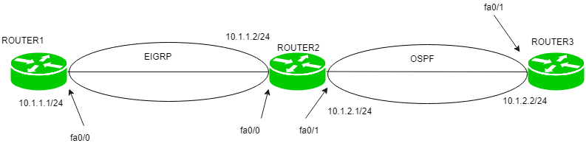

For example, Here, router2 one interface (fa0/0) is running EIGRP and other interface(fa0/1) is running OSPF then we have to advertise the routes of OSPF into EIGRP and vice-versa so that the routes learned by these routing protocols are advertised with each other. This process is called redistribution. Otherwise, the router1 will not be able to learn routes of router3 and router3 will not be able to learn routes of router1.