# ERPS – 3 Node Scenario:

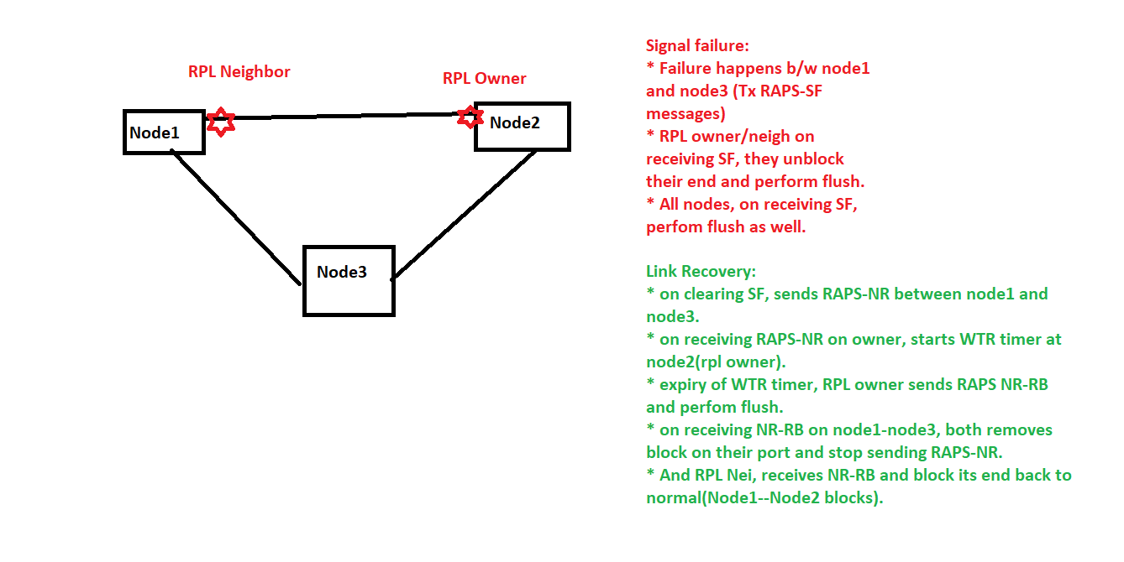

ERPS Shut/No shut flow in 2nodes:

RPL OWNER:

**Shut 🡪**ErpsSmV2RingHandleRAPSSF-->RING MOVES TO PROTECTION STATE (SIGNAL_FAIL)

**No Shut 🡪** ErpsMsgHandleCfmSignalFromEcfm, Invoking ErpsMsgProcessLinkClearSF (SIGNAL_OK)

ErpsMsgProcessLinkClearSF, Invoking ERPS_RING_LOCAL_CLEAR_SF_REQUEST

ISS# ErpsSmRingHandleWtrExpiry, RING MOVES TO IDLE STATE

RING MOVES TO IDLE STATE

RPL NEIGHBOR

**Shut 🡪** ErpsSmV2RingHandleRAPSSF-->RING MOVES TO PROTECTION STATE

**No Shut 🡪**ErpsMsgHandleCfmSignalFromEcfm, Invoking ErpsMsgProcessLinkClearSF

ErpsMsgProcessLinkClearSF, Invoking ERPS_RING_LOCAL_CLEAR_SF_REQUEST

ErpsSmV2RingHandleRAPSNRRB, RING MOVES TO IDLE STATE

RING MOVES TO IDLE STATE

Thread 43 "ERPT" hit Breakpoint 1, ErpsMsgProcessLinkClearSF (pRingInfo=pRingInfo@entry=0x7ffec028e1b0, MepInfo=...) at /home/NISHA/ISS_TAG_04JAN22_1515_11_1_1_REL_TAG_08/code/future/erps/src/erpsmsg.c:1847

1847 in /home/NISHA/ISS_TAG_04JAN22_1515_11_1_1_REL_TAG_08/code/future/erps/src/erpsmsg.c

#0 ErpsMsgProcessLinkClearSF (pRingInfo=pRingInfo@entry=0x7ffec028e1b0, MepInfo=...) at /home/NISHA/ISS_TAG_04JAN22_1515_11_1_1_REL_TAG_08/code/future/erps/src/erpsmsg.c:1847

#1 0x000000000159d804 in ErpsMsgHandleCfmSignalFromEcfm (pMsg=pMsg@entry=0x7ffec000f0b0) at /home/NISHA/ISS_TAG_04JAN22_1515_11_1_1_REL_TAG_08/code/future/erps/src/erpsmsg.c:2427

#2 0x000000000159dc7e in ErpsMsgHandleCfmSignal (pMsg=0x7ffec000f0b0) at /home/NISHA/ISS_TAG_04JAN22_1515_11_1_1_REL_TAG_08/code/future/erps/src/erpsmsg.c:1372

#3 ErpsMsgQueueHandler () at /home/NISHA/ISS_TAG_04JAN22_1515_11_1_1_REL_TAG_08/code/future/erps/src/erpsmsg.c:110

#4 0x0000000001595fc5 in ErpsMainTask (pi1Arg=pi1Arg@entry=0x0) at /home/NISHA/ISS_TAG_04JAN22_1515_11_1_1_REL_TAG_08/code/future/erps/src/erpsmain.c:107

#5 0x0000000001d7b659 in OsixTskWrapper (pArg=0x18f95fc0 <gaOsixTsk+5152>) at pthreads/osixpth.c:1273

#6 0x00007ffff7bc34a4 in start_thread () from /lib/x86_64-linux-gnu/libpthread.so.0

#7 0x00007ffff73f9d0f in clone () from /lib/x86_64-linux-gnu/libc.so.6

ErpsMsgProcessLinkClearSF, Invoking ERPS_RING_LOCAL_CLEAR_SF_REQUEST

Flows   
Configuration Sequence:

1. Vsiminp.c 🡪EgressFailOverID and vlan_port_create ()

2. erpsminp.c 🡪failover_set() block/unblock.

3. ECFM Domain configs(mep and meg level).

RAPs-NR:

01 19 a7 00 00 01 00 02 02 03 04 01 81 00 08 06  
89 02 c1 28 00 20 00 00 00 02 02 03 04 01 00 00  
00 00 00 00 00 00 00 00 00 00 00 00 00 00 00 00  
00 00 00 00 00 00 00 00 00 00 00 00

RAPS- NR RB:

01 19 a7 00 00 01 00 02 02 03 04 01 81 00 08 06  
89 02 c1 28 00 20 00 a0 00 02 02 03 04 01 00 00  
00 00 00 00 00 00 00 00 00 00 00 00 00 00 00 00  
00 00 00 00 00 00 00 00 00 00 00 00

RAPS-SF

01 19 a7 00 00 01 00 01 02 03 04 01 89 02 c1 28  
00 20 b0 00 00 01 02 03 04 01 00 00 00 00 00 00  
00 00 00 00 00 00 00 00 00 00 00 00 00 00 00 00  
00 00 00 00 00 00 00 00