Basic MPLS Topolgy

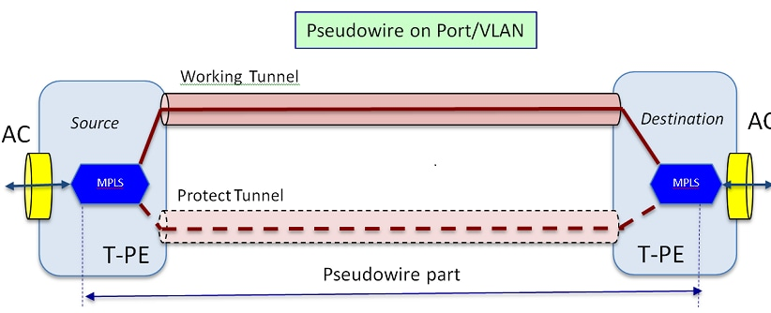

ERPS-MPLS

* provides customer to connect respective sites located in diff area.
* Using same service provider

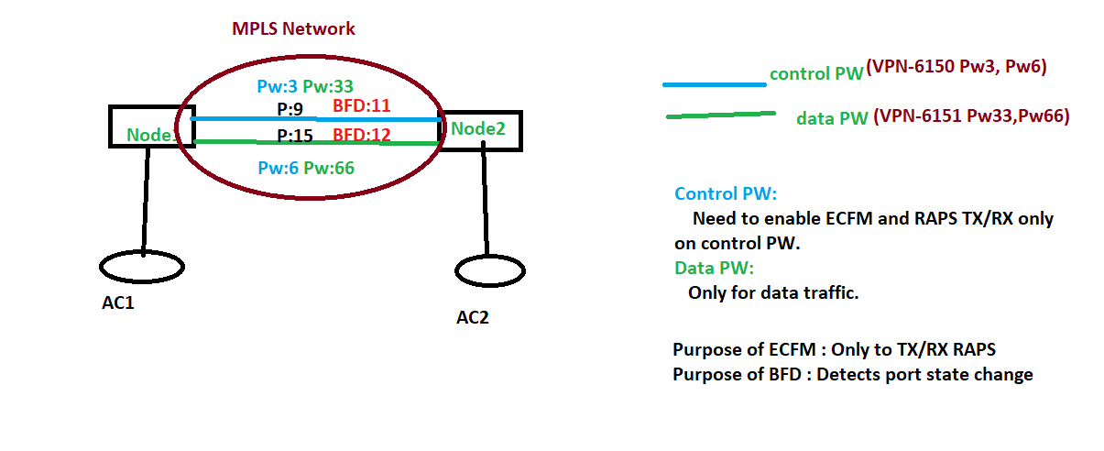

VPLS in ring:

* Every edge node is connected via PW belongs to same VPLS instance.
* VPLS has,  RAPS-VPLS and Data-VPLS used.
* RAPS-VPLS, group of PW in ring serve as RAPS channel for ring.
* In VPLS ring, RAPS protocol/control pkts sent over PW instead of phy port(as ethernet).
* **RAPS-VPLS**: maintain state, monitor, trigger protection(in SF).
* **DATA-VPLS**: group of PW responsible for data connectivity among custmers connected to that VPLS.
* PW  in VPLS mapped to PW Interfacs(RAPS and DATA) belong to ports/Subport of ring.
* VPLS: RPL link(owner and neight) is PW and blocked Initial state.
* .So with a single ring port, more than one sub-ports can be associated, provided that underlying path (LDP-LSP) is same for RAPS pseudo-wire and DATA pseudo-wires which are mapped to ring port and sub-ports respectively.
* If RAPS pw-port is blocked, then corresponding pw- sub-ports are also blocked to avoid the loop in DATA VPLS

ERPS-Ethernet Subring

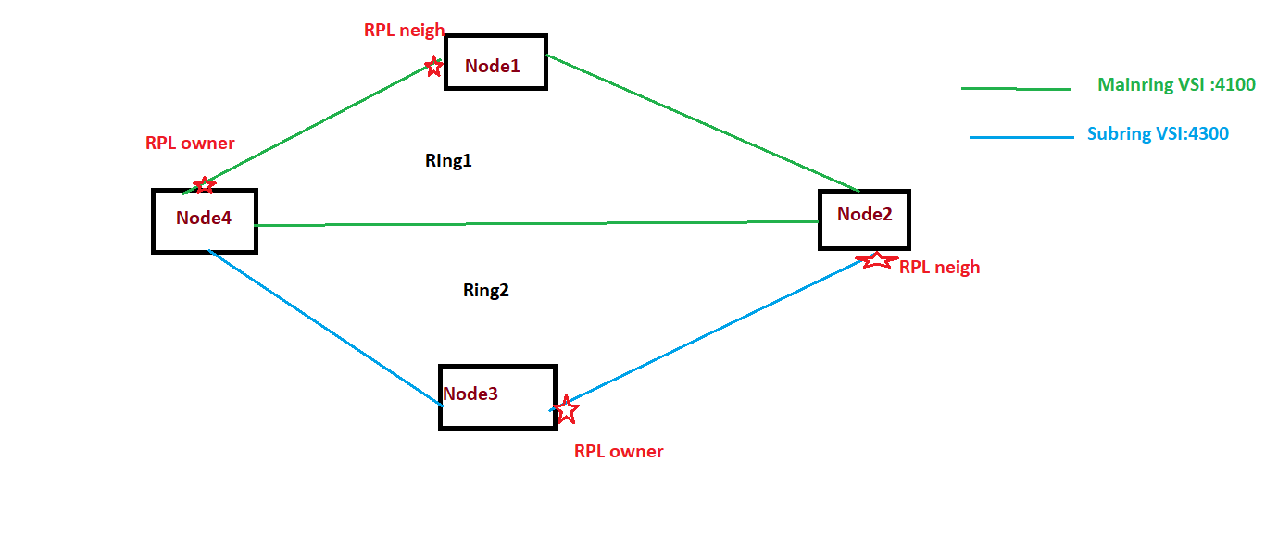

ERPS-MPLS Subring:

