The 5G NR radio access network is comprised of these protocol entities:

* Service data adaptation protocol (SDAP)
* Packet data convergence protocol (PDCP)
* Radio link control (RLC)
* Medium access control (MAC)
* Physical layer (PHY)

To meet the desired key capabilities of [5G NR](https://cafetele.com/5g-nr-network-function/), the other layers of the stack provide various enhancements over their LTE counterparts. The PDCP, RLC, and MAC protocols handle tasks such as header compression, ciphering, segmentation and concatenation, and multiplexing and de-multiplexing. PHY handles coding and decoding, modulation and demodulation, and antenna mapping.

USER Plane:  The figure below shows the protocol stack for the user plane, where SDAP, PDCP, RLC and MAC sublayers (terminated in gNB on the network side)

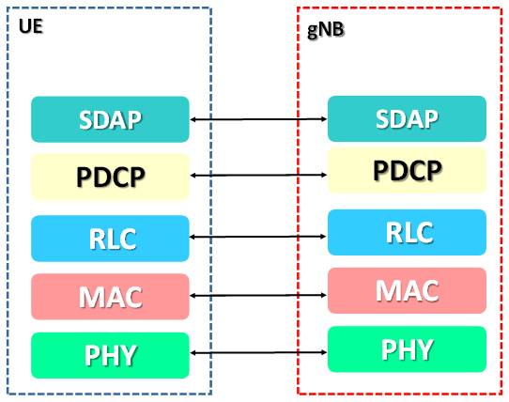

Control Plane :

The figure below shows the protocol stack for the control plane, where:

1. PDCP, RLC and MAC sublayers (terminated in gNB on the network side)
2. RRC (terminated in gNB on the network side)
3. NAS control protocol (terminated in AMF on the network side) performs the functions listed in TS 23.501,for instance: authentication, mobility management, security control…

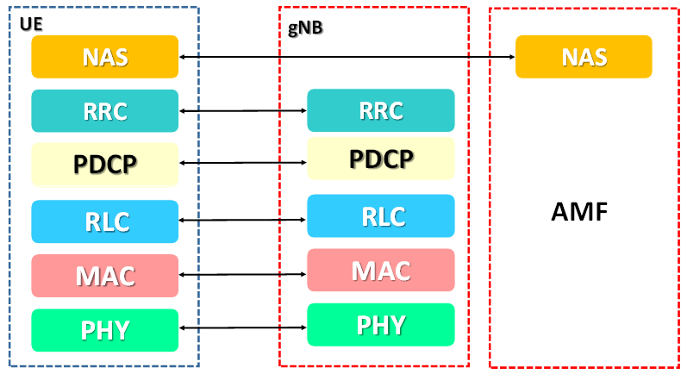

**SDAP Layer Pointers**

* The **SDAP layer** protocol is defined at part of 3GPP specification **TS 37.324**
* This layer is only applicable for **5G SA Architecture** and not used in **5G NSA Architecture**
* **SDAP** sublayer exists only in the **user plane** in both gNB&UE and is the **highest layer** within the RAN **protocol stack**
* From lower layers, SDAP expects **in-sequence delivery** of PDUs except when **out-of-sequence delivery** is configured by RRC at **PDCP**
* Apart from the transfer of **user plane data**, SDAP maps **QoS flows** to DRBs in both DL and UL
* **RRC** configures the **rules** by which **SDAP** does the mapping

**CU-DU**

