RLC Architecture:

Functions of the RLC sub layer are performed by RLC entities. For a RLC entity configured at the eNB, there is a peer RLC entity configured at the UE and vice versa. For an RLC entity configured at the transmitting UE for STCH or SBCCH there is a peer RLC entity configured at each receiving UE for STCH or SBCCH

An RLC entity receives/delivers RLC SDUs from/to upper layer and sends/receives RLC PDUs to/from its peer RLC entity via lower layers. An RLC PDU can either be a RLC data PDU (see sub clause 6.1.1) or a RLC control PDU (see sub clause 6.1.2). If an RLC entity receives RLC SDUs from upper layer, it receives them through a single SAP between RLC and upper layer, and after forming RLC data PDUs from the received RLC SDUs, the RLC entity delivers the RLC data PDUs to lower layer through a single logical channel. If an RLC entity receives RLC data PDUs from lower layer, it receives them through a single logical channel, and after forming RLC SDUs from the received RLC data PDUs, the RLC entity delivers the RLC SDUs to upper layer through a single SAP between RLC and upper layer. If an RLC entity delivers/receives RLC control PDUs to/from lower layer, it delivers/receives them through the same logical channel it delivers/receives the RLC data PDUs through. An RLC entity can be configured to perform data transfer in one of the following three modes: Transparent Mode (TM), Unacknowledged Mode (UM) or Acknowledged Mode (AM). Consequently, an RLC entity is categorized as a TM RLC entity, an UM RLC entity or an AM RLC entity depending on the mode of data transfer that the RLC entity is configured to provide.

The following functions are supported by the RLC sub layer:

- transfer of upper layer PDUs;

- error correction through ARQ (only for AM data transfer);

- concatenation, segmentation and reassembly of RLC SDUs (only for UM and AM data transfer);

- re-segmentation of RLC data PDUs (only for AM data transfer);

- reordering of RLC data PDUs (only for UM and AM data transfer);

- duplicate detection (only for UM and AM data transfer);

- RLC SDU discard (only for UM and AM data transfer);

- RLC re-establishment;

- Protocol error detection (only for AM data transfer).

Packet Data Convergence Protocol (PDCP)

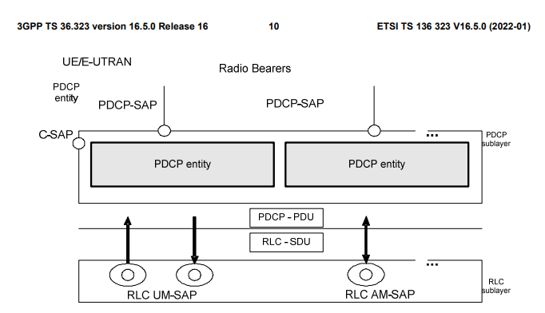

Each RB (i.e. DRB, SLRB and SRB, except for SRB0 and SRB1bis) is associated with one PDCP entity. Each PDCP entity is associated with one, two, or four (e.g uni-directional/bi-directional or split/non-split) RLC entities depending on the RB characteristic (i.e. uni-directional or bi-directional) or RLC mode: - For split bearers or for RBs configured with PDCP duplication, each PDCP entity is associated with two (bidirectional) AM RLC entities, two (for same direction) UM RLC entities or four (uni-directional) UM RLC entities. - For LWA bearers, each PDCP entity is associated with one (bi-directional) AM RLC entity or two (unidirectional) UM RLC entities and the LWAAP entity. - For DAPS bearers, each PDCP entity is associated with two UM RLC entities (for same direction, one for source and one for target cell), four (uni-directional) UM RLC entities (two for each direction on source cell and target cell), or two AM RLC entities (bi-directional, one for source cell and one for target cell). - Otherwise, each PDCP entity is associated with one UM RLC entity, two UM RLC entities (one for each direction), or one AM RLC entity (bi-directional).

The PDCP entities are located in the PDCP sublayer. Several PDCP entities may be defined for a UE. Each PDCP entity carrying user plane data may be configured to use either uplink data compression (UDC) or to use header compression. Each PDCP entity is carrying the data of one radio bearer. In this version of the specification, the robust header compression protocol (ROHC), Ethernet header compression (EHC), and UDC, are supported. Every PDCP entity uses at most one ROHC, one EHC, or one UDC compressor instance and at most one ROHC, one EHC, or one UDC decompressor instance. For DAPS bearers, the PDCP entity uses at most one ROHC compressor instance (i.e. use the ROHC compressor instance for source cell before uplink data switching, and use the ROHC compressor instance for target cell after uplink data switching) and at most two ROHC decompressor instances. UDC is not supported simultaneously with ROHC or EHC for the same radio bearer. ROHC and EHC are independently configured for the same radio bearer. A PDCP entity is associated either to the control plane or the user plane depending on which radio bearer it is carrying data for.

For RNs, integrity protection and verification are also performed for the u-plane.

For split and LWA bearers, routing is performed in the transmitting PDCP entity, and reordering is performed in the receiving PDCP entity.

For PDCP duplication, submission of duplicates is performed in the transmitting PDCP entity, and duplicate discard is performed in the receiving PDCP entity.

For split bearers, except when PDCP duplication is configured and activated, when requested by lower layers to submit PDCP PDUs, the transmitting PDCP entity shall:

- if ul-DataSplitThreshold is configured and the data available for transmission is larger than or equal to ulDataSplitThreshold

- submit the PDCP PDUs to either the associated RLC entity configured for SCG or the associated RLC entity configured for MCG, whichever the PDUs were requested by;

- else:

- if ul-DataSplitDRB-ViaSCG is set to TRUE by upper layers

- if the PDUs were requested by the associated lower layers configured for SCG:

- submit the PDCP PDUs to the associated RLC entity configured for SCG;

- else:

- if the PDUs were requested by the associated lower layers configured for MCG:

- submit the PDCP PDUs to the associated RLC entity configured for MCG

For LWA bearers, when submitting PDCP PDUs to lower layers, the transmitting PDCP entity shall:

- if ul-LWA-DataSplitThreshold is configured and the data available for transmission is larger than or equal to ulLWA-DataSplitThreshold:

- submit the PDCP PDUs to either the associated RLC entity upon request from lower layers or the associated LWAAP entity;

- else:

- if ul-LWA-DRB-ViaWLAN is set to TRUE by upper layers

- submit the PDCP PDUs to the associated LWAAP entity;

- else:

- submit the PDCP PDUs to the associated RLC entity upon request from lower layers

NOTE: The selection of PDCP PDUs submitted to the associated LWAAP entity is left up to the UE implementation

For bearers configured with PDCP duplication, when requested by lower layers to submit the PDCP PDUs, the transmitting PDCP entity shall:

- if PDCP duplication is activated:

- if the PDCP PDU is a PDCP Data PDU:

- duplicate the PDCP Data PDU and submit the PDCP Data PDU to the associated RLC entities;

- else:

- submit the PDCP Control PDU to the primary RLC entity;

- else:

- submit the PDCP PDU to the associated RLC entity.