RLC (RADIO LINK CONTROL):

* RRC is generally in control of the RLC configuration.
* For an RLC entity configured at the gNB, there is a peer RLC entity configured at the UE and vice versa.\
* An RLC entity receives/delivers RLC SDUs from/to upper layer and sends/receives RLC PDUs to/from its peer RLC entity via lower layers.
* An RLC PDU can either be an RLC data PDU or an RLC control PDU. If an RLC entity receives RLC SDUs from upper layer, it receives them through a single RLC channel between RLC and upper layer, and after forming RLC data PDUs from the received RLC SDUs, the RLC entity submits the RLC data PDUs to lower layer through a single logical channel.
* If an RLC entity receives RLC data PDUs from lower layer, it receives them through a single logical channel, and after forming RLC SDUs from the received RLC data PDUs, the RLC entity delivers the RLC SDUs to upper layer through a single RLC channel between RLC and upper layer. If an RLC entity submits/receives RLC control PDUs to/from lower layer, it submits/receives them through the same logical channel it submits/receives the RLC data PDUs through.
* An RLC entity can be configured to perform data transfer in one of the following modes.

1. Transparent Mode (TM)
2. Unacknowledged Mode (UM)
3. Acknowledged Mode (AM)

Consequently, an RLC entity is categorized depending on the mode of data transfer that the RLC entity is

1. TM RLC entity
2. UM RLC entity
3. AM RLC entity

**TM RLC entity:**

A TM RLC entity can be configured to submit/receive RLC PDUs through the following logical channels: BCCH, DL/UL CCCH, PCCH

* A TM RLC entity submits/receives TM PDU(RLC data PDU).

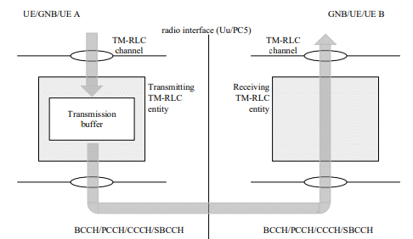

**Transmitting TM RLC entity:**

When a transmitting TM RLC entity forms TMD PDUs from RLC SDUs, It shall

* + Not segment the RLC SDUs.
  + Not include any RLC headers in the TMD PDUs.

**Receiving TM RLC entity:**

When a receiving TM RLC entity receives TMD PDUs, it shall:

* + Deliver the TMD PDUs (which are just RLC SDUs) to upper layer.

**UM RLC entity:**

An UM RLC entity can be configured to submit/receive RLC PDUs through the logical channels: DL/UL DTCH

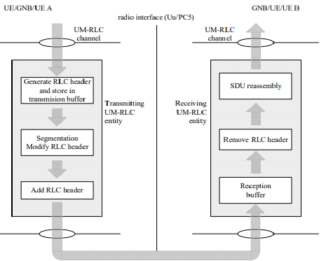

An UM RLC entity submits/receives UMD PDU(RLC data PDU).

**Transmitting UM RLC entity:**

* The transmitting UM RLC entity generates UMD PDU(s) for each RLC SDU.
* It shall include relevant RLC headers in the UMD PDU.
* When notified of a transmission opportunity by the lower layer, the transmitting UM RLC entity shall segment the RLC SDUs, if needed, so that the corresponding UMD PDUs, with RLC headers updated as needed, fit within the total size of RLC PDU(s) indicated by lower layer.

**Receiving UM RLC entity:**

When a receiving UM RLC entity receives UMD PDUs, it shall

* Detect the loss of RLC SDU segments at lower layers.
* Reassemble RLC SDUs from the received UMD PDUs and deliver the RLC SDUs to upper layer as soon as they are available.
* Discard received UMD PDUs that cannot be re-assembled into an RLC SDU due to loss at lower layers of an UMD PDU which belonged to the particular RLC SDU.

**AM RLC entity:**

* An AM RLC entity can be configured to submit/receive RLC PDUs through the logical channels

DL/UL DCCH, DL/UL DTCH

* An AM RLC entity delivers/receives the AMD PDU(RLC data PDUs)
* An AMD PDU contains either one complete RLC SDU or one RLC SDU segment
* An AM RLC entity delivers/receives the STATUS PDU (RLC control PDU)

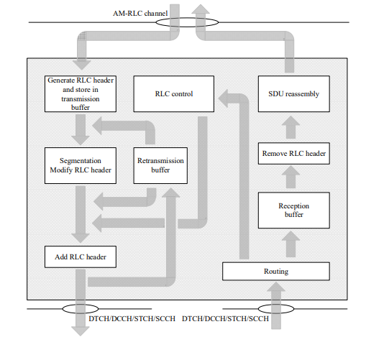

**Transmitting side:**

* The transmitting side of an AM RLC entity generates AMD PDU(s) for each RLC SDU.
* The transmitting side of an AM RLC entity supports retransmission of RLC SDUs or RLC SDU segments (ARQ):

1. if the RLC SDU or RLC SDU segment to be retransmitted (including the RLC header) does not fit within the total size of RLC PDU(s) indicated by lower layer at the particular transmission opportunity notified by lower layer, the AM RLC entity can segment the RLC SDU or re-segment the RLC SDU segments into RLC SDU segments.
2. the number of re-segmentation is not limited.

* When the transmitting side of an AM RLC entity forms AMD PDUs from RLC SDUs or RLC SDU segments, it shall:

“include relevant RLC headers in the AMD PDU”

**Receiving side:**

When the receiving side of an AM RLC entity receives AMD PDUs, it shall:

* Detect whether or not the AMD PDUs have been received in duplication, and discard duplicated AMD PDUs.
* Detect the loss of AMD PDUs at lower layers and request retransmissions to its peer AM RLC entity.
* Reassemble RLC SDUs from the received AMD PDUs and deliver the RLC SDUs to upper layer as soon as they are available.

**Services**

**Services provided to upper layers**

The following services are provided by RLC to upper layer:

- TM data transfer

- UM data transfer

- AM data transfer, including indication of successful delivery of upper layers PDUs.

**Services expected from lower layers**

The following services are expected by RLC from lower layer (i.e. MAC):

- data transfer;

- notification of a transmission opportunity, together with the total size of the RLC PDU(s) to be transmitted in the transmission opportunity.

**Functions:**

The following functions are supported by the RLC sub layer:

- transfer of upper layer PDUs;

- error correction through ARQ (only for AM data transfer);

- segmentation and reassembly of RLC SDUs (only for UM and AM data transfer);

- re-segmentation of RLC SDU segments (only for AM data transfer);

- duplicate detection (only for AM data transfer);

- RLC SDU discard (only for UM and AM data transfer);

- RLC re-establishment;

- Protocol error detection (only for AM data transfer).