The 5G NR radio access network is comprised of these protocol entities:

* Service data adaptation protocol (SDAP)
* Packet data convergence protocol (PDCP)
* Radio link control (RLC)
* Medium access control (MAC)
* Physical layer (PHY)

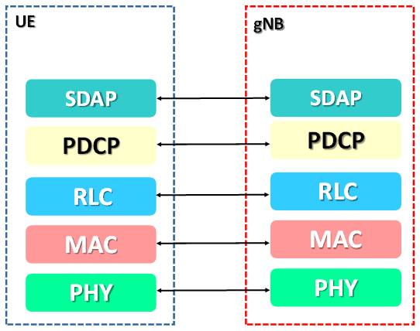

User Plane Protocol Stack

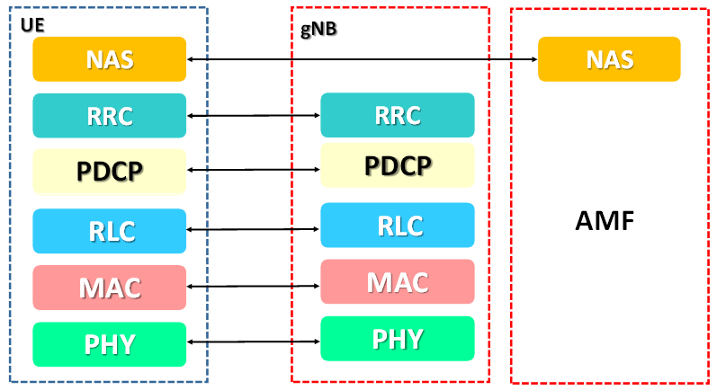 **Control Plane Protocol Stack**

SDAP**:** The**service data adaptation protocol** is a new sublayer in layer 2 which immediately interfaces with the network layer and provides a mapping between the QoS flows and data radio bearers (DRBs). It also marks the QoS flow identifiers (QFIs) in the downlink and uplink packets. A single-protocol entity of SDAP is configured for each individual PDU Session. SDAP applies also to LTE when connected to the 5G Core. The introduction of SDAP enables end-to-end QoS framework that works in both directions.

PDCP**:**PDCP sublayer processes the radio bearers and maps them in a one-to-one manner to RLC channels (i.e. a single radio bearer corresponds to a single RLC channel),   The PDCP layer also handles Robust Header Compression (ROHC) and security for the data packets.

RLC**:**RLC sublayer processes RLC channels and maps them in a one-to-one manner to logical channels (i.e. a single RLC channel corresponds to a single logical channel, segmentation and Automatic Repeat Request (ARQ) functionality are man function.

MAC**:** MAC sublayer processes logical channels and maps them to transport channels in a many-to-one manner (i.e. multiple logical channels can be mapped to a single transport channel), eg. Scheduling, multiplexing,HARQ( Hybrid Automatic request.)

PHY**:**  PHY layer processes transport channels and maps them to physical channels in a one-to-one manner (i.e. a single transport channel is mapped onto a single physical channel), coding, decoding.

**Core Network Architecture:**

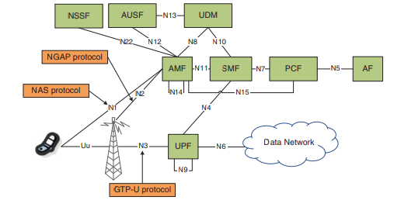

AMF(ACCESS AND MOBILITY MANAGEMENT FUNCTION)

It is a control plane function in 5G core network. The main functions and responsibilities of AMF are:

1. Registration Management
2. Reachability Management
3. Connection Management
4. Mobility Management

*Registration Management* allows a UE to register and de-register with the 5G system. A UE must complete the registration procedure to receive authorization to use 5G services.    
Registration moves the UE from RM-Deregistered state to the RM-Registered state. Registration creates a UE Context within the network. ​

*Connection Management* establishes and release the control plane signalling connections between the UE and AMF (across N1 interface). N1 signalling connection moves the UE from CM-Idle to CM-Connected.

*Reachability Managment* ensures that a UE is always reachable, i.e., it is possible to page the UE when there is a requirement to establish a mobile terminated connection. Paging a UE which is in the CM-Idle state triggers the UE to initiate the NAS Service request procedure and subsequently establish an N1 signalling connection before moving into the CM-Connected state.

*Mobility Management* is used to maintain knowledged of UE's location within the network. The UE is required to complete periodic registration updates after it has completed initial registration. These periodic updates act as keep-alive to verify that UE remains on the system, and has not moved out of coverage or become unavailable due to any other reason (for example UE stopped working, battery died). UE is also required to complete updates due to mobility. These updates are triggered if UE moves outside the current registration area (outside of tracking area or list of tracking areas within which the UE is currently registered)

**Next Generation Application Protocol (NGAP):**AMF is also responsible for handling Next Generation Application Protocol (NGAP) signalling which is transferred between the AMF and 5G RAN node ( which means between an AMF and Base Station). NGAP specifications are described in 3GPP TS 38.413 and is similar to S1AP in case of 4G LTE ( S1 AP is between MME and Base Station).

Different categories of NGAP signalling procedures include:

1. PDU Session Management
2. UE Context Managment
3. UE Mobility Management
4. Paging Procedures
5. Transport of NAS messages
6. Interface Management
7. Configuration Transfer
8. Warning Message Transmission

* *PDU Session Management* procedures are used to setup, modify and release resources at the Base station and UE. SMF is responsible for PDU Session Management so these procedures are completed after the AMF has been instructed by the SMF
* *UE Mobility Management* procedures are used to support handover procedures. Xn based handover procedures use the NGAP Path Switch Signalling procedure. N2 based handover procedures use the NGAP Handover Required, Handover Request, Handover Command and Handover Notify signalling procedures.
* *Transport of NAS messages*. NGAP is used to transfer NAS messages between the BTS and AMF, while a signalling radio bearer (SRB) is used to transfer NAS messages between the UE and BTS. The combination of these hops provides the end-to-end transfer of NAS messages across the N1 interface between UE and AMF.  The combination of NAS and NGAP signalling is shown in Figure below.
* *Interface Management procedure*. These procedures are used to setup the NG connection between the Base Station and AMF. Both N1 and N2 interface use the NG connection between the Base Station and AMF. Interface Management procedures also allow both RAN and AMF configuration  updates to be provided.  As an example RAN configuration update allows the Base Station to inform the AMF of any changes to the supported PLMN or Tracking Areas.
* *Configuration Transfer procedure*. This procedure allow the Base Station and AMF to exchange information related to Self Optimizing Networks . As an example, procedures can be used to support Automatic Neighbor Relations (ANR). The end to end transfer of information could be between a pair of Base Stations but the information has to be sent via the AMF if an Xn interface does not exist between the Base Stations.

SESSION MANAGEMENT FUNCTION (SMF):

The session management function (SMF) is part of control plane function within 5G Core Network.  The  main responsibilities of SMF are as follows

1. PDU Session Management
2. IP Address Allocation
3. GTP-U Tunnel Management
4. Downlink Notification Management

[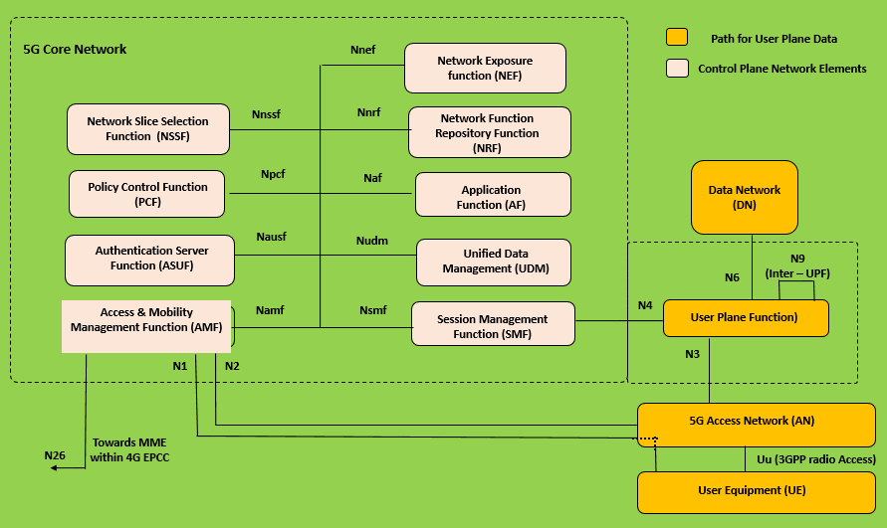](http://www.techtrained.com/figure_8/)

​The session management function (SMF) is part of control plane function within 5G Core Network.  The  main responsibilities of SMF are as follows

1. PDU Session Management
2. IP Address Allocation
3. GTP-U Tunnel Management
4. Downlink Notification Management

**PDU Session Ma​nagement** includes setup, modification and release of PDU sessions. For ease of understanding a *PDU session* is equivalent to the concept of EPS Bearer in 4G.  It is logical connection between UE and the exit of User Plane Function (UPF) towards a specific Data Network (External network, or Internet)

An example of PDU Session concept is shown below

[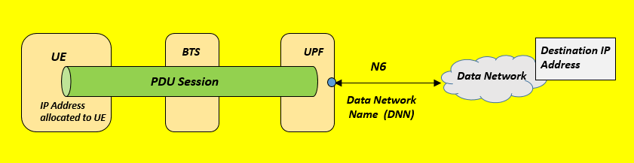](http://www.techtrained.com/fig_11/)

*​PDU Session Illustration*

1. ​PDU Session management requires SMF to complete signalling towards the UE, Base Station and User Plane Function (UPF).
2. SMF can signal directly with the UPF but requires the AMF to support signalling towards the UE and Base Station
3. SMF uses Non Access Stratum (NAS) signalling messages to communicate with the UE. Both the base station and AMF act as transparent routers for these messages which are relayed between the SMF and UE.
4. UE can initiate the setup of a PDU Session send a *NAS: PDU Session Establishment Request*. Assuming a successful setup, SMF responds with a *NAS: PDU Session Establishment* Accept message.
5. Signalling towards the base station requires the AMF to transfer messages using Next Generation Application Protocol (NGAP)
6. AMF and Base Station are responsible for managing NGAP signalling procedures but content is relayed to and from the SMF when those procedures relate to Session Management

**IP Address Allocation**depends upon the type of PDU Session.

1. A PDU session can be setup to transfer either IPv4, IPv6, Ethernet or Unstructured data types.
2. UE can request a specific data type within the NAS: PDU Session Establishment Request message. The allocated data type is confirmed within the NAS: PDU Session Establishment Accept message.
3. IP address allocation is applicable to PDU Sessions which transfer IPv4 or IPv6 packets.

**GTP-U Tunnel Management** refers to the management of user plane GTP-U tunnel between the Base Station and UPF.

1. GTP-U tunnels are used to transfer user plane data between the Base Station and UPF.
2. A GTP-U tunnel operates by adding a set of IP/UDP/GTP-U headers to the user plane data packets.  The IP layer is used to route the packets between the Base Station and UPF. The UDP layer is used to provide connectionless data transfer and to specify the port number for the GTP-U layer
3. The GTP-U layer specifies the Tunnel Endpoint Identifier (TEID) which links the user plane packet to a specific PDU Session.

General concept of GTP-U tunnel is illustrated below.

[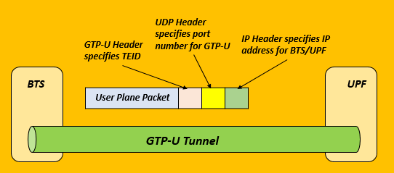](http://www.techtrained.com/fig_12/)

*​Illustration of GTP-U Tunnel between the Base Station and User Plane Function (UPF)*

*​User plane packet include its own IP header if the PDU session data type is IP. The additional IP header is only used to route the packet through the GTP-U tunnel and is removed by the UPF or base station*

**​Downlink Notification Management** refers to the initiation of paging procedure.

1. A UE needs to be paged if downlink data arrives at UPF after UE has been released to RRC Idle mode.UPF recognises that the UE does not a GTP-U tunnel towards the Base Station. It triggers the UPF to inform the SMF that downlink data has arrived for the UE.
2. SMF eventually informs the AMF from where the Network Triggered Service Request procedure is initiated or UE is paged.

**​SMF Responsibilities**

* **​**SMF is responsible for selecting an appropriate UPF during the setup of a PDU session. Selection for appropriate UPF depends upon appropriate load, geographic location, PDU session type etc.
* SMF is responsible for selecting an appropriate Policy Control Function (PCF) during setup of a PDU session. It selects the PCF to provide the policy for a specific PDU session. The selection criteria depends upon Data network name used by PDU session, configured information etc.
* SMF requests subscription information from Unified Data Management (UDM) function during the setup of a PDU Session.
* SMF provides support for interfacing with network charging system both for Online Charging System (OCS) and Offline Charging System (OFCS). ​

**USER PLANE FUNCTION:**

The User Plane Function (UPF) is one of the network functions (NFs) of the 5G core network (5GC).The UPF is responsible for

packet routing and forwarding,

packet inspection,

QoS handling, and external PDU session for interconnecting Data Network (DN)

 single instance of UPF provides some or all the following functionalities:

* Anchor point for Intra-RAT and Inter-RAT mobility (when applicable).
* External PDU session point of interconnect to Data Network.
* Packet routing and forwarding.
* Packet inspection. For example, Application detection that is based on the service data flow template and the optional PFDs received from the SMF in addition.
* User Plane part of policy rule enforcement. For example, Gating, Redirection, Traffic steering.
* Lawful intercept (UP collection).
* Traffic usage reporting.
* QoS handling for User Plane. For example, Uplink (UL) and Downlink (DL) rate enforcement, Reflective QoS marking in DL, and so on.
* Uplink Traffic verification (SDF to QoS Flow mapping).
* Transport level packet marking in the Uplink and Downlink.
* Downlink packet buffering and Downlink Data Notification triggering.
* Sending and forwarding of one or more "End Marker" to the source NG-RAN node.

**Interface between RAN Nodes (X2/Xn)**

The X2 interface used between eNBs in LTE is reused between RAN nodes in non-standalone operation (between eNB and en‒gNB and the Xn interface is newly specified between RAN nodes in standalone operation (between ng‒eNB and ng‒eNB/gNB and gNB/ng‒eNB and gNB

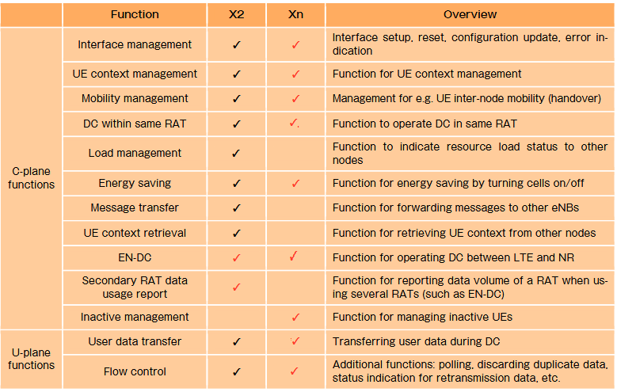

**Interface between RAN Node and Core Network (S1/NG)**

Similar to interface between RAN nodes, the interfaces between RAN nodes and Core network also differ for non-standalone and standalone operation. In non-standalone operation, the S1 interface is reused for between RAN node and EPC. On the other hand a new interface with name NG is specified between RAN nodes (ng‒eNB/gNB and 5GCs in standalone operation.

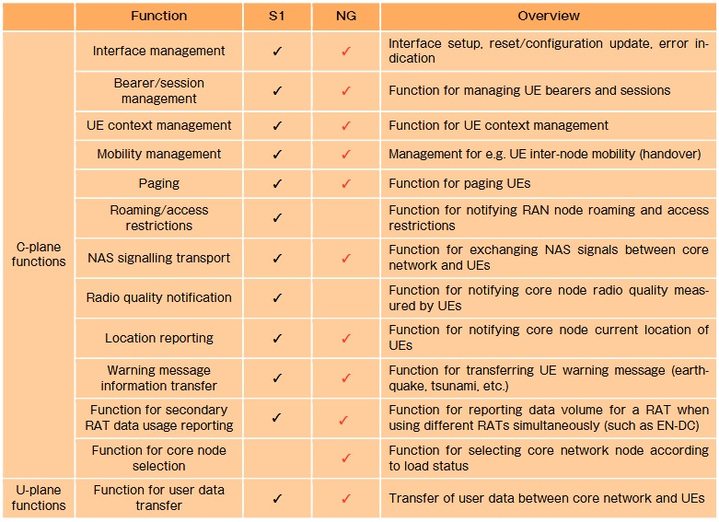

## Non Stand Alone Architecture

NSA means, initially 5G deployment will happen along with existing 4G networks.

It means, the speeds will not match the actual 5G speeds, but the implementation will be faster.

Here the primary network will be LTE eNB and secondary will be 5gNB.

It means in NSA 4G EPC core with Master LTE RAN and secondary 5G NR.

NSA is also known as E-UTRA-NR dual connectivity (EN-DC).

## Different types of Non Stand Alone Architecture

There are different options of NSA architecture are possible.

Some of them are mentioned below:

A detailed explanation is there in next chapter.

**Option 1:** SA Deployment. 4G EPC with 4G Radio allows a 4G device to access a 4G only network.

**Option 2:** SA Deployment. 5G Core with 5G New Radio (NR) allows a 5G device to access a 5G only network.

**Option 3:** NSA Deployment. Traffic is split across 4G and 5G at eNodeB.

**Option-3a:** NSA Deployment. Traffic is split across 4G and 5G at EPC (S-GW).

**Option-3x:** NSA Deployment. Traffic is split across 4G and 5G at 5G cell.

**Option 4:** NSA Deployment. 5G NR and 4G Radio devices connect into 5G Core

**Option 5:** SA Deployment. 4G devices using 4G radio access network device to 5G Core

**Option 7:** LTE (Long Term Evolution) and 5G NR connect into 5G Core

## Stand Alone Architecture

In Standalone architecture, all the components will be 5G components.

It will have 5G core and 5G NR access network.

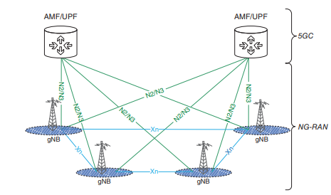

## Benefits of 5G NSA:

It will leverage existing network investments.

It will help to realize 5G sooner.

## Benefits of 5G SA:

It is fully virtualized, cloud native architecture that is easy way to manage, develop and deploy.

It will enable end to end slicing of logically seperate services.

With the help of cloud-native micro-service based architecture, MNOs can also decide on a variety of deployment models such as on-premise private cloud, public cloud or hybrid.

**Option 3: EN-DC (EUTRA-NR Dual Connectivity)**

Option 3 represents a network having both LTE and NR radio access, but using only the EPC core of LTE to route the Control signals. In this option, LTE is used as the control plane anchor for NR, and both LTE and NR are used for user data traffic.(user plane).

It could also be called as Non-Standalone (NSA) NR in Evolved Packet System.

The only difference between Options 3 and 3A is based on whether the user plane data is sent to NR directly or via the LTE RAN.

This option will be most attractive for operators which have early deployments of 5G NR access systems in areas where legacy eNB and EPC are operational.

In this option, the operators do not need a 5G Core. In the early 5G stages of deployment, Option 3/3a/3x will be the likely choice for many operators.

As this approach is tied to LTE, it is important not to disrupt the existing network. Operators have the options of deploying dual connectivity for data like high throughput in NR downlink and best coverage in LTE uplink, meanwhile voice traffic will be fully on LTE.

Option 3 requires routing 5G data through eNBs,

Option 3A can’t support dynamic switching between LTE and 5G.

Option-3/3a/3x are transparent to MME and P-GW, and translate to an E-RAB modification procedure at MME.

• Option-3 — Traffic is split between 4G and 5G at eNodeB.

• Option-3a — Traffic is split between 4G and 5G at EPC (S-GW).

• Option-3x — Traffic is split between 4G and 5G at 5G cell.

**Option 3:**   
  
In the plain option 3, all uplink/downlink data flows to and from the LTE part of the LTE/NR base station, i.e. to and from the eNB. The eNB then decides which part of the data it wants to forward to the 5G gNB part of the base station over the Xx interface. In simple terms, the 5G gNB never communicates with the 4G core network directly!

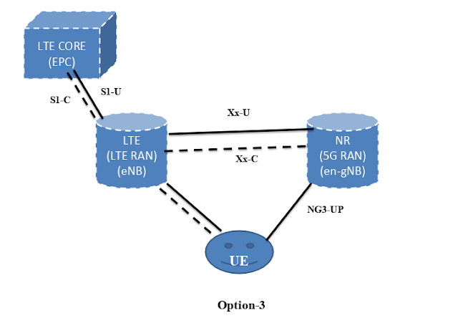Salient features:

▪ UE will be connected to both 5G NR and 4G LTE.

▪ For Option 3 Control Plane relies on EPS LTE S1-MME interface and LTE RRC Control.

▪ For Option 3 User Plane might split bearer

**Key advantages:**

▪ Reuse of EPC & S1

▪ Low investment (only for 5G BS gNB)

▪ Possible reuse of VoLTE with minor upgrade

**Up gradations required:**

▪ Increased complexity in 5G UEs (EN-DC capable)

▪ Upgrade eNB to connect to gNB via Xx/Xn interfaces

▪ Backhaul requirements of 5-30 ms between gNB and eNB

**Option 3A:**   
  
In this option, both the LTE eNB and the 5G gNB can directly talk to the EPS core network but they cannot directly talk with each other over the Xx (X2) interface. This means that a single data bearer cannot share the load over LTE and NR. For example, VoLTE voice traffic for a user is handled by LTE while his Internet traffic is handled by the 5G part of the base station. It would be difficult to implement this scenario if the devices keep moving in and out of 5G network coverage continuously.

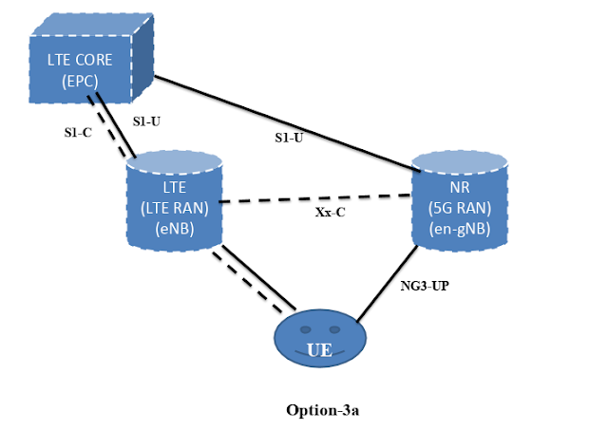

Note: **for dual connectivity between LTE and NR, X2-C interface will be used for Option 3a.**

**Option 3X**:

Option 3X is a combination of 3 and 3A.

In this configuration, user data traffic will flow directly to the 5G gNB part of the base station. From there, it is delivered over the air to the mobile device. A part of the data can also be forwarded over the X2 interface to the 4G eNB part of the base station and from there to the UE. Slow data streams (Low Data), e.g. VoLTE bearers with a different IP address than that used for Internet access can be directly delivered from the core network to the 4G eNB part of the 4G/5G base station. The advantage is that the 5G upgrade of the base station is likely to have the much better performing IP interface so it is better suited to handle the higher data rates that can only be reached with a 4G/5G Non-Standalone network deployment.

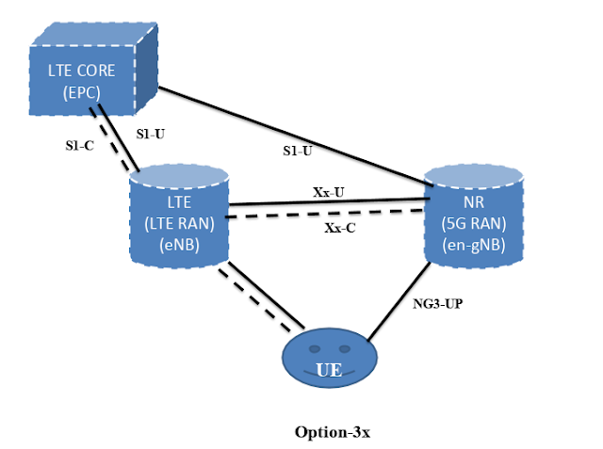

Option-3X provides robust coverage in higher frequencies and aggregated peak bit rate of LTE and 5G for lower frequencies.

Option-3X also provides near zero interrupt time LTE-5G mobility.

Option-3X provides allows voice in LTE without using RAT fallback.

This configuration can be used in scenarios where LTE coverage reach is superior to that of NR and thus leverages EPC.

In this configuration, the LTE eNB will act as the Master and will have control over which S1-U bearers are handled by radio of LTE or NR. Based on instructions from LTE eNB, MME will inform S-GW where to establish S1-U bearers, i.e. LTE or NR. If NR radio quality falls below a certain threshold,  S1-U bearer towards NR may be either split at NR and sent entirely over Xx to LTE or a PATH SWITCH may be triggered where all S1- U will go to LTE eNB.

**Summary of different Dual Connectivity architecture options**

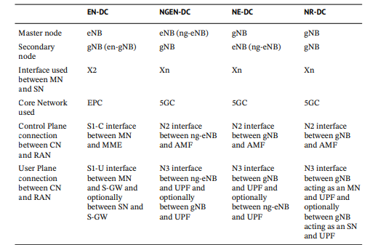

EN-DC -- OPTION3

NGEN-DC – OPTION7

NE-DC – OPTION4

NR-DC –OPTION2

* **eNB**: A 4G network element. Connects to a 4G UE and EPC. This relates to options 1 and 3.
* **gNB**: A newly introduced 5G network element. Connects to a 5G UE and 5G Core. This relates to options 2, 4 and 7.
* **en-gNB**: Sits in a 4G RAN and connects a 5G UE to EPC. Both 4G and 5G radio resources are active using dual connectivity. eNB is the master node while en-gNB is the secondary node. "en" refers to E-UTRA New Radio. This relates to option 3.
* **ng-eNB**: Connects to 5G Core but serves a 5G UE over 4G radio. "ng" refers to Next Generation. This relates to options 4, 5 and 7. There's dual connectivity in option 4 (gNB is master, ng-eNB is secondary) and option 7 (ng-eNB is master, gNB is secondary).