* **What is 5G:**

5G(Fifth-generation) is the latest iteration of cellular technology, engineered to greatly increase the speed and responsiveness of wireless networks. With 5G, data transmitted over wireless broadband connections can travel at multigigabit speeds, with potential peak speeds as high as 20 gigabits per second (Gbps) by some estimates.

* **What is Non-Standalone (NSA) & how many types of NSA in EPC and 5GC? Draw the diagram**.

**Non Stand Alone Architecture:**

NSA means, initially 5G deployment will happen along with existing 4G networks.

It means, the speeds will not match the actual 5G speeds, but the implementation will be faster.

Here the primary network will be LTE eNB and secondary will be 5gNB.

It means in NSA 4G EPC core with Master LTE RAN and secondary 5G NR.

NSA is also known as E-UTRA-NR dual connectivity (EN-DC).

**Different types of Non Stand Alone Architecture:**

There are different options of NSA architecture are possible.

Some of them are mentioned below:

**Option 1:** SA Deployment. 4G EPC with 4G Radio allows a 4G device to access a 4G only network.

**Option 2:** SA Deployment. 5G Core with 5G New Radio (NR) allows a 5G device to access a 5G only network.

**Option 3:** NSA Deployment. Traffic is split across 4G and 5G at eNodeB.

**Option-3a:** NSA Deployment. Traffic is split across 4G and 5G at EPC (S-GW).

**Option-3x:** NSA Deployment. Traffic is split across 4G and 5G at 5G cell.

**Option 4:** NSA Deployment. 5G NR and 4G Radio devices connect into 5G Core

**Option 5:** SA Deployment. 4G devices using 4G radio access network device to 5G Core

**Option 7:** LTE (Long Term Evolution) and 5G NR connect into 5G Core

* **Explain 5G NR network architecture, its elements and network interfaces?**

The numbers in the oval shape indicates the reference point between components. This shows NR network only in non-roaming condition. In the condition of roaming with other NR network or Legacy network, some additional function block and interface(reference point) is required

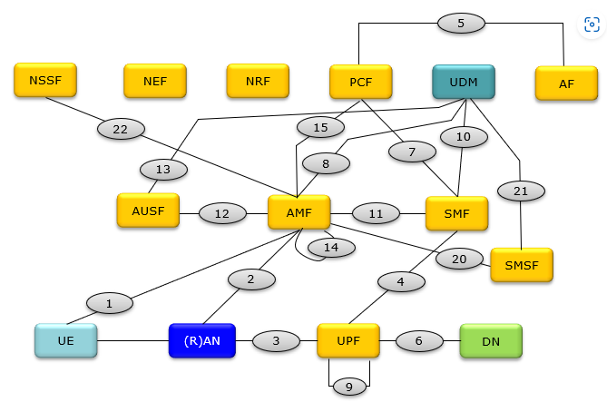

Each element name are as follows:-

AMF     Access and Mobility Management Function ==> Equivalent to MME in 4G

AUSF    Authentication Server Function

DN       Data Network

NEF      Network Exposure Function

NRF      Network Repository Function

NSSF    Network Slice Selection Function

PCF      Policy Control Function ==> Equivalent to PCRF in 5G

(R)AN   (Radio) Access Network

SMF     Session Management Function

UDM     Unified Data Management ==> Equivalent to HSS in 4G

UPF      User Plane Function ==> Equivalent to PGW in 4G

SMSF   SMS Function

* **Explain the CU-DU split architecture? Explain the CU-DU split architecture with protocol differentiation. Mention the interface between CU & DU?**

Overall Architecture of NR RAN (Radio Access Network) would not look much different from [LTE RAN Architecture](https://www.sharetechnote.com/html/Handbook_LTE_NetworkArchitecture.html). However getting into details, you would start seeing some differences as well. You see different name of each node and interface. MME/S-GW in LTE is replaced by AMF/UPF in NR and X2/S1 in LTE are replaced by Xn/NG-C/U in NR. Different name would mean different protocol and implemenation. Among all of these differences, out of the most outstanding one would be that the gNB internal structure is split into two parts called CU (Central Unit) and DU (Distributed Unit).

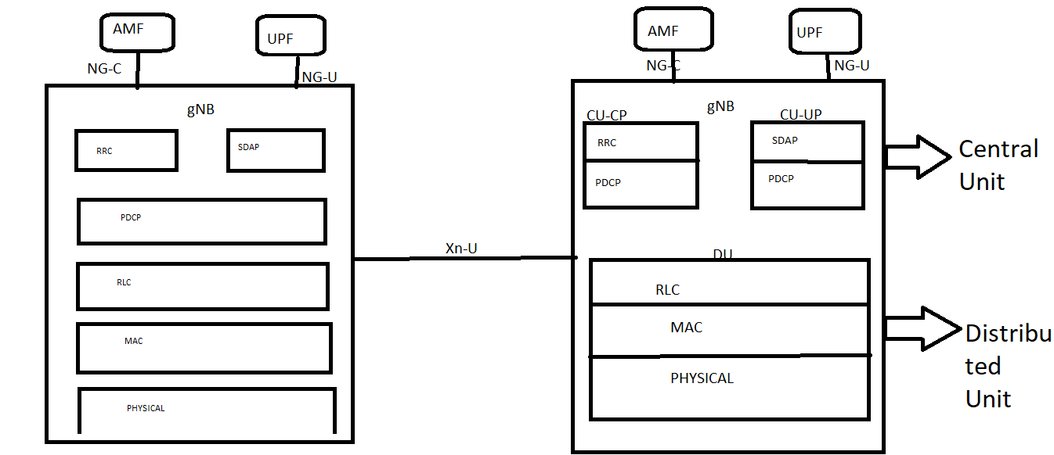

Interfaces:

1. Between CU and DU are “F1-interface”.
2. Between CU and AMF are “NG-C interface”.
3. Between CU and UPF are “NG-U interface”.
4. Between CU-CP and CU-UP are “E1 interface”.

* **What are the function of** gNB and ng-eNB?

**gNB:**

The gNB is radio node which is equivalent of eNB in 4G architecture. The gNB allows 5G UE to connect with 5G NG core using 5G NR air interface.

The gNB provides 5G NR User Plane and Control Plane terminations towards UE. It connects with NG-Core via NG interface.

**ng-eNB:**

It is enhanced version of 4G eNodeB. The ng-eNB connects 5G user equipment (UE) to 5G CN (Core Network) using 4G LTE air interface. UE (User Equipment) use 4G LTE radio resources to connect with ng-eNB. It provides E-UTRAN UP (User Plane) and CP (Control Plane) terminations towards UE. It connects with NG-Core via NG interface.

* **What is dual connectivity and what are the function of dual connectivity?**

Dual connectivity is used when a device consumes radio resources provided by atleast two different n/w access points such as gNB or eNB.

Terminology for Dual connectivity includes:

1. Bearer Split: This term refers to the ability to split a bearer over multiple RAN nodes.
2. MCG(Master Cell Group): Is the group of serving cells associated with the Master RAN node.
3. Master RAN node: This is an gNB/ng-eNB which terminates the core n/w connectivity and therefore acts as the mobility anchor towards the core n/w.
4. SCG(Secondary Cell Group): Is the group of serving cells associated with Secondary RAN node.
5. Secondary RAN node: This is an gNB/ng-eNB which provides additional resources to the device, which is not the Master RAN node.

* **What is NR multi connectivity? which one is dual connectivity & Carrier aggregation?**

**Multi-connectivity:**

One of the key features of 5G NR enumerated earlier is multi-connectivity (MC). It refers to the concurrent use of multiple independent communication paths, nodes, access points (APs) or base stations (BSs) for data transmission to a UE. In MC mode, the UE accesses radio resources from multiple nodes that have distinct schedulers.

* **What is the UE state in 5GC?**

Following are the three RRC states of UE as per 5G NR standard.  
• **RRC_IDLE** : Upon power ON, UE enters into RRC_IDLE mode. UE can move to this mode from either RRC_CONNECTED mode or RRC_INACTIVE mode.  
• **RRC_INACTIVE**: UE moves to this mode from RRC_CONNECTED mode. It is connected but inactive mode of UE. In this mode UE maintains RRC connection and at the same time minimizes signaling and power consumption.  
• **RRC_CONNECTED**: UE remains in connection with the 5G-RAN/5GC in this mode.

#### RRC_IDLE MODE:

Following actions are performed by UE in RRC IDLE mode.  
 • Selection of PLMN  
 • Broadcast of SI messages.  
 • Cell re-selection mobility  
 • Paging for mobile terminated data is initiated by 5GC  
 • Paging for mobile terminated data area is managed by 5GC  
 • DRX for CN paging configured by NAS, Support for UE discontinuous reception (DRX) is carried out to enable power saving in 5G UE.

#### RRC_INACTIVE MODE:

Following actions are performed by UE in RRC INACTIVE mode.  
 • Broadcast of system information  
 • Cell re-selection mobility  
 • Paging is initiated by NG-RAN (RAN paging)  
 • RAN-based notification area (RNA) is managed by NG-RAN  
 • DRX for RAN paging configured by NG-RAN  
 • 5GC to NG-RAN connection (both C/U-planes) is established for UE  
 • The UE AS context is stored in NG-RAN and the UE  
 • NG-RAN knows the RNA which the UE belongs to

#### RRC_CONNECTED MODE:

Following actions are performed by UE in RRC CONNECTED mode.  
 • 5GC to NG-RAN connection (both C/U-planes) is established for UE  
 • The UE AS context is stored in NG-RAN and the UE  
 • NG-RAN knows the cell which the UE belongs to  
 • Transfer of unicast data to/from the UE  
 • Network controlled mobility including measurements

* **Complete the Mapping of QoS flows to AN resources**

The SDAP layer handles the mapping between quality of service (QoS) flow and radio bearers. IP packets are mapped to radio bearers according to their QoS requirements.

The QoS flow is the lowest level granularity within the 5G system and is where policy and charging are enforced. One or more Service Data Flows (SDFs) can be transported in the same QoS flow if they share the same policy and charging rules (similar to an EPS bearer in 4G LTE).

Access Stratum level, the data radio bearer (DRB) defines the packet treatment on the radio interface (Uu). A DRB serves packets with the same packet forwarding treatment. The QoS flow to DRB mapping by gNB is based on QFI and the associated QoS profiles (i.e. QoS parameters and QoS characteristics)

* **Explain about 5G NR frame structure**

**5G NR frame structure:**

5G NR Supports two frequency ranges FR1 (Sub 6GHz) and FR2 (millimeter wave range, 24.25 to 52.6 GHz). NR uses flexible subcarrier spacing derived from basic 15 KHz subcarrier spacing used in LTE.

A frame has duration of 10 ms which consists of 10 subframes having 1ms duration each similar to LTE technology. Each subfame can have 2μ slots. Each slot typically consists of 14 OFDM symbols. The radio frame of 10 ms are transmitted continuously as per TDD topology one after the other. Subframe is of fixed duration (i.e. 1ms) where as slot length varies based on subcarrier spacing and number of slots per subframe. As shown below, it is 1 ms for 15 KHz, 500 µs for 30 KHz and so on. Subcarrier spacing of 15 KHz occupy 1 slot per subframe, subcarrier spacing of 30 KHz occupy 2 slots per subframe and so on. Each slot occupies either 14 OFDM symbols or 12 OFDM symbols based on normal CP and extended CP respectively.

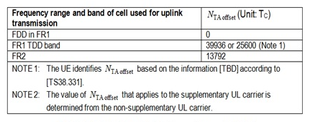

1. OFDM symbols in a slot can be classified as 'downlink', 'flexible', or 'uplink'.
2. In a slot in a downlink frame, the UE shall assume that downlink transmissions only occur in 'downlink' or 'flexible' symbols.
3. In a slot in an uplink frame, the UE shall only transmit in 'uplink' or 'flexible' symbols.

* **Explain about 5G NR numerology**

A frame in 5G NR consists of 10 ms duration. A frame consists of 10 subframes with each having 1ms duration similar to LTE. Each subframe consists of 2μ slots. Each slot can have either 14 (normal CP) or 12 (extended CP) OFDM symbols. All the subcarrier spacing options have 14 OFDM symbols. 60 KHz spacing supports both normal and extended CP types.

For μ = 0 there are 1 slots per subframe , for μ = 1 there are 2 slots per subframe, for μ = 2 there are 4 slots per subframe and so on. Number of slots per frame is ten times of number of slots per sub frame. Hence for μ = 2, there are 40 slots/frame. 5G NR uses 4096 FFT points which consists of 3300 data subcarriers for maximum bandwidth of 400 MHz.

Number of OFDM symbols per slot, slots per frame and slots per sub-frame for normal cyclic prefix is

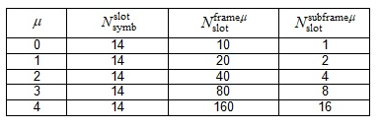

* **Explain about NR downlink and uplink channel with ( Logical channel,transport channel, Physical channel and reference signals)**

**Logical Channel Definition** : Medium Access Control (MAC) Layer of NR provides services to the Radio Link Control (RLC) Layer in the form of logical channels. A logical channel is defined by the **type** of information it carry and is generally differentiated  as a **control channel**, used for transmission of control and configuration information  or as a **traffic channel** used for the user data.

**List of Logical Channels for NR:**

* **Broadcast Control Channel (BCCH):**It is used for transmitting  system information from the network to  UEs in a cell coverage. Prior to accessing the system, a UE needs to acquire the system information to find out the system configuration. BCCH channel is used in Standalone (SA) operation of NR, in the case of non-standalone operation (NSA), system information is provided by the LTE cell and there is no BCCH.
* **Paging Control Channel (PCCH):**This is used to page the UEs whose location at cell level is not known to the network. The paging message therefore needs to be transmitted in multiple cells. Similar to BCCH PCCH is also used in SA operation, in the case of NSA operation, paging is provided by the LTE cell and there is no PCCH.
* **Common Control Channel (CCCH):**It is used for transmission of control information to UEs with respect to Random Access
* **Dedicated Control Channel (DCCH):**It is used for transmission of control information to/from a UE. This channel is used for individual configuration of UEs such as setting different parameters for different layers.
* **Dedicated Traffic Channel (DTCH):**It is used for transmission of user data to/from a UE. This is the logical channel type used for transmission of all unicast uplink and downlink user data.

**Transport Channel Definition:**A transport channel is defined by how and with what characteristics the information is transmitted over the radio interface. From the physical layer, the MAC layer uses services in the form of transport channels. . Data on a transport channel are organized into transport blocks.

**List of Transport Channels for NR:**

* **Broadcast Channel (BCH)** : It is used for transmitting the BCCH system information, more specifically Master Information Block (MIB). It has a fixed transport format, provided by the specifications.
* **Paging Channel (PCH):**This channel is used for transmission of paging information from the PCCH logical channel. The PCH supports discontinuous reception (DRX) to allow the device to save battery power by waking up to receive the PCH only at predefined time instants.
* **Downlink Shared Channel (DL-SCH)** : This is the main transport channel used for transmitting downlink data in NR. It supports key all NR features such as dynamic rate adaptation and channel aware scheduling, HARQ and spatial multiplexing. DL-SCH is also used for transmitting some parts of the BCCH system info which is not mapped to the BCH. Each device has a DL-SCH per cell it is connected to. In slots where system information is received there is one additional DL-SCH from the device perspective.
* **Uplink Shared Channel (UL-SCH):**This is the uplink counterpart to the DLSCH that is, the uplink transport channel used for transmission of uplink data.
* **Random-Access Channel (RACH):** RACH is also a transport channel, although it does not carry transport blocks.
* **What is the full form of PDCP Layer & function of PDCP layer?**

PDCP: (Packet Data Convergence Protocol)

Functions:

* Transfer of data (user plane or control plane)
* Maintenance of PDCP SNs
* Header compression and decompression using the ROHC
* Ciphering and deciphering
* Integrity protection and integrity verification
* Timer based SDU discard
* For split bearers,routing
* Duplication
* Reordering and in-order delivery
* Out-of-order delivery
* Duplicate discarding
* **What is the full form of RLC layer and function of RLC layers?**

RLC (RADIO LINK CONTROL):

-RRC is generally in control of the RLC configuration.

-For an RLC entity configured at the gNB, there is a peer RLC entity configured at the UE and vice versa.\

-An RLC entity receives/delivers RLC SDUs from/to upper layer and sends/receives RLC PDUs to/from its peer RLC entity via lower layers.

-An RLC PDU can either be an RLC data PDU or an RLC control PDU. If an RLC entity receives RLC SDUs from upper layer, it receives them through a single RLC channel between RLC and upper layer, and after forming RLC data PDUs from the received RLC SDUs, the RLC entity submits the RLC data PDUs to lower layer through a single logical channel.

-If an RLC entity receives RLC data PDUs from lower layer, it receives them through a single logical channel, and after forming RLC SDUs from the received RLC data PDUs, the RLC entity delivers the RLC SDUs to upper layer through a single RLC channel between RLC and upper layer. If an RLC entity submits/receives RLC control PDUs to/from lower layer, it submits/receives them through the same logical channel it submits/receives the RLC data PDUs through.

An RLC entity can be configured to perform data transfer in one of the following modes.

1. Transparent Mode (TM)
2. Unacknowledged Mode (UM)
3. Acknowledged Mode (AM)

* **What is the full form of SDAP protocol and function of SDAP protocols?**

SDAP(SERVICE DATA ADAPTATION PROTOCOL)

The User-plane protocol structure of NR is developed similar concepts like LTE, but obviously with some differences. The major difference in User-plane protocol structure in LTE and NR is the introduction of a new layer in the stack called SDAP.

Some IMP points:

* The PDU session and QoS flow is identified by gNB by a GTP- U header.
* After this the SDAP layer maps it into specific DRB.
* If header is used for reflective QoS, SDAP layer specifies the QoS flow associated with the packet. By using this information, the UE can decode the mapping between the QoS flow and DRB for uplink transmission.
* In Downlink the QoS Flow under the PDU session is identified using identity in GTP- U Header called GTP-U tunnel End Point Identifier (TEID)
* **What is ROHC, why ROHC is required?**

# Robust Header Compression

ROHC is a header compression protocol/algorithm that can be used compress the header of different IP packets. In normal case without compression  IPv4 header is 40 bytes and IPv6 header is 60 bytes but with the help of ROHC compression these header can be compressed to 1 or 3 bytes.

Why the header compression required means:-

The IP protocol is the choice of transport protocol for wired and wireless networks. As the networks grow to provide more bandwidth for the applications, services and the consumers of these applications and services, all compete to get bandwidth. For network operators it is important to offer a high quality of service (QoS) in order to attract more customers and encourage them to use their network as much as possible to achieving higher Average Revenue Rer User (ARPU).

In services and applications like Voice over IP, interactive games, messaging etc, the payload of the IP packets is almost of the same size or even smaller than the header. In end-to-end connection where it is consist of multiple hops, these protocol headers are extremely important but over just one link (hop-to-hop) these headers can be compressed and must be uncompressed at the other end. In many cases these header can compress these headers upto 90% and thus save the bandwidth and use the expensive resource efficiently. IP header compression also provides other important benefits, such as reduction in packet loss and improved interactive response time.

**How is works:**

1. At start of a session , the transmitter and receiver sends the full header information with out any compression
2. Both transmitter and receiver extract and store the information
3. for all further interaction, the transmitter sends only those information that is different from the information exchange at the very first transaction. As there lots of information in header remains static during the whole session, only small part is changing which is only 1 or 3 byte. Transmitting only changing part is the compressing the header.
4. Further Compress payload and other part of PDU/SDU.

* **How are Ciphering Keys generated in PDCP?**

**Ciphering:** It is a key based encryption algorithm, which is used for both user plane data and control plane data, to provide security.

The ciphering keys for the control plane and for the user plane are **KRRCenc** and **KUPenc,** respectively

* **Why we do integrity 1st and cyphering 2nd in pdcp?**

If we do ciphering 1st in lte the information of message is totally change so when we apply integrity after is should not works properly. So we apply 1st integrity to signalling messages after we apply ciphering to user data. If we do ciphering 1st in lte the information of message is totally change so when we apply integrity after is should not works properly. So we apply 1st integrity to signalling messages after we apply ciphering to user data.

* **What you understand by MAC-I? How does it help to ue?**

MAC-I Length: 32 bits

This field carries a message authentication code calculated. For SRBs for Uu interface, the MAC-I field is always present.

If integrity protection is not configured, the MAC-I field is still present but should be padded with padding bits set to 0.

For sidelink SRB1, SRB2 and SRB3, the MAC-I field is present only when the sidelink SRB1, SRB2 and SRB3 are configured with integrity protection. For DRBs (including sidelink DRBs for unicast), the MAC-I field is present only when the DRB is configured with integrity protection.

* **What is HARQ RTT Timer?**

The min amount of TTIs before a DL HARQ retransmission is expected by the UE.

Simple way to understand: the HARQ Round Trip Time (RTT) timer is defined for UE to sleep during HARQ RTT. When decoding DL TB for one HARQ fails, UE can next retransmission TB

after at least HARQ RTT sub frames.

While HARQ RTT timer is running, UE need not monitor PDCCH. At HARQ RTT timer expiry,UE resumes PDCCH reception.

* **What is the maximum size of PDCP SDU recommended**?

Maximum size of PDCP SDU is 9000bytes.

A PDCP SDU is a bit string and is aligned by bytes, that is, a multiple of 8 bits, in length. From the first bit of the PDCP Data PDU, a compressed or uncompressed SDU is included.

* **What is COUNT and what is it used for?**

Length: 32 bits

COUNT is**used as an input to algorithms security**

The COUNT value is composed of a HFN (Hyper Frame Number) and the PDCP SN(PDCP Sequence number). The size of the HFN part in bits is equal to 32 minus the length of the PDCP SN.

* **What is DRB and SRB. What is special about SRB0?**

SRB stands for Signaling Radio Bearer. In other words, SRB is a type of Radio Bearer that carries signaling message (i.e, RRC or/and NAS message).

**SRB0** is for RRC messages using the CCCH logical channel.

* **What is full form of RLC and position in all layers, where it stand in 5G NR? What are the basic function of RLC?**

RLC (RADIO LINK CONTROL)

RRC is generally in control of the RLC configuration.

For an RLC entity configured at the gNB, there is a peer RLC entity configured at the UE and vice versa.\

An RLC entity receives/delivers RLC SDUs from/to upper layer and sends/receives RLC PDUs to/from its peer RLC entity via lower layers.

An RLC PDU can either be an RLC data PDU or an RLC control PDU. If an RLC entity receives RLC SDUs from upper layer, it receives them through a single RLC channel between RLC and upper layer, and after forming RLC data PDUs from the received RLC SDUs, the RLC entity submits the RLC data PDUs to lower layer through a single logical channel.

If an RLC entity receives RLC data PDUs from lower layer, it receives them through a single logical channel, and after forming RLC SDUs from the received RLC data PDUs, the RLC entity delivers the RLC SDUs to upper layer through a single RLC channel between RLC and upper layer. If an RLC entity submits/receives RLC control PDUs to/from lower layer, it submits/receives them through the same logical channel it submits/receives the RLC data PDUs through.

* **How do you know that how many RAPIDs are there and length of the RAR?**

1 OCtet for RAPID, 7 Octets for RAR. So total 8 Octets

* **Name of 3 Entities of RLC Layer?**

An RLC entity is categorized depending on the mode of data transfer that the RLC entity is

1. TM RLC entity
2. UM RLC entity
3. AM RLC entity

* **For which services which entity is used?**

A TM RLC entity can be configured to submit/receive RLC PDUs through the following logical channels: BCCH, DL/UL CCCH, PCCH

A TM RLC entity submits/receives TM PDU(RLC data PDU).

An UM RLC entity can be configured to submit/receive RLC PDUs through the logical channels: DL/UL DTCH

An UM RLC entity submits/receives UMD PDU(RLC data PDU).

An AM RLC entity can be configured to submit/receive RLC PDUs through the logical channels: DL/UL DCCH, DL/UL DTCH

* + An AM RLC entity delivers/receives the AMD PDU(RLC data PDUs)
  + An AMD PDU contains either one complete RLC SDU or one RLC SDU segment
  + An AM RLC entity delivers/receives the STATUS PDU (RLC control PDU)

**Services**

**Services provided to upper layers**

The following services are provided by RLC to upper layer:

- TM data transfer

- UM data transfer

- AM data transfer, including indication of successful delivery of upper layers PDUs.

**Services expected from lower layers**

The following services are expected by RLC from lower layer (i.e. MAC):

- data transfer;

- notification of a transmission opportunity, together with the total size of the RLC PDU(s) to be transmitted in the transmission opportunity

* **Describe header formats of UMD PDU in RLC?**

UMD PDU header consists of a fixed part and an extension part. The fixed part of the header has a FI, an E and a SN field. The extension part consists of E(s) and LI(s).

NOTE: Both the fixed and extension part of UMD PDU are byte aligned.

Also it should be noted here that the SN (Sequence Number) field in UMD PDU header can be 5 bits or 10 bits long. When the header is 5 bits ling the fixed part of UMD PDU header is 1 byte long. When 10 bits SN is used the fixed part is 2 byte long and the first three bits of the header are R1 (Reserved) fields. R1 is always set to 0.

The extension part of UMD PDU has E(s) and LI(s). An UMD PDU header consists of an extension part only when more than one Data field elements are present in the UMD PDU, in which case an E and a LI are present for every Data field element except the last. Furthermore, when an UMD PDU header consists of an odd number of LI(s), four padding bits follow after the last LI.

**UMD PDU Header (No LI) – 5 bits SN**

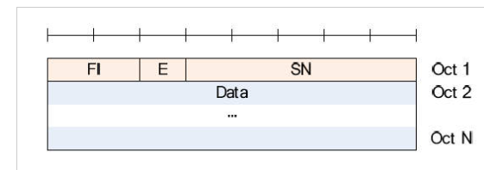

**UMD PDU Header (No LI) – 10 bits SN**

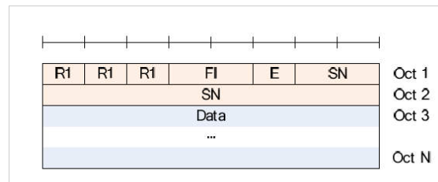

* **What is Bandwidth Parts in 5G NR**

In 5G New Radio the cell bandwidth is expected to be large compared to LTE, but a UE’s receive and transmit bandwidth is not necessarily required to be same as of cell bandwidth. The receive and transmit bandwidth of a UE can be adjusted to a subset of total cell bandwidth referred as BWP. This bandwidth can shrink during period of low activity to save power; the bandwidth location can be changed to allow different services. The bandwidth adaption can be achieved by configuring the UE with BWP(s) telling the UE which of the configured BWPs is currently the active one.

A **Bandwidth Part** (BWP) is a contiguous set of physical resource blocks (PRBs) on a given carrier. These RBs are  selected from a contiguous subset of the common resource blocks for a given numerology (u). It is denoted by **BWP**. Each BWP defined for a numerology can have following three different parameters.

* Subcarrier spacing
* Symbol duration
* Cyclic prefix (CP) length
* **Advantage of OFDM in 5g NR technology**

OFDM stands for Orthogonal Frequency Division Multiplexing. It is variation of FDM technique in which orthogonal subcarriers are closely spaced to have efficient utilization of bandwidth. OFDM subcarriers carry different data in parallel simultaneously to achieve high data rate. It is also known as digital multi-carrier modulation scheme

Following are the benefits or **advantages of OFDM data modulation**:  
➨The OFDM spectrum is composed of overlapped narrow subcarriers. This makes efficient usage of frequency spectrum compare to traditional FDM method.  
➨In OFDM broadband channel is divided into smaller narrowband subchannels. This makes OFDM resistive to frequency selective fading. Moreover OFDM transmit/receive chain uses channel encoder/decoder and interleaver/deinterlaver which help in recovering lost OFDM symbols due to fading.  
➨OFDM makes use of cyclic prefix to eliminate ISI (Inter Symbol Interference) found in the multipath channel environment. Hence it is robust to multipath fading.  
➨Channel estimation and equalization has been carried out using known pattern (i.e. preamble) and embedded pilot carriers in a symbol. This is more simpler and efficient compare to channel equalization used in SC (Single Carrier) system.  
➨Time offset estimation and correction algorithms are very easy due to correlation technique.  
➨It is possible to allocate bandwidth as per resource requirements. Hence OFDM is bandwidth scalable technique.  
➨OFDM is used to implement data modulation and demodulation by using computationally efficient FFT techniques.  
➨OFDM is less sensitive to sampling time offset impairments compare to SC system.  
➨OFDM is robust against narrow band co-channel interference.  
➨OFDM receiver does not require tuned sub-channel filters unlike FDM.  
➨OFDM facilitates SFNs (Single Frequency Networks) i.e. transmit macro diversity.

* **Disadvantage of OFDM in 5g NR technology**

Following are the drawbacks or **disadvantages of OFDM data modulation**:  
➨OFDM signal has high PAPR ( Peak to Average Power Ratio) due to its noise like amplitude having large dynamic range. Due to this, OFDM based transmission system requires RF PA (Power Amplifier) with higher PAPR.  
➨OFDM is more sensitive to CFO (carrier frequency offset) than SC system. It has higher CFO due to different LOs (Local Oscillators) and DFT leakage. This requires complex frequency offset correction algorithms at the OFDM receiver.  
➨It is prone to ISI (Inter Symbol Interference) and ICI (Inter Carrier Interference). This requires time offset and frequency offset correction algorithms.  
➨As OFDM spectrum travels through multiple paths which require guard band to avoid ISI errors due to timing offsets. Use of cyclic prefix lead to loss of efficiency.  
➨OFDM is sensitive to doppler shift.  
➨OFDM requires linear transmitter circuitry, which suffers from poor power efficiency.

* **What is the content of SIB#1 in 5G?**

**SRB1** is for RRC messages (which may include a piggybacked NAS message) as well as for NAS messages prior to the establishment of SRB2, all using DCCH logical channel.

* **What is SI-RNTI number?**

It is used to identification of Broadcast and System Information in the downlink.

**Transport channel** used is DL-SCH and **Logical channel** used is BCCH.

* **Explain ControlResourceSetZero & SearchSpaceZero ?**

In 5G NR, CORESET is known as **Control Resource Set**. It is a set of physical resources within a specific area in Downlink Resource Grid and used to carry PDCCH (DCI). NR PDCCHs are specifically designed to transmit in a configurable control resource set (CORESET). A CORESET is analogous to the control region in LTE but is generalized in the sense that the set of RBs and the set of OFDM symbols in which it is located are configurable with the corresponding PDCCH search spaces. Such configuration flexibilities of control regions including time, frequency, numerologies, and operating points enable NR to address a wide range of use cases.

A special CORESET with index 0 (CORESET 0) is defined, which is configured using a four-bit information element in the master information block (MIB) with respect to the cell-defining synchronization signal and physical broadcast channel (PBCH) block (SSB).

**Search Space**

The IE SearchSpace defines how/where to search for PDCCH candidates. Each search space is associated with one ControlResourceSet. For a scheduled SCell in the case of cross carrier scheduling, except for nrofCandidates, all the optional fields are absent (regardless of their presence conditions). For a scheduled SpCell in the case of the cross carrier scheduling, if the search space is linked to another search space in the scheduling SCell, all the optional fields of this search space in the scheduled SpCell are absent (regardless of their presence conditions) except for nrofCandidates.

The IE **SearchSpaceZero** is used to configure SearchSpace#0 of the initial BWP.

* **List the all available SIB in 5G?**

SIB1,[SIB2](https://www.sharetechnote.com/html/5G/5G_Mib_Sib.html#SIB2),[SIB3](https://www.sharetechnote.com/html/5G/5G_Mib_Sib.html#SIB3),[SIB4](https://www.sharetechnote.com/html/5G/5G_Mib_Sib.html#SIB4),[SIB5](https://www.sharetechnote.com/html/5G/5G_Mib_Sib.html#SIB5),[SIB6](https://www.sharetechnote.com/html/5G/5G_Mib_Sib.html#SIB6),[SIB7](https://www.sharetechnote.com/html/5G/5G_Mib_Sib.html#SIB7),[SIB8](https://www.sharetechnote.com/html/5G/5G_Mib_Sib.html#SIB8),[SIB9](https://www.sharetechnote.com/html/5G/5G_Mib_Sib.html#SIB9),[SIB10](https://www.sharetechnote.com/html/5G/5G_Mib_Sib.html#SIB10),[SIB11](https://www.sharetechnote.com/html/5G/5G_Mib_Sib.html#SIB11),[SIB12](https://www.sharetechnote.com/html/5G/5G_Mib_Sib.html#SIB12),[SIB13](https://www.sharetechnote.com/html/5G/5G_Mib_Sib.html#SIB13),[SIB14](https://www.sharetechnote.com/html/5G/5G_Mib_Sib.html#SIB14),[SIB15](https://www.sharetechnote.com/html/5G/5G_Mib_Sib.html#SIB15),[SIB16](https://www.sharetechnote.com/html/5G/5G_Mib_Sib.html#SIB16),[SIB17](https://www.sharetechnote.com/html/5G/5G_Mib_Sib.html#SIB17),[SIB18](https://www.sharetechnote.com/html/5G/5G_Mib_Sib.html#SIB18),[SIB19](https://www.sharetechnote.com/html/5G/5G_Mib_Sib.html#SIB19),[SIB20](https://www.sharetechnote.com/html/5G/5G_Mib_Sib.html#SIB20),[SIB21](https://www.sharetechnote.com/html/5G/5G_Mib_Sib.html#SIB21)

* **What is SubcarrierSpacingCommon?**

 Indicates the Subcarrier spacing for SIB1, Msg.2/4 for initial access and SI-messages. Interpretation of this value varies with frequency range as summarized in the following table.

In 5G NR, subcarrier spacing of 15, 30, 60, 120 and 240 KHz are supported.



* **What is Unified access control?**

UAC is a set of mechanism (algorithm) to determine whether to allow the UE for a specific services or state changes. UAC is a pretty complicated algorithm that get many factors involved at each point of decision making process. Overall concept similar to [LTE Access Control](https://www.sharetechnote.com/html/Handbook_LTE_AccessControl.html), but I think the related parameters are more dispersed here and there... causing more confusion -:).  In LTE, Access control is mainy controlled by RRC(SIBs) but it seems NAS has more control ever Access Control in NR seems.

Triggers for checking for UAC

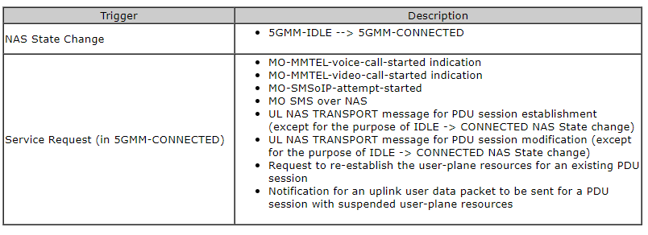

* **Explain Signaling Radio Bearers (SRBs) w.r.t. 5G?**

As it says, SRB stands for Signaling Radio Bearer. In other words, SRB is a type of Radio Bearer that carries signaling message (i.e, RRC or/and NAS message).

According to 38.331 4.2.2   Signalling radio bearers, there are four different types of SRB in NR defined as follows.

* **SRB0** is for RRC messages using the CCCH logical channel;
* **SRB1** is for RRC messages (which may include a piggybacked NAS message) as well as for NAS messages prior to the establishment of SRB2, all using DCCH logical channel;
* **SRB2** is for NAS messages, all using DCCH logical channel. SRB2 has a lower-priority than SRB1 and is always configured by the network after security activation;
* **SRB3** is for specific RRC messages when UE is in EN-DC, all using DCCH logical channel.
* **What is FMS (First Missing SN) and Bitmap for STATUS PDU?**

FMS :-PDCP SN of the first missing PDCP PDU

BITMAP

• The MSB of the first octet of the type "Bitmap" indicates whether or not the PDCP SDU with the SN (FMS + 1) modulo 4096 has been received and, optionally decompressed correctly.

• The LSB of the first octet of the type "Bitmap" indicates whether or not the PDCP SDU with the SN (FMS + 8) modulo 4096 has been received and, optionally decompressed correctly.

* **How much maximum padding bits should be added in Data PDU and STATUS PDU?**

Data PDU max value is 1 and Status PDU max value is 1111

* **Which SRB has highest and least priority?**

SRB1 AND SRB3 are having least priority and SRB2 has highest priority.

* **Which RLC mode is used for SRBs?**

AM mode

* **5G Cell Search – Synchronization Raster and Channel Raster?**

*Cell search is the procedure by which a UE acquires time and frequency synchronization with a cell and detects the Cell ID of that cell. NR cell search is based on the primary and secondary synchronization signals, and PBCH DMRS, located on the synchronization raster.*