1. Explain the CORESET 0 Position in Frequency Domain in signaling message according to controlresourceset value?

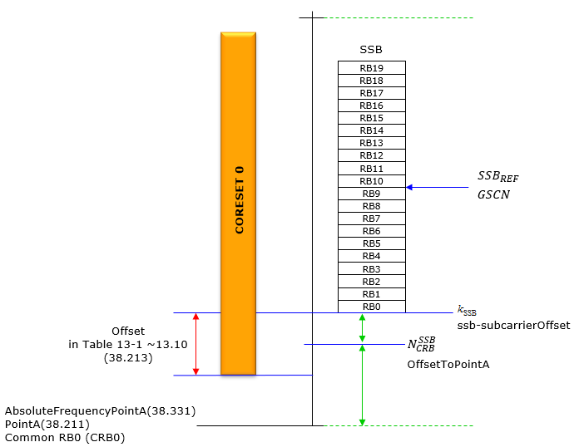

1. Configure the CCE to REG mapping with different CCE with the PDCCH toolbox?

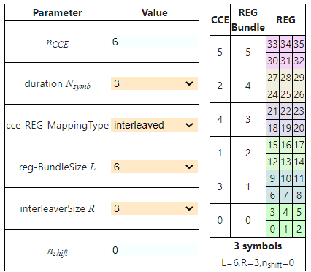

Answer:

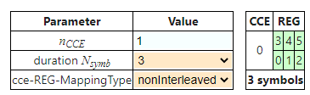

**CCE value 1 with Duration Symbols 3**

**Mapping type only NonInterleaved.**

**Interleaved not applicable**

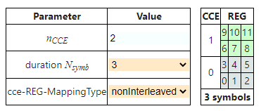 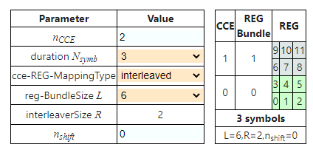

**CCE value 2 with Duration Symbols 3**

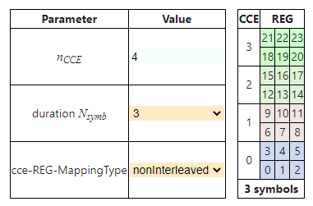

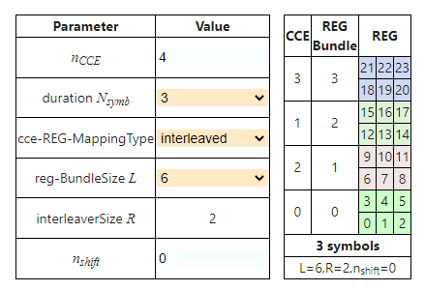

**CCE value 4 with Duration Symbols 3**

1. Design the NR Frame structure with different numerology (0,1,2,3,4)?

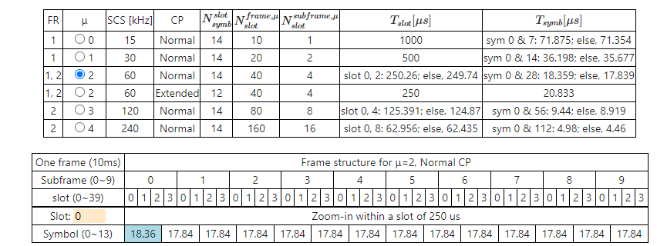

In above question m=2 with CP=normal.

Please find below m=2 with CP=Extended and Slot=0

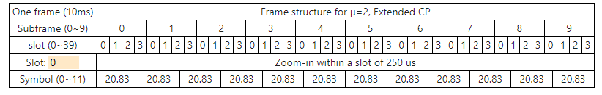

Please find below m=3 with CP=Normal and Slot=0

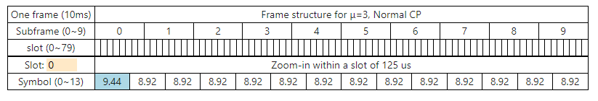

Please find below m=4 with CP=Normal and Slot=0

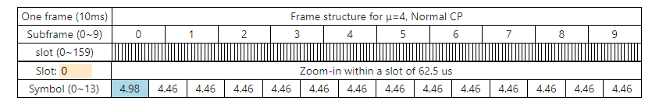

1. To find the point A location in 5G NR?

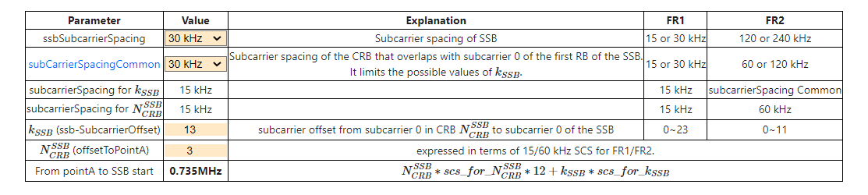

**Answer:**

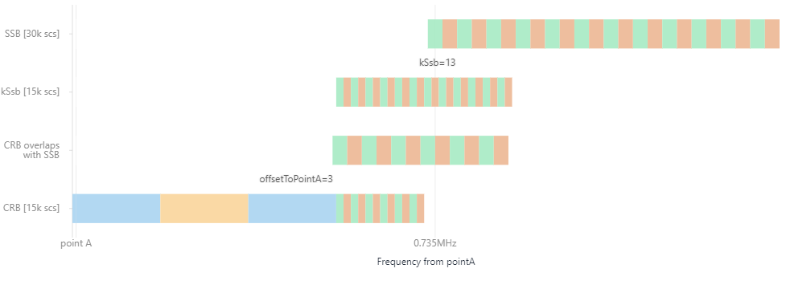

1. **To identify the MCG failure in 5G, which message we will look out?**

MCGFailureInformation-r16 ::= SEQUENCE {

criticalExtensions CHOICE {

mcgFailureInformation-r16 MCGFailureInformation-r16-IEs,

criticalExtensionsFuture SEQUENCE {}ETSI

}

}

MCGFailureInformation-r16-IEs ::= SEQUENCE {

failureReportMCG-r16 FailureReportMCG-r16 OPTIONAL,

lateNonCriticalExtension OCTET STRING OPTIONAL,

nonCriticalExtension SEQUENCE {} OPTIONAL

}

FailureReportMCG-r16 ::= SEQUENCE {

failureType-r16 ENUMERATED {t310-Expiry, randomAccessProblem, rlc-MaxNumRetx,

t312-Expiry-r16, lbt-Failure-r16, beamFailureRecoveryFailure-r16,

bh-RLF-r16, spare1} OPTIONAL,

measResultFreqList-r16 MeasResultList2NR OPTIONAL,

measResultFreqListEUTRA-r16 MeasResultList2EUTRA OPTIONAL,

measResultSCG-r16 OCTET STRING (CONTAINING MeasResultSCG-Failure) OPTIONAL,

measResultSCG-EUTRA-r16 OCTET STRING OPTIONAL,

measResultFreqListUTRA-FDD-r16 MeasResultList2UTRA OPTIONAL,

...

}

MeasResultList2UTRA ::= SEQUENCE (SIZE (1..maxFreq)) OF MeasResult2UTRA-FDD-r16

MeasResult2UTRA-FDD-r16 ::= SEQUENCE {

carrierFreq-r16 ARFCN-ValueUTRA-FDD-r16,

measResultNeighCellList-r16 MeasResultListUTRA-FDD-r16

}

MeasResultList2EUTRA ::= SEQUENCE (SIZE (1..maxFreq)) OF MeasResult2EUTRA-r16

Answer:

The MCGFailureInformation message is used to provide information regarding NR MCG failures detected by the UE.

1. **What are the reason for *SCGFailureInformationEUTRA* in below message?**

SCGFailureInformationEUTRA ::= SEQUENCE {

criticalExtensions CHOICE {

scgFailureInformationEUTRA SCGFailureInformationEUTRA-IEs,

criticalExtensionsFuture SEQUENCE {}

}

}

SCGFailureInformationEUTRA-IEs ::= SEQUENCE {

failureReportSCG-EUTRA FailureReportSCG-EUTRA OPTIONAL,

nonCriticalExtension SCGFailureInformationEUTRA-v1590-IEs OPTIONAL

}

SCGFailureInformationEUTRA-v1590-IEs ::= SEQUENCE {

lateNonCriticalExtension OCTET STRING OPTIONAL,

nonCriticalExtension SEQUENCE {} OPTIONAL

}ETSI

3GPP TS 38.331 version 17.1.0 Release 17 398 ETSI TS 138 331 V17.1.0 (2022-08)

FailureReportSCG-EUTRA ::= SEQUENCE {

failureType ENUMERATED {

t313-Expiry, randomAccessProblem,rlc-MaxNumRetx,

scg-ChangeFailure, spare4,

spare3, spare2, spare1},

measResultFreqListMRDC MeasResultFreqListFailMRDC OPTIONAL,

measResultSCG-FailureMRDC OCTET STRING OPTIONAL,

...,

[[

locationInfo-r16 LocationInfo-r16 OPTIONAL

]]

}

MeasResultFreqListFailMRDC ::= SEQUENCE (SIZE (1.. maxFreq)) OF MeasResult2EUTRA

Answer:

The SCGFailureInformationEUTRA message is used to provide information regarding E-UTRA SCG failures detected by the UE..

1. ***Which information shows about numerology in BWP?***

BWP ::= SEQUENCE {

locationAndBandwidth INTEGER (0..37949),

subcarrierSpacing SubcarrierSpacing,

cyclicPrefix

**Answer**

**CyclicPrefix**

1. **Explain about below RRC message for PDCCH Layer**

ControlResourceSet ::= SEQUENCE {

controlResourceSetId ControlResourceSetId,

frequencyDomainResources BIT STRING (SIZE (45)),

duration INTEGER (1..maxCoReSetDuration),

cce-REG-MappingType CHOICE {

interleaved SEQUENCE {

reg-BundleSize ENUMERATED {n2, n3, n6},

interleaverSize ENUMERATED {n2, n3, n6},

shiftIndex INTEGER(0..maxNrofPhysicalResourceBlocks-1) OPTIONAL -- Need S

},

nonInterleaved NULL

},

precoderGranularity ENUMERATED {sameAsREG-bundle, allContiguousRBs},

tci-StatesPDCCH-ToAddList SEQUENCE(SIZE (1..maxNrofTCI-StatesPDCCH)) OF TCI-StateId OPTIONAL, -- Cond NotSIB-initialBWP

tci-StatesPDCCH-ToReleaseList SEQUENCE(SIZE (1..maxNrofTCI-StatesPDCCH)) OF TCI-StateId OPTIONAL, -- Cond NotSIB-initialBWP

tci-PresentInDCI ENUMERATED {enabled} OPTIONAL, -- Need S

pdcch-DMRS-ScramblingID INTEGER (0..65535) OPTIONAL, -- Need S

...,

[[

rb-Offset-r16 INTEGER (0..5) OPTIONAL, -- Need S

tci-PresentDCI-1-2-r16 INTEGER (1..3) OPTIONAL, -- Need S

coresetPoolIndex-r16 INTEGER (0..1) OPTIONAL, -- Need S

controlResourceSetId-v1610 ControlResourceSetId-v1610 OPTIONAL -- Need S

]],

[[

followUnifiedTCIstate-r17 ENUMERATED {enabled} OPTIONAL -- Need R

Answer:

ControlResourceSet

1. ***find out about the location for initial downlink bandwidth part and UL BWP***

message c1: systemInformationBlockType1: {

servingCellConfigCommon {

downlinkConfigCommon {

frequencyInfoDL {

frequencyBandList {

{

freqBandIndicatorNR 78

}

},

offsetToPointA 30,

scs-SpecificCarrierList {

{

offsetToCarrier 0,

subcarrierSpacing kHz30,

carrierBandwidth 106

}

}

},

initialDownlinkBWP { // DL BWP 0

genericParameters {

locationAndBandwidth 12928,

subcarrierSpacing kHz30

},

....

},

uplinkConfigCommon {

frequencyInfoUL {

scs-SpecificCarrierList {

{

offsetToCarrier 0,

subcarrierSpacing kHz30,

carrierBandwidth 106

}

}

},

initialUplinkBWP { // UL BWP 0

genericParameters {

locationAndBandwidth 12928,

subcarrierSpacing kHz30

},

1. ***Explain about Master information block in L3 Message***

MIB ::= SEQUENCE {

systemFrameNumber BIT STRING (SIZE (6)),

subCarrierSpacingCommon ENUMERATED {scs15or60, scs30or120},

ssb-SubcarrierOffset INTEGER (0..15),

dmrs-TypeA-Position ENUMERATED {pos2, pos3},

pdcch-ConfigSIB1 PDCCH-ConfigSIB1,

cellBarred ENUMERATED {barred, notBarred},

intraFreqReselection ENUMERATED {allowed, notAllowed},

spar

....

Answer:

6 bits for System frame number

SubCarrierSpaceCommon is scs15,scs30

Ssb-SubcarrierOffset value from 0 to 15

dmrs TypeA-Position -- pos2 or pos3

pdcch config- SIB1

cellBarred- barred or not barred

intraFreqReselection - allowed or not allowed

spare -- is reserved bits for future use.