|  |
| --- |
|  |
| Destabilizing Factors in WLAN Propagation |
| Specifically under 2.4 GHz and 5.0 GHz Wi-Fi Channels |
|  |
| **Joshwa Edsall** |
| **2/20/2021**  **NETW-210-40**  **Instructor: Mr. Reginald Bell** |

|  |
| --- |
|  |

The Propagation of wireless RF signals is how we access something we find so simple in today’s world, but without the capability to transmit, receive, and interpret wireless signals correctly we would be stuck thirty years in the past. Wireless Signal Propagation is the movement of radio waves (RF Waves) between two or more transmitting and/or receiving antennas(Nelson, A. 2017). In this research paper I plan to focus on something that tends to limit the capability of propagation for wireless signals, something known as attenuation.

Attenuation is the “penetration loss” or predicted weakening of signals through obstacles between wireless transmission and reception. This is why my research is focused on the more common forms of construction materials found in your average home to include the following: Drywall, Lumber, and Concrete Board. I have designed enclosures, made of the afore mentioned materials that will be utilizing to install an ARRIS-DG3450A Wireless Router/Modem combination into. These enclosures will reflect the conditions of attenuation on a more concentrated level as compared to normal.

The enclosures were built measuring as follows:

* Drywall Enclosure: 8.25” x 4” x 6.25” x 1” in dimension (L x W x H x D) where L= Length, W=Width, H=Height, and D= Density of material
* Wood Enclosure: 8.25” x 4” x 6.25” x 1” in dimension (L x W x H x D)
* Concrete Board Enclosure: 8.25” x 4” x 6.25” x 1” in dimension (L x W x H x D)

These enclosures will be utilized to simulate the attenuation of signal strength due to environmental concerns, focused on the common materials used in homes. The following methods are going to be employed for this project:

* While utilizing each enclosure individually I will be testing signal strength and connectivity via the Wireless Network in my home. This will be conducted via the connection between a Laptop (Designated WiComp) and the following services that require Internet Connectivity:
  + Netflix streaming.
  + VoIP (such as Discord)
  + File Transfer Services between WiComp and my Desktop (Designated LANdler)
* During the connection between these services I will be conducting WireShark captures to determine the level of data corruption that occurs. In addition to this I will be monitoring network speeds via system tools on LANdler, and utilizing speed connection tests on WiComp.
* Following the completion of these tasks I will be installing Wireless Amplifiers to boost signal across my home and repeat the tasks I have already mentioned.
* Following this I shall compare the data to discern what type of common materials in construction truly are a concern for wireless propagation.

**II. Base Measurements of WLAN Environment:**

I have tested the base line measurements of my WLAN Environment using the planned three methods of Internet Connectivity (VoIP, Netflix Streaming, and File Transfer Services) to gain an accurate picture of how my network operates without outside enforcement. This following information was gained without the use of wireless amplification:

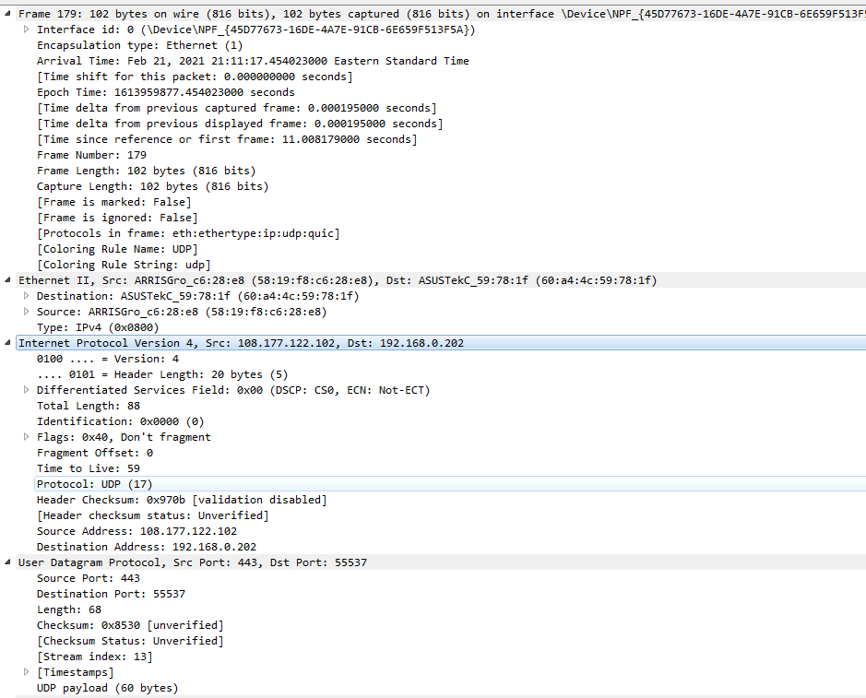

This is a screen capture of one particular QUIC/UPD packet captured via WireShark that is indicative of the connection quality and speed of video streaming services from Netflix.com. This capture lets us understand the time between data packet transmission, reception of this information, and any potential issues with data transmission. Currently there are no issues reported with the usage of Netflix.com and video streaming services on our baseline statistics.

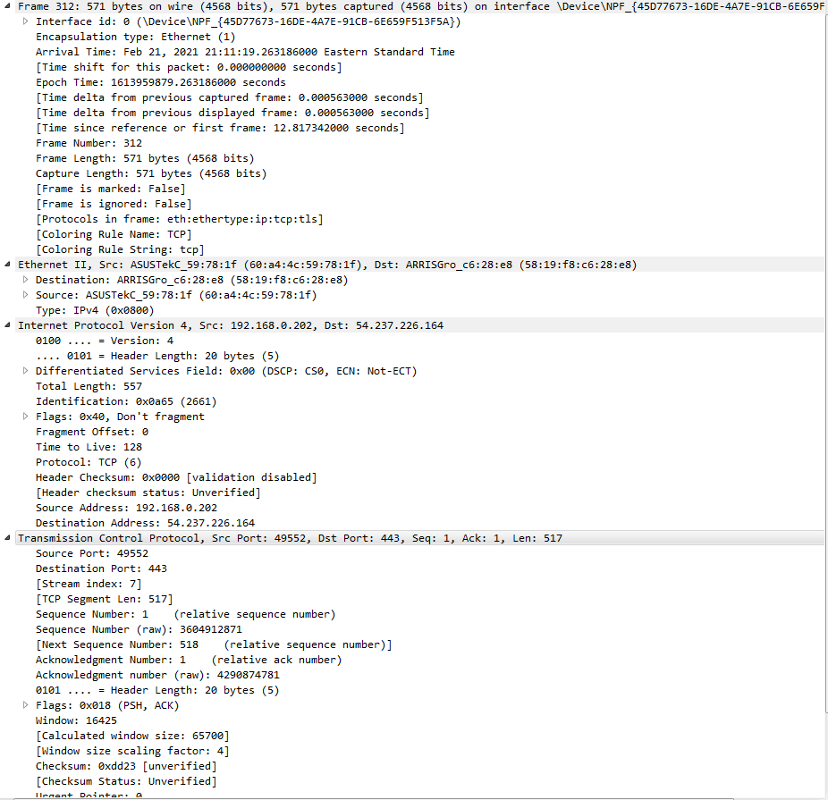

This is the baseline capture from WireShark for VoIP services utilizing the Discord Application on my computer. Once again, free from any potential issues with data transmission or encapsulation or reception.

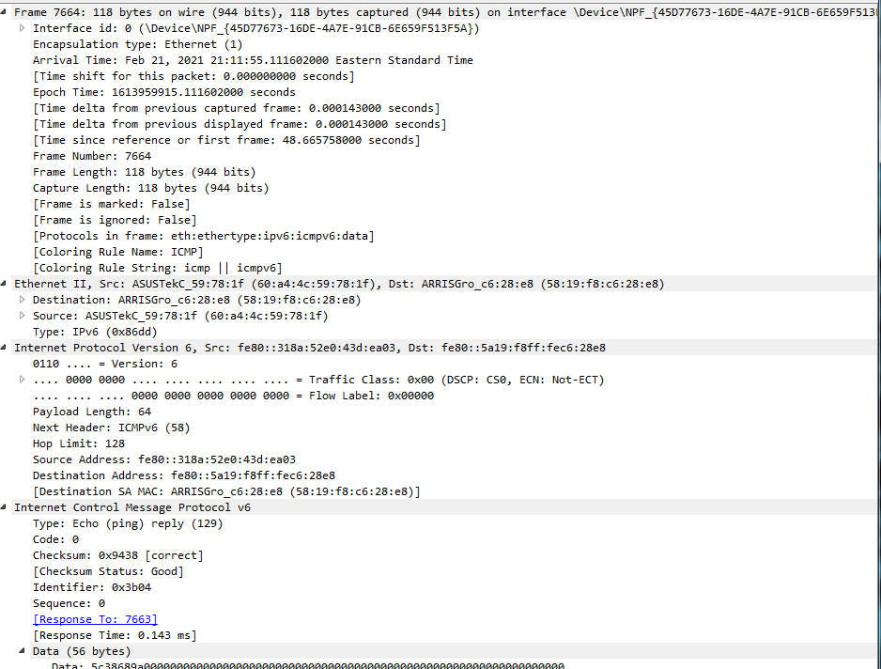

This is the baseline capture from WireShark for file transferring services on the network, free from any forms of data transmission issues.

In addition to this I shall include the Internet Speed Test conducted as a baseline model. 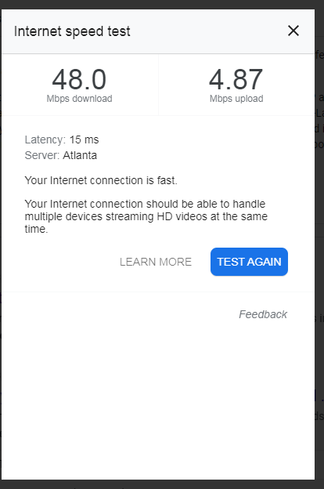

These are all just a baseline reading needed to measure against for the implementation of the enclosures in subsequent trials to be performed.

**III. Wooden Enclosure**

**Prior to Wireless Amplification:**

Upon installing my ARRIS- DG3450A into the Wooden Enclosure the very first step to consider will be the connection speed and strength between the router/modem and the internet. So I ran the Internet speed test once again to gain another reading: 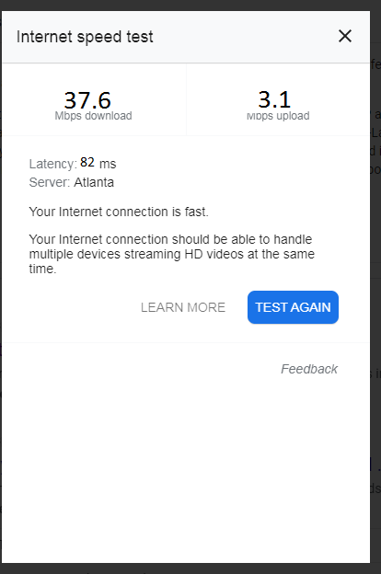

This shows us immediately that there is a large drop in download and upload speed due to issues found with signal propagation due to interference from the wooden enclosure. This is as I expected, there are going to be fluctuations in signal strength due to the density and absorption rating of the material blocking the signal. While wood is a extremely porous material it still hinders signal propagation to a degree of roughly 22% degradation in upload and download speeds.

Following this we shall look at the WireShark Captures for the three chosen methods of signal monitoring in an attempt to view the consequences of attenuation forced by the wooden enclosure.

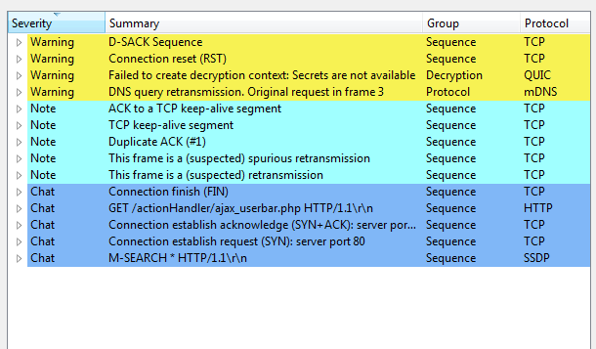

This is the resulting error recordings captured using analytic tools on WireShark, resulting in a reported number of 14 data transmission malfunctions. 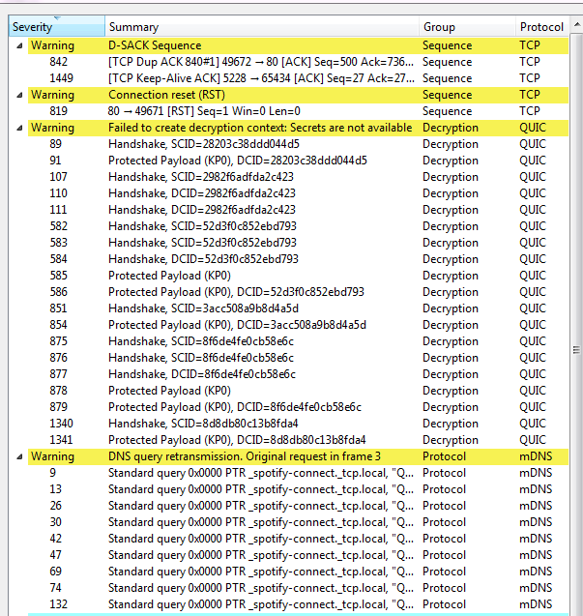

These are all issues regarding handshake protocols being missed, or projected data payloads being corrupted resulting in the need to reissue transmission requests. All handshakes needed to be broadcasted once again and reaffirmed prior to connection. I have also noted the wooden enclosure resulted in increased buffering times for Netflix, lag between speaking and transmission of voice over VoIP using Discord, and increased transferring times for file transfers on the network.

**Wireless Amplifier Installed on the Network:**

I have installed a TP-Link AC750 Wi-Fi extender (RE220) onto my home network in order to boost signal in an attempt to conserve the integrity of connection and signal strength on my WLAN. The AC750 Wi-Fi Extender (designated AC750 for this report) is rated to extend Wi-Fi coverage up to 1200 Square Feet and allows for up to 20 connections and allows for speeds up to 433 Mbps on a 5.0 GHz channel. I am currently utilizing solely a 5.0 GHz channel for this project.

Below we will see the captured post-amplifier internet speed test for my WLAN:

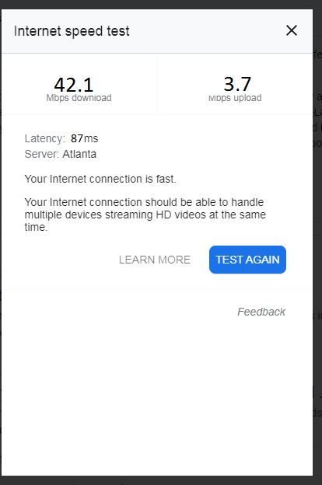

This shows us that the AC750 allows for the amplification of signal strength as it was designed to accomplish. This has resulted in a rough loss of 13% of download and upload speeds, and a noted but barely noticeable increase into latency.

Below we will look into the captured error report utilizing the AC750: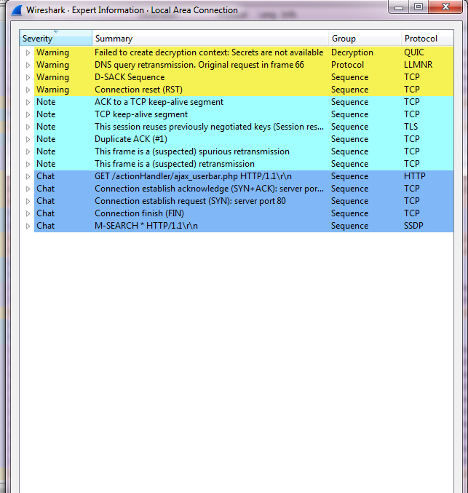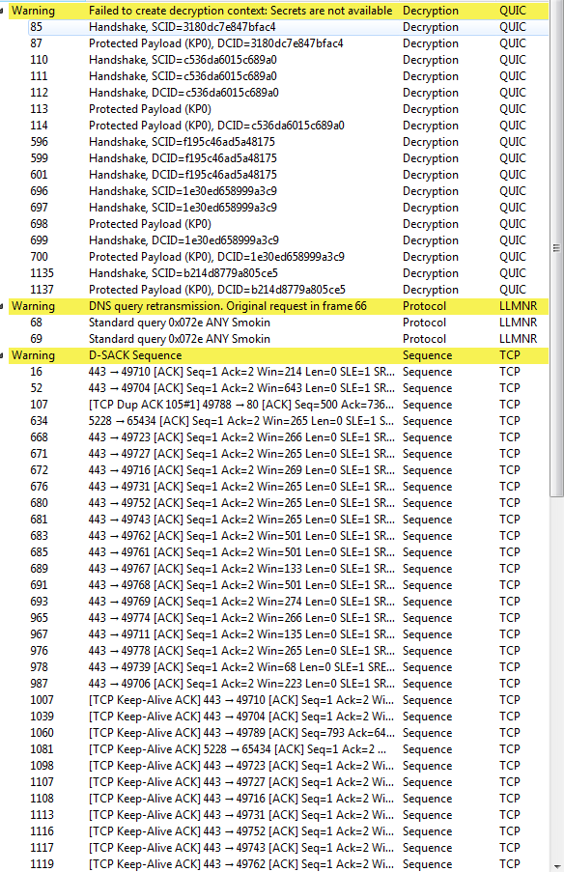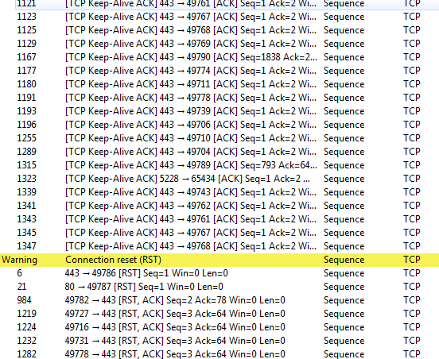

While the AC750 has allowed for an increase into the download and upload speed on the network, it has resulted in a larger number of errors mainly in ACK responses from the sending node (WiComp) to the receiving nodes for all tested connections.

Netflix streams have resulted in even larger buffering times, the max buffering time resulting in almost 2 minutes required buffering for 5 minutes of streaming. In addition to this there is a noticeable increase in response time for VoIP utilizing Discord, roughly a seven second delay in transmission. File transfers have maintained transferring speeds but has resulted in compression errors resulting in file corruption requiring validation to open transferred files.

**IV. Drywall Enclosure**

**Prior to Wireless Amplification:**

Upon installing my ARRIS- DG3450A into the Drywall Enclosure once again I need to record a baseline for the internet connection speed.

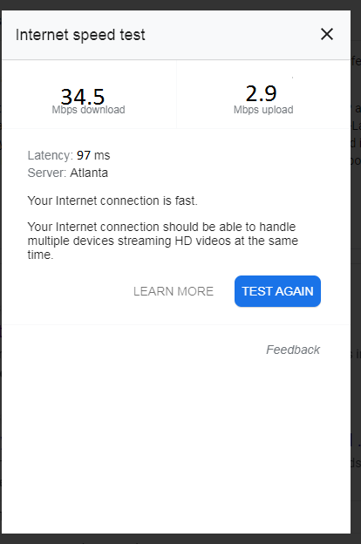

This shows us a 29% decrease in signal speed compared to the baseline measured without an enclosure, and a roughly 9% decrease in signal strength as compared to the wooden enclosure pre-amplification. Drywall is made up of woven material, with multiple pockets inside that I believe are the cause for signal attenuation due to refraction and reflection inside the material.

Below we will look at the reported errors utilizing WireShark to compare the rate of errors in reference to the Wooden Enclosure and Baseline models. 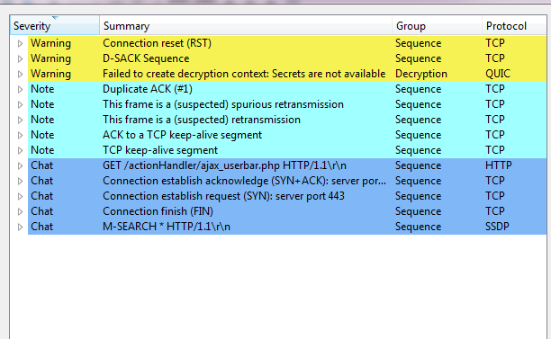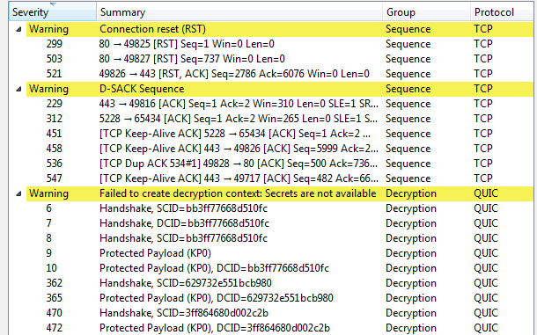

Strangely, there is a smaller number of reported errors utilizing the Drywall enclosure as compared to the Wooden enclosure. I would speculate this is due to the nature of drywall, the empty pockets in the material offer a way for the signal to continue its travel as compared to the more dense nature of wood in comparison. I believe this allows for the continuation of propagation as there is less medium in which to travel through, even if it offers a wider variable of potential propagation issues such as multipath and refraction, whereas wood is more often to absorb signals.

**Wireless Amplifier Installed on Network:**

Below we will see the reported internet connection speed following the installation of the AC750.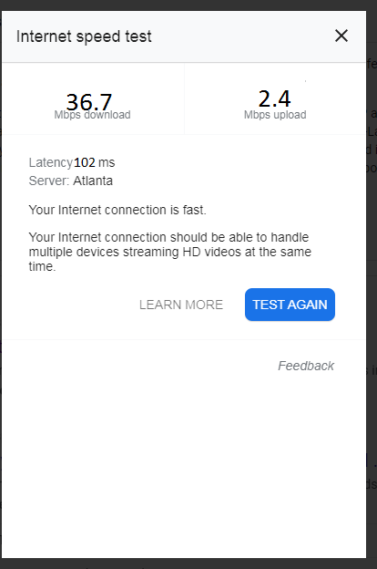

This gives us roughly a 6% increase in download and uploads rates as compared to the drywall enclosure prior to the installation of the wireless amplifier; a 13% decrease compared to the amplified speed of the wooden enclosure; and a 24% decrease compared to the baseline model internet speed.

Below we will consider the reported errors following the installation of the AC750:

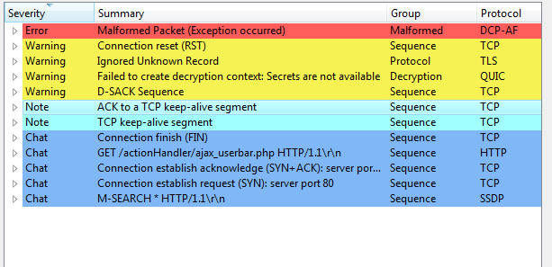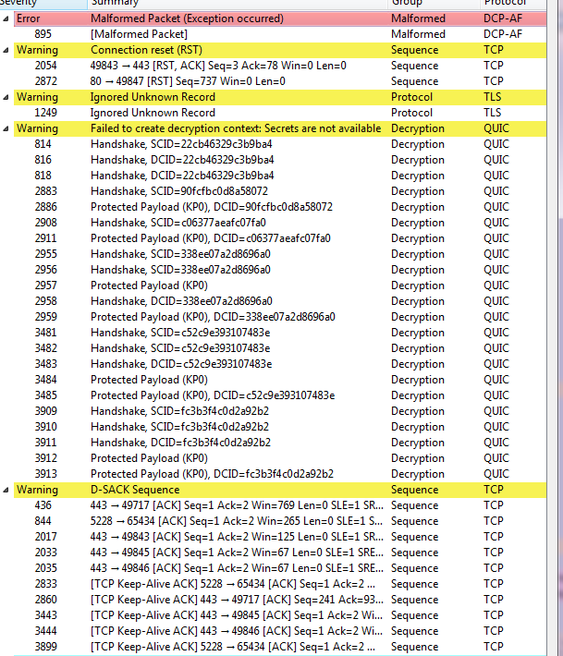

We see our first true indication of data corruption in frame 895 that resulted in a malformed packet between the sending node of WiComp and Discord. This led to the disconnection from Discord VoIP servers and required me to reconnect the application to utilize services. I have continued to notice increased buffering times for streaming services form Netflix, almost seven minutes of buffering needed for five minutes of streaming content. File transfer services have maintained the same speed and validation issues.

**V. Concrete Board Enclosure**

**Prior to Wireless Amplification:**

Below we will look at the baseline reading of the concrete board enclosure as measured utilizing the internet speed test:

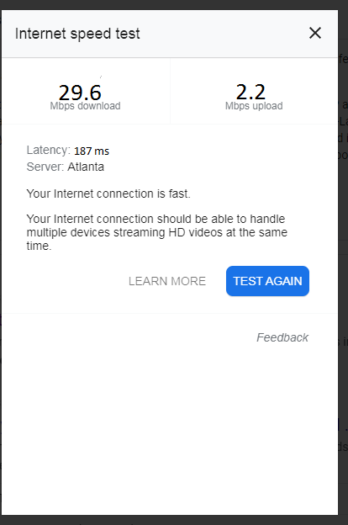

The baseline reading for the concrete board enclosure shows roughly a 14% decrease in speed as compared to the drywall enclosure prior to installation of AC750; a 21% decrease in speeds as compared to the wooden enclosure prior to installation of AC750; and a 38% decrease in speed as compared to the baseline model’s speed. Concrete board tends to combine the characteristics of drywall and wood both; allowing for small pockets of dead space but a heavy density resulting in an increased rate of absorption, multipath, and refraction.

Below we will look at the reported errors prior to the installation of the AC750:

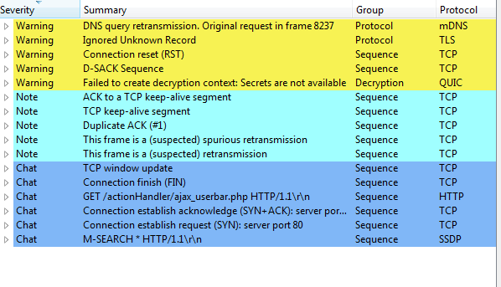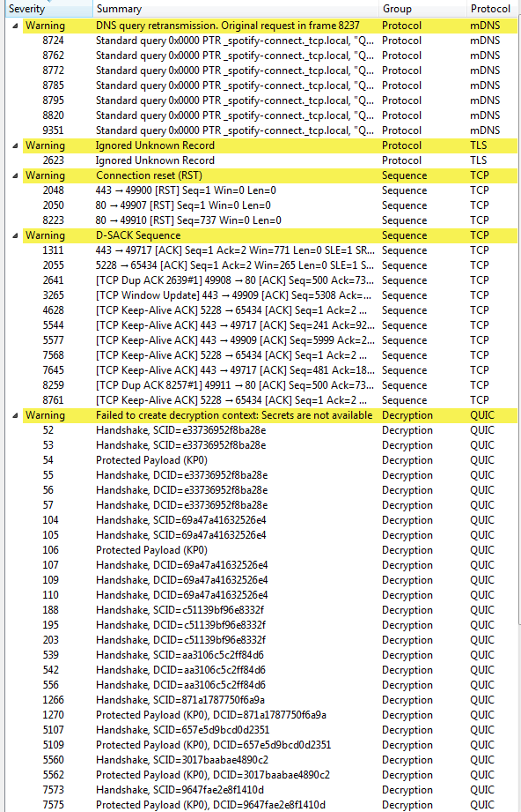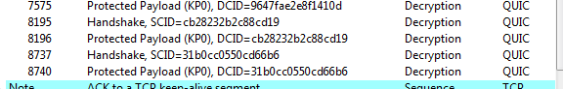

I have begun to notice an increase in the amount of protected payloads, and handshake errors being found due to the density of materials utilized in the enclosures. While there are still a large number of errors, there are no “true” data corruptions taking place in regards to packet transmission.

Streaming content from Netflix has retained the same rate as with the drywall enclosure, but I have begun to have serious issues in attempting to maintain connection with the Discord server in order to utilize VoIP services. The delay between transmission and reception for VoIP has increased from a seven second delay to almost a twelve second delay between speech and reception on the receiving endpoint. File transfer services have begun to “error” and refuse transfer from WiComp to LANdler without the use of intermediary devices such as flashdrives.

**Wireless Amplifier Installed on Network:**

Below is the recorded internet speed following the installation of the AC750:

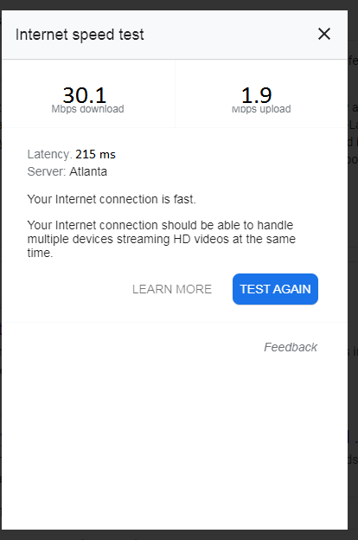

This gives us a roughly 18% decrease in speed as compared to the Drywall Enclosure with the AC750 installed; a 29% decrease in speed in comparison to the Wooden Enclosure with the AC750 installed; and a 37% decrease in speed as compared to the baseline model. So while the AC750 is still boosting speed, it has resulted in an increased number of errors in packet transmission once again as compared to the Drywall enclosure. In addition to this, the latency noticed following the AC750 installation has reached a new high, I believe due to the need for constant re-transmission.

Below we will look at the captured errors utilizing WireShark for the AC750 boosted Concrete Board Enclosure:

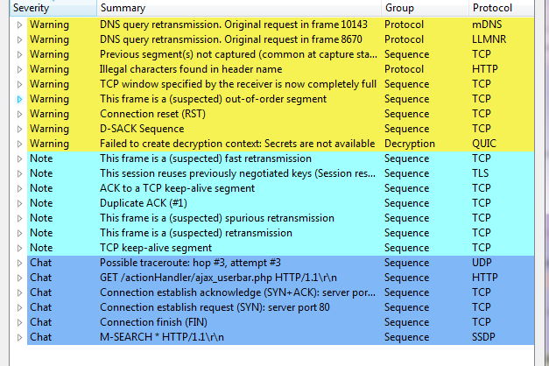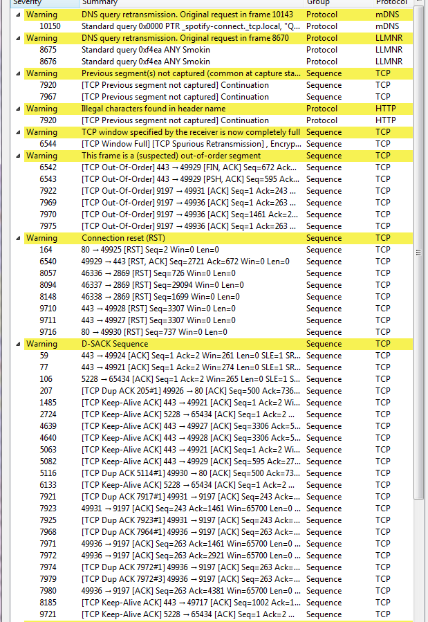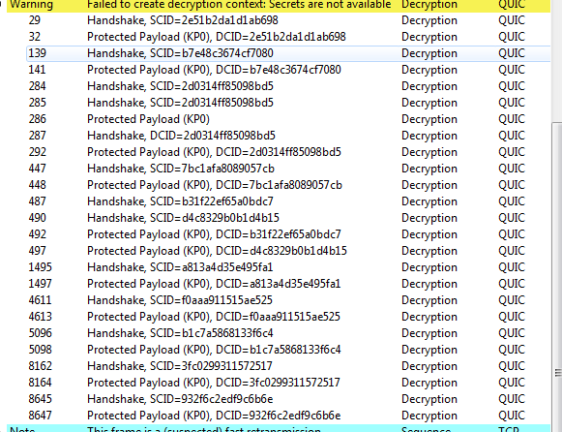

This capture has resulted in the highest number of errors by far as compared to the previously tested enclosures. Particularly of note, is the “failed to create decryption context” errors that have occurred along multiple frames. This is stating that the network was unable to determine the decryption requirements and thus was unable to receive transmitted data from all three tested sources.

Netflix has refused to load at this time, continuous buffering and DNS error reports from the website itself causing a cessation of streaming services. Discord as an application will run, but refuses to connect to the supported servers resulting in a cessation of VoIP services. File transfer services are still inoperable figure attached below.

**VI. Discussion**

I believe my initial thoughts on this matter have been proven somewhat correct; I believed prior to this research project that sufficiently dense materials would result in the complete loss of signal or total corruption of data. While there was a noticeable scaling level of signal degradation and connection speeds decreasing across the board, I was not prepared to see certain materials act in the manner that they did.

I believed that the Wooden Enclosure would be the most suited to signal propagation, offering very little in the way of signal disruption. I failed to take into account the varying density of certain types of wooden materials, as I used a form of compressed pine which allows for very little in the way of “dead” space inside the material, thus resulting in a greater disruption to signal propagation than I suspected.

I am surprised to note that only the Drywall Enclosure reported a total corruption of data packets during a certain frame. I believed that the Concrete Board would result in the largest form of signal and data corruption amongst all the constructed enclosures.

Though I am happy to have been proven correct, concrete board is one of the most common of materials in private homes and has a severe impact into the propagation of radio signals. The dense nature of this material, while still allowing the formation of various “dead” zones inside the sheets resulted in a very high rate of errors to occur (roughly a 27% error rate across the board).

This leads me to believe that the chosen medium of my wireless network is actually what is to blame for the level of degradation my internet speeds and corruption data suffered. I can speculate with a greater level of certainty that the usage of a “stronger” form of wireless transmitter (wireless router) on the network would result in a lowered chance of data corruption, and initial baseline speeds of the network would be higher.

**VII. Conclusion**

While this research topic may have been something that did not touch on more technical points of the subject, it showed us a very common problem in the real world. Not some technical issue that may come to pass, but something that affects every home WLAN in existence, as very few people are aware that the construction of their home plays such an important role in their wireless network.

This project has opened my eyes to glaring issues within my own WLAN structure, and has given me quite a few options into how I can correctly adjust my network topology in order to maintain sufficient connection integrity and speeds. I am truly glad for the opportunity to approach a practical issue that has many avenues of approach in order to ascertain a solution.

References:

Nelson, A. (2017, November 12). Wireless Signal Propagation Concepts. Retrieved February 20, 2021, from https://pubs.naruc.org/pub/EFD91286-EABF-A6FD-CD41-BB997244425D

Hosseini, N., Khatun, M., Guo, C., Du, K., Ozdemir, O., Matolak, D. W., . . . Mehrpouyan, H. (2020, April 27). Attenuation of Several Common Building Materials in Millimeter-Wave Frequency Bands: 28, 73 and 91 GHz. Retrieved February 20, 2021, from Attenuation of Several Common Building Materials in Millimeter-Wave Frequency Bands: 28, 73 and 91 GHz

Rodriguez Larrad, I., Nguyen, H., Jorgensen, N., Sorensen, T., & Mogensen, P. (2014, November 24). PROPAGATION into MODERN Buildings: Attenuation ... Retrieved February 20, 2021, from https://www.researchgate.net/publication/293105852_Radio_Propagation_into_Modern_Buildings_Attenuation_Measurements_in_the_Range_from_800_MHz_to_18_GHz

ITU (2015, July). Effects of building materials and structures on radiowave propagation above about 100 MHz. Retrieved February 20, 2021, from <https://www.itu.int/dms_pubrec/itu-r/rec/p/R-REC-P.2040-1-201507-I!!PDF-E.pdf>

A., Sydorov, Y., Keskikastari, M., Valkama, M., & Niemelä, J. (2014). Impact of modern construction materials on radio signal propagation: Practical measurements and network planning aspects. In 2014 IEEE 79th Vehicular Technology Conference (VTC2014-Spring), 18-21 May 2014, Seoul, Korea (pp. 1-7). Institute of Electrical and Electronics Engineers IEEE. https://tutcris.tut.fi/portal/files/21205803/Impact_of_modern_construction_materials_on_radio_signal_propagation_2014.pdf

A. Asp, Y. Sydorov, M. Valkama and J. Niemelä, (2012) "Radio signal propagation and attenuation measurements for modern residential buildings," IEEE Globecom Workshops, Anaheim, CA, USA, 2012, pp. 580-584, doi: 10.1109/GLOCOMW.2012.6477638. <https://ieeexplore.ieee.org/stamp/stamp.jsp?tp=&arnumber=6477638&isnumber=6477486>

Choroszucho, Agnieszka & Pienkowski, Cezary & Jordan, Andrzej. (2008). Electromagnetic wave propagation into building constructions. Przeglad Elektrotechniczny. 84. 44-49. <https://www.researchgate.net/publication/289178377_Electromagnetic_wave_propagation_into_building_constructions>

Wilson, R. (2002, August). Propagation Losses Through Common Building Materials 2.4 GHz vs 5 GHz. Retrieved February 20, 2021, from https://www.boggstech-consulting.com/Wilson_Propagation_Losses_2_and_5GHz.pdf