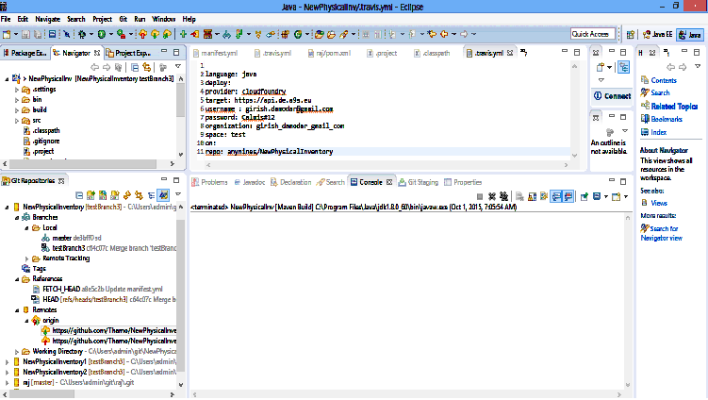

/// Automated Integration of eclipse and GIT using EGIT plugin

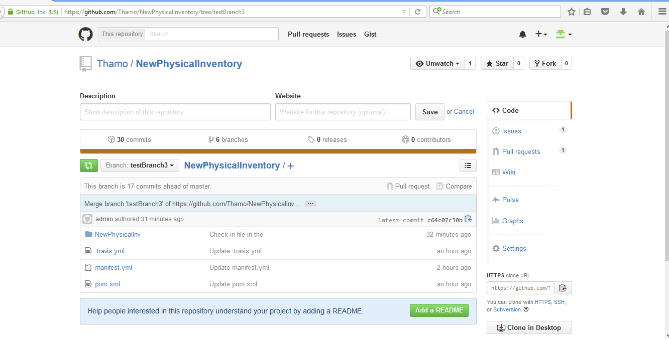

Deployment of war file into cloudfoundry(Any nine)

Using manifest file C:\Users\admin\NewPhysicalInventory\manifest.yml

Updating app manifest.yml in org girish_damodar_gmail_com / space test as girish
.damodar@gmail.com...
OK

Using route damodar.de.a9sapp.eu
Uploading manifest.yml...
Uploading app files from: C:\Users\admin\NewPhysicalInventory\techToolProj.war
Uploading 1.5K, 13 files
Done uploading
OK

Stopping app manifest.yml in org girish_damodar_gmail_com / space test as girish
.damodar@gmail.com...
OK

Starting app manifest.yml in org girish_damodar_gmail_com / space test as girish
.damodar@gmail.com...
-----> Downloaded app package (824K)
-----> Downloaded app buildpack cache (4.0K)
-----> Java Buildpack Version: v2.5 (offline) | https://github.com/cloudfoun
dry/java-buildpack.git#840500e
-----> Downloading Open Jdk JRE 1.8.0_20 from https://download.run.pivotal.io/op
enjdk/lucid/x86_64/openjdk-1.8.0_20.tar.gz (found in cache)
Expanding Open Jdk JRE to .java-buildpack/open_jdk_jre (1.9s)
-----> Downloading Tomcat Instance 8.0.12 from https://download.run.pivotal.io/t
omcat/tomcat-8.0.12.tar.gz (found in cache)
Expanding Tomcat to .java-buildpack/tomcat (0.5s)
-----> Downloading Tomcat Lifecycle Support 2.3.0_RELEASE from https://download.
run.pivotal.io/tomcat-lifecycle-support/tomcat-lifecycle-support-2.3.0_RELEASE.j
ar (found in cache)
-----> Downloading Tomcat Logging Support 2.3.0_RELEASE from https://download.ru
n.pivotal.io/tomcat-logging-support/tomcat-logging-support-2.3.0_RELEASE.jar (fo
und in cache)
-----> Downloading Tomcat Access Logging Support 2.3.0_RELEASE from https://down
load.run.pivotal.io/tomcat-access-logging-support/tomcat-access-logging-support-
2.3.0_RELEASE.jar (found in cache)

-----> Uploading droplet (46M)

1 of 1 instances running

App started

OK

App manifest.yml was started using this command `JAVA_HOME=$PWD/.java-buildpack/
open_jdk_jre JAVA_OPTS="-Djava.io.tmpdir=$TMPDIR -XX:OnOutOfMemoryError=$PWD/.ja
va-buildpack/open_jdk_jre/bin/killjava.sh -Xmx160M -Xms160M -XX:MaxMetaspaceSize
=64M -XX:MetaspaceSize=64M -Xss853K -Daccess.logging.enabled=false -Dhttp.port=$
PORT" $PWD/.java-buildpack/tomcat/bin/catalina.sh run`

Showing health and status for app manifest.yml in org girish_damodar_gmail_com /
space test as girish.damodar@gmail.com...
OK

requested state: started
instances: 1/1
usage: 256M x 1 instances
urls: damodar.de.a9sapp.eu
last uploaded: Thu Oct 1 03:39:26 +0000 2015
stack: lucid64
buildpack: java-buildpack=v2.5-offline-https://github.com/cloudfoundry/java-buil
dpack.git#840500e open-jdk-jre=1.8.0_20 tomcat-access-logging-support=2.3.0_RELE
ASE tomcat-instance=8.0.12 tomcat-lifecycle-support=2.3.0_RELEASE tomcat-logging
-support=2.3.0_RELEASE

state since cpu memory disk d
etails
#0 running 2015-10-01 09:10:03 AM 4.4% 146.7M of 256M 108.8M of 1G

//////////////////////////////////////////////////////////////////////////////////////////////

Automated Successful Build using travis CI , GIT and Eclipse(IDE) for checkin

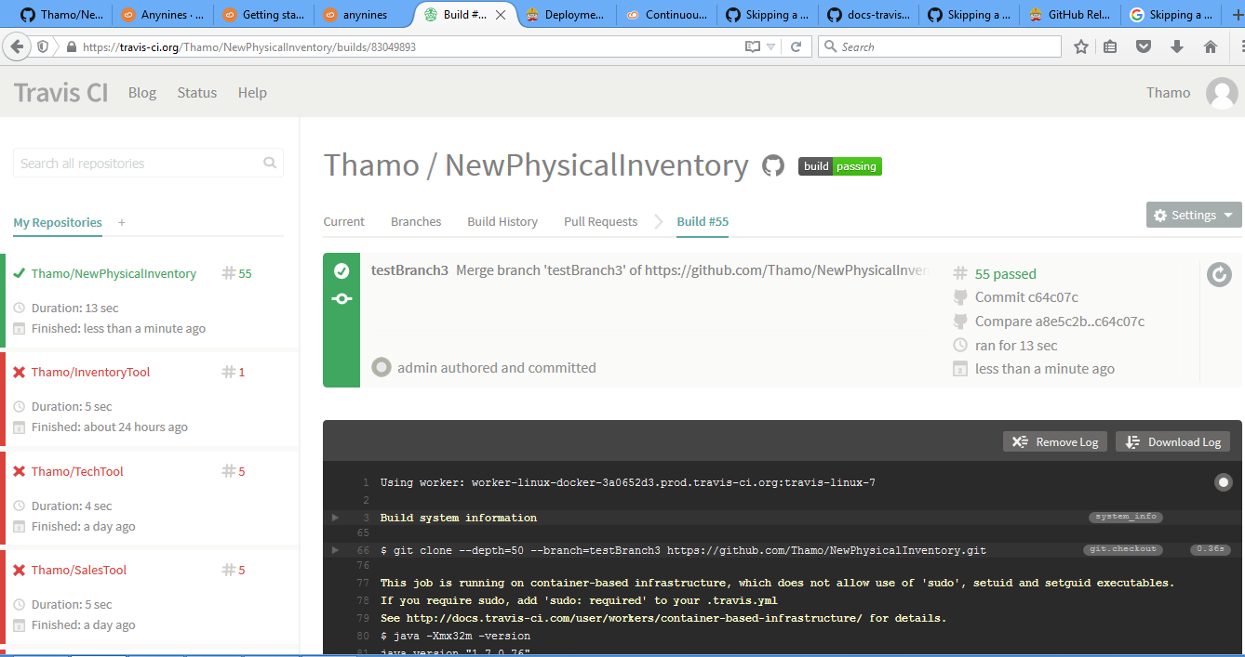

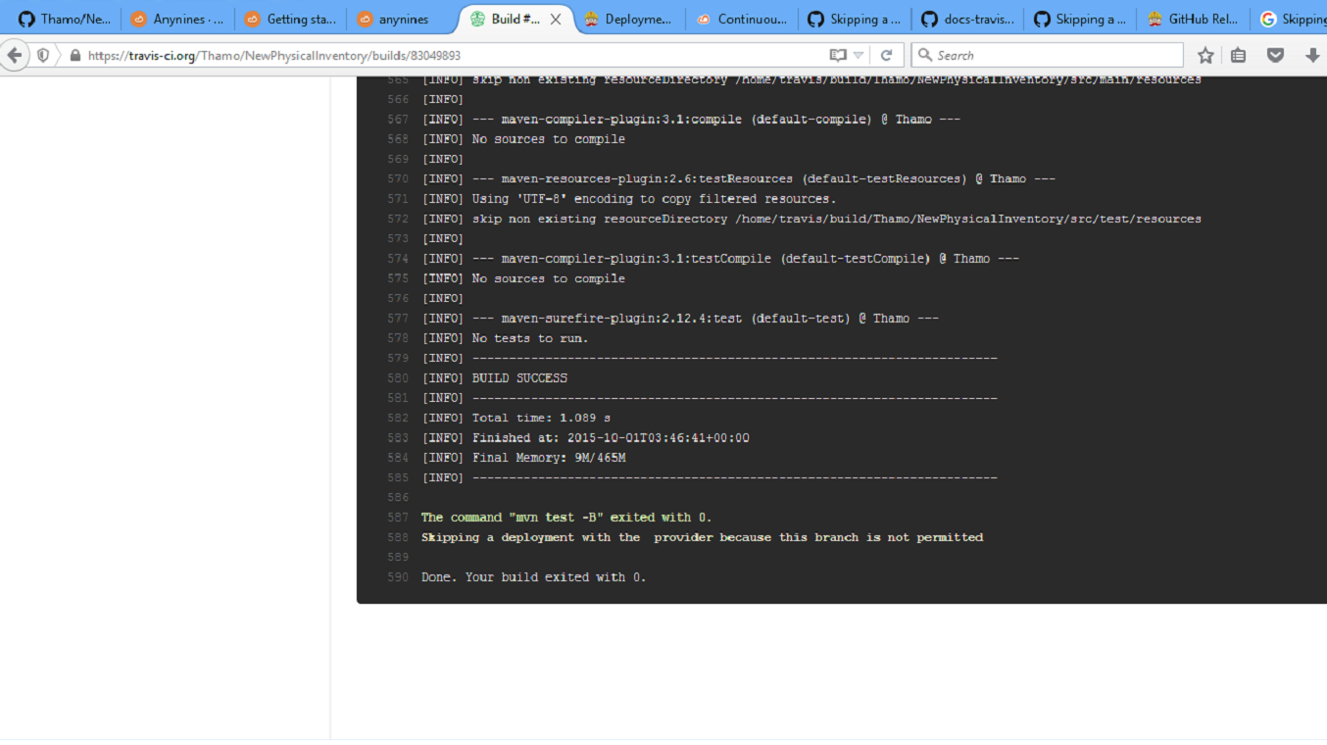

Using worker: worker-linux-docker-3a0652d3.prod.travis-ci.org:travis-linux-7

system_info

Build system information

Build language: java

Build image provisioning date and time

Thu Feb 5 15:09:33 UTC 2015

Operating System Details

Distributor ID: Ubuntu

Description: Ubuntu 12.04.5 LTS

Release: 12.04

Codename: precise

Linux Version

3.13.0-29-generic

Cookbooks Version

a68419e https://github.com/travis-ci/travis-cookbooks/tree/a68419e

GCC version

gcc (Ubuntu/Linaro 4.6.3-1ubuntu5) 4.6.3

Copyright (C) 2011 Free Software Foundation, Inc.

This is free software; see the source for copying conditions. There is NO

warranty; not even for MERCHANTABILITY or FITNESS FOR A PARTICULAR PURPOSE.

LLVM version

clang version 3.4 (tags/RELEASE_34/final)

Target: x86_64-unknown-linux-gnu

Thread model: posix

Pre-installed Ruby versions

......................
.

2.2.6

Installed Firefox version

firefox 31.0esr

.

Maven home: /usr/local/maven

Java version: 1.7.0_76, vendor: Oracle Corporation

Java home: /usr/lib/jvm/java-7-oracle/jre

Default locale: en_US, platform encoding: ANSI_X3.4-1968

OS name: "linux", version: "3.13.0-29-generic", arch: "amd64", family: "unix"

git.checkout

0.36s$ git clone --depth=50 --branch=testBranch3 https://github.com/Thamo/NewPhysicalInventory.git Thamo/NewPhysicalInventory

Cloning into 'Thamo/NewPhysicalInventory'...

remote: Counting objects: 125, done.

remote: Compressing objects: 100% (105/105), done.

remote: Total 125 (delta 43), reused 69 (delta 7), pack-reused 0

Receiving objects: 100% (125/125), 819.30 KiB | 0 bytes/s, done.

Resolving deltas: 100% (43/43), done.

Checking connectivity... done.

$ cd Thamo/NewPhysicalInventory

$ git checkout -qf c64c07c30b1578a4ea2b610f93f5fbd794389fc2

This job is running on container-based infrastructure, which does not allow use of 'sudo', setuid and setguid executables.

If you require sudo, add 'sudo: required' to your .travis.yml

See http://docs.travis-ci.com/user/workers/container-based-infrastructure/ for details.

$ java -Xmx32m -version

java version "1.7.0_76"

Java(TM) SE Runtime Environment (build 1.7.0_76-b13)

Java HotSpot(TM) 64-Bit Server VM (build 24.76-b04, mixed mode)

$ javac -J-Xmx32m -version

javac 1.7.0_76
install

6.05s$ mvn install -DskipTests=true -Dmaven.javadoc.skip=true -B -V

Apache Maven 3.2.5 (12a6b3acb947671f09b81f49094c53f426d8cea1; 2014-12-14T17:29:23+00:00)

Maven home: /usr/local/maven

Java version: 1.7.0_76, vendor: Oracle Corporation

Java home: /usr/lib/jvm/java-7-oracle/jre

Default locale: en_US, platform encoding: UTF-8

OS name: "linux", version: "3.13.0-40-generic", arch: "amd64", family: "unix"

[INFO] Scanning for projects...

[INFO]

[INFO] ------------------------------------------------------------------------

[INFO] Building Thamo 0.1

[INFO] ------------------------------------------------------------------------

[INFO] Downloading: https://repo.maven.apache.org/maven2/org/apache/maven/plugins/maven-resources-plugin/2.6/maven-resources-plugin-2.6.pom

[INFO] Downloaded: https://repo.maven.apache.org/maven2/org/apache/maven/plugins/maven-resources-plugin/2.6/maven-resources-plugin-2.6.pom (8 KB at 20.0 KB/sec)

................................................
[INFO] Downloaded: https://repo.maven.apache.org/maven2/org/apache/maven/plugin-tools/maven-plugin-annotations/3.1/maven-plugin-annotations-3.1.jar (14 KB at 360.4 KB/sec)

[INFO] Tests are skipped.

[INFO]

[INFO] --- maven-jar-plugin:2.4:jar (default-jar) @ Thamo ---

[INFO] Downloading: https://repo.maven.apache.org/maven2/org/apache/maven/maven-archiver/2.5/maven-archiver-2.5.pom

[INFO] Downloaded: https://repo.maven.apache.org/maven2/org/apache/maven/maven-archiver/2.5/maven-archiver-2.5.pom (5 KB at 443.2 KB/sec)

[INFO] Downloading: https://repo.maven.apache.org/maven2/org/codehaus/plexus/plexus-archiver/2.1/plexus-archiver-2.1.pom

[INFO] Downloaded: https://repo.maven.apache.org/maven2/org/codehaus/plexus/plexus-archiver/2.1/plexus-archiver-2.1.pom (3 KB at 304.8 KB/sec)

[INFO] Downloading: https://repo.maven.apache.org/maven2/org/codehaus/plexus/plexus-utils/3.0/plexus-utils-3.0.pom

[INFO] Downloaded: https://repo.maven.apache.org/maven2/org/codehaus/plexus/plexus-utils/3.0/plexus-utils-3.0.pom (4 KB at 441.3 KB/sec)

[INFO] Downloading: https://repo.maven.apache.org/maven2/org/sonatype/spice/spice-parent/16/spice-parent-16.pom

[INFO] Downloaded: https://repo.maven.apache.org/maven2/org/sonatype/spice/spice-parent/16/spice-parent-16.pom (9 KB at 1166.0 KB/sec)

[INFO] Downloading: https://repo.maven.apache.org/maven2/org/sonatype/forge/forge-parent/5/forge-parent-5.pom

[INFO] Downloaded: https://repo.maven.apache.org/maven2/org/sonatype/forge/forge-parent/5/forge-parent-5.pom (9 KB at 1020.9 KB/sec)

[INFO] Downloading: https://repo.maven.apache.org/maven2/org/codehaus/plexus/plexus-io/2.0.2/plexus-io-2.0.2.pom

[INFO] Downloaded: https://repo.maven.apache.org/maven2/org/codehaus/plexus/plexus-io/2.0.2/plexus-io-2.0.2.pom (2 KB at 211.5 KB/sec)

[INFO] Downloading: https://repo.maven.apache.org/maven2/org/codehaus/plexus/plexus-components/1.1.19/plexus-components-1.1.19.pom

[INFO] Downloaded: https://repo.maven.apache.org/maven2/org/codehaus/plexus/plexus-components/1.1.19/plexus-components-1.1.19.pom (3 KB at 376.4 KB/sec)

[INFO] Downloading: https://repo.maven.apache.org/maven2/org/codehaus/plexus/plexus/3.0.1/plexus-3.0.1.pom

[INFO] Downloaded: https://repo.maven.apache.org/maven2/org/codehaus/plexus/plexus/3.0.1/plexus-3.0.1.pom (19 KB at 2272.2 KB/sec)

[INFO] Downloading: https://repo.maven.apache.org/maven2/org/codehaus/plexus/plexus-interpolation/1.15/plexus-interpolation-1.15.pom

[INFO] Downloaded: https://repo.maven.apache.org/maven2/org/codehaus/plexus/plexus-interpolation/1.15/plexus-interpolation-1.15.pom (1018 B at 124.3 KB/sec)

[INFO] Downloading: https://repo.maven.apache.org/maven2/commons-lang/commons-lang/2.1/commons-lang-2.1.pom

[INFO] Downloaded: https://repo.maven.apache.org/maven2/commons-lang/commons-lang/2.1/commons-lang-2.1.pom (10 KB at 1077.3 KB/sec)

[INFO] Downloading: https://repo.maven.apache.org/maven2/org/apache/maven/maven-archiver/2.5/maven-archiver-2.5.jar

[INFO] Downloading: https://repo.maven.apache.org/maven2/org/codehaus/plexus/plexus-interpolation/1.15/plexus-interpolation-1.15.jar

[INFO] Downloading: https://repo.maven.apache.org/maven2/org/codehaus/plexus/plexus-archiver/2.1/plexus-archiver-2.1.jar

[INFO] Downloading: https://repo.maven.apache.org/maven2/org/codehaus/plexus/plexus-io/2.0.2/plexus-io-2.0.2.jar

[INFO] Downloaded: https://repo.maven.apache.org/maven2/org/apache/maven/maven-archiver/2.5/maven-archiver-2.5.jar (22 KB at 327.7 KB/sec)

[INFO] Downloading: https://repo.maven.apache.org/maven2/org/codehaus/plexus/plexus-utils/3.0/plexus-utils-3.0.jar

[INFO] Downloaded: https://repo.maven.apache.org/maven2/org/codehaus/plexus/plexus-interpolation/1.15/plexus-interpolation-1.15.jar (60 KB at 868.5 KB/sec)

[INFO] Downloading: https://repo.maven.apache.org/maven2/commons-lang/commons-lang/2.1/commons-lang-2.1.jar

[INFO] Downloaded: https://repo.maven.apache.org/maven2/org/codehaus/plexus/plexus-io/2.0.2/plexus-io-2.0.2.jar (57 KB at 862.1 KB/sec)

[INFO] Downloaded: https://repo.maven.apache.org/maven2/org/codehaus/plexus/plexus-archiver/2.1/plexus-archiver-2.1.jar (181 KB at 2144.2 KB/sec)

[INFO] Downloaded: https://repo.maven.apache.org/maven2/org/codehaus/plexus/plexus-utils/3.0/plexus-utils-3.0.jar (221 KB at 6690.1 KB/sec)

[INFO] Downloaded: https://repo.maven.apache.org/maven2/commons-lang/commons-lang/2.1/commons-lang-2.1.jar (203 KB at 5071.4 KB/sec)

[WARNING] JAR will be empty - no content was marked for inclusion!

[INFO] Building jar: /home/travis/build/Thamo/NewPhysicalInventory/build/helloutils.jar

[INFO]

[INFO] --- maven-install-plugin:2.4:install (default-install) @ Thamo ---

[INFO] Downloading: https://repo.maven.apache.org/maven2/org/codehaus/plexus/plexus-utils/3.0.5/plexus-utils-3.0.5.pom

[INFO] Downloaded: https://repo.maven.apache.org/maven2/org/codehaus/plexus/plexus-utils/3.0.5/plexus-utils-3.0.5.pom (3 KB at 272.6 KB/sec)

[INFO] Downloading: https://repo.maven.apache.org/maven2/org/codehaus/plexus/plexus/3.1/plexus-3.1.pom

[INFO] Downloaded: https://repo.maven.apache.org/maven2/org/codehaus/plexus/plexus/3.1/plexus-3.1.pom (19 KB at 2019.9 KB/sec)

[INFO] Downloading: https://repo.maven.apache.org/maven2/org/codehaus/plexus/plexus-digest/1.0/plexus-digest-1.0.pom

[INFO] Downloaded: https://repo.maven.apache.org/maven2/org/codehaus/plexus/plexus-digest/1.0/plexus-digest-1.0.pom (2 KB at 114.9 KB/sec)

[INFO] Downloading: https://repo.maven.apache.org/maven2/org/codehaus/plexus/plexus-components/1.1.7/plexus-components-1.1.7.pom

[INFO] Downloaded: https://repo.maven.apache.org/maven2/org/codehaus/plexus/plexus-components/1.1.7/plexus-components-1.1.7.pom (5 KB at 607.3 KB/sec)

[INFO] Downloading: https://repo.maven.apache.org/maven2/org/codehaus/plexus/plexus/1.0.8/plexus-1.0.8.pom

[INFO] Downloaded: https://repo.maven.apache.org/maven2/org/codehaus/plexus/plexus/1.0.8/plexus-1.0.8.pom (8 KB at 882.6 KB/sec)

[INFO] Downloading: https://repo.maven.apache.org/maven2/org/codehaus/plexus/plexus-container-default/1.0-alpha-8/plexus-container-default-1.0-alpha-8.pom

[INFO] Downloaded: https://repo.maven.apache.org/maven2/org/codehaus/plexus/plexus-container-default/1.0-alpha-8/plexus-container-default-1.0-alpha-8.pom (8 KB at 886.6 KB/sec)

[INFO] Downloading: https://repo.maven.apache.org/maven2/org/codehaus/plexus/plexus-utils/3.0.5/plexus-utils-3.0.5.jar

[INFO] Downloading: https://repo.maven.apache.org/maven2/org/codehaus/plexus/plexus-digest/1.0/plexus-digest-1.0.jar

[INFO] Downloaded: https://repo.maven.apache.org/maven2/org/codehaus/plexus/plexus-utils/3.0.5/plexus-utils-3.0.5.jar (226 KB at 17311.2 KB/sec)

[INFO] Downloaded: https://repo.maven.apache.org/maven2/org/codehaus/plexus/plexus-digest/1.0/plexus-digest-1.0.jar (12 KB at 890.8 KB/sec)

[INFO] Installing /home/travis/build/Thamo/NewPhysicalInventory/build/helloutils.jar to /home/travis/.m2/repository/yl/Thamo/0.1/Thamo-0.1.jar

[INFO] Installing /home/travis/build/Thamo/NewPhysicalInventory/pom.xml to /home/travis/.m2/repository/yl/Thamo/0.1/Thamo-0.1.pom

[INFO] ------------------------------------------------------------------------

[INFO] BUILD SUCCESS

[INFO] ------------------------------------------------------------------------

[INFO] Total time: 4.438 s

[INFO] Finished at: 2015-10-01T03:46:39+00:00

[INFO] Final Memory: 13M/465M

[INFO] ------------------------------------------------------------------------

2.76s$ mvn test -B

[INFO] Scanning for projects...

[INFO]

[INFO] ------------------------------------------------------------------------

[INFO] Building Thamo 0.1

[INFO] ------------------------------------------------------------------------

[INFO]

[INFO] --- maven-resources-plugin:2.6:resources (default-resources) @ Thamo ---

[INFO] Using 'UTF-8' encoding to copy filtered resources.

[INFO] skip non existing resourceDirectory /home/travis/build/Thamo/NewPhysicalInventory/src/main/resources

[INFO]

[INFO] --- maven-compiler-plugin:3.1:compile (default-compile) @ Thamo ---

[INFO] No sources to compile

[INFO]

[INFO] --- maven-resources-plugin:2.6:testResources (default-testResources) @ Thamo ---

[INFO] Using 'UTF-8' encoding to copy filtered resources.

[INFO] skip non existing resourceDirectory /home/travis/build/Thamo/NewPhysicalInventory/src/test/resources

[INFO]

[INFO] --- maven-compiler-plugin:3.1:testCompile (default-testCompile) @ Thamo ---

[INFO] No sources to compile

[INFO]

[INFO] --- maven-surefire-plugin:2.12.4:test (default-test) @ Thamo ---

[INFO] No tests to run.

[INFO] ------------------------------------------------------------------------

[INFO] BUILD SUCCESS

[INFO] ------------------------------------------------------------------------

[INFO] Total time: 1.089 s

[INFO] Finished at: 2015-10-01T03:46:41+00:00

[INFO] Final Memory: 9M/465M

[INFO] ------------------------------------------------------------------------

The command "mvn test -B" exited with 0.

Skipping a deployment with the provider because this branch is not permitted

Done. Your build exited with 0.
//////////////////////////////////////////////////////////////////////////////////////////

// Login Servlet code
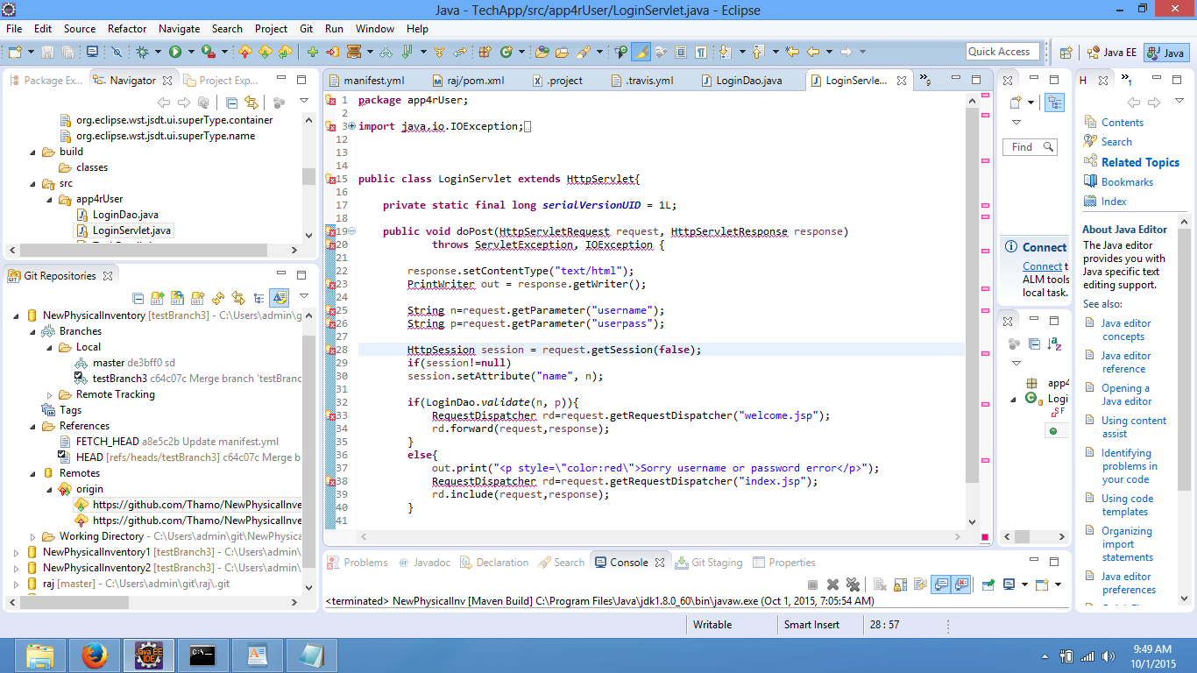

package app4rUser;

import java.sql.Connection;
import java.sql.DriverManager;
import java.sql.PreparedStatement;
import java.sql.ResultSet;
import java.sql.SQLException;

public class LoginDao {
public static boolean validate(String name, String pass) {
boolean status = false;
Connection conn = null;
PreparedStatement pst = null;
ResultSet rs = null;

String url = "jdbc:mysql://113.128.164.50/";
String dbName = "techtool";
String driver = "com.mysql.jdbc.Driver";
String userName = "monty";
String password = "some_pass";
try {
Class.forName(driver).newInstance();
conn = DriverManager
.getConnection(url + dbName, userName, password);

pst = conn
.prepareStatement("select * from tech_users where userlogid=? and password=?");
pst.setString(1, name);
pst.setString(2, pass);

rs = pst.executeQuery();
System.out.println("rs" +rs);
status = rs.next();
System.out.println("Status" +status);
} catch (Exception e) {
System.out.println(e);
} finally {
if (conn != null) {
try {
conn.close();
} catch (SQLException e) {
e.printStackTrace();
}
}
if (pst != null) {
try {
pst.close();
} catch (SQLException e) {
e.printStackTrace();
}
}
if (rs != null) {
try {
rs.close();
} catch (SQLException e) {
e.printStackTrace();
}
}
}
return true;
}
}

