# CHAPTER -1

## INTRODUCTION

Throughout recent years, almost every adult has got a university degree, which has led to a constant increment in the unemployment rates. On the other hand, the market is being dominated by big companies through advertising and capitalism, which leaves individuals tiny chances to get employed or work on projects. This website offers new opportunities for graduated engineers to directly contact with the costumers for building, recreating, and renewing properties. The website will enable interested costumers to post their problems in order for the engineers to review them and make their offers. All users and engineers on the website will be registered with strict requirements and rating system. The focus of the website will be on Architects, Interior Designers, and Engineers.

## THE MOTIVATION & PURPOSE

The motivation behind this project emerges from the efficiency of using e-recruiting websites and the demand of construction work in the kingdom of Saudi Arabia along with the lack of recruiting websites that work on small scales. Therefore, the purpose of this project is to help qualified engineers to work, in addition to making the process of hiring easier for clients.

## PROBLEM DESCRIPTION

The unemployment ratio of engineers and architects is increasing constantly, which is leaving many certified engineers unemployed. In 2019, Saudi Arabia's estimated unemployment rate amounted to approximately 5.92 percent. This increase is up .03 percent from the year before [2]. In addition, the requirements of recruiting inside big companies are getting harder, since most companies require masters degrees and many years of experience in order for them to hire people.

On the other hand, online hiring between clients and engineers put the clients’ safety and comfort in danger, due to the registration and the posting process of many website, for example, anyone can pretend to be an engineer and take the clients’ time and money if it’s not worse! .

## PROPOSED SOLUTION

This project suggests a problem solving website for the issues we mentioned in the previous section. Its goal is to provide work opportunities for the unemployed qualified engineers, and to help registered clients to post their offers and find the right people for the job through a safe online platform.

Freelance Engineers is a portable website that is developed using standard programming languages, which are HTML5, CSS, Java Script, and PHP.

## PROJECT OBJECTIVES

The objectives of this project are listed below as follows:

1. Creating a portal for online recruitment where clients can post construction work for the engineers to view them and present their offers.
2. Offering flexibility for the interested clients who want to hire engineers, since clients can browse the engineers’ profiles to see who fits their work best.
3. Building a competitive platform for engineers to present their best work for the clients, since average performance is unlikely to grab the clients’ attention, therefore, engineers become more careful about their work and the clients’ preference.

.

## PROJECT SCOPE

1)    The website will be available only for certified engineers and interested clients.

2)    All engineers will get fair assessments.

3)    No harming or unrelated posts will stay in the website.

## PROJECT SCHEDULE

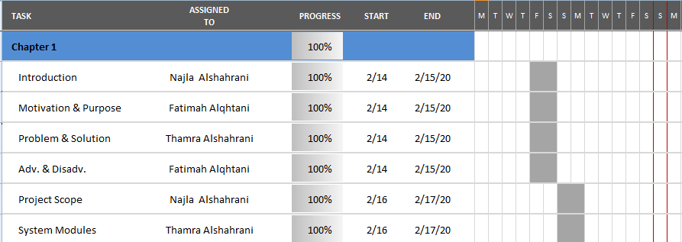Figure Chapter 1 Timeline

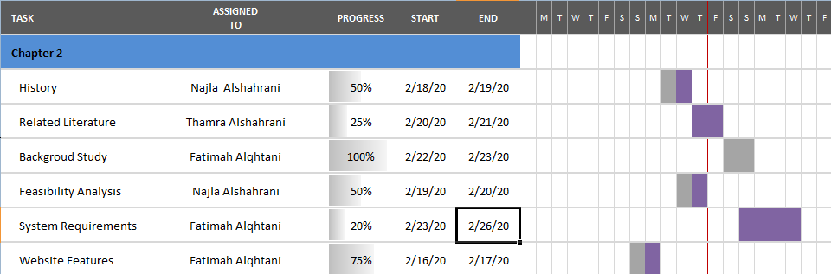Figure Chapter 2 Timeline

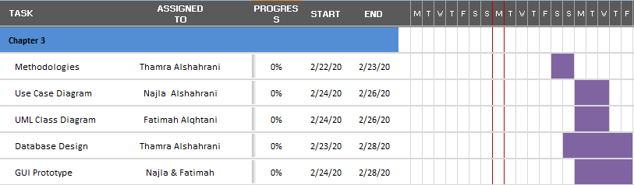Figure Chapter 3 Timeline

## ADVANTAGES & DISADVANTAGES

There are many advantages of using this website for both clients and engineers which are:

1. Lower cost of jobs advertising posted by the clients [1].
2. Agreements between clients and engineers happen without the need of mediators [1].
3. Easy and time-efficient recruiting process for both clients and engineers [1].
4. Variety of options for the clients to pick the right person for the construction requirements [1].
5. Clients can view everything they need to know about the engineers through their profiles [1].

Apart from the several benefits, Freelance Engineers have disadvantages too, some of them are:

1. Posts can be incredible and insincere since all users can post at anytime without strict restrictions [1].
2. There’s a lot of competition, no guarantees for engineers to get a chance of employment [1].

## SYSTEM MODULES

The actors and their level of authentication are listed below as follows:

ADMIN

* Accept (Users, Engineers).
* Update their information.
* Accept or declines the posts to be updated.

USERS

* Register.
* Login / Logout.
* Insert posts.
* Update and delete posts.
* View the engineers’ profiles.
* Update their information.
* Contact with engineers.

ENGINEERS

* Register
* Login / Logout
* View users’ posts.
* Update their information

# REFERENCES

1. Chand, S. (n.d.). *Advantages and disadvantages of E-Recruitment.* Retrieved from: <http://www.yourarticlelibrary.com/recruitment/advantages-and-disadvantages-of-e-recruitment/29525> Accessed on: 2/22/2020.
2. Statista, (Dec. 2019). *Saudi Arabia Unemployment Rate from 1999 to 2019.* Retrieved from: https://www.statista.com/statistics/262524/unemployment-rate-in-saudi-arabia/ Accessed on: 22/2/2020.