**Server**

XMPP server (XMPP-Extensible Messaging and Presence Protocol) server used by the Telegram. To transfer message between the open source Ejabberd has been used, it transfer messages between two or more user at any point of time.

Telegram make use of both HTTP and XMPP for the communication. XMPP used during asynchronous federated limited purpose communication whereas HTTP used synchronous unfedered general purpose communication

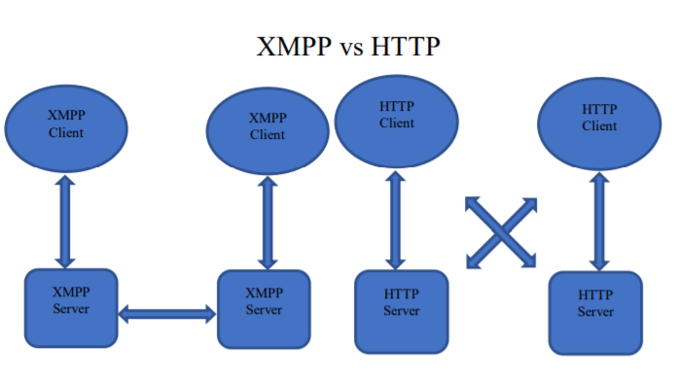

**Design model**

Telegram-Web is designed as a [Single Page Application](https://en.wikipedia.org/wiki/Single-page_application) and uses the AngularJS 1 framework. AngularJS was specifically developed to make building single page web applications easy, which is probably why it was used for Telegram-Web. It's based on the Model-View-Controller design pattern, which structures an application in three parts:

* **model:** the data (also called state) of the application;
* **view:** the interface of the application, which shows the data in the model. The view is defined in HTML-based Template files;
* **controller:** component that updates the model when the user makes a change to the view. This is the place where business logic such as validation of the user input happens.

There are some additional types of components in AngularJS:

* **directives:** updates part of the view when the model changes;
* **filters:** functions that format data for display to the user;
* **services:** reusable business logic that is independent of views.

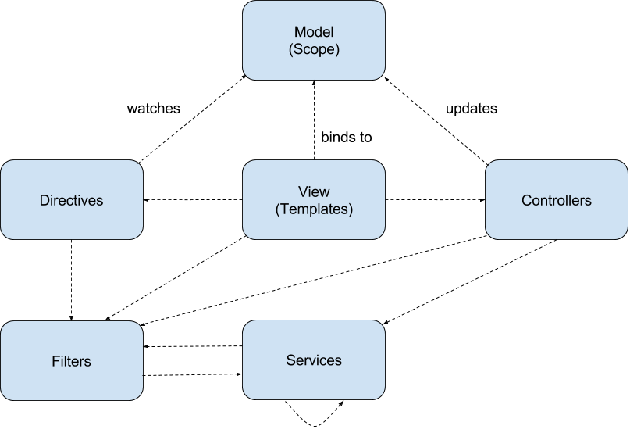

**Encryption scheme**

Telegram uses a [symmetric encryption](https://en.wikipedia.org/wiki/Symmetric_encryption) scheme called MTProto

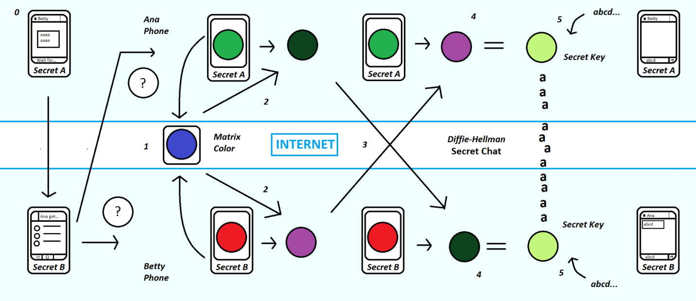

### Servers

Telegram's server-side software is closed-source and proprietary.

# **Telegram Applications**

**open source** and support **reproducible builds.** This means that anyone can independently verify that our [code on GitHub](https://telegram.org/apps#source-code) is the exact same code that was used to build the apps you download from App Store or Google Play