IOS PROJECT PROPOSAL
Project Title: AirSense
Team members
1. 6610308 Thanadon Ruangpakdee
2. 6610936 Thanakrit Kodklangdon
3. 6610387 Kitirat Pisithaporn
1. APP DESCRIPTION & PROBLEM STATEMENT
Air pollution, particularly PM2.5, is a critical environmental and health concern for residents in Bangkok and urban regions across Thailand. Existing weather applications often display raw pollution metrics without providing personal context, local caching, or actionable health guidelines.
AirSense is a personalized iOS application engineered to deliver real-time air quality monitoring, personalized health advice, and local historical exposure tracking. The application dynamically transforms its visual ambiance, background gradients, and mascot expressions based on real-time Air Quality Index (AQI) toxicity levels, empowering users to make safe, informed decisions for their daily routines and bookmarked locations (e.g., Home, University, Workplace).
2. CORE FEATURES
• Real-Time GPS Air Quality Monitoring: Automatically fetches live AQI, PM2.5, PM10, and gas pollutant breakdown based on current GPS location.
• Dynamic Ambiance & Expressive Air Mascot: Visual theme background color gradients (Green → Yellow → Red → Purple) and mascot expressions adapt dynamically to AQI toxicity levels.
• Saved Favorite Locations: Allows users to bookmark key places (Home, Uni, Work) for quick side-by-side air quality comparisons.
• Historical Offline Caching & Trends: Locally caches hourly/daily AQI readings to generate 7-day trend graphs accessible even without an active internet connection.
• Actionable Health Badges: Displays immediate outdoor activity recommendations (e.g., "Wear N95 Mask", "Close Windows", "Air Purifier Level 3 Recommended").

3. TECHNICAL ARCHITECTURE & RUBRIC COMPLIANCE
Category
Technical Implementation
External REST API Integration
Connected to WAQI (World Air Quality Index) REST API using modern Swift URLSession and async/await. Parsed via Swift Codable structs with robust error handling (offline alerts, retry triggers, and skeleton loading views).
Data Persistence
Implemented using SwiftData (@Model) to retain user-saved locations and historical AQI logs locally. Data persists 100% reliably across complete application force-quits and restarts. Uses UserDefaults for user notification preferences.
Advanced UI & UX
Designed in SwiftUI featuring a custom animated circular gauge built with Canvas, dynamic background particle effects, Swift Charts for trend visualizations, matchedGeometryEffect transitions, and haptic feedback.
4 Distinct Screens Hierarchy
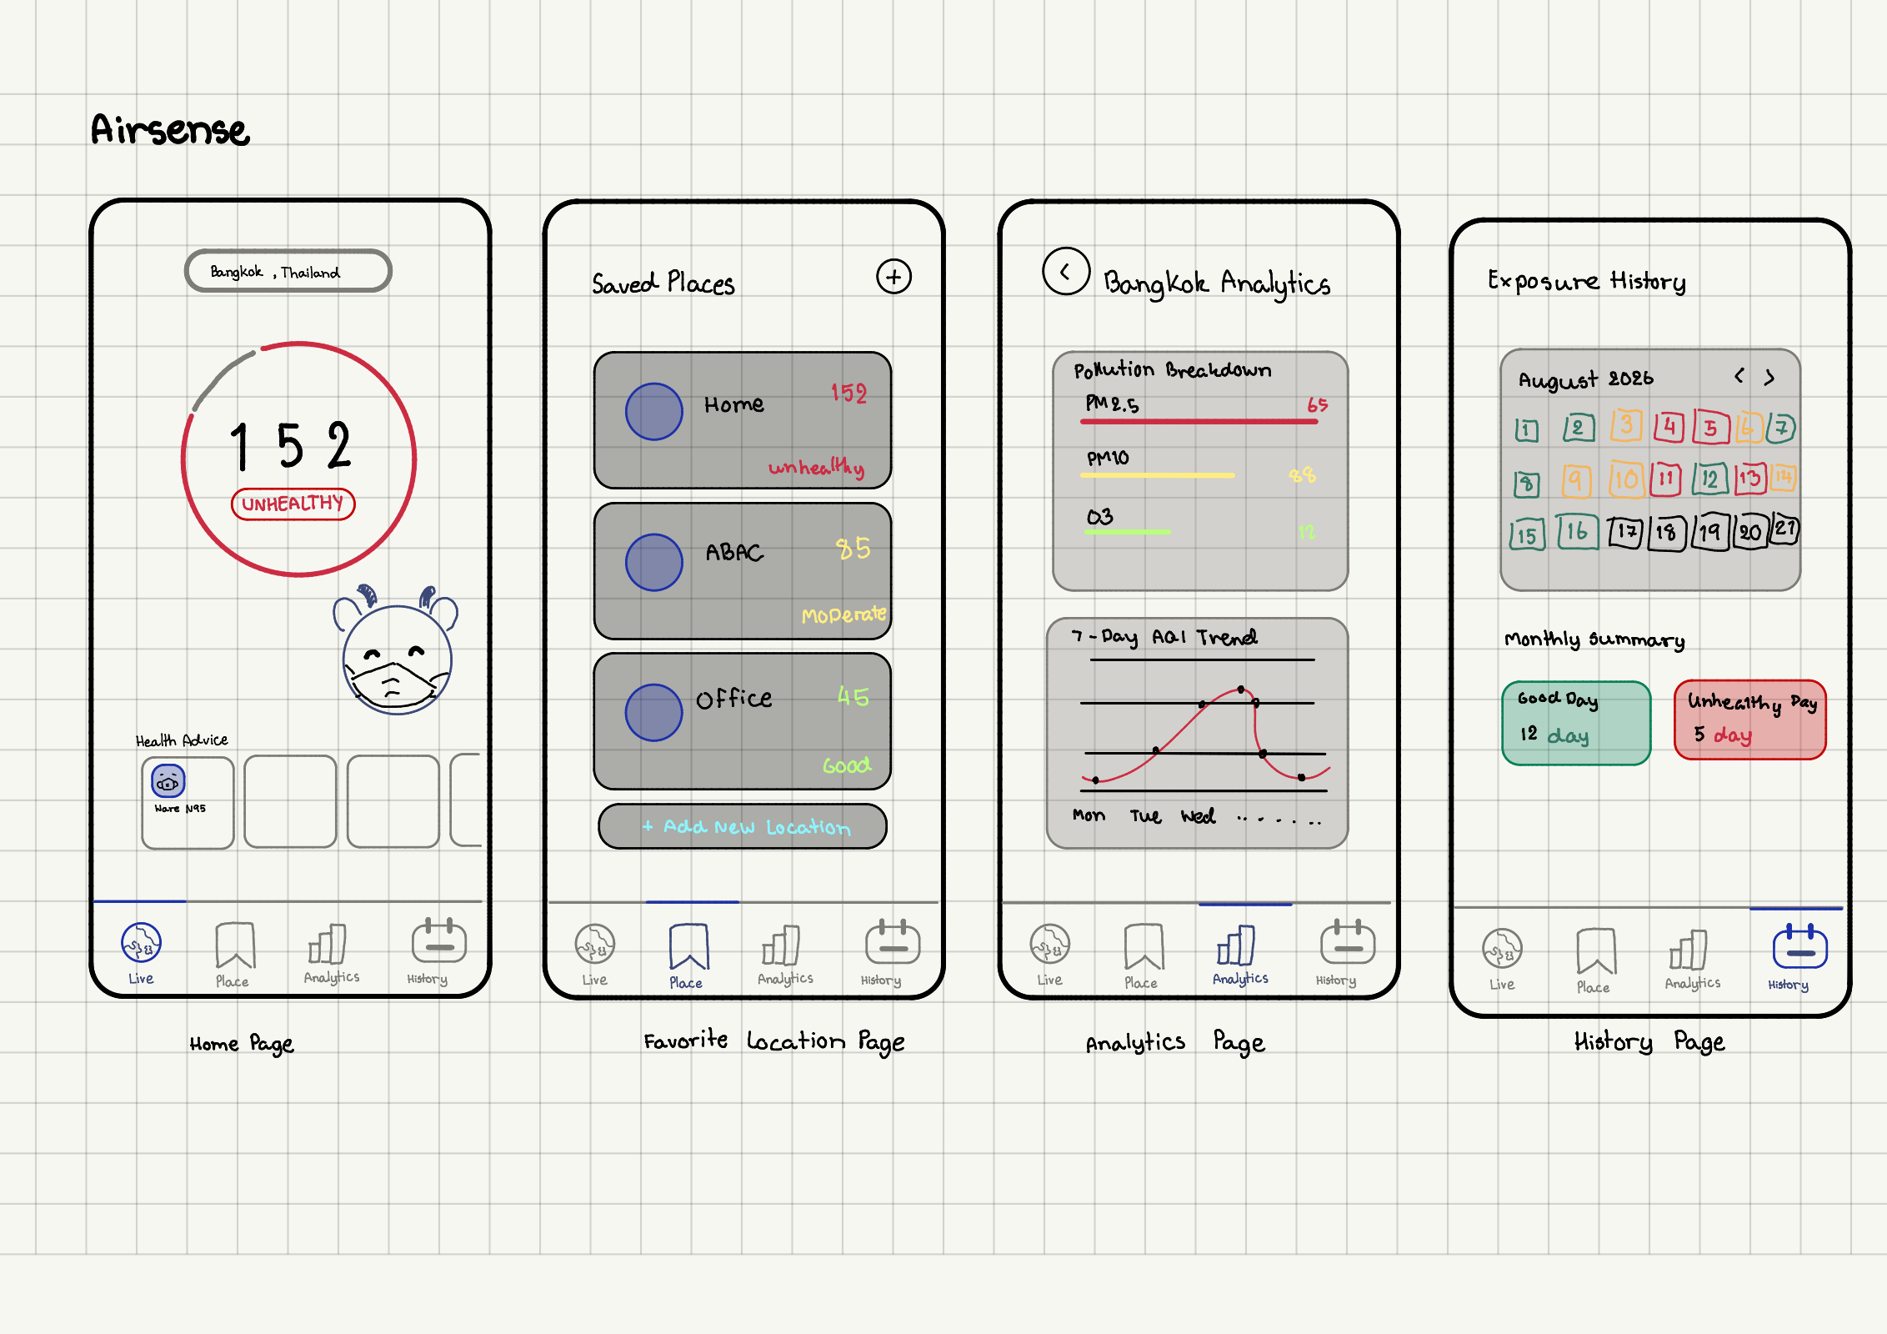
Structured with a TabView & NavigationStack hierarchy: (1) Live Dashboard, (2) Saved Places, (3) Air Analytics & Breakdown, and (4) Exposure History & Heatmap.

Hand-Writing

