
CSX4110 Backend Application Development  1/2026 | Vincent Mary School of Engineering, Science and Technology


SpaceReserve
CSX4110 Backend Application Development
PROJECT PROPOSAL
Prof. Dr. Chayapol Moemeng
SECTION - 542

Group members:
Ratchanon P. | 6610909
Badin Bangsen | 6611108
Warachai A. | 6610996
SEMESTER 1/2026

1 What is SpaceReserve?
SpaceReserve is the backend for a campus room-booking website. Students use it to find and reserve study rooms, project labs, and music practice rooms, and can bring friends along on a booking. Facility staff use it to manage the rooms: adding new ones, updating capacity, and blocking off rooms for maintenance.
It's a REST API built with Node.js and Express, storing everything in PostgreSQL through Prisma ORM. Every requirement from the course brief shows up somewhere: AD login, RBAC, Key Vault secrets, an AI feature, and a peer-to-peer API connection.
2 Who can do what (roles & access)
Everyone logs in with their normal university Microsoft account through Active Directory and OIDC, so there's no separate SpaceReserve password to remember. Once logged in, the system hands back a JWT, a signed digital pass that says who you are and what you're allowed to do.
● Student / Faculty  - Search for open rooms  - Create a booking  - Cancel their own booking  - Invite others to join a booking | ● Facility Staff  - Add, edit, or remove rooms  - Update room capacity & amenities  - Mark a room as out-of-order  - Override a booking for maintenance | ● System Admin  - Full system configuration  - View audit logs  - See room utilization stats
3 How the data is organized
There are four tables at the core of the system. In plain terms:
TABLE | WHAT IT STORES
User | Each person's basic info (name, email, AD ID) and their role: student, staff, or admin.
Room | Every bookable space: its name, how many people it fits, and its amenities (projector, whiteboard, etc).
Reservation | A single booking: who made it, which room, and the start and end time.
Reservation Attendee | The extra people invited to a booking, so a group can share one reservation.
Entity relationship diagram:
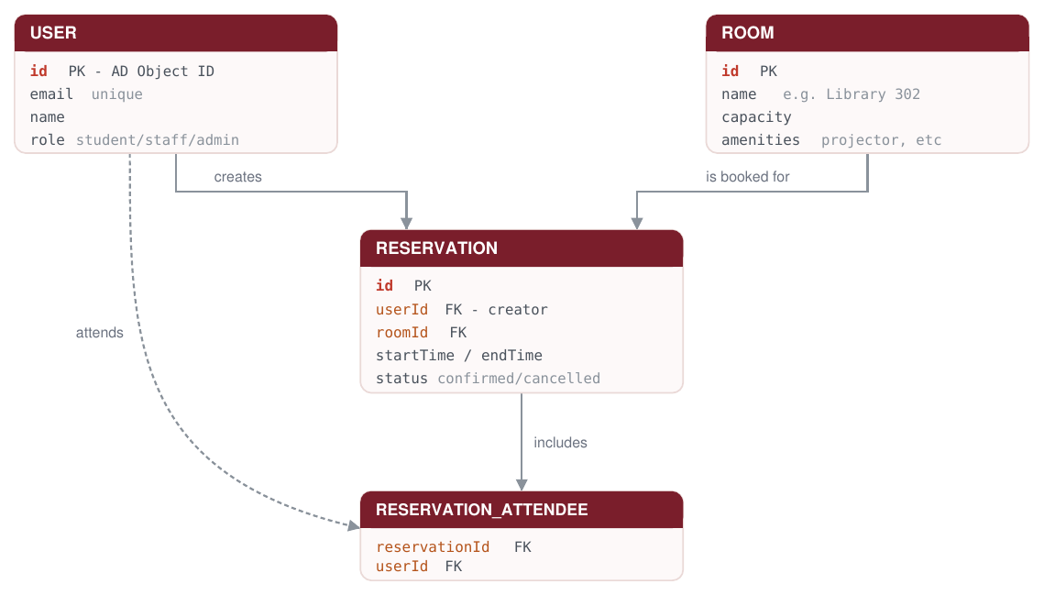

4 Outside services we're connecting to
Two external APIs cover the parts we can't build ourselves:
● Gemini AI: smart room search
Instead of clicking through filters, a student can just type what they need in plain English. We send that text to Gemini, which turns it into structured search parameters (capacity, time, amenities), and we use that to query the database.
"Find me a room for 4 people tomorrow at 3 PM with a whiteboard" turns into a real database search.

● SendGrid: booking emails
Whenever a booking is confirmed or cancelled, including staff overrides, SendGrid sends a confirmation email straight to the student's university email address. No manual follow-up needed.
5 Working with a classmate's project (peer API)
We're pairing up with a classmate's project, FinderAI, a campus Lost & Found system, so the two backends talk to each other.
THEY CALL US  We expose an endpoint  GET /api/v1/external/bookings/active-at  Protected with a static API key we generate just for FinderAI. When they log a found item in "Library Room 4B" at 2:00 PM, they call this endpoint to find out who had that room booked at that time, so they can notify the likely owner. | WE CALL THEM  We consume their endpoint  GET /api/v1/items/by-location  Using an API key they issue to us. When a student checks into a room, we check with FinderAI to see if any lost items were recently reported there. If so, we show a heads-up: "2 lost items were reported in this room. Did you lose something?"
6 Where it will live (infrastructure)
Deployment follows the course's production standards end to end:
- Hosted on a hardened Linux VPS (Oracle Cloud / Azure)
- Served through Nginx at its own path: /spacereserve
- Secured with a free Let's Encrypt SSL certificate
- No secrets in .env files, everything pulled from Azure Key Vault at runtime
- Database schema & changes tracked with Prisma migrations
- Full source code hosted on GitHub with a setup README

