# WHY do I trade?

It is undeniable financial trading is the most rewarding profession in the world. I can have millions opportunities lifetime where I can learn many things to grow up myself along side. Yes, it is my exit strategy where I can literally free myself from earthly system. I believe the wealth transferring will last until 2nd coming of the Lord. Therefore, it is still there thru fast-changing economics. Market wickedly and consistently lures me to the way I think I am smart to do something. There are always the inferred clues and distracted truths behind. Giving up easily devastates my soul literally while destroying my faith and confidence. I believe there will always be odds in the game through the grace of God even though I cannot see them now because He promised He will make a way. Surely, I could become anything by incorporating trading with my extravagant God to bring my neat identity and callings to the glory of God.

I could not agree with 9-to-5 jobs serving earthly masters whereas I bow down to the Lord. I believe He created me to deliver His people from this world, make them share the covenants with me and the saints. Laboring steals my time where I believe the Presence of the Lord will break this bondage. He asked me that night “Son, what do you want the most in life?” I replied naïvely with generic needs in life, but closing with helping people. I have a dream of the house of the lost gathering those who is weary coming back home, the Father’s house. I am willing to guide them with the truth and talents He gave me. More importantly, I do not want to stay in the system in which it distracts me from God to idols like job, money, and success. Unseen statue is the most dangerous.

Previously, I have never trusted anyone before. That wrecked me from the inside since I should have made a move but in vein. To overcome it, I need to get sweated and challenged, but it will surely take me a leap from past years when I look back into myself. There are so many things to learn and experiment. It keeps my heart beating against the odds I found. I will try to persist my rules, approaches, and thought processes with self-discipline until He moves His Presence over my edge. No absurd emotions, only hopes in His hands with the confidence in God. Not only deriving odds from recognizing various patterns in the market, but consistently walking with Him through faithful prayers and directed lessons where His Glory and wonders will be uncovered.

# MOTTO

***His heart will open to beloved servant***

**John 10:10**, *“The thief cometh not, but for to steal, and to kill, and to destroy: I am come that they might have life, and that they might have it more abundantly”*

**1 Peter 5:8**, *“Be sober, be vigilant; because your adversary the devil, as a roaring lion, walketh about, seeking whom he may devour”*

# What is my APPROACH ?

Bearing His victory in mind, no one can overcome the demon realm except God alone, so I will not complicate things or twist the strategies based on the **distracted truth or man-made theory**, but direct my hope and faith to God alone through the simple strategies governed by this truth. We can never trust the market or anticipate fruits of it. Lying tree bears no good fruits. Abide in His Presence, then reflect His light in the darkness.

**[ River Flow Strategy ]**

**# qualified momentum** = break and retest

**# 1st moment** = HH-HL / LH-LL

**# 2nd moment** = Double bottom in uptrend / Double top in downtrend

**# qualified entry** = percentage pullback on 1st break in lower timeframe or perfect retest in higher timeframe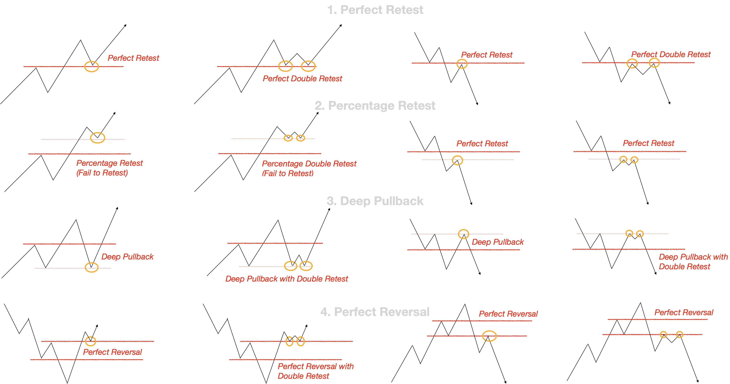

# 

# What are my key RULES ?

1. Always trade with clear trend
2. Always trade in line with the direction of the market
3. Always wait for confirmation
4. Always identify key levels
5. Always enter with enough range to go BE and 3RR
6. Always enter on a pullback not push phase
7. Always focus on Risk before Reward
8. Always place my SL above/below the key levels (structural level that you trade)
9. **Only** process the **recent** price action
10. Never get convinced by the very first evidence
11. Never anticipate the reversal
12. Never enter without at least 2 wick rejections
13. Never trade within the range
14. Never trade without pre-analysis
15. Surely see those lies uncovered while being walking with God

# What are my GOALS ?

**Monthly** – To trade like to prosper God’s account by committing opportunities aligned with His strategies with pre-analysis and post-analysis. To pay solely attention to be consistent and grow ‘singles & doubles’ through His strategies.

**Yearly** – To be more vigilant through day-to-day journey and education. I will be wisely manage my risk for getting rewards to keep expenses at its minimum. To see wonders in rising equity curve!

**Long Term** – To trade for living! To have multiple accounts and profitable strategies across instruments; one for my family income, one for donation, and another for wealth.

# What PAIR will I trade?

Whatever that is

backtested > 100 trades

# What TIMEFRAME will I trade?

Whatever that is

backtested > 100 trades

# What is my TRADE MANAGEMENT?

1. [25%] Breakeven (BE) at 1:1
2. [50%] at 1:2
3. [100%] Take Profit (TP) 1:3 or trail stop if possible
4. RRR should never below 3R

# PRE-Market ROUTINE

1. Go over my trading plan to set the rules for the day
2. Pray over negative emotions, fear, doubt, anxiety towards the markets today
3. Access note from yesterday
4. Assess fresh data of the data and disregard marking yesterday
5. Journalize with screenshots
6. Markets are random – my job is to execute my plan and nothing else

# POST-Market ROUTINE

1. Clear your mind thru prayers from past or recent execution no matter what result of the day is loss or win
2. Continue journalizing with screenshots
3. Make sure you journalize all numbers that could give your better insight after analyzing them
4. Enjoy and celebrate that you are faithful!

# TOOLS that I will use for my business

1. MT4
2. Tradingview
3. Forex Factory

# REVIEW Process

1. Only review your trades after 25 are logged and screenshotted.
2. DO NOT find faults if they are not there. Remember! If you followed the rules in every trade that you lost is the price you pay in this business
3. Make notes about each batch of trades – good and bad notions
4. Write how many out of 25 have the rules broken
5. Adjust your plan if there are issues – both mentally and approach itself if required

# How I should SEE the Markets

Chart is consecutive stories. First, identify direction and structure. Then, tryna say something like below

“*Price has pushed up. Big wick to the upside meaning that the bullish pressure is depleted. The bulls are taking profits and leaving another wick. Bears are in control now. The market has created a potential key level lower high*”

Remember: **don’t over-analyze**. Focus on the most recent price action and on your key levels. Keep it stupid simple! Talk it out loud, it really helps!

***Let the market tell the lies, and govern our strategy with the truth.***

# What to do to IMPROVE

You got to start building up chart time. How?

Mark up your charts and identify structure. Higher Highs, Higher Lows, Double Bottom, Double Top, Key Levels, Push, Exhaustion. Narrate the story the market is telling you.

By doing this you will start to understand how a pair moves. You will see more of your patterns. By marking up charts, narrating the story the market is telling you and taking the damn trades – **you will succeed.**

I will start doing this 30 minutes or less in the morning and in the afternoon each

# DISCIPLINE & MINDSET

* Trade **outcomes are random**, whether I like it or not. All I have power over is whether I follow my plan or not
* There are millions of traders watching the markets at the same time as me and they might not agree. But that doesn’t mean you’re wrong or they are wrong
* Wins or losses have absolutely no influence over the next trade
* If I identify my pattern and each key rule is respected, I will accept the risk and take the trade
* Anything” can happen
* I don’t need to know what is going to happen next in order to make money
* There is a random distribution between wins and losses for any given variable that defines an edge
* Edge is nothing more than an indication of a higher probability of one thing happening over another
* Every moment in the market is unique

# My trading COMMANDMENTS

* NEVER analyze or take a trade if I am not in the right state of mind
* ALWAYS **risk 1%** per trade
* NEVER exceed your DAILY LOSS of 2%
* NEVER trade when the market is not showing you the pattern you trade
* ALWAYS be mindful of the 4H candles closing and openings
* ALWAYS check the news in the morning
* NEVER hold trades overnight
* NEVER take a trade just to make up for a loss
* ALWAYS stick to my key rules
* NEVER take a trade that I did not prepare and analyze in advance
* WAIT patiently for the setups to come

This is a living document …

It may change as my experience or my knowledge of the market get increased