**FUTURE SALES PREDICTION (Phase 2)**

**Introduction:**

Time series forecasting is the process of analyzing time series data using statistics and modeling to make predictions and inform strategic decision-making. It’s not always an exact prediction, and likelihood of forecasts can vary wildly—especially when dealing with the commonly fluctuating variables in time series data as well as factors outside our control.

Here we are discussing about advanced time series forecasting techniques like Prophet or LSTM networks for improved accuracy in predicting future sales.

**Data Set Link:**

<https://www.kaggle.com/datasets/chakradharmattapalli/future-sales-prediction>

**Prophet:**

Prophet is a time series forecasting tool developed by Facebook. It can be useful for predicting future sales. Here are some steps for using Prophet in sales prediction:

**1. Data Preparation:** Gather historical sales data, ensuring it includes timestamps and sales values.

**2. Data Exploration:** Explore your data to identify any trends, seasonality, or outliers. This will help you better understand the underlying patterns.

**3. Data Preprocessing**: Clean and preprocess the data. Prophet is robust to missing data and outliers, but it's still a good practice to handle them appropriately.

**4. Prophet Implementation:** Use the Prophet library to build your model. You'll need to install and import the library and create a Prophet model. Tune the model parameters like seasonality and holidays to fit your data.

**5. Add Holidays and Events:** If sales are influenced by holidays or special events, you can incorporate this information into the model.

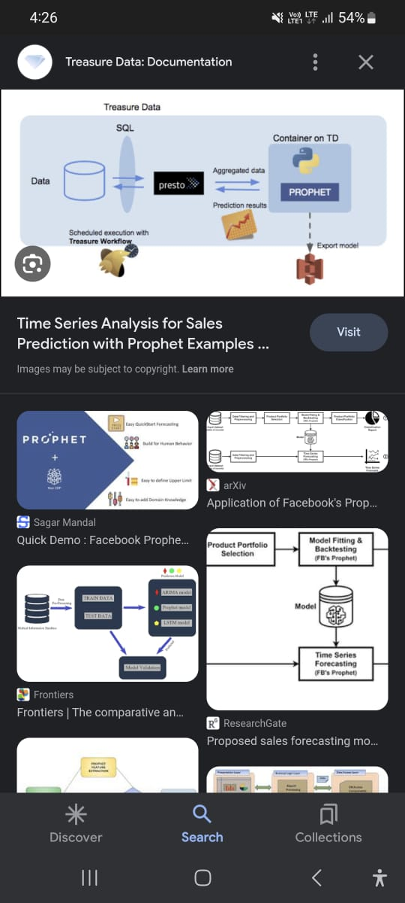

**6. Fitting the Model**: Fit your data to the model and obtain forecasts. You can also specify the number of periods into the future you want to forecast.

**7. Visualize Results:** Plot the historical data, forecast, and uncertainty intervals to visualize the predictions.

**8. Performance Evaluation:** Use appropriate metrics like MAE, RMSE, or MAPE to assess the accuracy of your forecasts. Adjust the model and parameters as needed to improve accuracy.

**9. Iterate and Refine:** Forecasting is often an iterative process. You may need to refine your model by adjusting parameters and retraining it as more data becomes available.

**10. Deployment:** Once you're satisfied with the model's performance, you can deploy it to make real-time predictions or use it to plan inventory and resources.

Prophet simplifies the forecasting process and is a good choice for business users who may not have extensive data science expertise. However, remember that no model is perfect, and it's crucial to monitor and update your forecasts regularly to adapt to changing market conditions.

**Long Short-Term Memory (LSTM):**

Long Short-Term Memory (LSTM) is a powerful type of recurrent neural network (RNN) that can be used for time series forecasting, including future sales prediction. Here's how you can use LSTM for sales forecasting:

**1. Data Preparation:**

- Gather historical sales data, including timestamps and sales values.

- Split the data into training and testing sets. The training set is used to train the LSTM model, and the testing set is used to evaluate its performance.

**2. Data Preprocessing:**

- Normalize or scale your data to ensure that it falls within a reasonable range.

- You can also handle missing data and outliers if necessary.

**3. LSTM Model Architecture:**

- Build an LSTM model using a deep learning framework like TensorFlow or PyTorch.

- You may choose the number of LSTM layers and the number of neurons in each layer based on the complexity of your data.

**4. Sequence Data:**

- LSTM models require sequence data. You can create sequences of sales data with a fixed number of time steps as input and the next time step as the output.

**5. Training:**

- Train the LSTM model using your training data. You'll need to specify the number of epochs, batch size, and a loss function.

- Monitor the model's performance on the validation set to avoid overfitting.

**6. Model Evaluation:**

- Evaluate the model's performance on the testing set using metrics like Mean Absolute Error (MAE) or Root Mean Squared Error (RMSE).

**7. HyperparameterTuning:**

- You can experiment with different hyperparameters, model architectures, and optimization techniques to improve forecasting accuracy.

**8. Forecasting:**

- Once the model is trained and evaluated, you can use it to make future sales predictions. Input the most recent data to predict future sales values.

**9. Visualization:**

- Visualize the model's predictions and compare them to actual sales data to assess the quality of the forecasts.

**10. Monitoring and Maintenance:**

- Continuously monitor the model's performance and update it as more sales data becomes available. LSTM models can adapt to changing patterns over time.

LSTM models are capable of capturing complex patterns and dependencies in time series data, making them a popular choice for sales forecasting. However, they may require more data and computational resources compared to traditional methods like ARIMA or Prophet. It's important to keep in mind that the success of your LSTM model depends on proper data preprocessing, architecture design, and hyperparameter tuning.

**Conclusion:**

Prophet is a user-friendly and efficient tool for time series forecasting, especially when dealing with data that has strong seasonal and holiday components. In contrast, LSTM is a more powerful but complex method, best suited for cases where there are intricate dependencies and ample data available. The choice between these techniques depends on the specific characteristics of time series data and resources.