#include <iostream>

ธนพล สิทธิมาศ

6706021410249

using namespace std;

int main() {

    string input;

    int Upper = 0;

    int Lower = 0;

    int Spaces = 0;

    int Special = 0;

    cout << "Enter message: ";

    getline(cin, input);

    for (char c : input) {

        // Check for uppercase letters

        if (c >= 'A' && c <= 'Z') {

            Upper++;

        }

        // Check for lowercase letters

        else if (c >= 'a' && c <= 'z') {

            Lower++;

        }

        // Check for spaces

        else if (c == ' ') {

            Spaces++;

        }

        // Everything else is considered special characters

        else {

            Special++;

        }

    }

        cout << "Your message has " << Upper << " Upper case characters\n";

        cout << "Your message has " << Lower << " Lower case characters\n";

        cout << "Your message has " << Spaces << " Space characters\n";

        cout << "Your message has " << Special << " Special characters\n";

}

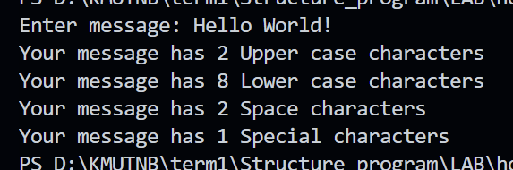

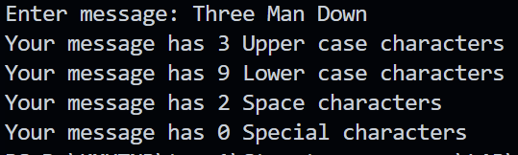

#include <iostream>

using namespace std;

int main()

{

int s,x1,x2;

cout << "Enter your x1 : ";

cin >> x1;

cout << "Enter your s : ";

cin >> s;

if ( s > -1000 && x1 > -1000 && s < 1000 && x1 < 1000)

  {

    x2 = (s \* 2) - x1 ;

    cout << x2;

  }else{

    cout << "Please enter number between -1000 to 1000 ";

  }

}

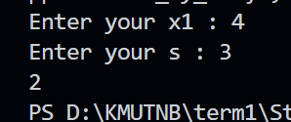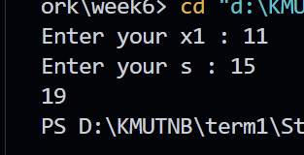

#include <iostream>

using namespace std;

int main() {

    int position = 0;

    cout << "What do you see cups move (Ex. AABCC): ";

    string moves;

    cin >> moves;

    for (char move : moves) {

        switch (move) {

            case 'A':

                if (position == 0) {

                    position = 1;

                } else if (position == 1) {

                    position = 0;

                }

                break;

            case 'B':

                if (position == 1) {

                    position = 2;

                } else if (position == 2) {

                    position = 1;

                }

                break;

            case 'C':

                if (position == 0) {

                    position = 2;

                } else if (position == 2) {

                    position = 0;

                }

                break;

            default:

                cout << "Somehing went wrong: " << move << endl;

        }

    }

    string positions[] = {"Left", "Mid", "Right"};

    cout << "ball is in " << positions[position] << " cup" << endl;

}

