#include <iostream>

นาย ธนพล สิทธิมาศ

6706021410249

using namespace std;

int main() {

    int number;

    cout << "Enter five numbers: ";

    for (int i = 0; i < 5; i++) {

        cin >> number;

        cout << number << " : ";

        for (int j = 0; j < number; j++) {

            cout << "*";

        }

        cout << endl;

    }

}

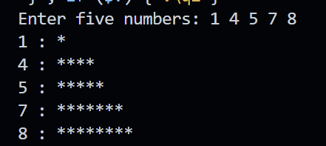

#include <iostream>

using namespace std;

int main() {

    int n,i;

    bool isPrime = true;

    cout << "Enter a number: ";

    cin >> n;

    if (n <= 1) {

        isPrime = false;

    } else {

        for (int i = 2; i < n; i++) {

            if (n % i == 0) {

                isPrime = false;

                break;

            }

        }

    }

    if (isPrime) {

        cout << n << " is a prime number." << endl;

    } else {

        cout << n << " is not a prime number." << endl;

    }

}

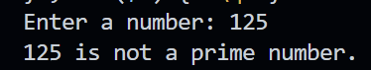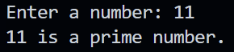

#include <iostream>

using namespace std;

int main(){

    int host_num,player;

    cout << "Host please enter number :";

    cin >> host_num;

    cout << endl ;cout << endl ;cout << endl ;cout << endl ;cout << endl ;cout << endl ;cout << endl ;

//เว้นบรรทัดเยอะๆ เพื่อไม่ให้ผู้ทายเห็นตัวเลขทึคนคิดโจทย์กรอก

    cout << "player guess a number :";

    cin >> player;

    while (player != host_num)

    {

        cout << "please try again:";

        cin >> player;

    }

    if (player == host_num)

    {

        cout << "correct!!";

    }else{

        cout << "something went wrong.";

    }

}

