1. From the circuit diagram, the BTNx is active High or active Low? Please provide your analysis.

Ans. **Active High.** Because from the description and diagram, they generate a low output when at rest (not pressed) and a high output only when they are pressed.

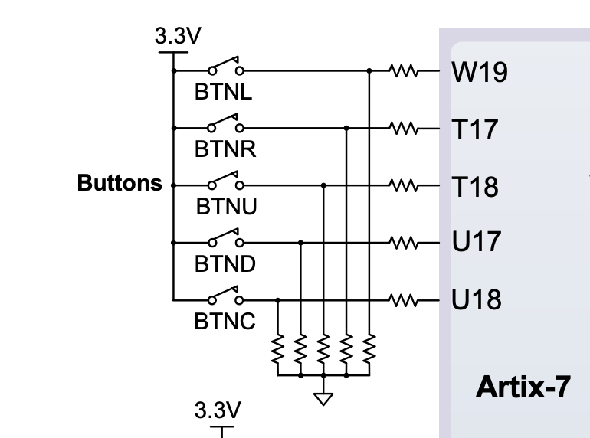

1. What is a bounce? How do you programmatically debounce the input? Please provide your analysis.

Ans.

When we press a button, two metal parts come into contact to short the supply. But they don’t connect instantly but the metal parts connect and disconnect several times before the actual stable connection is made. It’s also happening while releasing the button. This results the false triggering or multiple triggering like the button is pressed multiple times. It’s like falling a bouncing ball from a height and it keeps bouncing on the surface, until it comes at rest.

To debounce the input, we have defined a time variable. Then check that if the signal remains the same value continuously. until the specified time has elapsed. That means the signal is stable enough to read. But if not, wait until the signal is stable.

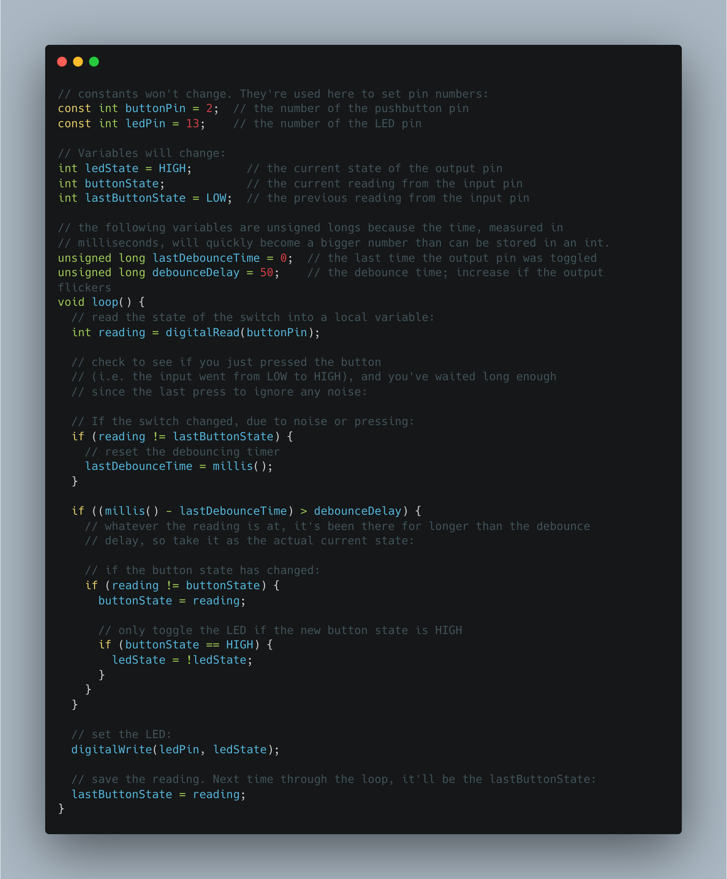

1. Please show your method for implementing a single pulser. (e.g. draw a state diagram, or verilogHDL code)

module singlePulser(

input pushed,

input clk,

output reg out

);

reg state; // 0-unpushed 1-pushed and still pushed

initial state=0;

always @(posedge clk) begin

out=0;

case({pushed,state})

2'b00: ; // do nothing

2'b01: state=0; // reset state to 0

2'b10: begin state=1; out=1; end // out to 1 only one clock

2'b11: ; // do nothing

endcase

end

endmodule