A Cyber-Resilient OTA Firmware Update Simulator for Automotive ECUs

Abstract
Over-the-air (OTA) software updates have become a fundamental component of modern connected vehicles, enabling manufacturers to deploy firmware patches, security updates, and feature enhancements without physical access to the vehicle. However, insecure OTA mechanisms expose Electronic Control Units (ECUs) to risks such as malicious firmware injection, spoofed update sources, and supply-chain attacks. This paper presents a cyber-resilient OTA firmware update simulator that models an OEM update server, a telematics control unit (TCU), and an ECU implementing A/B partition-based rollback protection under adversarial conditions. The proposed simulator evaluates checksum-based integrity verification, spoofed update metadata, malicious firmware delivery, and ECU watchdog-based recovery mechanisms. Experimental observations demonstrate that integrity validation combined with rollback-enabled ECU architectures significantly improves resilience against malicious OTA updates, highlighting the importance of secure update design in automotive software ecosystems.
Keywords
Over-the-Air Updates, Automotive Cybersecurity, ECU Security, Firmware Update, Cyber Resilience, OTA Simulation

1. Introduction
Modern vehicles have evolved into complex, software-defined systems composed of dozens of interconnected Electronic Control Units (ECUs). These ECUs control safety-critical functions such as braking, engine management, steering, and infotainment. As vehicle software complexity increases, manufacturers increasingly rely on Over-the-Air (OTA) updates to deploy bug fixes, security patches, and functional enhancements efficiently across large vehicle fleets [1].
OTA update mechanisms reduce maintenance costs and enable rapid response to newly discovered vulnerabilities. However, they also introduce a significant attack surface. Previous research has shown that insecure OTA channels may allow adversaries to inject malicious firmware, spoof update servers, or manipulate update metadata, potentially leading to ECU compromise or permanent system failure [2][3]. Such attacks are especially concerning in safety-critical automotive environments, where firmware integrity directly impacts vehicle operation and passenger safety.
To mitigate these risks, modern automotive systems employ security mechanisms such as cryptographic integrity verification, authenticated update sources, watchdog timers, and A/B partition-based rollback strategies [4]. Despite these defenses, evaluating the effectiveness of OTA security mechanisms in real vehicles is costly, risky, and often impractical. As a result, simulation-based testbeds have emerged as an important research tool for studying automotive OTA security under controlled conditions [5].
In this paper, we present a cyber-resilient OTA firmware update simulator that models a realistic vehicle update ecosystem, including an OEM server, a TCU, an ECU, and an adversarial update server. The simulator enables controlled experimentation with malicious OTA scenarios and recovery mechanisms, providing insights into the effectiveness of integrity checks and ECU resilience strategies.

2. Related Work
OTA security in automotive systems has been widely studied in recent years. Halder et al. provide a comprehensive survey of OTA software update architectures, security requirements, and threat models in connected vehicles [1]. Their work highlights the importance of authentication, integrity protection, and secure rollback mechanisms in preventing malicious updates.
Several studies have focused on secure OTA protocols and frameworks. ScalOTA proposes a scalable and cryptographically secure OTA update architecture designed to support large vehicle fleets while resisting common attack vectors [6]. Uptane, an industry-adopted framework, emphasizes secure metadata management and compromise-resilient update distribution for automotive environments [7].
Threat modeling approaches for OTA systems have also been explored extensively. Mocnik et al. analyze OTA update attack surfaces using structured threat modeling techniques, identifying spoofed servers and malicious firmware delivery as critical risks [8]. STPA-based security analysis methods have further been applied to OTA systems to systematically identify unsafe control actions and vulnerabilities [9].
In terms of ECU resilience, prior work has demonstrated that dual-bank (A/B) firmware update strategies significantly reduce the risk of permanent ECU failure during faulty or malicious updates [10]. Watchdog-based recovery mechanisms have also been shown to improve fault tolerance in embedded systems by enabling automatic rollback after boot failure [11].
While existing research provides valuable theoretical models and protocol designs, fewer works focus on practical, simulation-based evaluation of OTA attacks and ECU recovery behavior. Automotive cybersecurity testbeds have been proposed to address this gap, enabling experimental validation of security mechanisms without risking real vehicles [12]. Our work builds upon this idea by providing a lightweight yet realistic OTA simulator that integrates adversarial behavior and ECU-level resilience mechanisms.

3. System Overview
The proposed OTA simulator models a simplified but representative automotive update ecosystem. The system consists of four primary components:
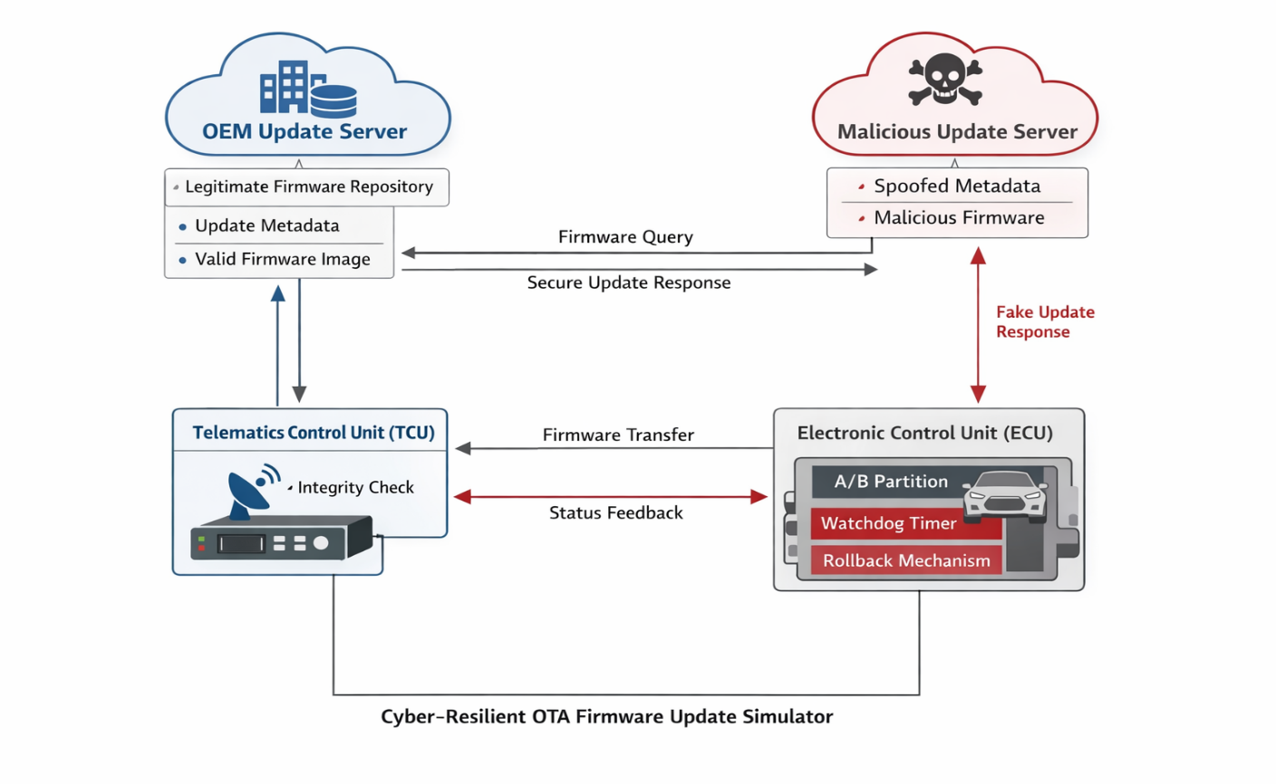
- OEM Update Server: Hosts legitimate firmware updates and provides version metadata and integrity hashes to requesting vehicles.
- Telematics Control Unit (TCU): Acts as the intermediary between external update servers and in-vehicle ECUs. The TCU queries update servers, downloads firmware images, verifies integrity, and transfers validated updates to the ECU.
- Electronic Control Unit (ECU): Simulates a safety-critical ECU implementing A/B partition-based firmware storage and watchdog-based recovery.
- Malicious Update Server: Simulates an adversarial entity that distributes malicious firmware while spoofing legitimate update metadata.
The simulator allows controlled activation and deactivation of security features such as checksum verification and ECU resilience, enabling comparative evaluation of different security configurations.

4. Threat Model
The threat model considered in this work assumes an attacker capable of operating a malicious OTA server that can respond to update requests from the TCU. The attacker attempts to deceive the TCU by spoofing update metadata, including firmware version numbers and claimed source identity, and by providing corrupted or malicious firmware images.
The attacker is assumed not to have physical access to the vehicle but can influence network-based OTA communications. Cryptographic key compromise is not assumed; instead, the attack focuses on weaknesses in update source validation and integrity enforcement. This threat model aligns with previously documented OTA supply-chain and man-in-the-middle attack scenarios [3][8].
The simulator evaluates two primary defense mechanisms: (i) checksum-based integrity verification at the TCU, and (ii) A/B partition-based rollback with watchdog detection at the ECU. The impact of disabling these defenses is analyzed to demonstrate their role in maintaining system resilience.
5. Implementation Details
The OTA firmware update simulator is implemented as a modular, process-based system to closely resemble real-world automotive OTA workflows. Each system component operates as an independent process, communicating through HTTP requests and shared filesystem interfaces to simulate network and in-vehicle communication.
5.1 OEM Update Server
The OEM server is implemented as a lightweight HTTP service that maintains a repository of legitimate firmware images. It responds to update queries by identifying the latest available firmware version and providing corresponding metadata, including version number, filename, and a cryptographic hash of the firmware image. This simulates the role of a manufacturer-managed OTA backend responsible for distributing trusted updates.
Upon receiving an update request from the TCU, the OEM server logs the vehicle identity and returns update metadata. Firmware images are served through a dedicated download endpoint, mimicking real OTA download behavior.
5.2 Malicious Update Server
To evaluate adversarial scenarios, a malicious update server is implemented that intentionally distributes corrupted or malicious firmware images. Unlike the OEM server, the malicious server spoofs update metadata by falsely claiming to be a legitimate source and providing incorrect integrity information. This behavior simulates supply-chain and man-in-the-middle style attacks discussed in prior literature [3][8].
The malicious server enables controlled testing of update source spoofing and integrity bypass attacks without requiring complex cryptographic compromise, allowing the focus to remain on update validation and resilience mechanisms.
5.3 Telematics Control Unit (TCU)
The TCU acts as the decision-making entity in the OTA process. It periodically queries both the OEM and malicious servers for available updates and compares the received version information against the currently installed firmware version. If a newer version is detected, the TCU downloads the firmware image from the corresponding server.
Integrity verification is performed using checksum comparison between the downloaded firmware and the checksum advertised by the server. This security feature can be enabled or disabled to study its impact. After successful verification, the firmware image is transferred to the ECU through a shared interface, and the TCU awaits an acknowledgment indicating update success or failure.
5.4 Electronic Control Unit (ECU)
The ECU component simulates a safety-critical embedded controller using an A/B partition-based firmware storage model. One partition contains the active firmware image, while the second serves as an inactive update target. Incoming firmware updates are written to the inactive partition.
After flashing, the ECU simulates a reboot and attempts to boot from the updated partition. If a failure or malicious condition is detected, a watchdog mechanism triggers a rollback to the previously known-good partition, provided resilience is enabled. The ECU then sends an acknowledgment status back to the TCU, enabling rollback awareness at the system level.

6. Experimental Evaluation
The simulator was evaluated under multiple scenarios to assess the effectiveness of integrity verification and ECU resilience mechanisms. Each experiment was conducted by triggering OTA update checks and observing system behavior through event logs and acknowledgment responses.
6.1 Legitimate Update Scenario
In the baseline scenario, the OEM server provided a valid firmware update with correct integrity metadata. The TCU successfully downloaded and verified the firmware image before transferring it to the ECU. The ECU flashed the firmware to the inactive partition, rebooted successfully, and committed the updated partition as active.
This scenario demonstrates normal OTA operation and validates the functional correctness of the simulator.
6.2 Malicious Update with Integrity Verification Enabled
In this scenario, the malicious server advertised a higher firmware version and provided corrupted firmware with falsified metadata. With checksum verification enabled at the TCU, the integrity mismatch was detected during validation. The firmware was discarded before reaching the ECU, preventing compromise.
This result confirms that integrity verification at the TCU is an effective first line of defense against malicious OTA updates, consistent with prior findings [1][6].
6.3 Malicious Update with Integrity Verification Disabled
When checksum verification was disabled, the TCU accepted the malicious firmware and transferred it to the ECU. Upon attempting to boot from the updated partition, the ECU detected abnormal behavior associated with the malicious firmware.
If ECU resilience was enabled, the watchdog mechanism initiated a rollback to the previously active partition, restoring normal operation. A failure acknowledgment was sent to the TCU, indicating unsuccessful update application.
6.4 Malicious Update with Resilience Disabled
In the most severe scenario, both checksum verification and ECU resilience mechanisms were disabled. The ECU accepted and committed the malicious firmware, resulting in a persistent compromised state. The system failed to recover automatically, simulating an ECU bricking condition.
This experiment highlights the critical role of layered defenses and demonstrates how the absence of rollback mechanisms can lead to catastrophic failure in automotive systems [10][11].

Comparison of OTA Update Scenarios and System Outcomes
Scenario ID | Update Source | TCU Integrity Check | ECU Resilience (A/B + Watchdog) | Observed Outcome | Security Impact
S1 | OEM Server | Enabled | Enabled | Firmware verified, flashed, and booted successfully | Normal and secure OTA update
S2 | OEM Server | Disabled | Enabled | Firmware installed successfully | Functional but reduced security assurance
S3 | Malicious Server (Spoofed) | Enabled | Enabled | Checksum mismatch detected; update rejected | Attack prevented at TCU level
S4 | Malicious Server (Spoofed) | Disabled | Enabled | Malicious firmware installed; boot failure detected; rollback executed | System recovered via ECU resilience
S5 | Malicious Server (Spoofed) | Disabled | Disabled | Malicious firmware installed; ECU stuck on corrupt partition | ECU compromised / bricked
S6 | Malicious Server (Spoofed) | Enabled | Disabled | Malicious firmware blocked before ECU | TCU-level protection sufficient
S7 | No Update Available | Enabled | Enabled | No update performed | Stable system state
S8 | Malformed Firmware | Enabled | Enabled | Integrity verification failed | Safe rejection

7. Discussion
The experimental results demonstrate that OTA security must be approached as a layered problem rather than relying on a single defense mechanism. Integrity verification at the TCU effectively blocks many attacks early in the update process; however, it is insufficient on its own if compromised or disabled.
ECU-level resilience mechanisms, particularly A/B partitioning and watchdog-based rollback, provide an essential safety net by preventing permanent system failure even when malicious firmware reaches the ECU. These findings align with existing research advocating for dual-bank update strategies in safety-critical embedded systems [10].
The simulator also illustrates the importance of accurate source validation. Spoofed metadata from malicious servers can mislead update clients if trust assumptions are weak. This reinforces the need for authenticated update frameworks such as Uptane in real-world deployments [7].
While simplified, the simulator provides a practical platform for evaluating OTA security behaviors and understanding failure modes without the risks associated with real vehicle testing.

8. Conclusion and Future Work
This paper presented a cyber-resilient OTA firmware update simulator designed to model realistic automotive update workflows under adversarial conditions. By integrating an OEM server, a TCU, a malicious update server, and an ECU with A/B partition-based rollback, the simulator enables controlled experimentation with OTA security mechanisms and attack scenarios.
Experimental evaluation demonstrated that checksum-based integrity verification and ECU-level resilience mechanisms significantly improve system robustness against malicious OTA updates. In particular, A/B partitioning combined with watchdog-based rollback effectively prevents permanent ECU failure, even when malicious firmware is delivered.
Future work will extend the simulator to include cryptographic authentication mechanisms, such as signed metadata and certificate-based trust models. Additional enhancements may include CAN or SOME/IP-based in-vehicle communication simulation, multi-ECU update coordination, and integration with intrusion detection systems for real-time attack detection.
References
[1] M. Halder, M. Conti, and S. B. Mokhtar, “Secure Over-the-Air Software Updates in Connected Vehicles: A Survey,” arXiv preprint arXiv:1904.00685, 2019.
[2] S. Ghosal, A. Das, and S. Roy, “Secure Over-the-Air Software Update for Connected Vehicles,” arXiv preprint arXiv:2208.07338, 2022.
[3] R. Mocnik, “Vehicular Over-the-Air Software Upgrade Threat Modelling,” University of Warwick, Tech. Rep., 2023.
[4] K. Shoker, D. Basin, and R. Schmid, “ScalOTA: Scalable Secure Over-the-Air Software Updates for Vehicles,” arXiv preprint arXiv:2307.02032, 2023.
[5] M. Ring, D. Schlör, D. Landes, and A. Hotho, “A Survey of Network-Based Intrusion Detection Data Sets,” IEEE Access, vol. 7, pp. 104 208–104 235, 2019.
[6] J. Woo, D. Kim, and H. Lee, “Man-in-the-Middle Attacks on Automotive Over-the-Air Update Systems,” arXiv preprint arXiv:2105.08905, 2021.
[7] J. Cappos, J. Samuel, S. Baker, and J. H. Hartman, “Uptane: Secure Software Updates for Automobiles,” in Proc. USENIX Security Symposium, 2018.
[8] Y. Yu, J. Zhu, and X. Wang, “STPA-Based Security Analysis of In-Vehicle Diagnostic and OTA Update Systems,” arXiv preprint arXiv:2006.09108, 2020.
[9] H. Kim, J. Lee, and S. Park, “Reliable Firmware Updates Using Dual-Bank Memory for Embedded Systems,” IEEE Embedded Systems Letters, vol. 10, no. 3, pp. 89–92, 2018.
[10] J. Lee and D. Shin, “Secure and Reliable Firmware Updates for Embedded Systems,” ACM Transactions on Embedded Computing Systems, vol. 16, no. 5s, pp. 1–23, 2017.
[11] J. Han, K. Lee, and S. Kim, “Watchdog-Based Fault Recovery Mechanisms for Embedded Systems,” IEEE Embedded Systems, vol. 8, no. 4, pp. 36–45, 2016.
[12] A. Hoppe, S. Kiltz, and J. Dittmann, “Security Threats to Automotive CAN Networks—Practical Examples and Selected Short-Term Countermeasures,” SAE International Journal of Passenger Cars – Electronic and Electrical Systems, vol. 4, no. 1, pp. 235–248, 2011.
[13] T. Checkoway et al., “Comprehensive Experimental Analyses of Automotive Attack Surfaces,” in Proc. USENIX Security Symposium, 2011.
[14] J. Tian, L. Xu, and Y. Chen, “Firmware Tampering Attacks on Vehicles and Their Countermeasures,” IEEE Internet of Things Journal, vol. 9, no. 3, pp. 2104–2116, 2022.
[15] M. Kwon, J. Park, and H. Kim, “Software Supply Chain Attacks in Cyber-Physical Systems,” arXiv preprint arXiv:2002.12312, 2020.
[16] F. Sommer and F. Dressler, “Simulation Frameworks for Automotive Network Security Testing,” in Proc. IEEE Vehicular Networking Conference (VNC), 2018.
[17] J. Lee, S. Park, and H. Kim, “Design of OTA Update Testbeds for Connected Vehicles,” in Cyber-Physical Systems Security, Springer, 2021, pp. 137–156.
[18] M. De Vincenzi, L. Ferretti, and A. Castiglione, “Contextualizing Security and Privacy of Software-Defined Vehicles,” arXiv preprint arXiv:2411.10612, 2024.
[19] S. Park, J. Kim, and D. Lee, “Implementation and Evaluation of ECU Firmware OTA Reliability,” International Journal of Automotive Technology, vol. 23, no. 4, pp. 789–801, 2022.
[20] AUTOSAR Consortium, “Secure Onboard Communication and Software Update,” AUTOSAR Technical Report, 2021.

