Prototype Technology

For

Future HCI

ICT116

Josie C. Calfoforo

Kristy La-anan

BSCS 3-A

The recent developments in technology have made noteworthy positive impacts on the human-computer interaction (HCI).

Incridible Prototypes that show the future of human-computer interaction.

#### HOLOFLEX

#### Holoflex is the next generation of that screen: a flexible smartphone that you bend to interact with. The Holoflex is capable of achieving this neat trick by projecting 12-pixel-wide circular “blocks” through more than 16,000 fisheye lenses. It’s really low resolution right now (160 x 104–less than the original Apple II), but give this technology five years, and we might all be walking around with holographic iPhones.

#### Holoflex—World's first holographic flexible smartphone (w/ Video)

#### SPARSELIGHT

Augmented reality headsets like Microsoft’s HoloLens allow wearers to see the physical and the digital at the same time, but the lenses they depend on have such small field of view that it’s easy for the effect to be ruined. The idea is that you can augment the field of view in head-mounted displays by putting cheap grids of LEDs in the peripheral of a user’s vision. SparseLight technology can be applied to both virtual reality headsets and augmented reality headsets to increase immersion, and Microsoft Research even reckons it can help cut down on some of the motion sickness problems users experience when wearing these headsets too.

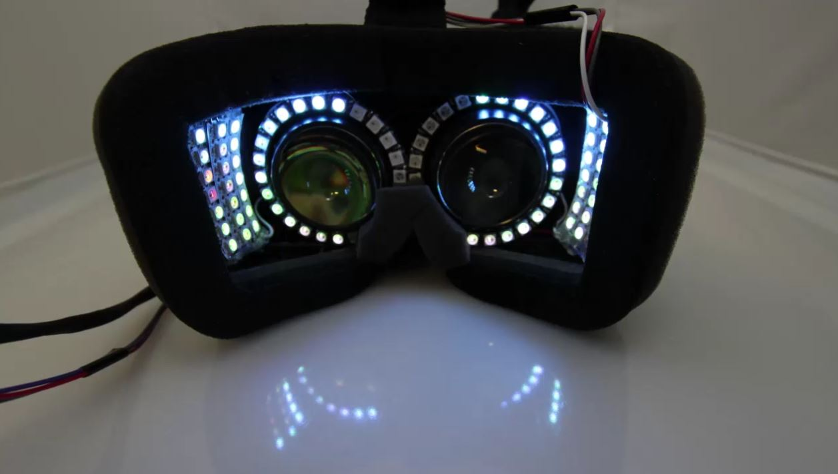

#### SKINTRACK

SkinTrack is a new technology developed by the Human-Computer Interaction Institute’s Future Interfaces Group, which expands your smartwatch’s “touchscreen” over your entire hand and arm–just by wearing a specially designed ring.

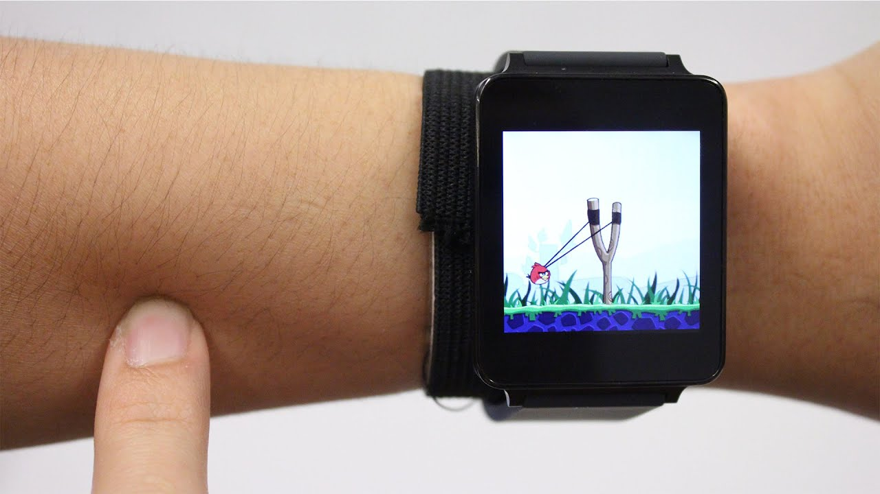

#### PAPERID

#### Researchers from the University of Washington, Disney Research, and Carnegie Mellon University have figured out how to do that, giving a piece of paper the ability to sense its surroundings and respond to gesture commands, as well as connect to the Internet of Things. [It’s called PaperID](http://www.eurekalert.org/pub_releases/2016-05/uow-pg051116.php), and it uses a printable antenna. The possibilities are fascinating: Imagine a physical book that is linked to your Kindle e-book, so that turning a page in the real world also turns the page on your e-reader.

#### PaperID: A Technique for Drawing Functional Battery-Free Wireless Interfaces on Paper – Ubicomp Lab – Ubiquitous Computing Lab at the University of Washington

#### PRE-TOUCH

It showed off a new type of smartphone that can detect how it’s being gripped, and also detect when a finger is approaching the screen. This could open up some amazing new UI possibilities in mobile by improving the precision of tapping on small on-screen elements, and dynamically adjusting what on-screen interface a user sees according to how they’re holding their device–or if a finger is approaching the screen.

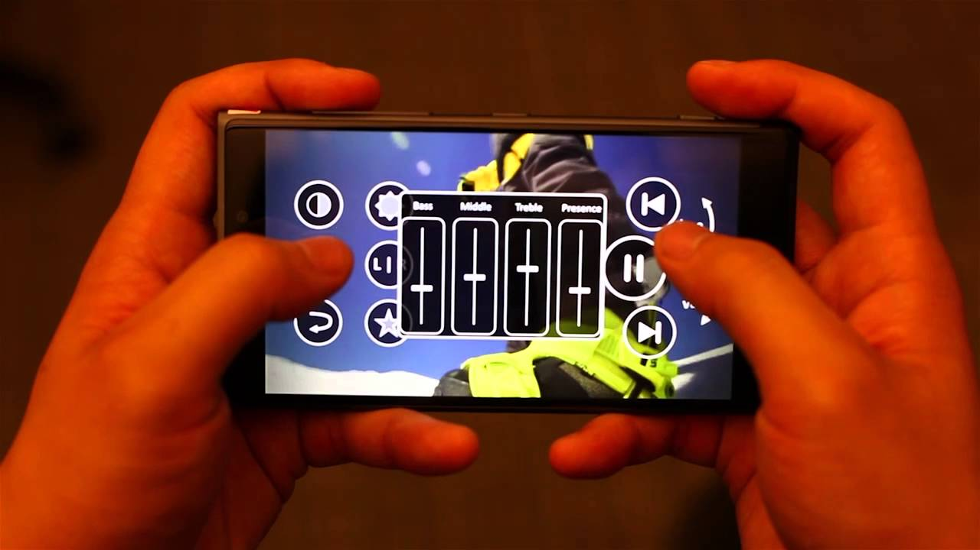

#### DEXTA HAPTIC GLOVES

Upon entering virtual reality, Dexta’s Dexmo Gloves simulate feedback by locking and unlocking finger joints when you try to touch digital objects with varying degrees of force. Using this relatively simple technique, the gloves can simulate haptic sensations such as hardness, springiness, softness, and more.

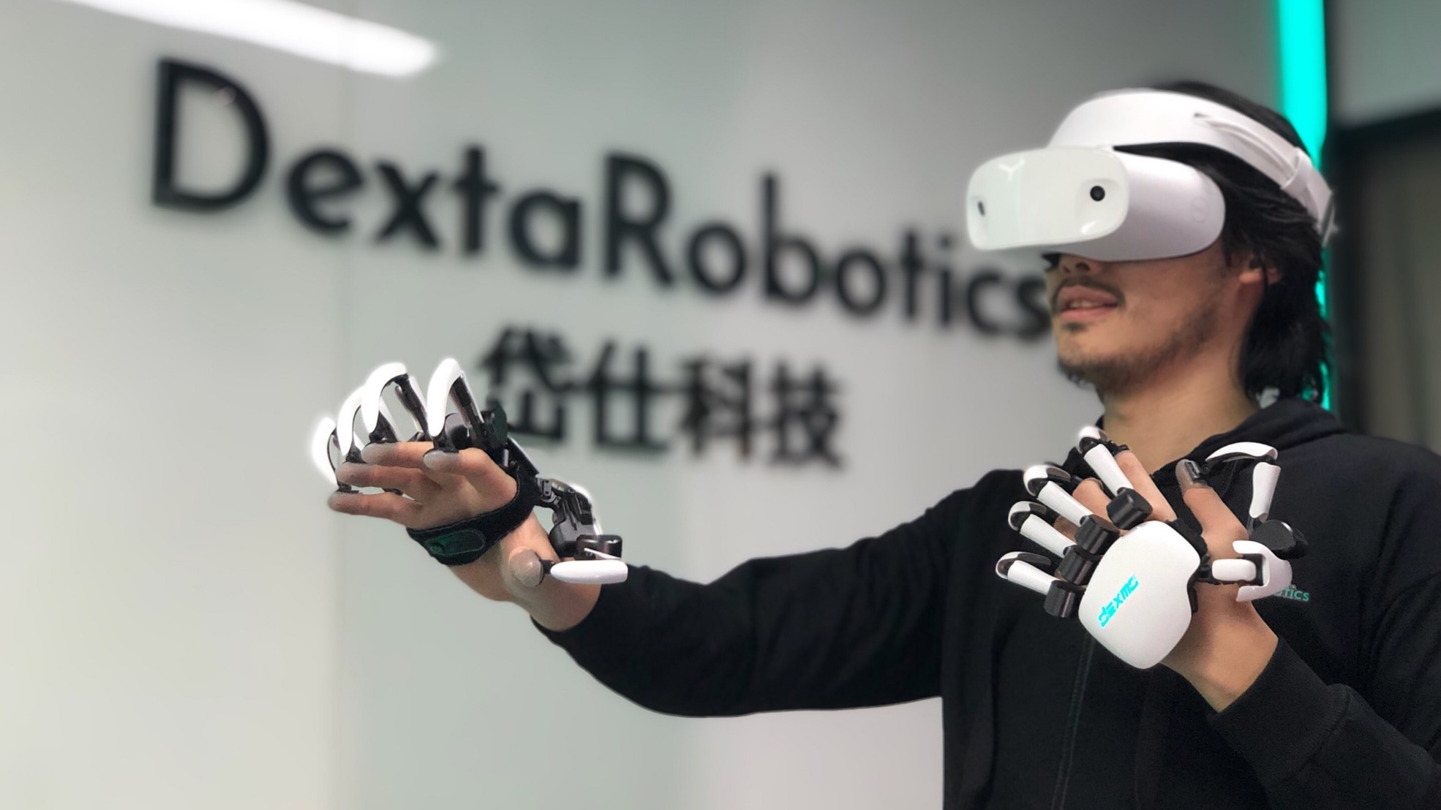

# **Virtual reality (VR) and augmented reality (AR):**

VR is a three-dimensional computer-generated environment which a person can [explore and interact with](https://prescouter.com/2017/11/virtual-reality-painkiller/). It is an [overlay of virtual content on the real world](https://prescouter.com/2017/01/augmented-reality-revolution/) through computer programs/interface. Through AR, one can enhance/augment the real world environment with a virtual environment (such as information from the web). For example, pointing your smartphone at the Eiffel Tower might automatically “pop up” information about the landmark and surrounding areas.

