Compare the following:

1. A paperback and an ebook
2. 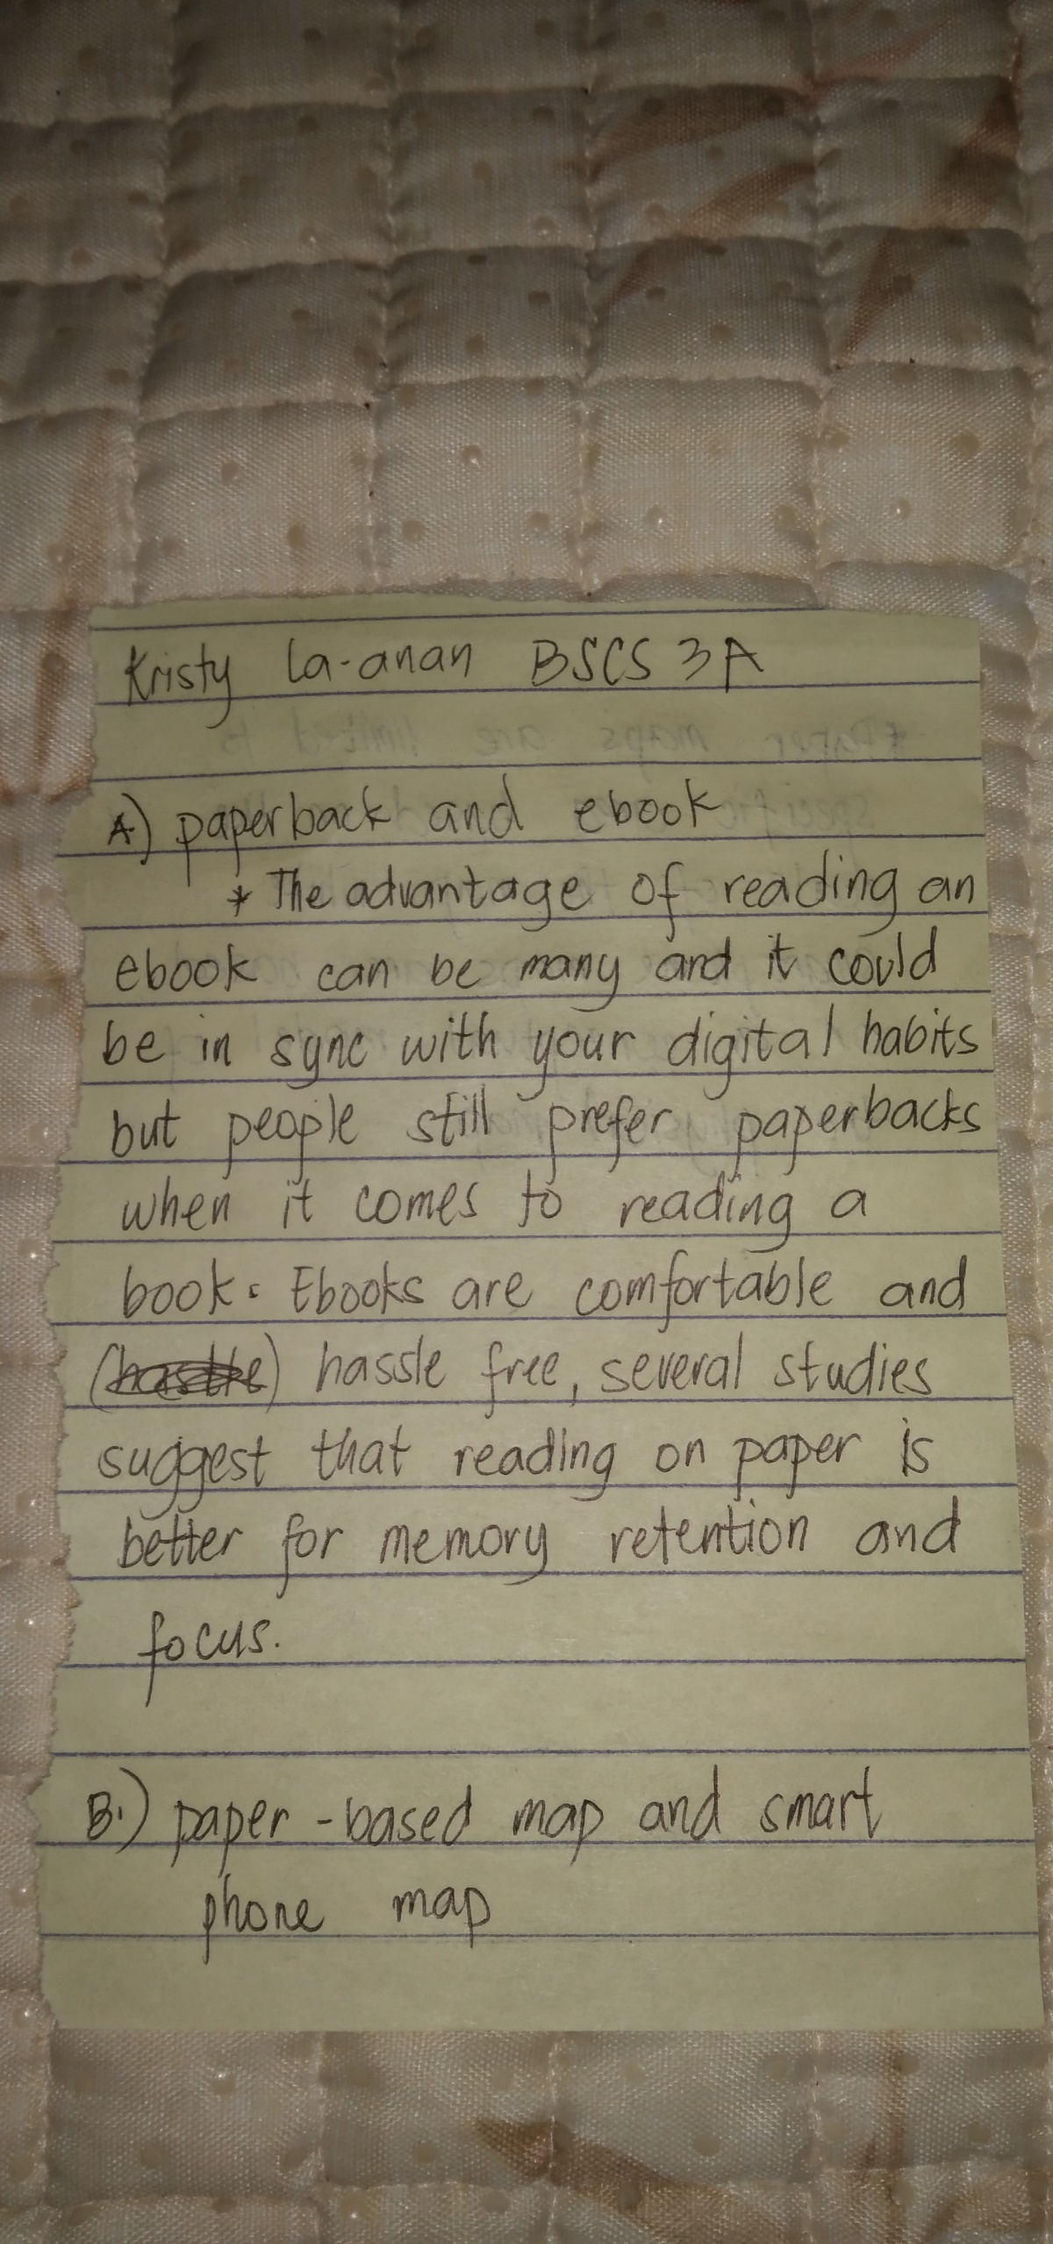A paper-based map and a smartphone

