ASSIGNMENT-3

Name: Naga Thanay Kancharla

ID:16342917

1. Set a seed (to ensure work reproducibility) and take a random sample of 25 observations andfind the mean Glucose and highest Glucose values of this sample and compare these statistics with the population statistics of the same variable.

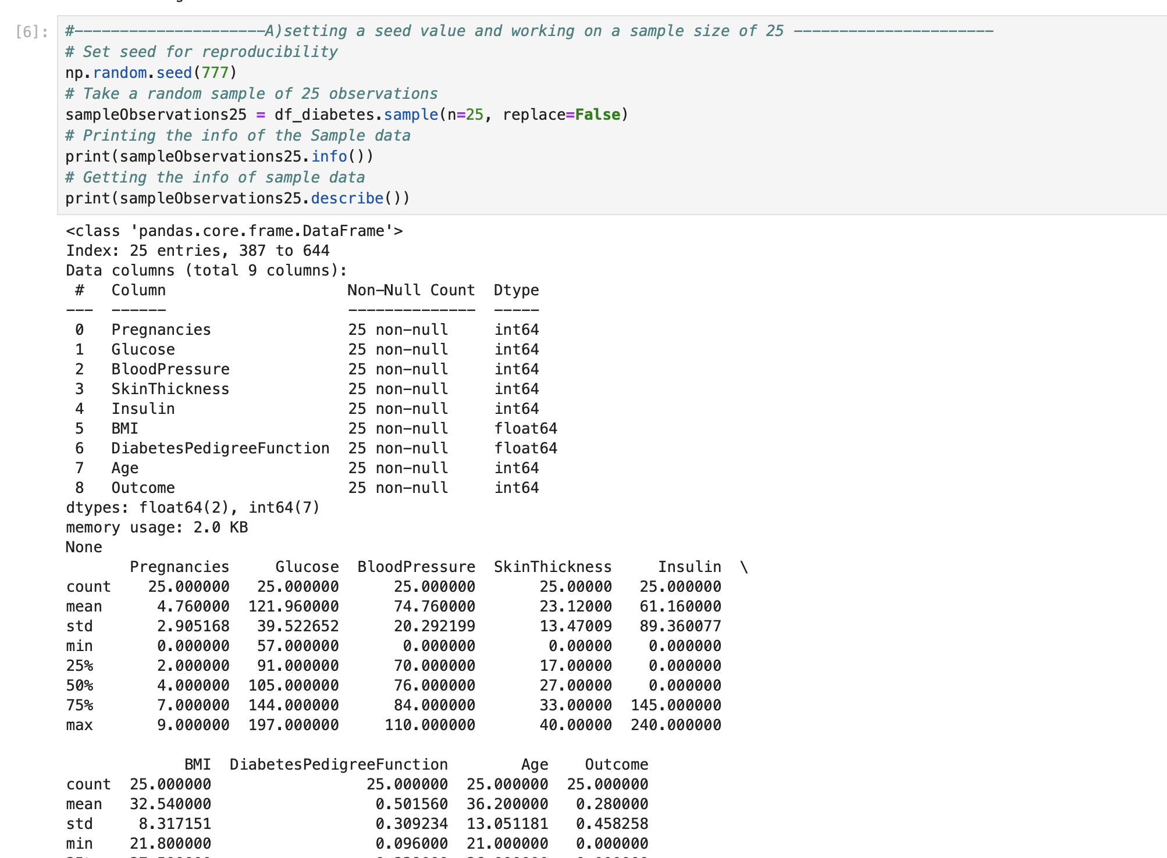

1. The 98th percentile of BMI of your sample and the population and compare the results

using charts

The 98th percentile value of BMI for the population and sample size of 25 are almost similar i:e 47.53and 51.59

1. Using bootstrap (replace= True), create 500 samples (of 150 observation each) from the

population and find the average mean, standard deviation and percentile for BloodPressure and

compare this with these statistics from the population for the same variable. Again, you should

create charts for this comparison

