1. Summary
This report provides a comprehensive overview of the data engineering architecture designed to support the Employee Analytics Platform. The system integrates workforce scheduling, certification tracking, and employee reference data into a unified analytical environment, enabling operational visibility and AI-assisted querying through a conversational chatbot interface.

The architecture follows a modern, layered data warehouse pattern built on Snowflake, with automated ingestion pipelines, structured transformations, and a semantic model that powers a Snowflake Cortex Analyst-backed Streamlit application.

2. Architecture Overview
The platform is structured across five distinct layers, each serving a specific role in the data lifecycle:

Layer | Description
Data Sources | Raw input data from Microsoft Outlook, CSV spreadsheets, and employee reference files.
Data Ingestion | GitHub Actions-triggered pipeline executing Python ETL scripts for cleaning and transformation.
Raw Layer | Unprocessed Snowflake tables: Schedule_Raw, Certification_Raw, Employee_Raw.
Curated Layer | Business-ready fact and dimension tables derived from raw data.
Semantic Layer | YAML-based semantic model exposing curated tables to the AI layer.
AI & Application Layer | Snowflake Cortex Analyst + Streamlit chatbot for natural language querying.

3. Data Sources
The platform ingests data from three primary sources:

- Microsoft Outlook Calendar / Schedule Data — Employee meeting and calendar events used to derive scheduling metrics and load analysis.
- Certification Spreadsheet / CSV — Structured records of employee technology certifications, including validity periods, costs, and expiration statuses.
- Employee Tech Team Reference CSV — A canonical employee reference file containing identity, contact, and employment status information.

4. Data Ingestion Pipeline
The ingestion pipeline is automated via GitHub Actions, which serves as the orchestration layer. Upon trigger, the workflow executes a series of Python ETL scripts responsible for:

- Extracting data from source systems and files.
- Cleaning and standardising raw records (name normalisation, date formatting, deduplication).
- Transforming data into structured formats suitable for loading into Snowflake raw tables.

This approach provides version-controlled, reproducible pipeline execution with full audit trails via Git history.

5. Snowflake Data Warehouse

5.1 Raw Layer
The raw layer stores ingested data in its lightly processed state, preserving source fidelity. Three tables are maintained:

- Schedule_Raw — Calendar and meeting event data from Outlook.
- Certification_Raw — Technology certification records per employee.
- Employee_Raw — Employee identity and employment status records.

5.2 Curated Layer
The curated layer applies business logic, joins, and aggregations to produce analytics-ready tables. The following four tables are defined:

Table Name | Description
FACT_SCHEDULE_MEETINGS | Granular meeting-level records with duration, load percentage, weekday, time of day, load band, and a summary sentence per meeting.
FACT_DAILY_SCHEDULE | Daily aggregated schedule summaries per employee, including total meeting minutes, free time, meeting count, and workload category.
FACT_CERTIFICATIONS | Full certification register per employee with status, expiration, cost, validity years, partner tier, and days until expiry.
DIM_EMPLOYEE | Employee dimension table with identity fields, email, name variants, and employment status for use in joins.

6. Data Model & Relationships
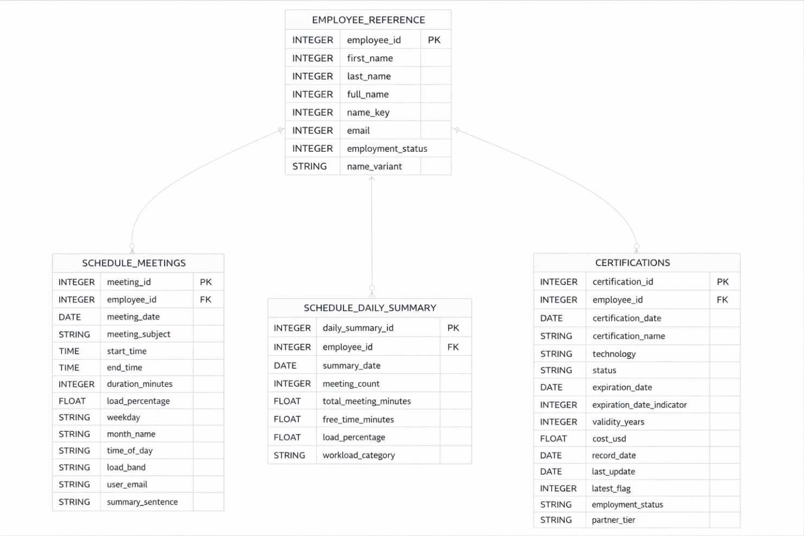

The data model follows a star schema pattern centred on the EMPLOYEE_REFERENCE (DIM_EMPLOYEE) table. The entity relationships are as follows:

Parent Table | Child Table | Join Key | Cardinality
EMPLOYEE_REFERENCE | SCHEDULE_MEETINGS | employee_id | 1 : Many
EMPLOYEE_REFERENCE | SCHEDULE_DAILY_SUMMARY | employee_id | 1 : Many
EMPLOYEE_REFERENCE | CERTIFICATIONS | employee_id | 1 : Many

6.1 EMPLOYEE_REFERENCE
Acts as the central dimension. Key fields include: employee_id (PK), first_name, last_name, full_name, name_key, email, employment_status, name_variant.

6.2 SCHEDULE_MEETINGS
Fact table for individual meeting events. Key fields include: meeting_id (PK), employee_id (FK), meeting_date, meeting_subject, start_time, end_time, duration_minutes, load_percentage, weekday, month_name, time_of_day, load_band, user_email, summary_sentence.

6.3 SCHEDULE_DAILY_SUMMARY
Aggregated daily fact table. Key fields include: daily_summary_id (PK), employee_id (FK), summary_date, meeting_count, total_meeting_minutes, free_time_minutes, load_percentage, workload_category.

6.4 CERTIFICATIONS
Certification fact table with slowly changing dimension (SCD) support. Key fields include: certification_id (PK), employee_id (FK), certification_date, certification_name, technology, status, expiration_date, expiration_date_indicator, validity_years, cost_usd, record_date, last_updated, latest_flag, employment_status, partner_tier, days_until_expiry, as_of_date.

7. Design Considerations
Principle | Implementation
Auditability | GitHub Actions pipelines maintain a full commit history of all ETL runs.
Data Freshness | Automated pipeline scheduling ensures curated tables are kept up to date.
SCD Support | latest_flag and as_of_date fields in CERTIFICATIONS enable point-in-time analysis.
Governance | Semantic model enforces consistent metric definitions across all consumer queries.
Scalability | Snowflake's elastic compute scales with query volume and data growth.
Usability | Streamlit chatbot removes the need for end users to write SQL.

