E-COMMERCE ORDER MANAGEMENT SYSTEM
A DBMS Capstone Project Report submitted in partial fulfillment of the requirements for the award of the degree of
BACHELOR OF TECHNOLOGY
in
ARTIFICIAL INTELLIGENCE AND MACHINE LEARNING
Submitted By
T.DEVESH – 25B11AIA25
S.ANITHA – 25B11AIB17
T.JAYANTH – 25B11AIB70
T.HARSHA – 25B11AIB93
Under the esteemed guidance of
Mrs. G. L. Narasamba Vanguri M.Tech, (Ph.D.)
Assistant Professor


DEPARTMENT OF ARTIFICIAL INTELLIGENCE AND MACHINE LEARNING
ADITYA UNIVERSITY
(Formerly Aditya Engineering College (A))
Aditya Nagar, ADB Road, Surampalem, Andhra Pradesh, India
2026 – 2027


Aditya Nagar, ADB Road, Surampalem, Andhra Pradesh, India
DEPARTMENT OF ARTIFICIAL INTELLIGENCE AND MACHINE LEARNING
CERTIFICATE
This is to certify that the DBMS Capstone Project report entitled “E-Commerce Order Management System” is being submitted by DEVESH (Roll No. 25B11AIA25), ANITHA (Roll No. 25B11AIB17), JAYANTH (Roll No. 25B11AIB70) and HARSHA (Roll No. 25B11AIB93) in partial fulfillment of the requirements for the award of the B.Tech. degree in Artificial Intelligence and Machine Learning. The work documented in this report was carried out as part of the Capstone Project for the course Database Management Systems (2501IT05) during the academic year 2026–2027, and records the database design, implementation, and documentation undertaken by the team.
Project Guide  Mrs. G. L. Narasamba Vanguri, M. Tech, (Ph.D.)  Assistant Professor | Head of the Department  Dr. K. Naga Bhargavi, M. Tech, Ph.D.  Associate Professor & HOD
External Examiner
DECLARATION
We hereby declare that the DBMS Capstone Project entitled “E-Commerce Order Management System” is a genuine work carried out by us. The database design, SQL implementation, queries and documentation presented in this report are our own work, completed under the guidance of Mrs. G. L. Narasamba Vanguri, Department of Artificial Intelligence and Machine Learning, Aditya University, Surampalem. We further declare that this work has not been submitted, in full or in part, for the award of any degree of this or any other educational institution.
Project Associates

R.DEVESH (25B11AIA25)
S.ANITHA (25B11AIB17)
T.JAYANTH (25B11AIB70)
T.HARSHA (25B11AIB93)
Date: 14 September 2026
Place: Surampalem
ACKNOWLEDGEMENT
It is with immense pleasure that we express our indebted gratitude to our project guide, Mrs. G. L. Narasamba, Department of Artificial Intelligence and Machine Learning, who guided us throughout the capstone project. We are thankful for the constant encouragement and valuable suggestions received at every review stage.
We are grateful to Dr. K. Naga Bhargavi, Head of the Department, for inspiring us and for arranging the facilities and resources needed for this project.
We extend our sincere thanks to the Management, Dr. M. Sreenivasa Reddy, Deputy Pro-Chancellor, Dr. M. B.Srinivas, Vice-Chancellor, and Dr. A. Ramesh, Pro Vice-Chancellor (Engineering & Sciences), for providing an excellent academic environment.
Not to forget, we thank the Teaching and Non-Teaching Staff, our parents and our friends, who have directly or indirectly supported us in completing this project on time.
Project Associates

R.DEVESH (25B11AIA25)
S.ANITHA (25B11AIB17)
T.JAYANTH (25B11AIB70)
T.HARSHA (25B11AIB93)
ADITYA UNIVERSITY
Surampalem
Department of Artificial Intelligence and Machine Learning
DBMS CAPSTONE PROJECT
PROJECT DOCUMENTATION REPORT
Project Title: E-Commerce Order Management System
Submitted by:
S.No | Student Name | Roll Number
1 | R.DEVESH | 25B11AIA25
2 | S.ANITHA | 25B11AIB17
3 | T.JAYANTH | 25B11AIB70
4 | T.HARSHA | 25B11AIB93
Course: Database Management Systems (DBMS)
Faculty Coordinator: Mrs. G. L. Narasamba Vanguri
Academic Year: 2026–27
GitHub Repository Link: https://github.com/Thandra-Sriharsha/E-COMMERCE-ORDER-MANAGEMENT-SYSTEM/blob/main/app.py

1. ABSTRACT
The E-Commerce Order Management System is a database-based application designed to efficiently manage and organize the complete order process in an online shopping environment. The system maintains important information related to customers, products, orders, order items, payments, and deliveries in a structured database.
The main objective of the system is to simplify order management and reduce data duplication, errors, and manual work. It allows users to add, update, delete, and retrieve customer and product information, place orders, track order details, and manage payment and delivery information. Various SQL operations such as DDL, DML, DQL, CRUD operations, joins, aggregate functions, views, subqueries, and indexes are used to manage and retrieve the required data efficiently.
The database is designed using appropriate primary keys, foreign keys, constraints, and normalization techniques to maintain data integrity and consistency. The system provides an organized way to handle large amounts of e-commerce data and enables quick access to important information such as customer orders, product details, order status, and total sales.
Overall, the E-Commerce Order Management System provides a reliable, efficient, and scalable solution for managing online orders and related database operations. It demonstrates how database management concepts can be applied to develop a practical real-world e-commerce application.

TABLE OF CONTENTS
Chapter | Title | Page No.
 | Certificate | i
 | Declaration | ii
 | Acknowledgement | iii
 | Project Documentation Report | iv
1 | ABSTRACT | v
 | List of Figures | vii
 | List of Tables | vii
2 | INTRODUCTION | 1
 | 2.1 Background | 1
 | 2.2 Purpose of the Database | 1
3 | PROBLEM STATEMENT | 1
4 | OBJECTIVES | 1
5 | TOOLS & TECHNOLOGIES USED | 1
6 | DATABASE DESIGN | 2
 | 6.1 Identified Entities | 2
 | 6.2 Entity Attributes | 2
 | 6.3 ER Diagram | 3
 | 6.4 Relationships & Cardinality | 3
 | 6.5 Relational Database Schema | 3
 | 6.6 Normalization | 4
7 | DATABASE IMPLEMENTATION | 6
 | 7.1 DDL — Database and Table Creation | 6
 | 7.2 Sample Data — DML | 7
 | 7.3 Constraints & Data Integrity | 7
 | 7.4 SQL Operations & Queries | 7
 | 7.5 Sample Outputs / Screenshots | 8
8 | MODULES & FUNCTIONALITIES | 9
9 | GITHUB REPOSITORY & TEAM RESPONSIBILITIES | 9
10 | ENHANCEMENTS & FUTURE IMPROVEMENTS | 9
11 | CONCLUSION | 9
12 | REFERENCES | 10
 | APPENDIX | 11
 | A. Complete SQL Script | 11
 | B. Additional Screenshots / Outputs | 11

LIST OF FIGURES
Figure No. | Title of the Figure | Page No.
6.3 | ER Diagram | 3
Figure 1 | Customer records / basic SELECT output | 7
Figure 2 | Product filtering / inventory output | 8
Figure 3 | Aggregate or GROUP BY output | 8
Figure 4 | Join or subquery output | 9

LIST OF TABLES
Table No. | Title of the Table | Page No.
5 | TOOLS & TECHNOLOGIES USED | 1
6.1 | Identified Entities | 2
6.2 | Entity Attributes | 2
6.4 | Relationships & Cardinality | 3
6.5 | Relational Database Schema | 3
7.2 | Sample Data — DML | 6
7.3 | Constraints & Data Integrity | 6
7.4 | SQL Operations & Queries | 6
8 | MODULES & FUNCTIONALITIES | 9
9 | GITHUB REPOSITORY & TEAM RESPONSIBILITIES | 9

2. INTRODUCTION

2.1 Background
E-commerce systems handle large amounts of structured information related to customers, products, categories, orders, order items, and payments. A relational database is required to store this information consistently and to maintain relationships between the different records. In this project, the e-commerce domain is represented using six related tables: Customer, Product, Category, Order, OrderItem, and Payment. The schema separates data into appropriate entities and uses keys and constraints to reduce duplication and maintain data integrity. SQL queries are then used to retrieve, update, aggregate, and analyse the stored information.

2.2 Purpose of the Database
The database provides a centralized structure for managing customer details, product information, product categories, order details, ordered items, and payment records. It can support e-commerce administrators and staff who need to retrieve customer and product information, manage orders, track order items, maintain payment details, and generate summary information. The relationships between the tables allow related information to be accessed through SQL joins and subqueries instead of maintaining disconnected records.

3. PROBLEM STATEMENT
Traditional e-commerce record keeping can lead to duplicate customer information, inconsistent product records and difficulty in tracking orders and payments.
The proposed system centralizes customer, product, category, order, order item and payment information into a single relational database.
The system provides structured data management, referential integrity, validation and SQL-based reporting for efficient e-commerce operations.

4. OBJECTIVES
- DESIGN: Design a relational schema containing six related e-commerce entities.
- PROTECT: Implement primary keys, foreign keys, NOT NULL, UNIQUE, CHECK, and DEFAULT constraints for data integrity.
- POPULATE: Populate the database with representative customer, product, category, order, order item, and payment records.
- DEMONSTRATE: Demonstrate SQL retrieval, updates, joins, aggregate functions, GROUP BY/HAVING, and subqueries.
- DOCUMENT: Document the database design, implementation, sample data, queries, and team responsibilities.

5. TOOLS & TECHNOLOGIES USED
Category | Tool / Technology Used
Database Server | SQL-compatible relational database
Query / Admin Tool | SQL client / SQL environment
Front-end (if any) | Not specified in the uploaded project files
Operating System | Not specified in the uploaded project files
Version Control | GitHub

6. DATABASE DESIGN

6.1 Identified Entities
S.No | Entity Name | Description
1 | Customer | Stores customer identity, contact information, address, and account creation details.
2 | Product | Stores product name, category, price, stock quantity, and product status.
3 | Category | Stores product category names and category descriptions.
4 | Order | Stores customer orders, order date, total amount, and order status.
5 | OrderItem | Stores products included in each order, quantities, unit prices, and line totals.
6 | Payment | Stores payment details, payment method, amount, payment date, and payment status.

6.2 Entity Attributes

The Entity and Attribute table describes the main entities and their attributes used in the E-Commerce Order Management System. Each entity represents an important part of the system, while attributes describe the properties or details of that entity.
Entity | Attribute | Data Type | Key (PK/FK/—) | Attribute Type
Customer | CustomerID | INTEGER | PK | Simple
Customer | FirstName | VARCHAR(30) | — | Simple
Customer | LastName | VARCHAR(30) | — | Simple
Customer | Email | VARCHAR(100) | — | Simple
Customer | Phone | VARCHAR(15) | — | Simple
Customer | Address | VARCHAR(150) | — | Simple
Customer | CreatedAt | DATE | — | Derived/Default
Product | ProductID | INTEGER | PK | Simple
Product | CategoryID | INTEGER | FK | Simple
Product | ProductName | VARCHAR(100) | — | Simple
Product | Price | DECIMAL(10,2) | — | Simple
Product | StockQuantity | INTEGER | — | Simple
Product | Status | VARCHAR(20) | — | Simple
Category | CategoryID | INTEGER | PK | Simple
Category | CategoryName | VARCHAR(50) | — | Simple
Category | Description | VARCHAR(200) | — | Simple
Order | OrderID | INTEGER | PK | Simple
Order | CustomerID | INTEGER | FK | Simple
Order | OrderDate | DATE | — | Derived/Default
Order | TotalAmount | DECIMAL(12,2) | — | Simple
Order | Status | VARCHAR(20) | — | Simple
OrderItem | OrderItemID | INTEGER | PK | Simple
OrderItem | OrderID | INTEGER | FK | Simple
OrderItem | ProductID | INTEGER | FK | Simple
OrderItem | Quantity | INTEGER | — | Simple
OrderItem | UnitPrice | DECIMAL(10,2) | — | Simple
Payment | PaymentID | INTEGER | PK | Simple
Payment | OrderID | INTEGER | FK | Simple
Payment | PaymentMethod | VARCHAR(20) | — | Simple
Payment | Amount | DECIMAL(12,2) | — | Simple
Payment | PaymentDate | DATE | — | Derived/Default
Payment | Status | VARCHAR(20) | — | Simple

6.3 ER Diagram
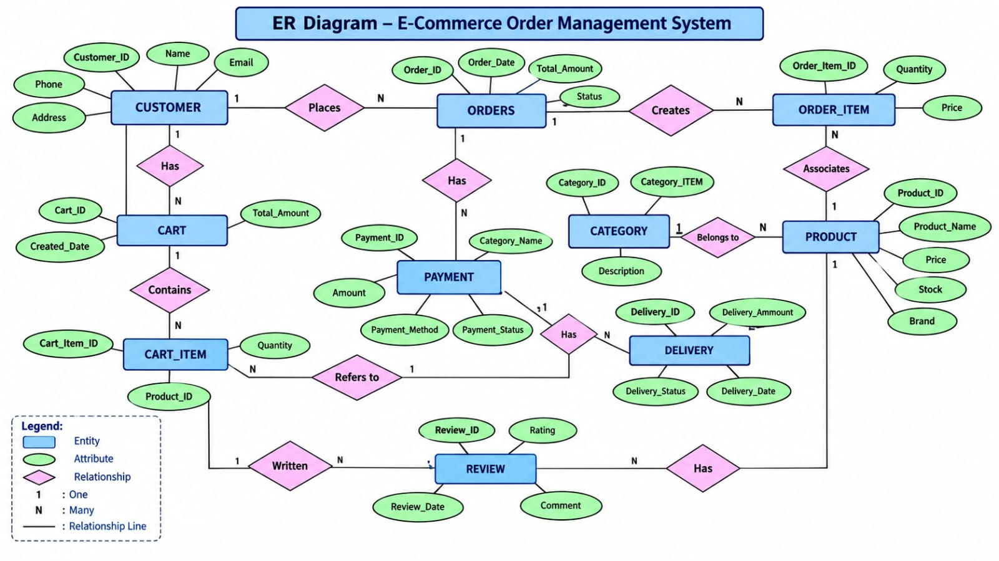
Fig. 6.3: ER Diagram — E-Commerce Order Management System

6.4 Relationships & Cardinality
Entity 1 | Relationship | Entity 2 | Cardinality (1:1 / 1:N / M:N)
Category | contains | Product | 1:N
Customer | places | Order | 1:N
Order | contains | OrderItem | 1:N
Product | appears in | OrderItem | 1:N
Order | has | Payment | 1:N

6.5 Relational Database Schema
Table Name | Column Name | Data Type | PK/FK/— | Constraints
Customer | CustomerID | INTEGER | PK | PRIMARY KEY, NOT NULL
Customer | FirstName | VARCHAR(30) | — | NOT NULL
Customer | LastName | VARCHAR(30) | — | NOT NULL
Customer | Email | VARCHAR(100) | — | NOT NULL, UNIQUE
Customer | Phone | VARCHAR(15) | — | NOT NULL
Customer | Address | VARCHAR(150) | — | NOT NULL
Customer | CreatedAt | DATE | — | DEFAULT CURRENT_DATE
Product | ProductID | INTEGER | PK | PRIMARY KEY, NOT NULL
Product | CategoryID | INTEGER | FK | NOT NULL, FOREIGN KEY → Category
Product | ProductName | VARCHAR(100) | — | NOT NULL
Product | Price | DECIMAL(10,2) | — | NOT NULL, CHECK > 0
Product | StockQuantity | INTEGER | — | NOT NULL, DEFAULT 0, CHECK >= 0
Product | Status | VARCHAR(20) | — | NOT NULL, DEFAULT 'Active'
Category | CategoryID | INTEGER | PK | PRIMARY KEY, NOT NULL
Category | CategoryName | VARCHAR(50) | — | NOT NULL, UNIQUE
Category | Description | VARCHAR(200) | — | NULL allowed
Order | OrderID | INTEGER | PK | PRIMARY KEY, NOT NULL
Order | CustomerID | INTEGER | FK | NOT NULL, FOREIGN KEY → Customer
Order | OrderDate | DATE | — | DEFAULT CURRENT_DATE
Order | TotalAmount | DECIMAL(12,2) | — | NOT NULL, CHECK >= 0
Order | Status | VARCHAR(20) | — | NOT NULL, DEFAULT 'Pending'
OrderItem | OrderItemID | INTEGER | PK | PRIMARY KEY, NOT NULL
OrderItem | OrderID | INTEGER | FK | NOT NULL, FOREIGN KEY → Order
OrderItem | ProductID | INTEGER | FK | NOT NULL, FOREIGN KEY → Product
OrderItem | Quantity | INTEGER | — | NOT NULL, CHECK > 0
OrderItem | UnitPrice | DECIMAL(10,2) | — | NOT NULL, CHECK > 0
Payment | PaymentID | INTEGER | PK | PRIMARY KEY, NOT NULL
Payment | OrderID | INTEGER | FK | NOT NULL, FOREIGN KEY → Order
Payment | PaymentMethod | VARCHAR(20) | — | NOT NULL, CHECK allowed methods
Payment | Amount | DECIMAL(12,2) | — | NOT NULL, CHECK > 0
Payment | PaymentDate | DATE | — | DEFAULT CURRENT_DATE
Payment | Status | VARCHAR(20) | — | NOT NULL, DEFAULT 'Pending'

6.6 Normalization
UNF → 1NF → 2NF → 3NF
UNF: E-commerce information could be represented as a large combined record containing customer, product, category, order, order-item, and payment details.
1NF: The design separates repeating groups and keeps attributes atomic. For example, customer details and product details are stored in separate fields and each order item is stored as a separate record.
2NF: Each entity is separated into its own table with a primary key so non-key attributes depend on the complete key.
3NF: Relationships are represented using foreign keys, so customer, category, product, order, order-item, and payment facts are stored in their appropriate tables rather than being repeatedly duplicated. This reduces update, insertion, and deletion anomalies.

7. DATABASE IMPLEMENTATION

7.1 DDL — Database and Table Creation : In a Database Management System (DBMS), DDL stands for Data Definition Language. It is a subset of SQL commands used to create, modify, and destroy the structure of database objects (like tables, indexes, and views) rather than the actual data stored inside them.
-- Drop tables if they exist
DROP TABLE IF EXISTS Payment;
DROP TABLE IF EXISTS OrderItem;
DROP TABLE IF EXISTS `Order`;
DROP TABLE IF EXISTS Product;
DROP TABLE IF EXISTS Category;
DROP TABLE IF EXISTS Customer;

-- 1. CUSTOMER TABLE
CREATE TABLE Customer (
CustomerID INTEGER PRIMARY KEY,
FirstName VARCHAR(30) NOT NULL,
LastName VARCHAR(30) NOT NULL,
Email VARCHAR(100) NOT NULL UNIQUE,
Phone VARCHAR(15) NOT NULL,
Address VARCHAR(150) NOT NULL,
CreatedAt DATE DEFAULT CURRENT_DATE
);

-- 2. CATEGORY TABLE
CREATE TABLE Category (
CategoryID INTEGER PRIMARY KEY,
CategoryName VARCHAR(50) NOT NULL UNIQUE,
Description VARCHAR(200)
);

-- 3. PRODUCT TABLE
CREATE TABLE Product (
ProductID INTEGER PRIMARY KEY,
CategoryID INTEGER NOT NULL,
ProductName VARCHAR(100) NOT NULL,
Price DECIMAL(10,2) NOT NULL CHECK (Price > 0),
StockQuantity INTEGER NOT NULL DEFAULT 0 CHECK (StockQuantity >= 0),
Status VARCHAR(20) NOT NULL DEFAULT 'Active',
FOREIGN KEY (CategoryID) REFERENCES Category(CategoryID)
);

-- 4. ORDER TABLE
CREATE TABLE `Order` (
OrderID INTEGER PRIMARY KEY,
CustomerID INTEGER NOT NULL,
OrderDate DATE DEFAULT CURRENT_DATE,
TotalAmount DECIMAL(12,2) NOT NULL CHECK (TotalAmount >= 0),
Status VARCHAR(20) NOT NULL DEFAULT 'Pending',
FOREIGN KEY (CustomerID) REFERENCES Customer(CustomerID)
);

-- 5. ORDER ITEM TABLE
CREATE TABLE OrderItem (
OrderItemID INTEGER PRIMARY KEY,
OrderID INTEGER NOT NULL,
ProductID INTEGER NOT NULL,
Quantity INTEGER NOT NULL CHECK (Quantity > 0),
UnitPrice DECIMAL(10,2) NOT NULL CHECK (UnitPrice > 0),
FOREIGN KEY (OrderID) REFERENCES `Order`(OrderID),
FOREIGN KEY (ProductID) REFERENCES Product(ProductID)
);

-- 6. PAYMENT TABLE
CREATE TABLE Payment (
PaymentID INTEGER PRIMARY KEY,
OrderID INTEGER NOT NULL,
PaymentMethod VARCHAR(20) NOT NULL CHECK (PaymentMethod IN ('UPI','Card','Cash on Delivery','Net Banking')),
Amount DECIMAL(12,2) NOT NULL CHECK (Amount > 0),
PaymentDate DATE DEFAULT CURRENT_DATE,
Status VARCHAR(20) NOT NULL DEFAULT 'Pending',
FOREIGN KEY (OrderID) REFERENCES `Order`(OrderID)
);

7.2 Sample Data — DML

Data Manipulation Language (DML) consists of SQL commands used to add, change, remove, and query rows of data inside existing database table.
Table | No. of Records | Sample Data / Screenshot Reference
Customer | 10 | dml.sql — Customer seed records
Category | 6 | dml.sql — Category seed records
Product | 15 | dml.sql — Product seed records
Order | 15 | dml.sql — Order seed records
OrderItem | 30 | dml.sql — Order item seed records
Payment | 15 | dml.sql — Payment seed records

7.3 Constraints & Data Integrity

Constraints are used to maintain accuracy and consistency in the database. Primary Key uniquely identifies records, while Foreign Key connects related tables. NOT NULL prevents empty values, UNIQUE avoids duplicate values, and CHECK prevents invalid data. DEFAULT automatically provides values when they are not entered. These constraints ensure data integrity, reliability, and proper relationships in the E-Commerce Order Management System.
Constraint / Validation | Applied On | Purpose | Evidence / Screenshot
PRIMARY KEY | All six tables | Uniquely identifies each record and prevents duplicate key values. | ddl.sql
FOREIGN KEY | Product, Order, OrderItem, Payment | Maintains valid relationships between related tables. | ddl.sql
NOT NULL | Required fields across tables | Prevents missing values in required attributes. | ddl.sql
UNIQUE | Customer.Email; Category.CategoryName | Prevents duplicate unique identifiers/category names. | ddl.sql
CHECK | Product price/stock, Order amount, OrderItem quantity/price, Payment amount/method | Restricts invalid or out-of-range values. | ddl.sql
DEFAULT | CreatedAt, OrderDate, Product.StockQuantity, Order.Status, PaymentDate, Payment.Status | Provides default values when not explicitly supplied. | ddl.sql

7.4 SQL Operations & Queries
S.No | Operation / Query | Purpose | SQL Query / Screenshot Ref.
1 | Basic SELECT — all customers | Retrieve customer records. | queries.sql Q1
2 | Filtered SELECT — active products | Find active products with available stock. | queries.sql Q2
3 | LIKE filtering | Search products by name or customers by email. | queries.sql Q3
4 | Order lookup | Display details of a selected order. | queries.sql Q4
5 | UPDATE + INSERT | Update product stock and record a related order item. | queries.sql Q5
6 | Order history | Display orders for a customer in descending date order. | queries.sql Q6
7 | SUM aggregate | Calculate total sales value across orders. | queries.sql Q7
8 | COUNT aggregate | Count orders by status. | queries.sql Q8
9 | GROUP BY + aggregates | Calculate product count and average price by category. | queries.sql Q9
10 | GROUP BY + aggregates | Calculate order count and total sales by order status. | queries.sql Q10
11 | JOIN + GROUP BY + HAVING | Find customers whose total order value exceeds a selected amount. | queries.sql Q11
12 | JOIN + GROUP BY + HAVING | Find products ordered more than once. | queries.sql Q12
13 | Subquery | Find products priced above the average product price. | queries.sql Q13
14 | Subquery + ORDER BY + LIMIT | List orders belonging to the highest-value order/customer result. | queries.sql Q14

7.5 Sample Outputs / Screenshots
Figure 1: Customer records / basic SELECT output
Displays customer details retrieved from the Customer table using a basic SELECT query.
It shows customer ID, name, email, phone, address, and creation date.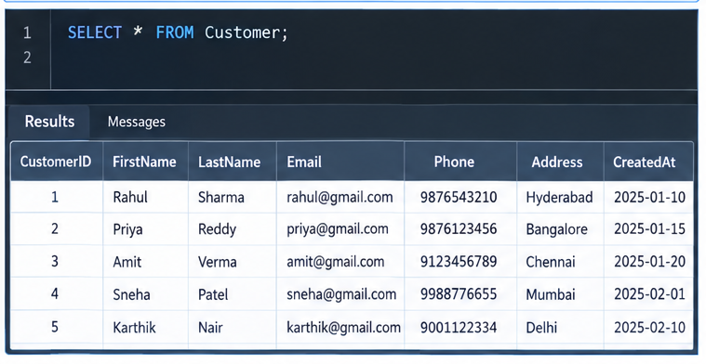

Figure 2: Product filtering / inventory output
Displays active products with their prices and available stock quantities.
The query filters products based on their status and stock availability.
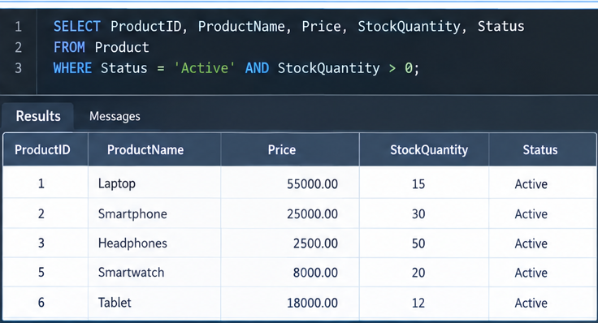

Figure 3: Aggregate or GROUP BY output
Displays summarized product information grouped according to product categories.
Aggregate functions are used to calculate the total number of products and available stock.
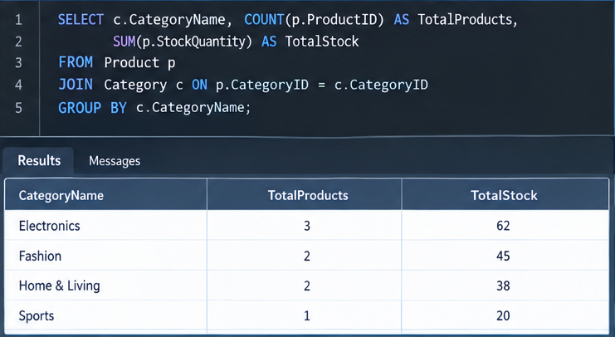

Figure 4: Join or subquery output
Displays combined information from Customer, Order, OrderItem, and Product tables.
The JOIN query helps retrieve complete order details for a particular customer or order.
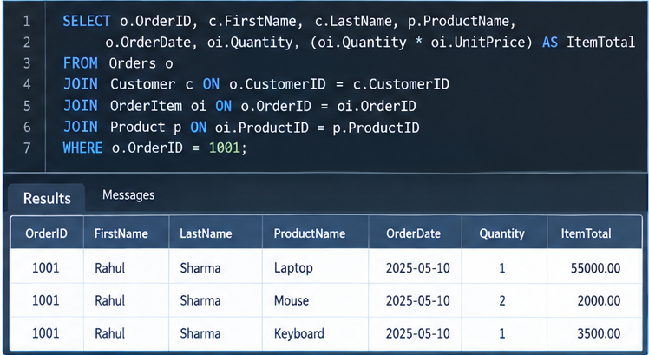

8. MODULES & FUNCTIONALITIES
S.No | Module Name | Functionality
1 | Customer Management | Stores and organizes customer identity, contact information, address, and account creation details.
2 | Category Management | Maintains product categories and their descriptions.
3 | Product Management | Maintains product information including category, price, stock quantity, and status.
4 | Order Management | Stores customer orders, order dates, total amounts, and order status.
5 | Order Item Management | Records the products included in each order, quantities, and unit prices.
6 | Payment Management & Analysis | Stores payment details and supports payment and order analysis through aggregate and grouped SQL queries.

9. GITHUB REPOSITORY & TEAM RESPONSIBILITIES
Repository Link: [Add the E-Commerce Order Management System GitHub repository link]
Student Name | Roll Number | Role / Responsibility | Contribution Status
DEVESH | 25B11AIA25 | [Add role / responsibility] | [Add status]
ANITHA | 25B11AIB17 | [Add role / responsibility] | [Add status]
JAYANTH | 25B11AIB70 | [Add role / responsibility] | [Add status]
HARSHA | 25B11AIB93 | [Add role / responsibility] | [Add status]

10. ENHANCEMENTS & FUTURE IMPROVEMENTS
Future improvements can extend the current database with user authentication and role-based access, richer sales reporting and dashboards, automated stock updates, order tracking, audit logging, stored procedures/triggers where supported, indexing for frequently queried columns, and a front-end interface for e-commerce administrators. These are proposed enhancements unless implemented in the current submission.

11. CONCLUSION
The E-Commerce Order Management System successfully models the main e-commerce entities and their relationships using a relational database structure. The DDL defines six tables with primary keys, foreign keys, NOT NULL, UNIQUE, CHECK, and DEFAULT constraints. The DML supplies representative records for customers, categories, products, orders, order items, and payments. The query section demonstrates selection and filtering, order and product management, joins, aggregate functions, GROUP BY/HAVING, and subqueries. The project therefore meets its core objectives of relational design, data integrity, sample-data population, and practical SQL analysis. The team also divided the work across DDL development, ER/schema design, query development, and documentation/screenshot compilation.

12. REFERENCES
- Uploaded project DDL script: ddl.sql.
- Uploaded project DML/sample-data script: dml.sql.
- Uploaded SQL query script: queries.sql.
- Aditya University — DBMS Capstone Project documentation template.
- GitHub repository: E-Commerce Order Management System (project repository).

APPENDIX

A. Complete SQL Script
The final SQL implementation is supplied through the project SQL files:
- ddl.sql — database table definitions, keys, foreign keys, and constraints.
- dml.sql — sample data for all six tables.
- queries.sql — representative SQL operations and analytical queries.
Repository: https://github.com/Thandra-Sriharsha/E-COMMERCE-ORDER-MANAGEMENT-SYSTEM/blob/main/app.py

B. Additional Screenshots / Outputs
Additional evidence can include SQL execution screenshots showing table creation, sample data, customer/product retrieval, order processing, aggregate results, joins, GROUP BY/HAVING results, and subquery outputs. Actual execution screenshots should be added by the team.
