DOCKER

* is an open platform for developing, shipping, and running applications.

Docker lets you run an application on any operating system

It uses isolated user-space instances known as containers

Docker allows you to ship, test, and deploy your applications in any environment without worrying about incompatible issues regardless of the machine's configuration settings

 Docker containers have their own file system, dependency structure, processes, and network capabilities.

Docker allows you to separate your applications from your infrastructure so you can deliver software quickly

By taking advantage of Docker’s methodologies for shipping, testing, and deploying code quickly, you can significantly reduce the delay between writing code and running it in production.

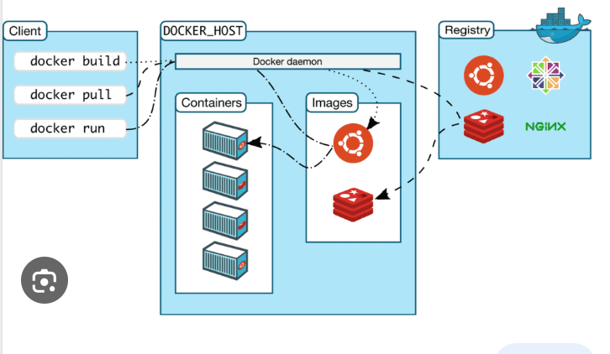

Is Docker Engine free?

Docker Desktop is free for small businesses (fewer than 250 employees AND less than $10 million in annual revenue), personal use, education, and non-commercial open source projects. Otherwise, it requires a paid subscription for professional use. Paid subscriptions are also required for government entities.

Installation : <https://docs.docker.com/desktop/install/windows-install/>

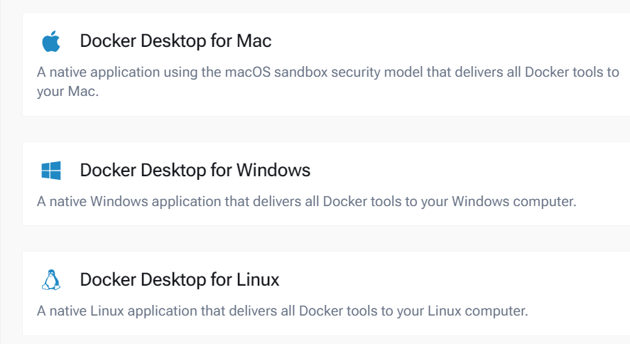

DOCKER TOOLS:

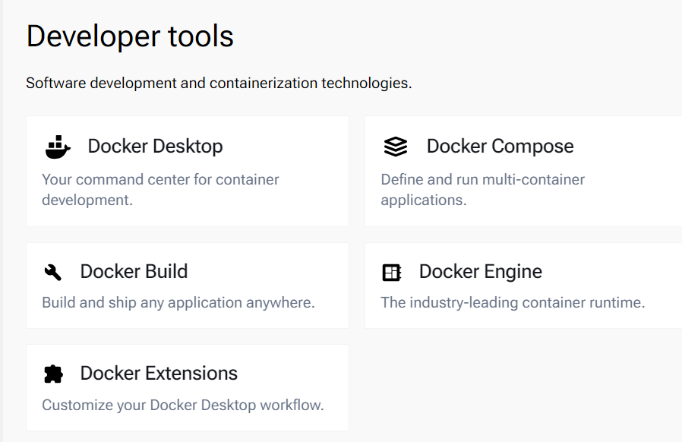

DOCKER ENGINE :

is **an open source containerization technology for building and containerizing your applications**

Docker Machine

is a tool used to install and manage Docker Engine

Docker Compose

allows you to define and manage multi-container applications in a single YAML file

This simplifies the complex task of orchestrating and coordinating various services, making it easier to manage and replicate your application environment.

**Docker - Hub**

Docker Hub is a registry service on the cloud that allows you to download Docker images that are built by other communities. You can also upload your own Docker built images to Docker hub. In this chapter, we will see how to download and the use the Jenkins Docker image from Docker hub.

<https://hub.docker.com/>

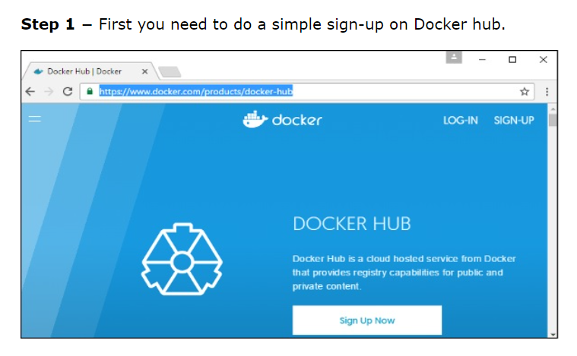

# Docker - Images

In Docker, everything is based on Images. An image is a combination of a file system and parameters. Let’s take an example of the following command in Docker.

TO RUN : docker run hello-world

TO Check the images : docker images

TO Remove Image : docker rmi

docker rmi ImageID

EX: docker rmi 7a86f8ffcb25

## **docker images -q**

docker images -q

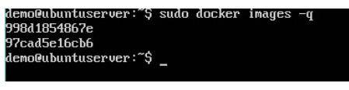

## **Running a Container**

Containers are instances of Docker images that can be run using the Docker run command. The basic purpose of Docker is to run containers. Let’s discuss how to work with containers.

To check the all the containers in docker :

docker ps

to Check all the container

## **docker ps -a**

## **docker history**

docker history ImageID

CMDS : <https://docs.docker.com/reference/dockerfile/>

1 )Create a Simple Spring boot application

2 ) Add the DockerFile and specify the instruction

3 )

 Docker Engine acts as a client-server application

What are the 3 types of cloud computing?

public cloud, private cloud, and hybrid cloud. Within these deployment models, there are four main services: infrastructure as a service (IaaS), platform as a service (PaaS), software as a service (SaaS), and serverless computing.

https://www.geeksforgeeks.org/difference-between-iaas-paas-and-saas/

