Hotel Room Booking System Specifications
Version 1.1

I. Hotel Room Booking System 8
II. Supplementary Specification 10
III. Data Flow Diagram (DFD) 11
IV. Use-Case diagram 12
1. overview diagram 12
1.1. List of actors 13
1.2. List of Use-cases 13
2. Use-case Register account 14
1.1. Summary 14
1.2. Flow of events 14
1.2.1. Basic flow 14
1.2.2. Alternative flows 15
1.2.2.2. The user enters missing or incorrect information 15
1.3. Special requirements 15
1.4. Preconditions 15
1.5. Postconditions 15
1.6. Extension points 15
3. Use-case login 15
2.1. Summary 15
2.2. Flow of events 15
2.2.1. Basic flow 15
2.2.2. Alternative flows 16
2.2.2.1. Incorrect email or password 16
2.2.2.2. Incorrect password entered more than 3 times 16
2.2.2.3. Account locked by Admin 16
2.3. Special requirements 16
2.4. Preconditions 16
2.5. Postconditions 16
2.6. Extension points 16
3. Use-case Logout 16
3.1. Summary 16
3.2. Flow of events 16
3.2.1. Basic flow 16
3.2.2. Alternative flows 17
3.3. Special requirements 17
3.4. Preconditions 17
3.5. Postconditions 17
3.6. Extension points 17
4. Use-case Reset password 17
4.1. Summary 17
4.2. Flow of events 17
4.2.1. Basic flow 17
4.2.2. Alternative flows 17
4.2.2.1. The email does not exist in the system 17
4.2.2.2. Failed to send the email 17
4.3. Special requirements 17
4.4. Preconditions 18
4.5. Postconditions 18
4.6. Extension points 18
5. Use-case Change password 18
5.1. Summary 18
5.2. Flow of events 18
5.2.1. Basic flow 18
5.2.2. Alternative flows 18
5.2.2.1. Invalid information entered 18
5.3. Special requirements 18
5.4. Preconditions 18
5.5. Postconditions 19
5.6. Extension points 19
6. Use-case Update profile 19
6.1. Summary 19
6.2. Flow of events 19
6.2.1. Basic flow 19
6.2.2. Alternative flows 19
6.2.2.1. The customer cancels the operation 19
6.2.2.2. Invalid information entered 19
6.4. Preconditions 19
6.5. Postconditions 19
6.6. Extension points 20
7. Use-case Search room 20
7.1. Summary 20
7.2. Flow of events 20
7.2.1. Basic flow 20
7.2.2. Alternative flows 20
7.2.2.1. Invalid search criteria 20
7.2.2.2. No suitable room 20
7.3. Special requirements 20
7.4. Preconditions 20
7.5. Postconditions 20
7.6. Extension points 21
8. Use-case View room detail 21
8.1. Summary 21
8.2. Flow of events 21
8.2.1. Basic flow 21
8.2.2. Alternative flows 21
8.2.2.1. The room does not exist or is no longer in business 21
8.3. Special requirements 21
8.4. Preconditions 21
8.5. Postconditions 21
8.6. Extension points 21
9. Use-case Book room 21
9.1. Summary 21
9.2. Flow of events 22
9.2.1. Basic flow 22
9.2.2. Alternative flows 22
9.2.2.1. The customer is not logged in 22
9.2.2.2. Invalid information entered 22
9.2.2.3. The room is no longer available 23
9.2.2.4. Room hold time expired 23
9.2.2.5. Online payment unsuccessful 23
9.3. Special requirements 23
9.4. Preconditions 23
9.5. Postconditions 23
9.6. Extension points 23
10. Use-case Apply voucher 23
10.1. Summary 23
10.2. Flow of events 23
10.2.1. Basic flow 23
10.2.2. Alternative flows 24
10.2.2.1. Invalid voucher code 24
10.3. Special requirements 24
10.4. Preconditions 24
10.5. Postconditions 24
10.6. Extension points 24
11. Use-case Make online payment 24
11.1. Summary 24
11.2. Flow of events 24
11.2.1. Basic flow 24
11.2.2. Alternative flows 25
11.2.2.1. Payment failed or canceled 25
11.2.2.2. Room hold time expired 25
11.3. Special requirements 25
11.4. Preconditions 25
11.5. Postconditions 25
11.6. Extension points 25
12. Use-case View my bookings 25
12.1. Summary 25
12.2. Flow of events 25
12.2.1. Basic flow 25
12.2.2. Alternative flows 26
12.2.2.1. The customer has no bookings 26
12.3. Special requirements 26
12.4. Preconditions 26
12.5. Postconditions 26
12.6. Extension points 26
13. Use-case Cancel booking 26
13.1. Summary 26
13.2. Flow of events 26
13.2.1. Basic flow 26
13.2.2. Alternative flows 27
13.2.2.1. The customer does not agree to cancel 27
13.2.2.2. The booking cannot be cancelled 27
13.2.2.3. Cancellation less than 24 hours before check-in time 27
13.3. Special requirements 27
13.4. Preconditions 27
13.5. Postconditions 27
13.6. Extension points 27
14. Use-case Review stay 27
14.1. Summary 27
14.2. Flow of events 27
14.2.1. Basic flow 27
14.2.2. Alternative flows 28
14.2.2.1. The booking is not eligible for review 28
14.3. Special requirements 28
14.4. Preconditions 28
14.5. Postconditions 28
14.6. Extension points 28
V. Class diagram 29

Hotel Room Booking System

The hotel reservation system has the following basic features:
- Accounts and Personal Information
- The system allows new users to register an account by entering their full name, email address, phone number, and password. During registration, the system verifies that the email address has not been used, the phone number is valid, and the password meets security requirements. After successful registration, the user becomes a customer of the system.
- Users log in using their email address and password. If the information is correct, the system directs them to the interface appropriate for their role—either customer or administrator. If incorrect, the system displays an error message and records the number of failed login attempts. Once logged in, users can log out to end their session. If they forget their password, they enter their registered email address to receive password reset instructions via email. Users can also proactively change their password by entering their old password and a new one.
- Once they have an account, customers can update their personal information, including full name, phone number, national ID number, address, gender, and date of birth.

- View, Search, and Filter Rooms
- All users, including those who are not logged in, can view the list of rooms and prices. Each room displays actual photos, price per night, capacity, room type, and availability. When viewing a room’s details, users see additional information such as a detailed description, square footage, included amenities, and reviews from previous guests.
- Users can search for rooms by keyword, check-in date, check-out date, and number of guests. The system returns only rooms that are available during that date range and have sufficient capacity. If a user makes a spelling mistake, the system will still attempt to return relevant results. Results can be further filtered by price range and availability status.

- Room Reservations and Reservation Management
- Only users with an account can select and book rooms. If a guest who is not logged in attempts to select a room, the system redirects them to the login page and then returns them to the step they were on.
- When making a reservation, guests select a room, check-in date, check-out date, and enter the number of adults and children. The system checks room availability and creates a reservation request in “pending” status. A single reservation may include multiple rooms. During the booking process, guests can add additional services such as spa treatments or breakfast; the cost of these services will be added to the total cost.
- Customers can review their reservations by status: pending, confirmed, in-stay, completed, and canceled. Customers can also cancel a reservation in accordance with the hotel’s policy. The system checks the cancellation conditions before changing the reservation to “canceled” status and returning the room to “available” status. After completing their stay, guests can rate the room with a star rating and write a review. This feature is only available once the reservation has been completed.
- For guests arriving directly at the hotel without an account, staff create an account for the guest using the user management feature, then book a room for them as they would for any other guest.

- Billing and Payment
- The system automatically calculates the total cost based on the number of nights stayed and the number of rooms, plus services, taxes, and surcharges (if any), then deducts any discounts. Customers can enter a discount code. The system verifies that the code exists, is valid, and is currently active; only one code can be used per booking.
- Before payment, the system displays a summary including the base amount, the discount from the voucher, the deposit, taxes, and the total, and asks the customer to confirm. Customers can pay online via the payment gateway or choose to pay at the hotel. Upon successful payment, the system records the transaction, issues an invoice linked to the reservation, and sends a confirmation email to the customer.
- If a guest cancels a booking in accordance with the policy and the booking was paid for online, the system initiates a refund through the payment gateway, records the refund amount, and updates the transaction status to “refunded.” Bookings paid for at the hotel do not go through this step.

- Administration
- An administrator has full authority to manage the system and, like all other users, can view, search for, and filter rooms.
- Regarding data, administrators manage rooms and room types (add, edit, delete, update prices, images, and descriptions), manage services and assign them to rooms, manage discount codes, and manage users—including viewing the user list, locking or unlocking accounts, and creating accounts for walk-in guests.
- Regarding reservations, administrators view all guest reservations and approve pending reservations to move them to “Confirmed” status. When guests arrive, administrators check in confirmed reservations, verify ID cards against reservation information, and move the reservation to “Staying.” During the stay, any additional charges incurred are recorded on the reservation along with the reason. When guests check out, the administrator processes the checkout; the system finalizes the additional charges, recalculates the total amount, issues an invoice, marks the reservation as “completed,” and returns the room to “vacant” status. Finally, the administrator can view the hotel’s revenue—a privilege reserved exclusively for administrators.

Supplementary Specification

Usability
The system assists users when they make spelling mistakes during a search, preventing situations where a search returns no results simply because of a few incorrect characters. Additionally, before checkout, the system must confirm the details with the customer and clearly and accurately display each item—including the base price, voucher amount, deposit, tax, and total—so the customer can be confident about the amount due.

Reliability
Once a room has been booked for a specific time period, the system must lock that room to prevent multiple people from booking it simultaneously. If two people attempt to book the same room at the same time, only one booking will be successful. Furthermore, the system must operate reliably 24/7 so that customers can book rooms at any time.

Performance
The system must be able to handle 5,000 concurrent users while continuing to function normally. Page reload time must not exceed 3 seconds. When users filter information based on their criteria, results must be returned within 3 seconds.

Security
Passwords must include lowercase letters, uppercase letters, numbers, and special characters. If an account enters the wrong password more than 3 times, the system sends a warning email to the account owner. The system also sends a notification email every time a password is changed. Access permissions are strictly enforced: only administrators are allowed to view revenue and use administrative functions; customers attempting to access these functions will be denied.

Development Requirements
Web-based applications. HTML + CSS + the Python programming language + the Figma UI design platform + the GitHub code hosting platform + the Draw.io diagramming platform + Google Docs text creation and editing tool

Data Flow Diagram (DFD)
Level 0:
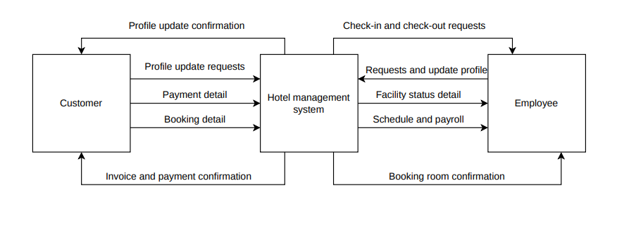
Level 1:
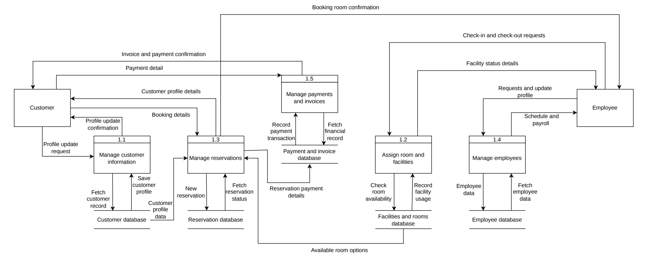

Use-Case diagram

overview diagram
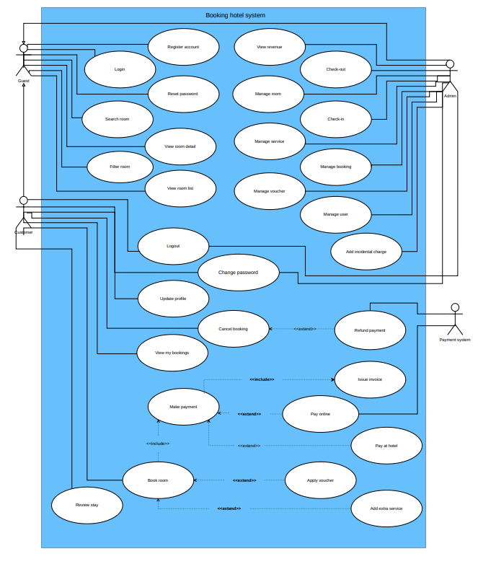

List of actors

No. | Actor | Description
1 | Guest | A general system user, including those without an account. Can view, search, and filter rooms; register; and log in. The Customer and Admin actors inherit from this actor.
2 | Customer | A customer with an account. In addition to the Guest’s functions, can book rooms, make payments, cancel reservations, and leave reviews.
3 | Admin | Administrator (hotel staff). In addition to the Guest’s functions, they can manage data and reservations, handle check-ins and check-outs, and view revenue.
4 | Payment system | External payment gateway. Processes online payment transactions and refunds.

List of Use-cases

No. | Use-cases | Description
1 | Register account | Sign up for a new account using your full name, email address, phone number, and password.
2 | Login | Log in to the system with your email and password
3 | Reset password | Reset your password via email if you forget it.
4 | View room list | View the room list with photos, nightly rates, capacity, and availability.
5 | View room detail | View details about a room: description, size, included amenities, and reviews from previous guests.
6 | Search room | Search for rooms by keyword, check-in date, check-out date, and number of guests.
7 | Filter room | Filter rooms by price range and availability.
8 | Logout | Log out, end your session.
9 | Change password | Change your password by entering your old password and your new password.
10 | Update profile | Update personal information: full name, phone number, national ID number, address, gender, date of birth.
11 | Book room | Select a room, check-in date, check-out date, and number of guests, then create a reservation.
12 | Apply voucher | Enter the discount code when booking a room (optional; click “Book Room” to expand).
13 | Add extra service | Add additional services such as spa treatments and breakfast when booking a room (optional, under “Book a Room”).
14 | Make payment | Pay for your reservation, including reviewing the cost summary and selecting a payment method.
15 | Pay online | Pay online through the payment gateway.
16 | Pay at hotel | Pay directly at the hotel.
17 | Issue invoice | Issue an invoice and send a confirmation email after payment is successfully processed.
18 | View my bookings | View your reservations by status.
19 | Cancel booking | Cancel the reservation in accordance with the hotel's policy.
20 | Refund payment | Refunds for valid cancellations and orders paid online
21 | Review stay | Rate with stars and leave a review once your stay is complete.
22 | Manage room | Add, edit, and delete rooms and room types.
23 | Manage service | Add, edit, and delete services, and assign services to rooms.
24 | Manage voucher | Create, edit, and disable discount codes.
25 | Manage user | View the list of users, lock or unlock accounts, and create accounts for walk-in customers.
26 | Manage booking | View all reservations, review reservations, and cancel reservations.
27 | Add incidental charge | Record any additional charges on the order form along with the reason.
28 | Check-in | Confirm the guest's check-in, verify their ID card, and update their status to “currently staying.”
29 | Check-out | Confirm guest checkout, finalize additional charges, issue an invoice, and mark the reservation as completed.
30 | View revenue | View hotel revenue; only Admins can access this.

Use-case Register account

1.1. Summary
This use-case describes how a guest registers a member account in order to book rooms.

1.2. Flow of events

1.2.1. Basic flow
The use-case starts when the user selects the Register function.
- The system asks the user to provide: full name, email, phone number, password, and password confirmation.
- The user enters the information and submits the registration request.
- The system validates the information, encrypts the password, and adds the new account (role: Customer) to the system.
- The system notifies the user that registration was successful and redirects the user to the login function.

1.2.2. Alternative flows
1.2.2.1. The email (login name) already exists in the system
If, in the Basic flow, the user enters an email that already exists in the system, the system displays an error message. The user can choose to return to the beginning of the Basic flow or cancel the operation, in which case the use-case ends.

1.2.2.2. The user enters missing or incorrect information
If the user omits required information (full name, email, phone number, password), enters an email or phone number in the wrong format, enters a password that does not follow the rules, or the password confirmation does not match, the system displays an error message stating which information is incorrect. The user can choose to return to the beginning of the Basic flow or cancel the operation, in which case the use-case ends.

1.3. Special requirements
- The password must have at least 8 characters, including lowercase letters, uppercase letters, digits, and special characters.

1.4. Preconditions
None.

1.5. Postconditions
If the use-case succeeds, the new account information is added to the system. Otherwise, the system state is unchanged.

1.6. Extension points
None.

3. Use-case login

2.1. Summary
This use-case describes how a user logs in to the Hotel Booking System.

2.2. Flow of events

2.2.1. Basic flow
The use-case starts when the user selects the Login function.
- The system asks the user to enter an email and password.
- The user enters the email and password and submits the login request.
- The system checks the email and password. If they are correct, the system allows the user to log in.
- The system redirects the user to the page that matches the user's role: the home page for customers, the administration page for Admin.

2.2.2. Alternative flows

2.2.2.1. Incorrect email or password
If, in the Basic flow, the user enters an incorrect email or password, the system displays an error message and records the number of consecutive failed attempts. The user can choose to return to the beginning of the Basic flow or cancel the operation, in which case the use-case ends.

2.2.2.2. Incorrect password entered more than 3 times
If the user enters an incorrect password more than 3 times in a row, the system temporarily locks login for that account for a period of time (for example, 15 minutes) and sends a warning email to the account's email address. The use-case ends.

2.2.2.3. Account locked by Admin
If the account has been locked by Admin, the system displays a message that the account cannot log in and instructs the user to contact the hotel. The use-case ends.

2.3. Special requirements
- Login is temporarily locked after 3 incorrect password attempts to prevent password guessing.

2.4. Preconditions
The user is not logged in to the system.

2.5. Postconditions
If the use-case succeeds, the user is logged in to the system. Otherwise, the system state is unchanged (except that the number of consecutive failed attempts is recorded).

2.6. Extension points
- Use-case Reset password: the user can switch to the password recovery function when the user does not remember the password.

3. Use-case Logout

3.1. Summary
This use-case allows a logged-in user to exit the system.

3.2. Flow of events

3.2.1. Basic flow
The use-case starts when the user selects the Logout function.
- The system ends the user's login session.
- The system redirects the user to the home page in the not-logged-in state.

3.2.2. Alternative flows
None.

3.3. Special requirements
None.

3.4. Preconditions
The user must be logged in to the system.

3.5. Postconditions
If the use-case succeeds, the login session ends and the user returns to the not-logged-in state. Otherwise, the system state is unchanged.

3.6. Extension points
None.

4. Use-case Reset password

4.1. Summary
This use-case allows a user to create a new password when the user has forgotten the password.

4.2. Flow of events

4.2.1. Basic flow
The use-case starts when the user selects the Reset password function.
- The system asks the user to enter an email.
- The user enters the email and requests a password reset.
- The system checks whether the email exists in the system. If it does, the system generates a new random password and sends it to the user's email.
- The system notifies the user of the result of the password reset.

4.2.2. Alternative flows

4.2.2.1. The email does not exist in the system
If the email does not exist, the system notifies the user. The user can restart this function or exit it.

4.2.2.2. Failed to send the email
If the system cannot send the email, the system displays an error message and keeps the old password. The user can try again later.

4.3. Special requirements
- The new password must be randomly generated and follow the password rules (at least 8 characters, including lowercase letters, uppercase letters, digits, and special characters).

4.4. Preconditions
None.

4.5. Postconditions
If the use-case succeeds, the password is changed and an email containing the new password is sent to the user. Otherwise, the system state is unchanged.

4.6. Extension points
None.

5. Use-case Change password

5.1. Summary
This use-case allows a logged-in user (customer or Admin) to change his or her own password.

5.2. Flow of events

5.2.1. Basic flow
The use-case starts when the user selects the Change password function.
- The system asks the user to enter the current password, the new password, and the new password confirmation.
- The user enters the information and requests the password change.
- The system checks whether the current password is correct, whether the new password follows the rules and differs from the current password, and whether the confirmation matches. If everything is valid, the system updates the new password.
- The system sends an email to the user notifying that the password was changed successfully.
- The system notifies the user of the result of the password change.

5.2.2. Alternative flows

5.2.2.1. Invalid information entered
If the current password is incorrect, the new password does not follow the rules or is the same as the current password, or the new password confirmation does not match, the system displays an error message. The user can choose to return to the beginning of the Basic flow or cancel the operation, in which case the use-case ends.

5.3. Special requirements
- The new password must have at least 8 characters, including lowercase letters, uppercase letters, digits, and special characters.

5.4. Preconditions
The user must be logged in to the system.

5.5. Postconditions
If the use-case succeeds, the password is updated and a notification email is sent to the user. Otherwise, the system state is unchanged.

5.6. Extension points
None.

6. Use-case Update profile

6.1. Summary
This use-case allows a customer, after logging in, to edit his or her personal information.

6.2. Flow of events

6.2.1. Basic flow
The use-case starts when the customer selects the function to edit his or her personal information.
- The system displays the customer's current personal information: full name, email, phone number, address, gender (the password is not displayed).
- The customer edits the information as desired (except the email).
- The customer clicks the update button.
- The system validates the information and updates it in the system.
- The system notifies the customer of the update result.

6.2.2. Alternative flows

6.2.2.1. The customer cancels the operation
If the customer cancels the operation, the system does not update the information and the use-case ends.

6.2.2.2. Invalid information entered
If the customer leaves required information empty (full name, phone number) or enters a phone number in the wrong format, the system displays an error message. The user can choose to return to the beginning of the Basic flow or cancel the operation, in which case the use-case ends.
6.3. Special requirements
- A customer can only view and update his or her own information.

6.4. Preconditions
The customer (Customer) must be logged in to the system.

6.5. Postconditions
If the use-case succeeds, the personal information is updated. Otherwise, the system state is unchanged.

6.6. Extension points
None.

7. Use-case Search room

7.1. Summary
This use-case allows a user to search for available rooms by check-in date, check-out date, number of guests, and number of rooms; the results can be filtered and sorted.

7.2. Flow of events

7.2.1. Basic flow
The use-case starts when the user selects the room search function.
- The system displays a form for the user to enter search criteria: check-in date, check-out date, number of adults, number of children, number of rooms.
- The user enters the criteria and requests the search.
- The system validates the criteria, then finds and lists the rooms that are available during that period (room name, image, price per night, capacity, area). The list is paginated, with a maximum of 10 rooms per page.
- The user may choose to filter the results (by price range, room type, amenities, capacity), choose a sort order (by price ascending or descending), or choose the page to view.
- The system displays the list of rooms according to the user's choices.

7.2.2. Alternative flows

7.2.2.1. Invalid search criteria
If the check-in date is before the current date, the check-out date is not after the check-in date, or the number of guests or rooms is invalid, the system displays an error message and asks the user to re-enter.

7.2.2.2. No suitable room
If no room meets the criteria, the system notifies the user that no room was found and suggests that the user change the criteria.

7.3. Special requirements
- For at least 95% of requests, search and filter results must be returned within 3 seconds.
- Only list rooms that have no active booking overlapping the selected period.

7.4. Preconditions
None.

7.5. Postconditions
None.

7.6. Extension points
- Use-case View room detail: if the user chooses to view the details of a room.
- Use-case Book room: if the user chooses to book a room.

8. Use-case View room detail

8.1. Summary
This use-case allows a user to view the detailed information of a room.

8.2. Flow of events

8.2.1. Basic flow
The use-case starts when the user chooses to view the details of a room.
- The system displays the room's detailed information, including: room number, room type, real photos, detailed description, area, capacity, bed type, amenities, price per night, included services, cancellation policy, and ratings and comments from guests who have stayed.

8.2.2. Alternative flows

8.2.2.1. The room does not exist or is no longer in business
If the room no longer exists or is no longer in business, the system displays a message and returns the user to the room list.

8.3. Special requirements
- All users, including those who are not logged in, can view room information and prices.

8.4. Preconditions
None.

8.5. Postconditions
None.

8.6. Extension points
- Use-case Book room: if the user chooses to book the room being viewed.

9. Use-case Book room

9.1. Summary
This use-case allows a customer to book a room: choose additional services, enter booking information, view the total cost, choose a payment method, and receive a confirmation email.

9.2. Flow of events

9.2.1. Basic flow
The use-case starts when the customer chooses to book a room (from the search results list or from the room detail page) with the check-in date, check-out date, and number of guests already selected.
- The system displays the selected room's information (check-in date, check-out date, number of nights, price per night) and the list of additional services (name, price) such as spa and breakfast.
- The customer selects additional services and quantities (optional).
- The system asks for booking information: full name and phone number of the occupant (by default taken from the customer's profile, and may differ from the person booking), number of adults, number of children, and special requests.
- The customer enters the information and requests to continue.
- The system calculates the total cost, including the room charge (price per night multiplied by the number of nights), service charge, tax, minus any discount, and calculates the deposit (30% of the total).
- The system displays the order confirmation page showing the original price, voucher discount, deposit, tax, and total, and asks the customer to confirm the booking.
- If the customer confirms, the system checks that the room is available during the selected period and temporarily holds the room for 15 minutes.
- The system asks the customer to choose a payment method: online payment (paying the deposit) or payment at the hotel.
- If the customer chooses online payment, the system moves to the online payment function.
- If the customer chooses payment at the hotel, or the online payment succeeds, the system records the booking with the status Pending and notifies the booking result.
- The system sends a booking confirmation email with the booking code and full order information to the customer's email.

9.2.2. Alternative flows

9.2.2.1. The customer is not logged in
If the user is not logged in when choosing to book, the system asks the user to log in or register an account, then returns to the booking step in progress.

9.2.2.2. Invalid information entered
If the information entered is invalid (missing occupant's full name or phone number, number of guests exceeding the room's capacity), the system displays an error message. The user can choose to return to the beginning of the Basic flow or cancel the operation, in which case the use-case ends.

9.2.2.3. The room is no longer available
If, at the checking step, the room has already been booked by someone else during the selected period, the system notifies that the room is no longer available and returns the customer to the room search function.

9.2.2.4. Room hold time expired
If more than 15 minutes pass since the temporary hold and the booking has not been completed, the system releases the room, notifies that the hold time has expired, and the customer must make the booking again.

9.2.2.5. Online payment unsuccessful
If the online payment fails, the customer can try again, choose payment at the hotel, or stop the booking; when the customer stops, the system releases the room and the use-case ends.

9.3. Special requirements
- A room cannot be booked for two overlapping periods, even when multiple customers book at the same time.
- The amounts displayed and the amounts recorded in the booking must be absolutely accurate.
- The deposit equals 30% of the total; the customer can cancel for free up to 24 hours before check-in time.

9.4. Preconditions
The customer (Customer) must be logged in to the system.

9.5. Postconditions
If the use-case succeeds, the booking is added to the system with the status Pending, the room is held for the booked period, and a confirmation email is sent to the customer. Otherwise, the system state is unchanged.

9.6. Extension points
- Use-case Apply voucher: if the customer chooses to enter a discount code.
- Use-case Make online payment: if the customer chooses online payment.

10. Use-case Apply voucher

10.1. Summary
This use-case allows a customer to enter a voucher code during booking to receive a discount.

10.2. Flow of events

10.2.1. Basic flow
The use-case starts when the customer chooses to enter a discount code at the booking step.
- The system asks the customer to enter a voucher code.
- The customer enters the voucher code and requests to apply it.
- The system checks the voucher code: the code exists, is active, is within its validity period, and still has remaining uses.
- If the code is valid, the system recalculates the discount amount, deposit, tax, and total, and displays them again to the customer.

10.2.2. Alternative flows

10.2.2.1. Invalid voucher code
If the code does not exist, has expired, is inactive, or has no remaining uses, the system displays an error message stating the reason. The customer can enter another code or skip applying a voucher, in which case the use-case ends.

10.3. Special requirements
- The amount after the discount must be calculated absolutely accurately.

10.4. Preconditions
The customer must be logged in and in the process of booking a room.

10.5. Postconditions
If the use-case succeeds, the voucher is applied to the booking in progress and the total is updated. Otherwise, the system state is unchanged.

10.6. Extension points
None.

11. Use-case Make online payment

11.1. Summary
This use-case allows a customer to pay the deposit of a booking through the online payment gateway (Payment System).

11.2. Flow of events

11.2.1. Basic flow
The use-case starts when the customer chooses online payment at the booking step.
- The system creates a payment transaction with the deposit as the amount and redirects the customer to the online payment gateway.
- The customer enters the payment information and confirms on the payment gateway.
- The payment gateway (Payment System) processes the transaction and returns the result to the system.
- If the payment is successful, the system records the payment (type: deposit) for the booking and takes the customer to the page showing the booking result.

11.2.2. Alternative flows

11.2.2.1. Payment failed or canceled
If the payment fails, the customer cancels at the payment gateway, or the payment gateway does not respond, the system does not record the payment and displays an error message. The customer can try again, choose payment at the hotel, or stop the booking.

11.2.2.2. Room hold time expired
If the 15-minute room hold has passed, the system releases the room and does not allow the payment to continue. If a successful payment result is returned after that time and the room is no longer available, the system does not create the booking and refunds the amount to the customer.

11.3. Special requirements
- The system does not store the customer's payment card information; entering and processing card information is entirely handled by the payment gateway.
- The amount sent to the payment gateway must be absolutely accurate.

11.4. Preconditions
The customer must be logged in, have confirmed the booking, and the room must be temporarily held.

11.5. Postconditions
If the use-case succeeds, the deposit payment is recorded for the booking. Otherwise, the system state is unchanged.

11.6. Extension points
None.

12. Use-case View my bookings

12.1. Summary
This use-case allows a customer to view the list of bookings that he or she has made and the status of each booking.

12.2. Flow of events

12.2.1. Basic flow
The use-case starts when the customer chooses the function to view his or her bookings.
- The system displays the customer's list of bookings in descending order (newer bookings first), including booking code, check-in date, check-out date, total amount, and status (Pending, Confirmed, Checked-in, Completed, Cancelled).
- The customer chooses the "View details" function for a booking.
- The system displays the booking's detailed information, including: list of rooms, additional services, occupant information, number of guests, special requests, voucher, deposit, tax, total amount, payment method, payments made, and booking status.

12.2.2. Alternative flows

12.2.2.1. The customer has no bookings
If the customer has no bookings, the system notifies that there are no bookings.

12.3. Special requirements
- A customer can only view his or her own bookings.

12.4. Preconditions
The customer (Customer) must be logged in to the system.

12.5. Postconditions
None.

12.6. Extension points
- Use-case Cancel booking: if the customer chooses to cancel a booking.

13. Use-case Cancel booking

13.1. Summary
This use-case allows a customer to cancel a booking in accordance with the hotel's cancellation policy.

13.2. Flow of events

13.2.1. Basic flow
The use-case starts when the customer chooses to cancel a booking.
- The system displays a confirmation dialog for the cancellation, stating the cancellation policy (free cancellation up to 24 hours before check-in time) and the amount to be refunded.
- If the customer agrees, the system checks that the cancellation is valid (the booking belongs to the customer, and the booking status is Pending or Confirmed).
- The system changes the booking status to "Cancelled" and releases the held room.
- If the customer paid the deposit online and the cancellation is free of charge, the system sends a refund request to the payment gateway (Payment System) and records the refund.
- The system notifies the result of the cancellation.

13.2.2. Alternative flows

13.2.2.1. The customer does not agree to cancel
If the customer does not agree in the confirmation dialog, the system closes the dialog and keeps the booking unchanged.

13.2.2.2. The booking cannot be cancelled
If the booking is already checked-in, completed, cancelled, or does not belong to the customer, the system displays an error message and does not change the booking.

13.2.2.3. Cancellation less than 24 hours before check-in time
If the time of cancellation is less than 24 hours before check-in time, the confirmation dialog warns the customer that the deposit will not be refunded. If the customer still agrees, the booking is changed to "Cancelled" and no refund is made.

13.3. Special requirements
- The refund amount must be absolutely accurate.
- A customer can only cancel his or her own bookings.

13.4. Preconditions
The customer must be logged in to the system and viewing his or her list of bookings.

13.5. Postconditions
If the use-case succeeds, the booking is changed to the "Cancelled" status, the room is released, and the deposit is refunded if eligible. Otherwise, the system state is unchanged.

13.6. Extension points
None.

14. Use-case Review stay

14.1. Summary
This use-case allows a customer to rate and write a comment about the stay after the booking is completed.

14.2. Flow of events

14.2.1. Basic flow
The use-case starts when the customer chooses the function to review a completed booking.
- The system displays a review form containing a rating (from 1 to 5 stars) and comment content.
- The customer enters the rating and comment and requests to submit the review.
- The system validates the request (the booking belongs to the customer, the booking status is Completed, the booking has not been reviewed yet, the rating is valid) and saves the review.
- The system notifies the result and displays the review on the room detail page.

14.2.2. Alternative flows

14.2.2.1. The booking is not eligible for review
If the booking is not in the Completed status or has already been reviewed, the system displays an error message and the use-case ends.

14.3. Special requirements
- Each booking can be reviewed only once.

14.4. Preconditions
The customer (Customer) must be logged in to the system.

14.5. Postconditions
If the use-case succeeds, the customer's review is added to the system. Otherwise, the system state is unchanged.

14.6. Extension points
None.

Class diagram

