Algonquin College Logo

# SCHOOL OF ADVANCED TECHNOLOGY

### ICT - Applications & Programming

### Computer Engineering Technology – Computing Science



A11

Game Interface

Team:

[Quoc Thang Tran] - Id: [041009239]

Game Proposal - NUMPUZ

***This template is suggested (not mandatory) to answer A11 Specification.***

|  |  |
| --- | --- |
| **Part**  **1** | **GUI Definition** |

**EXPLANATION**

*The purpose of this assignment is to define the elements of the GUI application to be used in your game implementation.*

* ***Example****:*

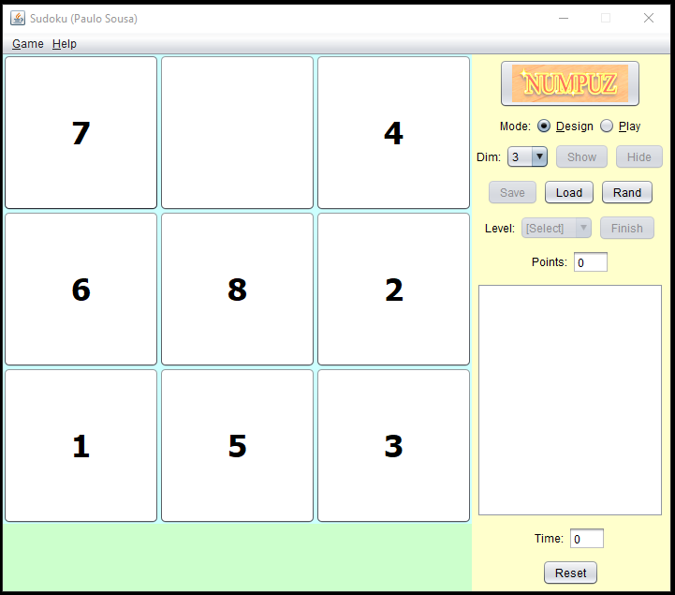

* ***Note****: The professor interface is also a proposal. It means that your own implementation can be different. What does matter is that the game functionality will be respected.*
  1. **Defining the Components**

**List of components**

*Include the list of components that you will use (they can be from Swing or* ***JavaFX****).*

* Button
* RadioButton
* ChoiceBox
* TextArea
* ProgressBar

**Functionalities and Behaviors**

*What are the behaviors and functionalities that you will provide? How these elements are related with functionalities.*

***Example****: The game mode can be selected by RadioButtons, etc.*

* The game’s name “Numpuz” can be presented by Image class ( javafx.scene.image ).
* The game mode (design or start) can be selected by RadioButtons.
* Mode (play or design) are presented by TextArea.
* The dimension (the square grid’s dimension) can be chosen in a ChoiceBox.
* The game’s configuration can be saved to files or loaded from files.
* The game’s configuration can be set up randomly by Button.
* The game’s time (How long the user has been playing with the current game) is presented by Text Area.
* The progress (How much the player has been done so far with the puzzle) is presented by Text Area.
* The player can reset the game (keep the same dimension, change the numbers’ orders randomly, reset the time and progress) with Button.

**Details**

*Drawn your interface (ex: in an image from Paint / Powerpoint slide, or any sketch tool), describing:*

* *The components;*
* *The properties (ex: size, dimension, color, position, etc)*
* *Additional GUI components (ex: the layout to be used).*

* 1. **User Manual**

**Basic cycle**

*Create a brief description about how your game can be used.*

***Example****: If you have to design the solution to be saved and played later, how are the stems. Most importantly, how someone can play the* ***NumPuz****.*

* *Note: your process do not need to be followed exactly when you are going to the implementation. For while, it is only a script about how to play.;*

The default mode of the game is design (where you can configure the game). To **start** to play the game, please choose the dimension of the grid (The default dimension is 3) and click on play button.

**Game rules**: The sequence of number in the grid is in random orders. The challenge is to put them in the right incremental order from top-left corner to the end of the row and again and again until the right-bottom corner. You can only move one number at a time ( move to the blank space )

**Options:**

* You can load your current progress to a file or load another progress from a file.
* You can reset the game and start a new one by clicking on Reset button.

**Stats:**

* Time: Show how much time you have played.
* Progress: Show your progress of winning the game..

That’s all! Quite simple! Have fun playing !!!

**FINAL SUGGESTIONS**

*Here some ideas to think about your language....*

* *Try to create a game whose execution can be very intuitive (easy to be played).*
* *Remember that this game will be in fact implemented only in the next assignment.*

**References**

*[Include eventual references used here]*

Algonquin College

Fall, 2022